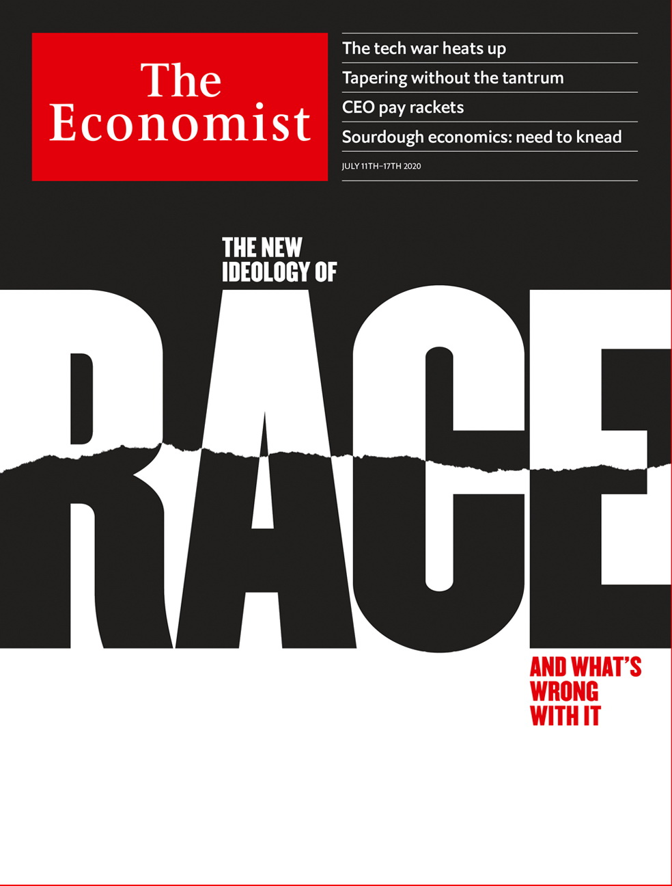

# Table of Contents

The world this week

Politics this week

Business this week

KAL’s cartoon

Leaders

Race and social change: The new ideology of race

The world economy: Tapering without the tantrum

Nuclear proliferation: A better way to contain Iran

Sino-American tensions: Techtonic plates

Sourdough economics: The need to knead

Letters

Letters to the editor: On the UN, foreign aid, Olof Palme, green finance, China, coronaspeak

Briefing

Race in America: Staying apart

United States

Economic policy: The covid bonus

Kansas’s Senate race: The 88-year itch

Policing: Bands of blue

The courts: Reform squared

Chaplains: Civil rites

Lexington: The mark of Cain

The Americas

Brazil: Christianity, covid, contact

Dominican Republic: A rare power shift

Bello: Promise and disappointment

Asia

Covid-19 in India: Flattening the wrong curve

Regional development in South Korea: Seoul v the rest

Asylum in Taiwan: A whispered welcome

Australia and covid-19: Lock, unlock, repeat

Lockdown in the Philippines: Four months and counting

Banyan: Wai-five

China

Civil society: Who you gonna call?

Human rights: The party’s grip

Chaguan: American soft power, trashed

Middle East & Africa

Jihad in the Sahel: Fighting a spreading insurgency

Zimbabwe: For a few dollars more

Ethiopia: The fragile federation

Iran and the bomb: Booms in the night

Europe

Turkey: Converting Istanbul’s Hagia Sophia

France’s reshuffle: L’inconnu

Italy: The last bandit

Bosnia’s memory war: A genocide still denied

Spain’s economy: A lopsided recovery

Charlemagne: A Dutch dilemma

Britain

Relations with China: About turn

Human rights: From red carpet to blacklist

Fiscal policy: Sunak’s summer splurge

Economic data: Wrong numbers

Theatres: Cast adrift

Crime in lockdown: Catching up on their to-do lists

Food: Retro diners

Bagehot: Fading Anglophilia

International

Race and liberal philosophy: In the balance

Business

Executive compensation: Pay guaranteed, performance optional

Sino-American tech tussles: What goes up, and up and up

Online business: E-shopping frenzy

Bartleby: Parkinson’s law updated

Schumpeter: The battle for low-Earth orbit

Finance & economics

The global economy: How to feel better

China’s stockmarket: A bull market returns

Global trade: Leading question

The European Union: Seeking haven

Stock exchanges: Down time

Buttonwood: Default settings

Free exchange: Which way, Jay?

Science & technology

The 23rd International AIDS Conference: Social distancing

Archaeology: How illuminating

Climate change: Delayed cool

Books & arts

Populism and democracy: Party like it’s 1999

Japan under the shogunate: A handmaid’s tale

Johnson: Shock value

Choral singing: Voices off

Thought-provoking fiction: Not going gently

Economic & financial indicators

Economic data, commodities and markets

Graphic detail

GDP and life satisfaction: Blessed are the rich in spirit

Obituary

William Dement: Perchance to dream



### Friday, July 10, 2020

|  |  |
| --- | --- |
| The world this week | 3 |
| Leaders | 5 |
| Letters | 1 |
| Briefing | 1 |
| United States | 6 |
| The Americas | 3 |
| Asia | 6 |
| China | 3 |
| Middle East & Africa | 4 |
| Europe | 6 |
| Britain | 8 |
| International | 1 |
| Business | 5 |
| Finance & economics | 7 |
| Science & technology | 3 |
| Books & arts | 5 |
| Economic & financial indicators | 1 |
| Graphic detail | 1 |
| Obituary | 1 |

|  |  |  |
| --- | --- | --- |
|  | Sections | Leaders |

The world this week

Politics this week

.

Business this week

.

KAL’s cartoon

.

|  |  |  |
| --- | --- | --- |
|  | Sections | Leaders |

|  |  |  |  |
| --- | --- | --- | --- |
|  | Articles | Sections | Next |

# Politics this week

Jul 11th 2020 |

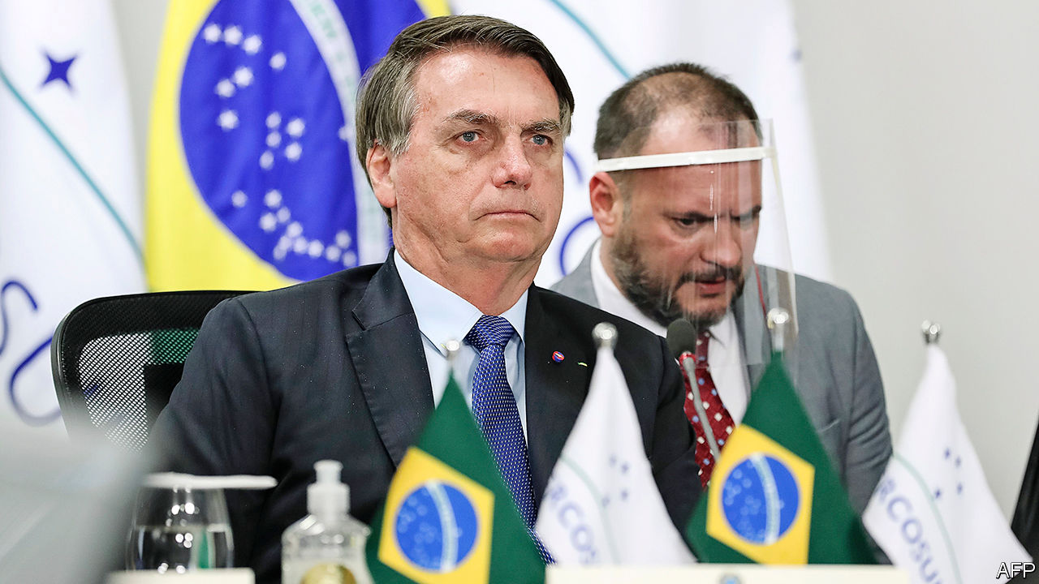

Brazil’s president, Jair Bolsonaro, who has downplayed the threat of covid-19, flouted social-distancing guidelines and said that his “athletic history” would protect him, tested positive for the coronavirus.

Luis Abinader, a businessman from the centre-left Modern Revolutionary Party, won the Dominican Republic’s presidential election. His victory ends 16 years of rule by the Dominican Liberation Party. The vote, originally scheduled for May, was delayed because of covid-19. See article.

Fabián Gutiérrez, who was a secretary to Cristina Fernández de Kirchner, Argentina’s president from 2007 to 2015 and now its vice-president, was murdered. Mr Gutiérrez had agreed to co-operate with the prosecution in the “notebooks” scandal, centred on bags of cash delivered to officials during Ms Fernández’s presidency, and to her home. She denies wrongdoing. Mr Gutiérrez’s murder is not thought to be politically motivated.

A British judge ruled that Venezuela’s de facto president, Nicolás Maduro, cannot access $1.8bn-worth of gold held in the Bank of England because Britain recognises the leader of the opposition, Juan Guaidó, as the president.

The Trump administration gave formal notice to the World Health Organisation that America will withdraw from the body on July 6th 2021. Joe Biden said he will scrap that decision and “rejoin” the WHO if he is elected president in November.

Brian Kemp, the governor of Georgia, called up the National Guard to deploy to Atlanta, where tensions are running high over policing. Mr Kemp issued his order after a sharp increase in criminal shootings and homicides, including that of an eight-year-old girl.

In a rare instance of unanimity, the justices on America’s Supreme Court ruled that members of the electoral college who vote against the presidential candidate chosen by the popular vote in their state can be punished.

China’s central government set up an office in Hong Kong to oversee enforcement of a new national-security law. Its staff includes secret police from the mainland. Hong Kong’s government formed a committee on national-security policy and gave the police sweeping new powers. A senior mainland official is an “adviser” on the body. Australia suspended its extradition treaty with Hong Kong and urged its citizens there to consider leaving. See article.

Police in Beijing detained a prominent law professor, Xu Zhangrun. Mr Xu has long been one of the Communist Party’s most outspoken critics.

Widespread flooding killed dozens of people and displaced millions in several Chinese provinces. The city of Wuhan, where covid-19 first took hold, issued a flood alert.

Koike Yuriko was re-elected the governor of Tokyo with 60% of the vote. Ms Koike, who used to be a member of the ruling Liberal Democratic Party but now leads an opposition party, has won plaudits for her handling of the covid-19 crisis in the city, boosting her national profile.

Rescue workers said there was little hope of finding any more survivors from a landslide at a jade mine in northern Myanmar that killed at least 170 people. Many of the dead were scouring the mine’s rubble for remnants of the gemstone.

President Emmanuel Macron reshuffled his cabinet following disappointing results in local elections. Despite being well-regarded, France’s prime minister, Edouard Philippe, was replaced by a little-known technocrat, Jean Castex. See article.

Iran said a fire at a nuclear facility in Natanz caused significant damage. It did not say what caused the blaze, but spooks in the region believe it was a bomb. Suspicion has fallen on Israel and America, which have sabotaged Iran’s nuclear programme in the past. Other mysterious incidents, including recent explosions at power plants and factories, remain unexplained. See article.

Hisham al-Hashimi, one of Iraq’s most prominent security analysts, was shot dead in Baghdad. An expert on armed groups, he had strongly supported moves by Iraq’s prime minister, Mustafa Kadhimi, to challenge Iranian-sponsored militia groups. Mr Hashimi had reportedly been threatened by some of those militias, as well as Islamic State.

At least 180 men have been murdered by security forces in Burkina Faso, according to Human Rights Watch. See article.

Gunmen killed eight construction workers building Africa’s largest gas project in northern Mozambique. A growing jihadist insurgency in the country has claimed more than 1,000 lives since 2017.

Amadou Gon Coulibaly, the prime minister of Ivory Coast, died, casting a shadow over the presidential election scheduled for October. Mr Coulibaly was the ruling party’s candidate to replace Alassane Ouattara, who had said he would not run for a third term.

High-altitude balloons started providing internet services in Kenya, offering a new way of allowing people in remote villages to get online. The service is operated by Loon, which is owned by Google’s parent company, Alphabet.

## Coronavirus briefs

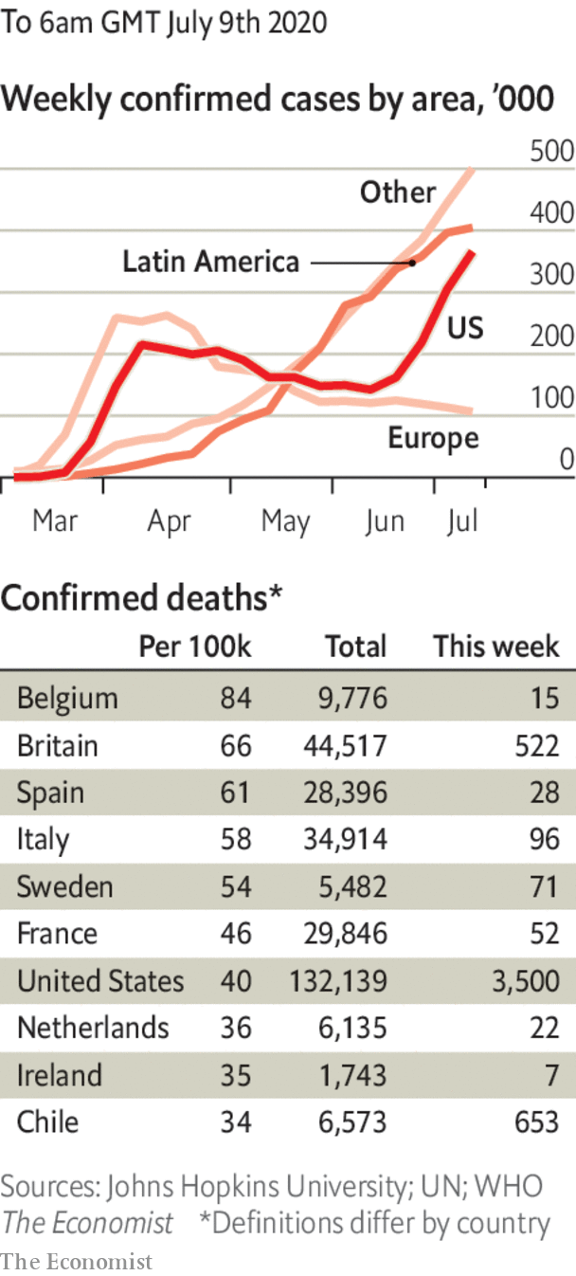

The WHO admitted that the risks from airborne transmission of covid-19 may be higher than it had thought.

A senior health official resigned in Israel as the number of new daily cases passed 1,000. The head of a panel of advisers said the government had “lost control” of the virus.

India passed Russia to record the third-highest cumulative number of coronavirus infections. A recent increase in testing capacity may help authorities get a better picture of the progress of the disease. See article.

Melbourne, Australia’s second-biggest city, went back into lockdown. The border between the states of Victoria and New South Wales was closed. See article.

There were riots outside Serbia’s National Assembly when lockdowns were reimposed and the government threatened a curfew.

This article was downloaded by calibre from <https://www.economist.com/the-world-this-week/2020/07/11/politics-this-week>

|  |  |  |  |
| --- | --- | --- | --- |
|  | Articles | Sections | Next |

|  |  |  |  |
| --- | --- | --- | --- |
| Previous | Articles | Sections | Next |

# Business this week

Jul 11th 2020 |



Google, Facebook, Microsoft and Twitter have all suspended processing requests for user data from the government of Hong Kong while they consider the implications of the draconian new national-security law imposed on the territory by the government in mainland China. None has a big business presence in China. See article.

## A hostile environment

Sina, which in 2000 became the first Chinese internet company to list on the Nasdaq, received an offer from Charles Chao, its chairman and CEO, to take it private. That prompted speculation about the possibility of other Chinese tech firms exiting American stockmarkets to escape any forthcoming regulatory clampdown that targets Chinese firms.

United Airlines sent out notices to 36,000 employees warning that their jobs could be at risk when federal support for the aviation industry stops. The list includes 2,250 pilots. The hopes of airlines for a small improvement in travel have been dashed by the new surge of covid-19 cases in America, which now top 3m.

A judge dismissed a lawsuit from General Motors which had accused Fiat Chrysler Automobiles of collaborating with union leaders to drive up wages at GM in order to force the company into a merger. The judge said GM had failed to prove it was a victim.

Uber struck a deal to buy Postmates, America’s fourth-biggest food-delivery service. At $2.65bn, it is a bite-size transaction compared with the recent takeover of Grubhub, which Uber had wanted to acquire; Just Eat Takeaway snapped it up instead for $7.3bn. Postmates, which has a strong presence in Los Angeles, Phoenix and San Diego, will still operate as a separate app from Uber Eats.

Rishi Sunak, Britain’s finance minister, announced more measures to help the pandemic-hit economy. Companies that bring back furloughed workers during the three months starting with November will be given a £1,000 ($1,260) bonus for each job saved. Stamp duty, the main tax on buying homes, will be suspended until March for purchases of less than £500,000, a boost to the housing market and its many associated services. Help was also dished out to restaurants and eateries: during August the government will subsidise each diner to the tune of £10 from Mondays to Wednesdays. See article.

Turkey’s stock exchange banned six foreign banks, including Barclays, Credit Suisse and Goldman Sachs, from betting against Turkish share prices. The country’s market regulator had only just lifted short-selling restrictions on the biggest companies. Turkey’s latest action fits a pattern of interfering in markets, such as temporarily excluding three foreign banks from trading in the lira earlier this year.

António Horta-Osório said he would step down as chief executive of Lloyds Banking Group, one of Britain’s biggest banks, next June. Mr Horta-Osório took up the job in 2011, and has been praised for steering Lloyds out of public ownership in the aftermath of the financial crisis. It returned fully to private ownership in 2017, when the government sold its remaining shares.

Intesa Sanpaolo, Italy’s second-biggest bank, formally launched a takeover offer for ubi Banca, the fifth-biggest, despite being rejected by UBI’s board.

Dominion Energy agreed to sell its gas transmission and storage assets to an affiliate of Berkshire Hathaway for $9.7bn. Dominion is investing heavily in clean energy in order to reach a target of net zero carbon and methane emissions by 2050. For Warren Buffett, Berkshire’s boss, it is another big bet on fossil fuels, following the $10bn funding he put towards Occidental’s takeover of Anadarko last year.

Russia’s environmental watchdog imposed a record penalty on Nornickel (also known as Norilsk Nickel) for a fuel spill in May that released 21,000 tonnes of diesel into rivers and subsoil near the city of Norilsk, located above the Arctic Circle. The fine, equivalent to $2.1bn, represents a third of the nickel-and-palladium producer’s net profit last year. It “disputes the amount of damage caused to the environment” resulting from the incident.

Brooks Brothers, founded in 1818 and the oldest retailer of men’s clothing in America, filed for bankruptcy protection. Privately owned, Brooks has outfitted American presidents and been a purveyor of the finest sartorial elegance to countless businessmen, and, continuously from 1976, businesswomen. Even before the pandemic its business had to contend with the fashion for more casual office attire among executives.

## Maybe if they made a onesie

The popularity of loungewear and loose pants during the lockdown is possibly one reason why Levi Strauss suffered a 62% slump in quarterly sales. The maker of tight jeans is slashing 15% of its staff.

This article was downloaded by calibre from <https://www.economist.com/the-world-this-week/2020/07/11/business-this-week>

|  |  |  |  |
| --- | --- | --- | --- |
| Previous | Articles | Sections | Next |

|  |  |  |  |
| --- | --- | --- | --- |
| Previous | Articles | Sections | Next |

# KAL’s cartoon

Jul 11th 2020 |

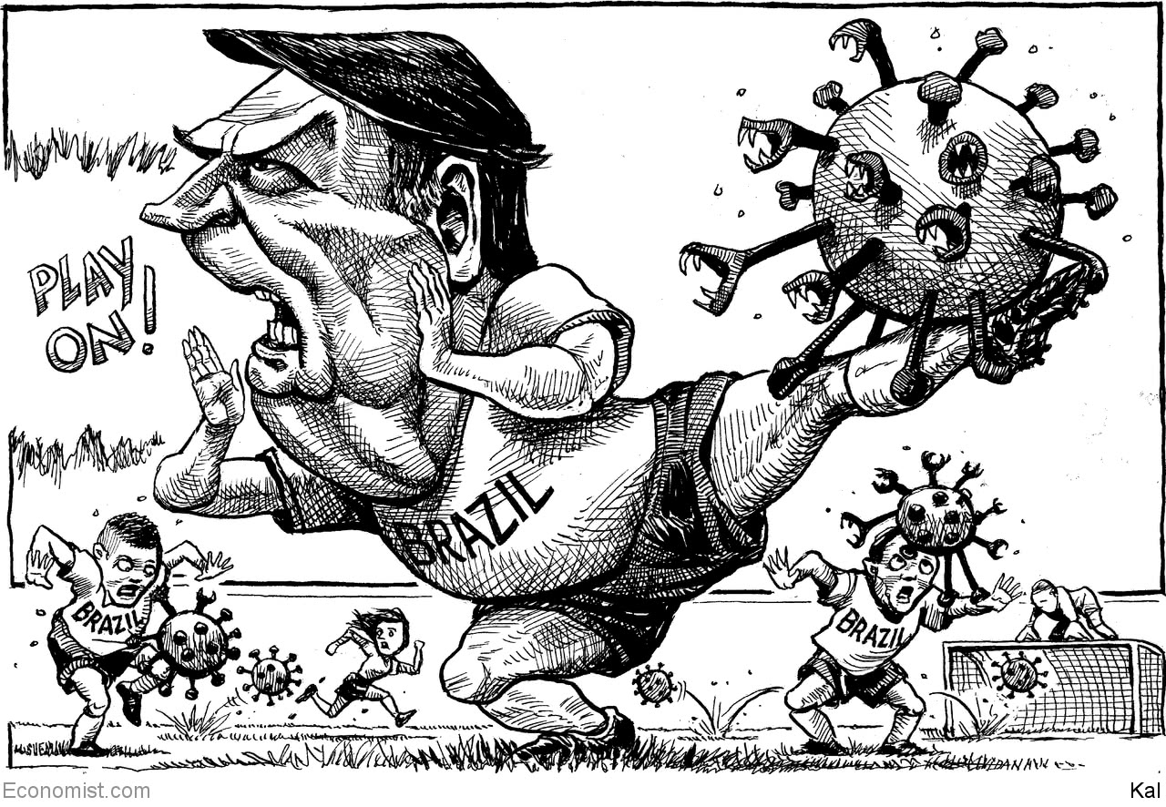

This article was downloaded by calibre from <https://www.economist.com/the-world-this-week/2020/07/11/kals-cartoon>

|  |  |  |  |
| --- | --- | --- | --- |
| Previous | Articles | Sections | Next |

|  |  |  |
| --- | --- | --- |
| The world this week | Sections | Letters |

Leaders

Race and social change: The new ideology of race

.

The world economy: Tapering without the tantrum

.

Nuclear proliferation: A better way to contain Iran

.

Sino-American tensions: Techtonic plates

.

Sourdough economics: The need to knead

.

|  |  |  |
| --- | --- | --- |
| The world this week | Sections | Letters |

|  |  |  |  |
| --- | --- | --- | --- |
|  | Articles | Sections | Next |

#### Tackling racism

# The new ideology of race

And what is wrong with it

Jul 9th 2020 |

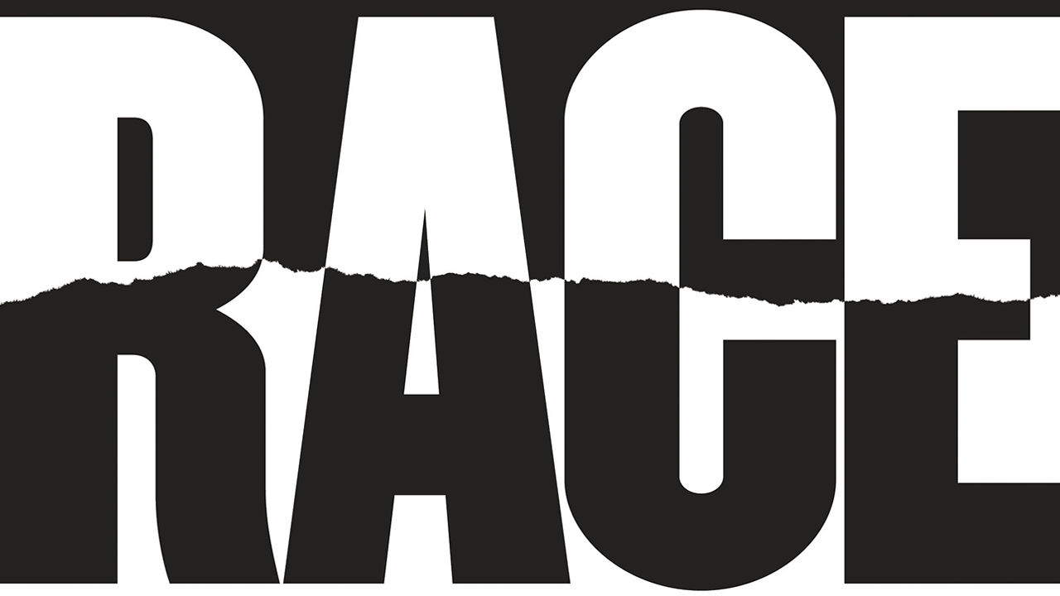

AMERICA’S PROBLEM with racism can be divided into two parts. One contains all the myriad injustices that still blight African-American lives a century and a half after the end of slavery. The other is the way that factions on the right exploit racial division as a political tool. An example of the first occurred on May 25th on a shabby street corner in Minneapolis, when George Floyd was killed by a white policeman. An example of the second occurred on July 3rd, at Mount Rushmore, against the monumental backdrop of the country’s greatest presidents, when Donald Trump sought to inflame a culture war centred on race to boost his chances of a second term. To be successful, a campaign for racial justice needs to deal with both.

Leaders like Frederick Douglass and Martin Luther King used vigorous protest and relentless argument to push society towards their vision of equality of opportunity and equality before the law. Most Americans still hew to that classical liberal ideal as do many of those who marched with justified anger over the killing of Mr Floyd. But a dangerous rival approach has emerged from American universities (see article). It rejects the liberal notion of progress. It defines everyone by their race, and every action as racist or anti-racist. It is not yet dominant, but it is dynamic and it is spreading out of the academy into everyday life. If it supplants liberal values, then intimidation will chill open debate and sow division to the disadvantage of all, black and white.

The premise underpinning this ideology is correct: that racial inequality is shockingly persistent. Even though attitudes to race have improved, the quality of African-American lives has not kept pace. A third of black boys born in 2001 will probably spend time locked up, compared with one in 17 white boys. In 1968 black households earned around 60% as much as white households, and owned assets that were less than 10% of those of a typical white family. They still do.

This ideology also has some valid insights. Racism is sustained by unjust institutions and practices. Sometimes, as in policing, this is overt. More often, in countless small put-downs and biases, it is subtle but widespread and harmful.

But then the ideology takes a wrong turn, by seeking to impose itself through intimidation and power. Not the power that comes from persuasion and elections, but from silencing your critics, insisting that those who are not with you are against you, and shutting out those who are deemed privileged or disloyal to their race. It is a worldview where everything and everyone is seen through the prism of ideology—who is published, who gets jobs, who can say what to whom; one in which in-groups obsess over orthodoxy in education, culture and heritage; one that enforces absolute equality of outcome, policy by policy, paragraph by paragraph, if society is to count as just.

It is tempting to see such ideas as nothing more than overheated campus radicalism. And, true enough, they have not yet taken over a political party. When people speak of ending white privilege, most of them have good things in mind like inclusion and justice. But ideas are important, and the spread of campus terminology into newsrooms and boardrooms invites in ideologues. Their approach is already taking a toll. In universities research agendas are being warped. Outside them, public shaming and intimidation have been curbing debate.

The pity is that these ideas will not solve America’s problems with race. They will not eliminate inequality because they are a poor way to bring about beneficial change. Unless you can freely analyse causes and question orthodoxies you will not be able to solve problems. And unless you can criticise people and practices without fear of being called out, you will not be able to design effective policies and then go on to refine them.

The new race theory blocks progress in another way, too. The barriers to racism can be dismantled only when they are exposed—and so they must be, however painful. But the false idea that ingrained racism will forever block African-Americans at every turn is a barrier in its own right.

And, by focusing on power and division, this ideology only creates more space for some on the right to exploit race as a tool. A fundamental belief in power above persuasion frustrates coalition-building. Essential allies are not carried along, but forced along. When every transaction at work, at home, or at the school gate is seen through a prism of racial power, no encounter between different races can be innocent.

The new ideology of race is not just wrong and dangerous, it is also unnecessary. Liberalism can offer a fairer, more promising route to reform. It asserts the dignity of the individual and the legal, civil and moral equality of all people, whatever the colour of their skin. It believes in progress through argument and debate, in which reason and empathy lift truthful ideas and marginalise bigotry and falsehood.

Liberalism thrives on a marketplace of ideas, so diversity has a vital role. New voices and experiences enrich the debate. Liberalism does not fight power with power, which risks replacing one abusive regime with another. Instead it uses facts and evidence, tested in debate, to help the weak take on the strong.

Liberalism is all about progress, including about putting right its mistakes—and there have been many, especially over race, including finding reasons to accommodate imperialism and slavery. That is one reason why, in the 250 years in which it has been influential, humanity has seen unprecedented material, scientific and political gains, as well as a vast extension of social and political rights. Progress on racial inequities has been part of this—as in South Africa, where liberals joined forces with the trade unions and communists to sink apartheid.

Liberals can help in America, too. Much of the material gulf between African-Americans and whites can be bridged with economic policies that improve opportunity. You do not need to build a state based on identity. Nor do you need tools like reparations, which come with practical difficulties and have unintended consequences. Economic policies that are race-neutral, which people qualify for because of poverty, not the colour of their skin, can make a big difference. They have a chance of uniting Americans, not dividing them. If the mood now really is for change, they would be politically sellable and socially cohesive.

Our Briefing lays out what some of these policies might look like. Top of the list is tackling the housing segregation that is central to America’s racial economic inequality. The reform of zoning laws and the grant of rent-assistance vouchers are the chief ingredients. That would bring many benefits, improving public services and lessening violence. More integrated housing would integrate schools too and, given America’s locally financed education, mean that more would be spent on black children. Affordable measures, including advice and modest cash grants, have been shown to boost graduation from college. A third tool is the tax system. The earned-income tax credit tops up wages of working adults. A child allowance would cut poverty. A baby bond would help shrink the wealth gap.

In the past liberals have helped bring about change when society faced a challenge to the status quo, as when reforms limited child labour and won women the vote. If America has reached such a moment today, it must not resort to identity politics—and suffer intolerance, intimidation and division. Instead, for reform on race that works, it must look to liberalism. ■

This article was downloaded by calibre from <https://www.economist.com/leaders/2020/07/09/the-new-ideology-of-race>

|  |  |  |  |
| --- | --- | --- | --- |
|  | Articles | Sections | Next |

|  |  |  |  |
| --- | --- | --- | --- |
| Previous | Articles | Sections | Next |

#### How to wind down stimulus

# As the economy recovers fiscal policy has to shift

Is it time to wind down emergency stimulus

Jul 11th 2020 |

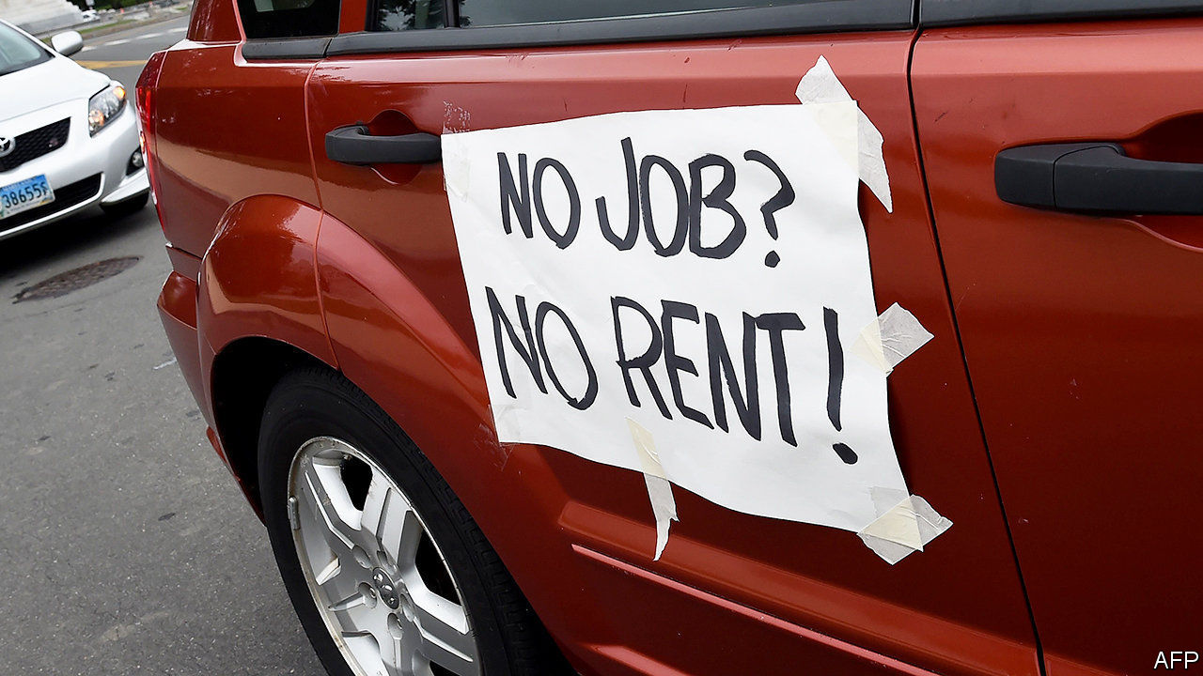

Editor’s note: Some of our covid-19 coverage is free for readers of The Economist Today, our daily [newsletter](https://my.economist.com/user#newsletter). For more stories and our pandemic tracker, see our [hub](https://www.economist.com/news/2020/03/11/the-economists-coverage-of-the-coronavirus)

AS THEY FIRST battled the pandemic with lockdowns earlier this year, governments in the rich world pumped cash into the economy almost indiscriminately. Output was collapsing and the speed and scale of support rightly trumped any worries about its cost, accuracy or side-effects. Now lockdowns are easing, there are tentative signs of economic recovery (even in places where covid-19 is still raging) and political debate has shifted to whether, when, and how far to pare back these dauntingly expensive emergency fiscal policies. America’s unemployment top-up scheme expires on July 31st, Britain’s furlough scheme at the end of October. What should governments do?

They should start by acknowledging that the largesse worked. Massive fiscal support has proved remarkably effective. Nothing could have prevented a sudden stop in activity as lockdowns were imposed. But generous top-ups to unemployment benefits and direct cheques from Uncle Sam meant that in April household incomes in America were 12% above their level a year earlier, even as joblessness reached its highest level since the Depression. Remarkably, the poverty rate has fallen since the start of this year (see article). In Britain and the euro area, where governments have channelled stimulus through furlough schemes, the share of people in unemployment is no higher than in January.

However, the recovery is fragile. Not only is the virus still spreading rapidly in much of America’s south and west; localised outbreaks are also happening in countries where caseloads have fallen. And even without full lockdowns, rising infection rates will weaken the recovery. The latest real-time mobility data from Australia and America suggest that supposedly gung-ho consumers get spooked fast when infection rates spike (see article).

Why not just continue the stimulus? One reason is the staggering cost. Rich-country governments have collectively launched stimulus programmes worth 10% of GDP, with one-third of that either subsidising work or compensating people who lose it. Before the year is out, government deficits in these countries will easily be in double digits.

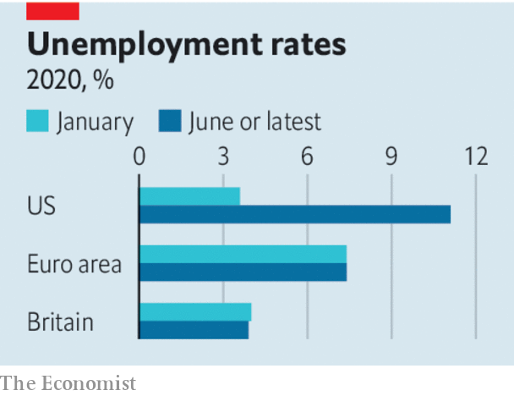

It also makes no sense to freeze the economy for too long. All the signs are that life in the 2020s will be different from life in 2019—think of the surge in e-commerce and remote working; or the expectation of a long-term dampening of demand for air travel; or the reality that customers in pubs may no longer be allowed to elbow their way through crowds to order pints. Workers will have to leave their old jobs, and find new ones. In Europe a fifth of furloughed workers have jobs in industries that seem likely to shrink over time, such as hospitality and leisure.

As governments grapple with this, lots of bad ideas are creeping in. In June the French government said it would extend its furlough scheme to two years, in return for reductions in working hours. France also makes extra allowances for the tourism trade, even though Parisian guides and Club Med windsurfing instructors may face a permanent drop in demand. Meanwhile on July 8th Britain’s chancellor, Rishi Sunak, said he would cut value-added taxes for hospitality and leisure firms and introduce a scheme that cuts up to £10 ($12.60) off restaurant bills on Mondays to Wednesdays (soft drinks are included, but not the hard stuff). Some economists have called for wage subsidies for the worst-hit industries.

Instead of giveaways and gimmicks, the right way to taper depends on the type of support already in place. America has funnelled cash to people through unemployment insurance, extending the duration of benefits, and topping up their amount by $600 a week. Letting the extension lapse when unemployment still exceeds 10% would be cruel, yet because the support is so generous, three-quarters of claimants are making more from benefits than they did from work. The solution, as a group of former White House advisers has proposed, is to taper benefit payments as unemployment falls. Linking the generosity of payments to states’ unemployment rates would steer stimulus to worst-hit areas—including those that experience fresh bouts of covid-19. In Europe the risk is that employers and workers are frozen in an unproductive relationship for too long. The best approach is to taper furlough payments which, for example, cover more than four-fifths of wages in France. They would then converge towards unemployment insurance, which does not shackle the claimant to an employer. That is how Germany’s Kurzarbeit scheme operates in normal times.

There will be repeated flare-ups of the virus, and it is hard to predict how much that will scare consumers. Hence, even as governments trim stimulus, they must stand prepared to crank up support again. Early on, their aim was simply to throw cash at the economy. Now it is to use finite resources to help workers and firms through the pandemic and adjust to a brave new world. ■

This article was downloaded by calibre from <https://www.economist.com/leaders/2020/07/11/as-the-economy-recovers-fiscal-policy-has-to-shift>

|  |  |  |  |
| --- | --- | --- | --- |
| Previous | Articles | Sections | Next |

|  |  |  |  |
| --- | --- | --- | --- |
| Previous | Articles | Sections | Next |

#### Explosions and suspicion

# A better way to contain Iran’s nuclear programme

Sabotage might set it back. A deal would limit it

Jul 11th 2020 |

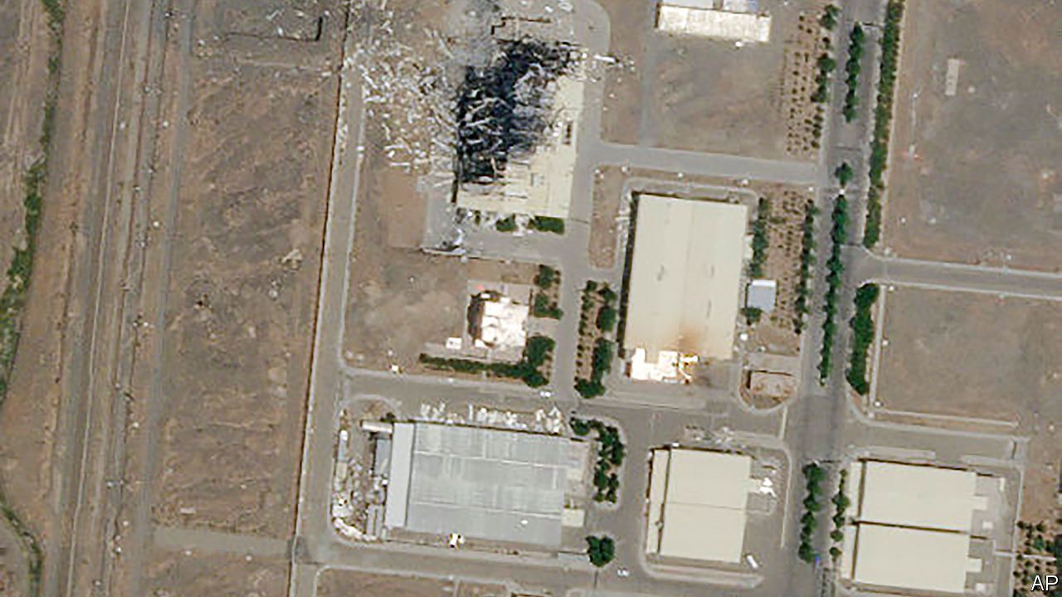

MUCH MYSTERY still surrounds the fire that broke out at an important nuclear facility in Iran on July 2nd. Some of the region’s spooks say the blaze was the result of a cyber-attack. Others insist it was a bomb. Suspicion has fallen on Israel and America, which have a history of sabotaging Iran’s nuclear programme. Other episodes have raised eyebrows in recent months—explosions at power plants and near military sites, a gas leak at a chemical plant. Some of these may also have been the work of saboteurs (see article).

It is safe to say that America and Israel are pleased by the outcome: Iran says that the latest incident caused “significant damage”. But what looks like a tactical success is actually evidence of strategic failure. Iran’s nuclear activity had been constrained by the agreement that it signed with world powers in 2015. President Donald Trump, with encouragement from Israel, yanked America out of the accord and heaped sanctions on Iran, claiming that he would be able to negotiate something better. Not only has Mr Trump failed to get a better deal, he has pushed Iran into dangerous new territory.

Iran is hardly blameless. It often threatens to destroy Israel, while being coy about its nuclear programme. International inspectors say Iran is hiding activity. It was developing new centrifuges at the facility that was damaged on July 2nd. The devices are needed to enrich uranium, which can be used to make power—or, if highly enriched, a bomb. Iran has enough of the stuff to produce a single weapon. So there was a case for pre-emptive action, which has proved effective before. A bit of malware called Stuxnet, believed to be an American-Israeli cyber-weapon, wreaked havoc on Iran’s nuclear programme a decade ago.

Sabotage might set back the programme some months. But it is no match for a deal that constrained Iran for at least a decade. Under the accord, Iran gave up 97% of its uranium fuel (enough to make over a dozen bombs) and kept its stockpile well below the one-bomb threshold. It was subject to tough inspections. Even America said it was complying. Compare that with the results of Mr Trump’s “maximum pressure”. Iran now has about eight times as much enriched uranium as allowed under the agreement. It is stonewalling inspectors. Every month it moves further from the deal, which other signatories have tried to save.

Mr Trump’s policy has failed in other ways, too. He said he wanted an accord that curbed Iran’s missile programme and halted its support to proxy militias in the region. Some in his administration seemed bent on regime change. Yet Iran says it has built underground “missile cities”. From Syria to Iraq, its adventurism continues. Maximum pressure may produce a leadership change—but not the kind America wants. American sanctions have caused a backlash against Iranian politicians who engaged with the West, such as President Hassan Rouhani. Hardliners now want to impeach him.

Despite the calls for talks, Mr Trump and his administration have done all they can to poison relations. Iran is betting that he will be voted out of office in November. Its actions, though, are making it difficult for any future president to jump back into the nuclear deal or negotiate a new one. More rounds of dull, arduous negotiations, like those that took place in Vienna in 2015, will be needed. They would not grab headlines like a sabotage campaign, nor would they produce a perfect agreement. But it is increasingly clear that the alternative is worse. ■

This article was downloaded by calibre from <https://www.economist.com/leaders/2020/07/11/a-better-way-to-contain-irans-nuclear-programme>

|  |  |  |  |
| --- | --- | --- | --- |
| Previous | Articles | Sections | Next |

|  |  |  |  |
| --- | --- | --- | --- |
| Previous | Articles | Sections | Next |

#### The tech cold war is hotting up

# TikTok and the Sino-American tech split

The tech industry is dividing

Jul 11th 2020 |

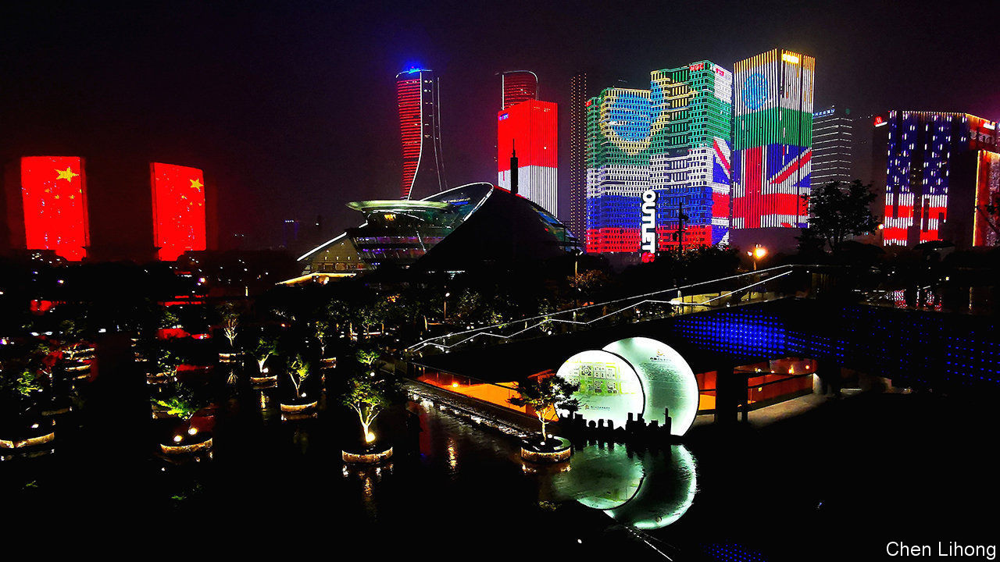

OVER THE past few years countless predictions have been made that the global technology industry will suffer a painful rupture because of tensions between America and China. Real damage has been surprisingly hard to spot. Last year Apple made over $100m of sales a day in China, while Huawei reported record revenues despite America’s campaign to cripple it. Investors have piled into tech companies’ shares, buoyed by the prospect of new technologies such as 5G and a pandemic that is forcing billions of customers to spend more time and money online. Judged by sales, profits and shareholder returns, it has been a golden era for American and Chinese tech. The industry now has a colossal market capitalisation of $20trn and accounts for a quarter of the world’s stockmarket value.

Yet if you examine the events of the past two weeks you can sense the split that is about to come. On July 6th Mike Pompeo, America’s secretary of state, said that the administration was considering banning TikTok, a Chinese-run app that is wildly popular in the West. This followed India’s decision a week earlier to prohibit it, and 58 other Chinese apps, after lethal brawls between soldiers in the Himalayas. Britain and France are considering sidelining Huawei from their 5G networks (see [article](https://www.economist.com/node/21789097)). Between July 6th and 7th Facebook, Google, Microsoft and Twitter all said that they will stop co-operating with Hong Kong’s authorities for the time being, because of the introduction of China’s brutal security law there. And SMIC, China’s aspiring semiconductor champion, has just said that it will raise $7bn in a state-supported listing in Shanghai—it delisted from New York last year (see [article](https://www.economist.com/node/21789109)). The proceeds will be used to supersize China’s home-grown chipmaking capacity.

The split is happening at two velocities. The American and Chinese software and internet universes are heading at light-speed towards total separation. They were never particularly connected—American software firms made just 3% of their sales in China last year, and China has long kept its internet users isolated from the world. The bill for shutting up shop and finding substitute products is usually low. TikTok creates few jobs and pays little or no tax in America or India, so the main cost of banning it is sullen teenagers. Likewise, Facebook and the other firms taking a stand in Hong Kong do little or no business in China. Two important exceptions have been Microsoft’s office software and, especially, Google’s system of apps like Gmail and Maps, found on Chinese-made phones sold worldwide. America’s blacklisting of Huawei has cut off the world’s second-biggest phone seller from some of the world’s most popular apps. Chinese handset firms are racing to develop an alternative. The American and Chinese software worlds are thus quickly becoming entirely separate universes.

Hardware is moving much more slowly. That is because it is more globally integrated and involves $1trn of physical plant and $400bn of inventories. Later this year Apple will launch a new 5G handset that will still rely on the same vast manufacturing cluster in China that it used five years ago. Even so, the techtonic plates are shifting. Because of a new set of American restrictions on the use of chipmaking tools put in place in May, Huawei may run out of stock of its specialist chips in early 2021 and will have to scramble to find an alternative. That will be cumbersome and costly. The SMIC capital-raising shows that China intends to create a chip giant on a par with Intel or Taiwan’s TSMC, although it will take years to do so. If Britain and France both eventually ditch Huawei, they will shift to using Nokia and Ericsson in their networks, which will be expensive and take several years.

If the splintering now seems inevitable, there will be some surprises. One is how the two technospheres of influence are drawn. American policymakers tend to assume the world will use Silicon Valley products, but plenty of countries may ally with China’s tech system or hedge their bets. India is frosty towards both American and Chinese digital firms and hopes to build up its own champions, although it cannot compete yet in hardware. Another surprise is how much the split could cost. The global listed hardware industry has annual expenses of $600bn, much of which may need to be replicated. Plenty of key firms, including Apple and TSMC, are equally dependent on America and China and have no clear plan to cope with a deeper divide. The tech split is under way. Do not assume it will happen safely.■

This article was downloaded by calibre from <https://www.economist.com/leaders/2020/07/11/tiktok-and-the-sino-american-tech-split>

|  |  |  |  |
| --- | --- | --- | --- |
| Previous | Articles | Sections | Next |

|  |  |  |  |
| --- | --- | --- | --- |
| Previous | Articles | Sections | Next |

#### Hometruths about breadmaking

# Sourdough economics: no need to knead

Why the time has come to say no to dough

Jul 11th 2020 |



FUTURE ARCHAEOLOGISTS of the internet will unearth a fascinating shift in digital content in early 2020. Before this turning-point, social media were cluttered with videos of cats doing cute things. Now they are dominated by pictures of sourdough loaves doing nothing.

This transformation is one of the ripple effects of covid-19. When the pandemic locked people into their homes, they had a surplus of their own time and a dearth of others’ labour, so domestic life reverted to pre-capitalist self-sufficiency, and professionals turned their hands to whatever was needed. Deprived of fresh bread, bankers took up baking. When their shelves fell down, consultants tried a bit of carpentry. Faced with partners who began to look like yetis, barristers became barbers.

The experience of working with their hands has been, for many, revelatory. Kneading dough is more fun than manipulating figures. Erecting shelves is more satisfying than propping up failing companies. Snipping hair is more enjoyable than cutting budgets. Liberated from their narrow professional niches, these knowledge workers have found satisfaction exploring new skills. Deprived by homeworking of the competitive arena that offices provide, they have discovered a new one: social media, where they show off their wonky cupboards and lumpy loaves.

Now that the economy is coming back to life, these fledgling bakers, carpenters and barbers may be tempted to nurture those skills. They should resist, for three reasons.

First, if the bankers judged their output with the cold objectivity they apply to their own work, they would see that, compared with a skilled baker’s loaves, their sourdough is as unpalatable as an ill-structured deal. There’s a logic to the division of labour: people who have spent a lifetime developing a skill are better at it than those who have turned their hand to it for a few hours during the longueurs of lockdown. What, after all, would a banker think of the work of a baker who dabbled in a bit of M&A while the loaves were proofing?

Cool calculation would also reveal to professionals a second reason for hanging up their aprons: the cost of their product, when their labour is properly valued. If an average New York lawyer spent an hour lovingly stretching and folding the sourdough, his loaf would cost around $400. No bread is worth so much bread—certainly not his. A lawyer who argued that time thus spent was a benefit not a cost, since breadmaking had turned from work into pleasure, might persuade a jury of economists. But that argument would raise the third reason why professionals should abjure handiwork: for the sake of their friends and family.

The pleasure which professionals take in practising their new crafts may not be shared by those condemned to consume their output. No doubt their nearest and dearest will assure them that the density of the bread lends it gravitas and the tufts in the haircut originality; but such assurances should be taken as a measure not of the quality of the product but of love for the producer. These caring kith and kin deserve the best, and professionals who persist in making second-rate stuff for their own satisfaction are not providing it.

Bankers who want to be really good bakers can give up their day jobs and take it up full time, but as their loaves rise, so their incomes will fall. Which raises one of the great questions in life: cash or craft? Dough or dough?■

This article was downloaded by calibre from <https://www.economist.com/leaders/2020/07/11/sourdough-economics-no-need-to-knead>

|  |  |  |  |
| --- | --- | --- | --- |
| Previous | Articles | Sections | Next |

|  |  |  |
| --- | --- | --- |
| Leaders | Sections | Briefing |

Letters

Letters to the editor: On the UN, foreign aid, Olof Palme, green finance, China, coronaspeak

.

|  |  |  |
| --- | --- | --- |
| Leaders | Sections | Briefing |

|  |  |  |  |
| --- | --- | --- | --- |
|  | Articles | Sections | Next |

#### On the UN, foreign aid, Olof Palme, green investing, China, coronaspeak

# Letters to the editor

A selection of correspondence

Jul 11th 2020 |

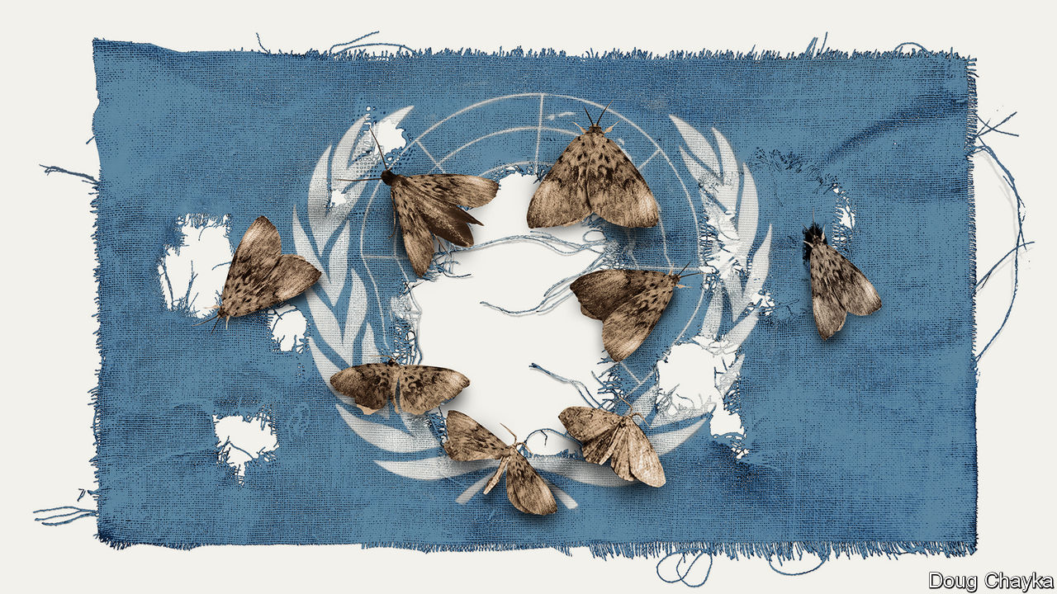

## The UN at 75

Your special report on the UN ([June 20th](https://www.economist.com/special-report/2020/06/18/global-leadership-is-missing-in-action)) outlined several “great fractures” that could lead to worldwide bedlam. One scenario missing from the list is the possibility of China annexing Taiwan. This would confirm the UN’s impotence. Just as America vetoes any resolution condemning Israel, China can veto any resolution condemning its actions, even if those actions are condemned by every other UN country.

Your call for a summit of the five permanent members of the Security Council is timely. But with at least four of those five showing little of the statesmanship that created the UN and much of the thuggery, self-interest and bloody-mindedness that could destroy it, few could have any confidence that such a gathering would resolve that, or any other, crisis.

Instead, it is time for “we the people” of the digital world to harness our borderless technologies to prevent delusional governments from pushing us into collective suicide through war, resource depletion or climate change. In this regard, the UN High-level Panel on Digital Co-operation, led by Melinda Gates and Jack Ma, has a role in sorting out the new world disorder you speak of.

DAVID WOOLLCOMBE  
Founder and president  
Peace Child International  
Buntingford, Hertfordshire

The digital era has enabled governments to engage in aggressive finger-pointing through social media, making calmer, less-public efforts at consensus-building more difficult. Yet the wider benefits of digital connections have not been fully explored by diplomats. A collective, virtual telediplomacy would work away from the glare of trolls and memes. If tele-education and telemedicine can bring mutual benefits through engagement, why not a permanent telediplomacy platform?

Leaders engage in diplomacy because it is to their advantage, to produce shared actions that meet shared interests. Platforms of diplomatic engagement do not evolve accidentally. We knew before covid-19 that the UN needed to reform; the pandemic has shown that diplomacy needs new options for constant real-time interaction.

PAUL HARE  
Pardee School of Global Studies  
Boston University

One cause of the UN’s tragic mistakes in peacekeeping and other missions is the fact that it has immunity. This means that it conducts its operations without any accountability to the people whose lives it is directly affecting. Immunity does give the UN the necessary space to carry out its tasks, but there is no justification for it not to be accountable to those who are harmed by its actions. The responsibility for correcting this lack of answerability rests with the leadership of the UN Secretariat and its specialised agencies. They need to create an independent accountability mechanism with the authority to investigate complaints, report its findings directly to the secretary-general and to make the report publicly available.

This may be a big step for the UN but it is not unprecedented. Such independent accountability mechanisms have existed in many multilateral development banks for decades.

PROFESSOR DANIEL BRADLOW  
Centre for Human Rights  
University of Pretoria

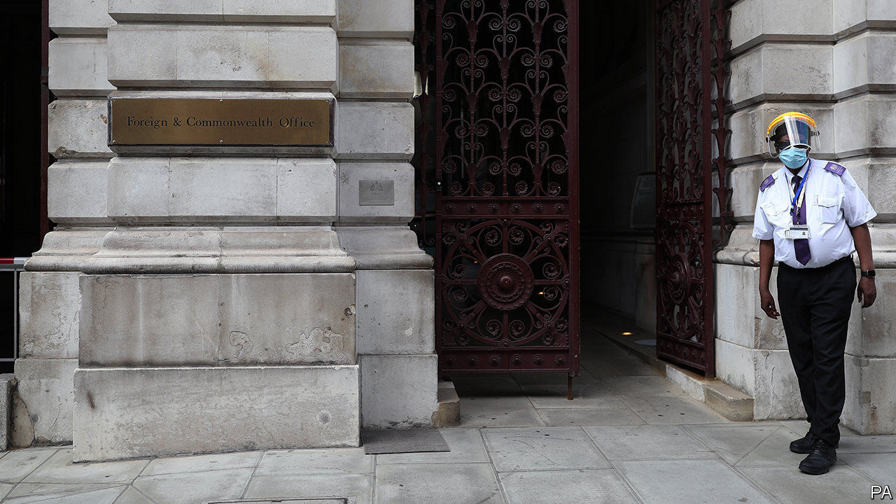

## Aid breeds corruption

I read your article about which government department in Britain should allocate aid money (“Will charity begin at home?”, [June 20th](https://www.economist.com/britain/2020/06/19/british-diplomats-and-donors-are-told-to-merge)). The more critical question is, what happens to aid money when it reaches a poor country? Downing Street has proclaimed zero tolerance for corruption, and aid contracts normally contain anti-corruption clauses.

Our statistical analysis shows that aid money does affect corruption, but not in the direction those donors would like. Transparency International’s Corruption Perceptions Index is 14 points lower in countries in which aid is the highest proportion of national income than in countries receiving no aid.

In addition to enriching senior politicians, foreign aid also encourages a culture of corruption at the grassroots. Where aid is most important, it increases the likelihood of individuals paying bribes for services, such as health care and education, by 18%.

PROFESSOR RICHARD ROSE  
University of Strathclyde  
Glasgow



## A Swedish prime minister

It is true that Olof Palme considered himself a democratic socialist and improved diplomatic relations with the Soviet Union and Cuba (“Who killed Olof Palme?”, [June 13th](https://www.economist.com/europe/2020/06/11/sweden-unmasks-a-prime-ministers-assassin)). He was also an opponent of the South African apartheid regime, his awareness of racial oppression a result of his travels in the American South as the first Swedish leader to receive a university education in the United States. But Palme was, like nearly all social democrats of his generation, a staunch anti-communist. He publicly criticised Swedish student radicals and elements in the labour movement in the 1960s for their naive support of communism. Indeed, he presided over an administration that controversially registered communist sympathisers through a branch of Swedish military intelligence (the IB Affair).

Palme did indeed oppose America’s war in Vietnam, referring rather bluntly to the Nixon government as “bloody murderers” in the wake of the Christmas bombing campaign of North Vietnam in 1972, but if anything his views on the North Vietnamese (and the Cubans) were rooted in a strong sense of the right of smaller nations to determine their own fate even in the shadow of superpowers, rather than any kind of pro-communist sentiment. This is why Palme was so strong in his denunciation of the Soviet Union’s puppet states in eastern Europe.

STEFAN ANDREASSON  
Bangor, Down



Green investing  
* Your leader rightly tackles the importance of the global energy transition challenge and the nexus between capital investment, climate and energy systems developments ("The trouble with green finance", [June 20th](https://www.economist.com/leaders/2020/06/20/green-investing-has-shortcomings)). Whilst pointing out that public discourse is often full of “woolly thinking, marketing guff and bad data” you omitted to say that the grand transition represents the largest capital reallocation in the history of mankind and that accelerating the process is not solely about new supply.

The World Energy Council has been using scenarios for almost two decades to navigate the “disruption as usual” nature of the grand transition era. Our latest covid-19 scenarios highlight that the human qualities of ambition and trust could be the determining factors in deciding the future of the global energy landscape and the direction and speed of the transition process.

Put simply, what degree of trust and ambition do investors, governments and, increasingly, other stakeholders have to address is the need to rethink resilience, enable sustained behavioural change and to move away from the single issue and siloed quick wins agenda? High quality, inclusive and informed debate—covering the whole systems experience, analysis and cooperation—will play a critical role in shaping the energy landscape of the future.

ANGELA WILKINSON  
Secretary General and CEO  
World Energy Council  
London

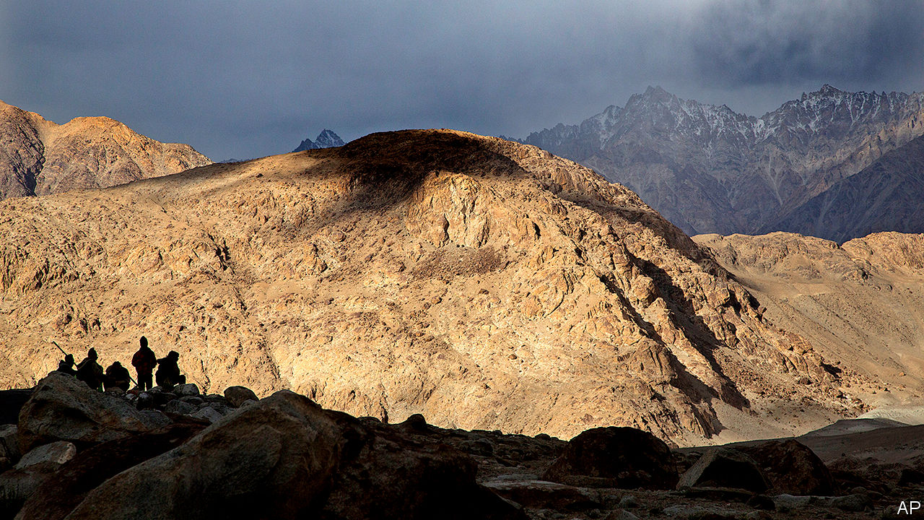

## People as numbers

China’s casual approach to casualties it may have suffered reminded me of a story about the old communist regime (“Death valley”, [June 20th](https://www.economist.com/asia/2020/06/18/india-and-china-have-their-first-deadly-clashes-in-45-years)). Perusing a mandarin’s feasibility study of a dam project, Mao Zedong underlined the report’s sentence that “Such measures would benefit the citizens”, then scrawled a rhetorical question in the margin, “What is a citizen?” Appropriate demotion was swiftly meted out to the study’s author.

BUSH GULATI  
Toronto



## Coronaspeak

I was amused by Johnson’s survey of the pandemic panglossary ([June 27th](https://www.economist.com/books-and-arts/2020/06/27/the-rules-of-coronaspeak)). Yet it struck me that a calendar term for this new epoch was missing. How else am I to refer to the normal days of having a drink: BC (Before Corona)? I am aware that this may mask an existing nomenclature, but we have to move with the times.

ULRICH ATZ  
New York

Though it may have become popular again during the pandemic, the word “smizing” was coined in 2009 by Tyra Banks on an episode of “America’s Next Top Model”. Credit where it is due.

CHARLES HAWKINGS  
Washington, DC

Here in New York, people who refuse to wear masks or practise social distancing are known as coronassholes. And quite rightly, too.

JOHN S. MAJOR  
New York

* Letters appear online only

This article was downloaded by calibre from <https://www.economist.com/letters/2020/07/11/letters-to-the-editor>

|  |  |  |  |
| --- | --- | --- | --- |
|  | Articles | Sections | Next |

|  |  |  |
| --- | --- | --- |
| Letters | Sections | United States |

Briefing

Race in America: Staying apart

.

|  |  |  |
| --- | --- | --- |
| Letters | Sections | United States |

|  |  |  |  |
| --- | --- | --- | --- |
|  | Articles | Sections | Next |

#### How black lives can get better

# Segregation still blights the lives of African-Americans

There are policies that could improve things a lot

Jul 9th 2020 | WASHINGTON, DC

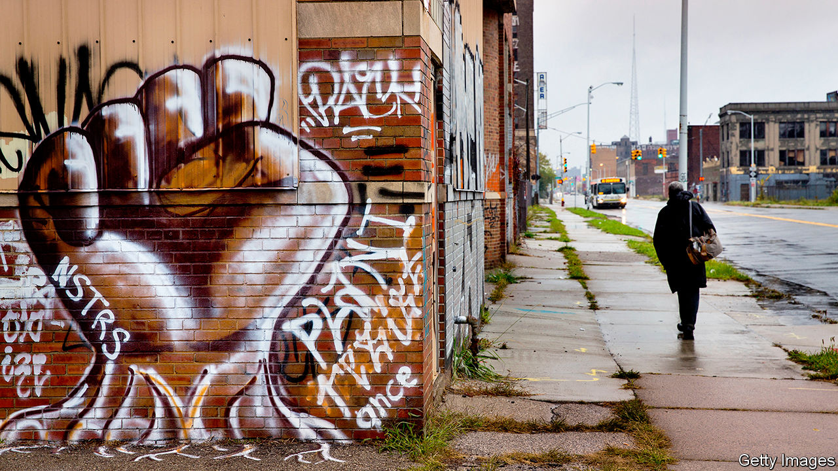

“IF SOMETHING isn’t done, and done in a hurry, to bring the coloured peoples of the world out of their long years of poverty, their long years of hurt and neglect, the whole world is doomed,” Martin Luther King Jr told striking workers the day before he was shot dead in Memphis, Tennessee. In 1968 black Americans had only just realised formal legal equality after two centuries of slavery and one of Jim Crow, indentured servitude, lynchings and enforced residential segregation. They had been deliberately excluded from economic supports such as Social Security, mortgage guarantees and subsidised college for veterans. As a result, black American households earned around 60% of what white households did, and the typical black family had less than 10% of the assets of a typical white family.

The past half century has seen visible progress. The ceiling white society once imposed on black opportunity and ambition has started to lift. Barack Obama became president. Yet systemic prejudice persists. Unarmed citizens killed by American police forces are disproportionately black. That most brutal of injustices explains much of the power, the extent and the focus of the protests spurred by the killing of George Floyd, protests that have drawn a level of attention to race relations unseen since the 1970s.

The criminal-justice system is a baleful presence in black lives. The incarceration rate for black men and women more than tripled from 1960 to 2010. One in three African-American men born in 2001 can expect to be imprisoned at some point in his life, compared with one in 17 white boys. The sons of black families in the top 1% of America’s income distribution are as likely to go to prison as white sons from the bottom third. If today’s protests achieve real reform in the criminal-justice system, it will be welcome.

But those are not the only reforms needed to put right the hurt and neglect Dr King spoke of. The economic disadvantage that black America labours under is, in many ways, as stark now as it was 50 years ago. The household income gap is the same as it was in 1968. So is the wealth gap (see chart 1). Crime and the criminal justice system are part of that story of stagnation, as is persistent, if lessened, racism. Changes in individual behaviour and in the economy at large have also played a role. The most important factor is the degree to which the concentrated poverty in largely segregated black communities shuts their members off from opportunity.

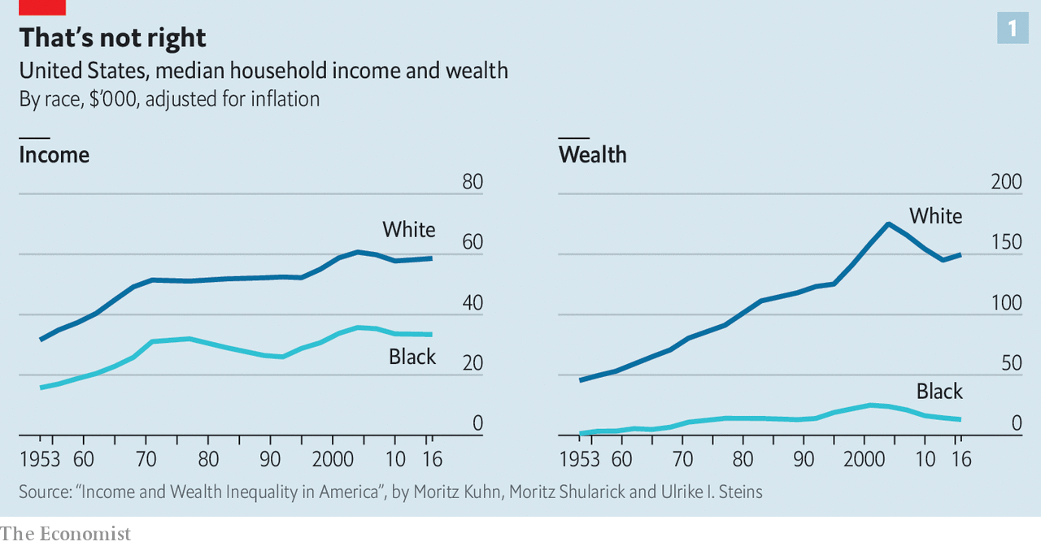

“We got rid of ‘whites only’ signs and legal segregation is no longer possible. But why are we at this moment? There’s a lot of things that didn’t change and probably won’t change with only focus on police brutality and reforming the police,” says Clayborne Carson, a historian at Stanford who edited Dr King’s letters and papers. “Yes, that should be done. But don’t expect that to have any impact on the race problem. It’s the tip of the iceberg. You can have polite police—that would be wonderful. You can have social workers. But unless people have the ability to basically change the opportunity structure, the changes are not going to be apparent.”

Children who grow up poor—as 32% of African-American children do, a rate nearly three times that of white children—all tend to do badly by various measures. But children who do so in communities where over 20% of the population is poor do very badly indeed. Whatever their race, such children face increased risks of dropping out of school, getting pregnant while still teenagers, being incarcerated, experiencing poverty in adulthood and dying early.

And for black children in America, as for Native American children, concentrated poverty has been the norm. Only 6% of white children born between 1985 and 2000 spent part of their childhood in neighbourhoods with at least a 20% poverty rate. For black children the figure was 66%, according to Patrick Sharkey, a sociologist at Princeton; experience of such neighbourhoods was normal for middle-class black families. Today’s generation is in a similar position. 26% of black children currently live in neighbourhoods where the poverty rate is higher than 30%. Only 4% of white children do.

## Jammed in

Poor neighbourhoods impose environmental costs, as well as social ones. Black families are 70% likelier than the rest of the population to live in substandard housing, and black children are nearly three times as likely to have high levels of lead in their blood, which stunts intelligence and leads to greater violence in adulthood. Compared with white children they are almost one and a half times as likely to have asthma—and five times likelier to die from it. Greater exposure to fine particulate matter—the sort of pollution which most damages lungs—and delays in treatment brought on by a lack of good health insurance may explain why covid-19 now seems to be killing African-Americans at twice the rate of it does white Americans.

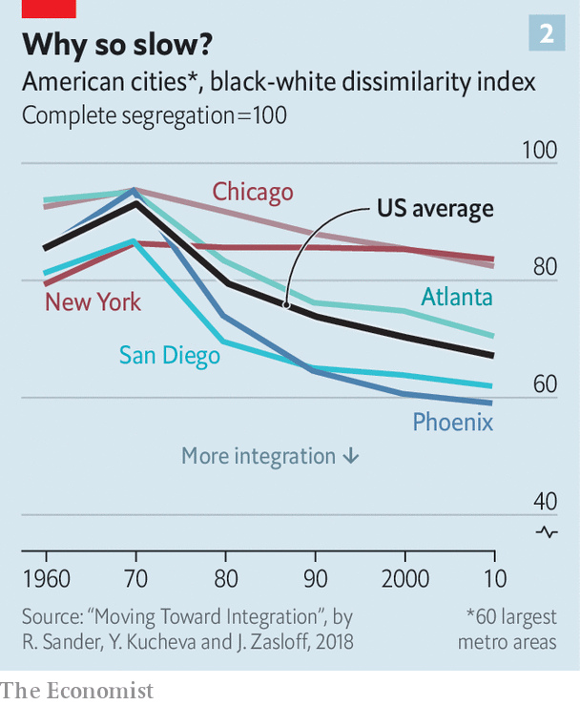

This concentrated poverty is the legacy of enforced segregation. When, in the Great Migration of the early and mid 20th century, millions of African-Americans moved to the cities of the north, a mixture of law and prejudice required that they live in neighbourhoods that became almost exclusively black. In 1970 American cities were almost completely segregated, in that 93% of black residents would have needed to move to ensure complete integration. At the time of the most recent census, in 2010, this number was 70%, an improvement that is hardly worth cheering (see chart 2 ).

Zoning rules which keep the cost of housing high by restricting supply make it very hard for poor black families to move to better neighbourhoods. As income inequality has risen, well-to-do families have bid up the price of homes near good schools, further concentrating poverty. Public-housing programmes, which could break up these patterns, do little. Continuing discrimination makes matters worse. A recent investigation into rentals in Boston showed that in situations where a white applicant secured a viewing 80% of the time a black applicant with identical financial credentials would get a viewing just 48% of the time.

In the absence of integrated neighbourhoods, it might be possible at least to try to integrate education—a cornerstone of the civil-rights movement since racial segregation in schools was deemed unconstitutional in 1954. Attempts to reduce school segregation by busing black students into white neighbourhoods began in the 1960s and were extended in the early 1970s. By the mid-1970s, though, such efforts had fizzled in the face of massive resistance from white parents. School segregation has not changed since the 1980s.

Rucker Johnson, an economist at the University of California, Berkeley, studied the outcomes of black children who attended integrated schools during the peak of efforts to end educational segregation. He found they had enormous effects on adult life. Integrated schooling increased wages by 30% and reduced the chance of incarceration by 22 percentage points. Other studies estimate a 68% increase in the chance of attending a four-year college. “There’s nothing magic about sitting next to white children,” says Francis Pearman, a professor of education at Stanford. “But one thing that’s consistent in the history of American schooling is that resources follow white children.”

The racial achievement gap on test scores between black and white students has narrowed in the past four decades, but remains at roughly two to four years of learning. Mr Pearman’s research has documented that poor neighbourhoods adversely affect students’ maths scores even if their schools are good. Black students who get to college are less likely than others to complete their courses; black men have an especially poor chance of making it to graduation. In 2016 only 29% of black adults above the age of 25 had an associate degree or higher, compared with 44% of white adults. At a time when the premium that a degree adds to lifetime earnings has increased a lot, this disparity is a big economic disadvantage.

There are aspects of black American private life that exacerbate these gaps. Well-intentioned, left-leaning commentators in America shy away from discussing the role that the increasingly unstable families play in passing black disadvantage down the generations. Seven in 10 African-American babies are born out of wedlock; their parents are overwhelmingly likely to have broken up five years after birth. Those rates are significantly higher than for other ethnic groups, even after controlling for education and income.

## Spreading out

The rate of joblessness and the number of out-of-wedlock births in black communities both increased after the 1960s, notes William Julius Wilson, a sociologist at Harvard. The ravages urban deindustrialisation and mass incarceration inflicted on black men permanently reduced the pool of eligible partners for black women, he argues. Kathryn Edin, of Princeton, and Maria Kefalas, of St Joseph’s University in Philadelphia, two sociologists, note the sense of self-worth poor women with little social capital get from early child-rearing, whether in the presence of a father or not

Behaviour, policy, present-day discrimination and the unfair initial conditions seeded by centuries of historical discrimination are tied together in a complicated knot of pathology. Some of the tangled factors—persistent racism, or family breakdown—make it easy to develop a narrative which apportions blame. Looking at it in the whole, though, the threads which will yield the most if tugged at are fairly obvious. The priorities are segregation, education and childhood poverty.

Addressing segregation is paramount. Most of the other problems—exposure to violence, a paucity of public services, segregated schooling and the persistence of stereotyping—can be traced back to it. The most obvious starting-point is stripping away the zoning rules that ban apartments in high-cost cities. They deny opportunity to poor families of all colours even as they drag down economic productivity.

Rental assistance from the federal government could help more than it does. Currently it is, quite literally, a lottery. Winners get most of their housing costs paid for; losers whose claim may be equally sound—and who outnumber the winners three to one—get nothing at all. And most of the poor households lucky enough to receive subsidised housing still live in places of concentrated poverty; the typical recipient lives in an area with a poverty rate of 26.3%.

A promising randomised experiment in Seattle recently showed how this might be changed, at least in some cases. A modest amount of help in terms of finding properties and dealing with prospective landlords increased the share of families with rental vouchers living in high-opportunity areas (those with a history of greater upwards mobility for children born into poverty) from 15% to 53%.

Obviously not everyone can move to the most promising places. But the Seattle experiment strongly suggests that today’s government spending could get better results, thus strengthening the case for more tomorrow. Abolishing the mortgage-interest tax deduction, which subsidises the home-buying of the already wealthy and well-capitalised, would allow the federal government to double the size of its housing-assistance programmes for the poor.

Increasing integration of neighbourhoods will in time produce more integrated schools. Until that happens, however, there are more immediate solutions to present-day educational disparities. Higher spending helps performance. An influential study by Kirabo Jackson, Rucker Johnson and Claudia Persico, three economists, found that boosting schools’ spending per pupil by 10% reduced poor children’s chances of poverty in adulthood by 6.8 percentage points.

Schools in poor neighbourhoods need particularly good teachers. But the schools that require the greatest talent often receive the most inexperienced instructors, in part because there is little financial encouragement for the best to work in them. Care in recruitment and the pairing of new instructors with experienced ones goes some way to explaining why charter schools often deliver enormous educational returns for poor black and brown children stuck in otherwise-failing urban schools. For all that teachers’ unions and many on the left dislike them, charter schools that prove to be engines of opportunity should be expanded. Those that do not should have their charters revoked.

Keeping students in college is also an area where a little money can do a lot if applied with good sense. In New York a system that gives students access to an adviser, subway tickets and modest cash grants has been shown to double graduation rates from community college, and to have particularly beneficial effects on black and Hispanic students.

## Investing early

Then there is child poverty. Expanding the earned-income tax credit (EITC), which tops up the wages of working low-income adults, and a universal child tax credit could drastically reduce child poverty—and reduce the tremendous costs to be incurred decades from now in lower tax revenues and higher expenses on incarceration, homelessness services and health care. A programme combining a $2,700 annual child allowance and a 40% expansion of the EITC would reduce child poverty by half, and cost $110bn a year, according to a report by the National Academies. Canada’s implementation of a similar programme in 2016 took just two years to reduce child poverty by a third.

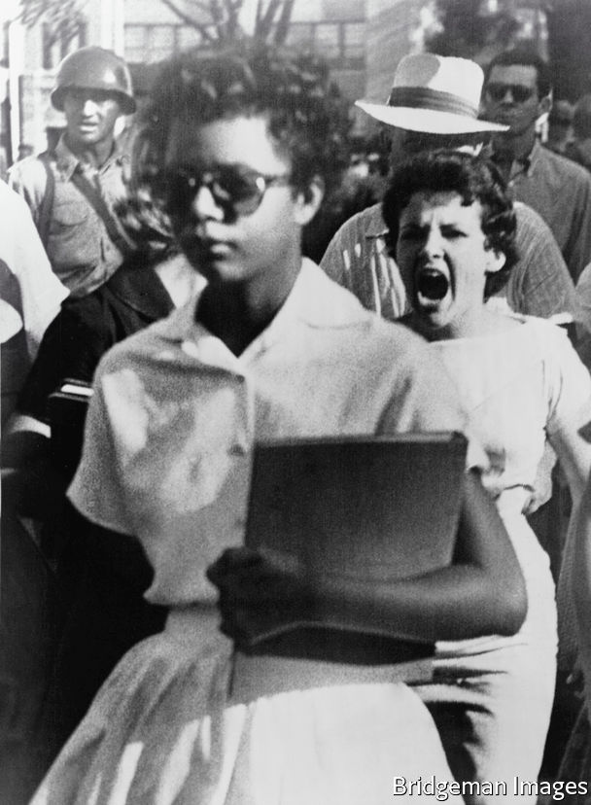

Integration was never easy

A more radical idea is that all children should get government-funded trust accounts—“baby bonds”—with the funding for children born into poverty more generous than for the rest. A scheme in which the bonds were worth $50,000 by the time a child born into poverty turned 18 would reduce the wealth disparity between young white and black Americans from 16:1 to 1.4:1 even if it were strictly race neutral, according to calculations by Naomi Zewde of the City University of New York.

This proposal has a price tag close of about $80bn a year. This means that enacting a child tax credit, EITC expansion and baby-bond programme would still cost less than the $207bn the government will forgo this year by taxing dividends and long-term capital gains at lower levels than income. The idea of paying reparations to the descendants of slaves—a bill that might cost upwards of $4trn to settle—would be much costlier. Nor are they obvious cause for a white backlash, since unlike reparations—or, for that matter, affirmative-action policies at universities and elsewhere—they would be based purely on economic criteria, not racial ones.

Unfortunately, the fact that the benefits of such programmes would accrue disproportionately to African-Americans might make it hard to build broad political support. Safety-net programmes such as cash welfare or the expansion of health coverage for the poor, part of Mr Obama’s health-care reform, have been unpopular with some white Americans. That could make it politically expedient to concentrate on universal programmes. Social Security, which provides pensions, and Medicare, which provides health insurance for the elderly, have become close to politically untouchable in part because they are universal. Child tax allowances and baby bonds might aspire to similar standing.

“My parents literally had to get a white couple to pose as us in order to buy a home in an affluent area of suburban New Jersey with great public schools,” remembers Cory Booker, now a senator from that state. As well as promoting a bipartisan bill on criminal-justice reform, Mr Booker has also pushed a programme to remove lead pipes in schools; baby bonds formed a major plank in his run for the Democratic nomination.

“[Dr King] eloquently said that we have to repent in our day and age, not just for the vitriolic words and violent actions of the bad people, but the appalling silence and inaction of the good people,” Mr Booker says. “Well, I fear that we will have to repent in our generation, if more of us who are good people—and that is the overwhelming majority of Americans—let another generation go by where we don’t correct these persistent injustices.”■

This article was downloaded by calibre from <https://www.economist.com/briefing/2020/07/09/segregation-still-blights-the-lives-of-african-americans>

|  |  |  |  |
| --- | --- | --- | --- |
|  | Articles | Sections | Next |

|  |  |  |
| --- | --- | --- |
| Briefing | Sections | The Americas |

United States

Economic policy: The covid bonus

.

Kansas’s Senate race: The 88-year itch

.

Policing: Bands of blue

.

The courts: Reform squared

.

Chaplains: Civil rites

.

Lexington: The mark of Cain

.

|  |  |  |
| --- | --- | --- |
| Briefing | Sections | The Americas |

|  |  |  |  |
| --- | --- | --- | --- |
|  | Articles | Sections | Next |

#### The covid bonus

# America’s huge stimulus is having surprising effects on the poor

Though severe deprivation is rising, not everyone is worse off

Jul 6th 2020 |

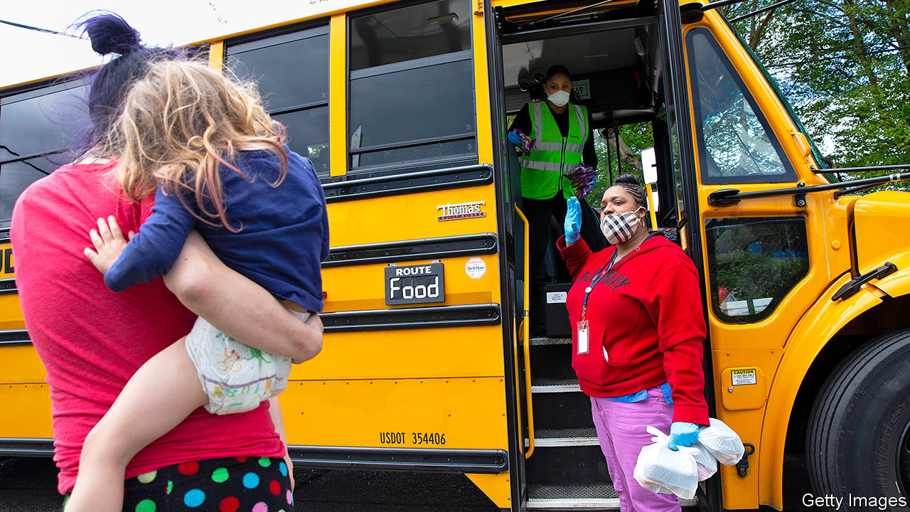

NO ONE WELCOMES a recession, but downturns are especially difficult when you are poor. Rising unemployment means rising poverty: the recession of 2007-09 prompted the share of Americans classified as poor, on a widely used measure, to jump from 12% to 17%. That economic shock, as bad as it was, pales in comparison with what America is seeing today during the coronavirus pandemic. The jobs report for June, published on July 2nd, showed that unemployment remained well above the peak of a decade ago.

Severe deprivation is certainly on the rise. According to a new survey from the Census Bureau, since the pandemic began the share of Americans who “sometimes” or “often” do not have enough to eat has grown by two percentage points, representing some 2m households. An astonishing 20% of African-American households with children are now in this position. Meanwhile, the proportion of Americans saying that they are able to pay the rent is falling. Many more people are typing “bankrupt” into Google.

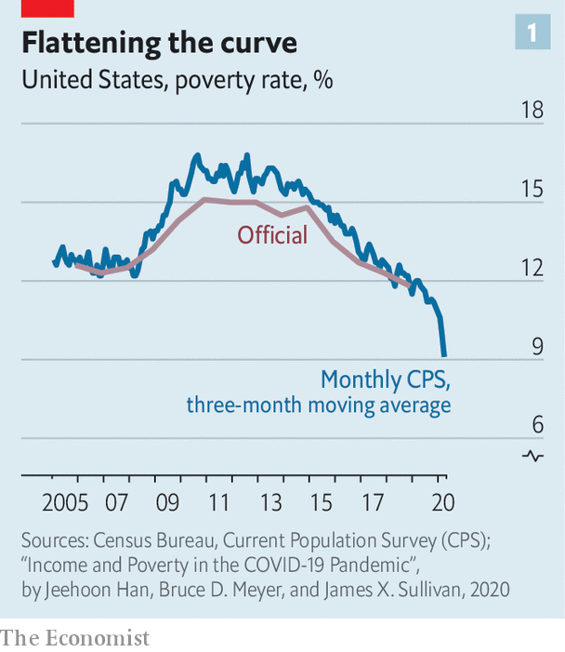

Yet these trends, bad as they are, do not appear to be part of a generalised rise in poverty. The official data will not be available for some time. A new paper from economists at the University of Chicago and the University of Notre Dame, however, suggests that poverty, as measured on an annual basis, may actually have fallen a bit in April and May, continuing a trend seen in the months before the pandemic hit (see chart 1).

Why? The main reason is that fiscal policy is helping to push poverty down. The stimulus plan passed by Congress is twice the size of the one passed to fight the recession of a decade ago. Much of it, including cheques worth up to $1,200 for a single person and a $600-a-week increase in unemployment insurance (UI) for those out of work, is focused on helping households through the lockdowns. At the same time, unemployment now looks unlikely to rise to 25% or higher, as some economists had predicted in the early days of the pandemic, thereby exerting less upward pressure on poverty than had been feared.

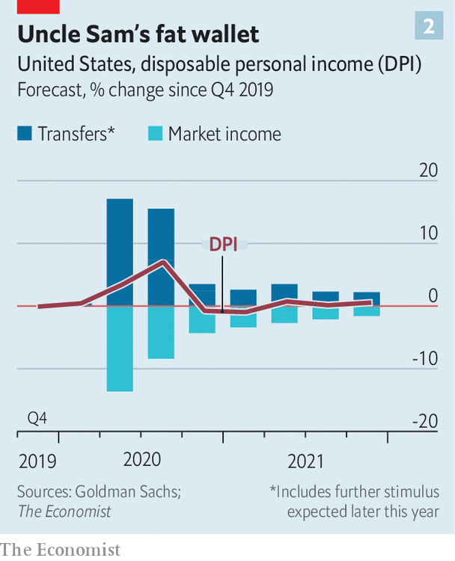

The upshot is that the current downturn looks different from previous ones. Household income usually falls during a recession—as it did the last time, pushing up poverty. But a paper in mid-June from Goldman Sachs, a bank, suggests that this year nominal household disposable income will actually increase by about 4%, pretty much in line with its growth rate before the pandemic (see chart 2). The extra $600 in UI ensures, in theory, that three-quarters of job losers will earn more on benefits than they did in work.

By international standards, America’s unexpected success at reducing poverty nonetheless remains modest. Practically every other rich country has a lower poverty rate. It is also a fragile accomplishment. The extra $600-a-week payments are supposed to expire at the end of July. The authors of a recent paper from Columbia University show that poverty could rise sharply in the second half of the year, which seems likely if unemployment has not decisively fallen by then. Goldman’s paper assumes that Congress will extend the extra unemployment insurance, but that the value of the payment will drop to $300. Even then, household disposable income would probably fall next year.

Whether extra stimulus would help those at the very bottom of America’s socio-economic ladder—including people not able to buy sufficient food—is another question. Six per cent of adults do not have a current (checking), savings or money-market account, making it difficult for them to receive money from Uncle Sam. Some may have been caught up in the delays which have plagued the UI system, and a small number may be undocumented immigrants not entitled to fiscal help at all. Others report not being able to gain access to shops closed under lockdowns. The best way to remedy this would be to get the virus under control and the economy firing on all cylinders once again. But that still looks some way off.■

To keep up with our coverage of the pandemic, visit our coronavirus [hub](https://www.economist.com/news/2020/03/11/the-economists-coverage-of-the-coronavirus). Some of our covid-19 coverage is free for readers of The Economist Today, our daily [newsletter](https://my.economist.com/user#newsletter).

This article was downloaded by calibre from <https://www.economist.com/united-states/2020/07/06/americas-huge-stimulus-is-having-surprising-effects-on-the-poor>

|  |  |  |  |
| --- | --- | --- | --- |
|  | Articles | Sections | Next |

|  |  |  |  |
| --- | --- | --- | --- |
| Previous | Articles | Sections | Next |

#### The 88-year itch

# Could Democrats pick up a Senate seat in Kansas?

The party has a strong candidate, but needs an FDR-like performance at the top of the ticket

Jul 11th 2020 |

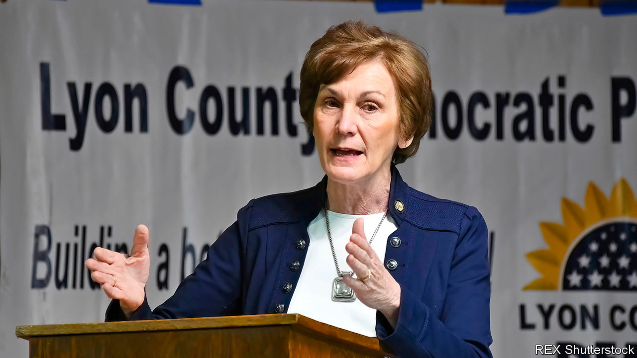

STALIN RULED the Soviet Union. George V occupied the British throne. America’s public was awed by a young Kansan, Amelia Earhart, who had become the first woman pilot to fly solo across the Atlantic. The year 1932 was memorable for many. But Democrats in Kansas recall it for a special reason: that was the last time their state elected a Democratic senator.

Could it happen again in November? Kris Kobach, a Republican and former secretary of state in Kansas, scoffs at the idea. He campaigned this week in Topeka, the state capital, after a weekend of attending Independence Day parades and picnics. “It won’t be 1932 again,” he said, predicting that he, or whoever else emerges from a crowded field of 11 in the Republican primary on August 4th, will go on to win the Senate race by ten percentage points.

Such confidence could be misplaced. The Democrats will field an unusually strong candidate. Barbara Bollier, a retired anaesthesiologist, has raised $3.7m this quarter, a hefty sum that dwarfs efforts on the Republican side. Democrats nationally are shovelling money into Kansas, as a victory there could help win control of the Senate—or the threat of one might at least distract Republicans from other battles.

Ms Bollier’s biography makes success seem possible. Until two years ago she was a moderate Republican in the state Senate. She was dismayed by a dire tax-cutting experiment under the previous Republican governor, Sam Brownback, and by her (former) party’s rightward lurch on social issues. She endorsed Laura Kelly, a Democrat, who won the race to be governor in 2018. Then she jumped party.

Having an ex-Republican doctor on the ticket should be an advantage as covid-19 spreads. Ms Bollier is making health care her main issue. That is astute: Republicans vow to repeal the Affordable Care Act, though polls suggest most Kansans want government-backed care expanded. If the pandemic worsens, voters may grow more concerned. Ms Bollier also has the advantage of coming from Johnson County, which includes some suburbs of Kansas City. Doing well there could be decisive.

Democrats are also encouraged by conniptions among Republicans after the incumbent, Pat Roberts, said he would retire. For months the national party tried to press Mike Pompeo, the secretary of state, to run. He eventually refused, but the long uncertainty sent a message that Mitch McConnell, the Senate leader, does not trust the local alternatives as a safe bet.

Most are nonentities. Easily the best-known is Mr Kobach, who may have a slight lead over his rivals because of a strong base of conservative backers. He was previously close to Donald Trump, but lost favour once Ms Kelly thumped him in the governor’s race. He has proved himself a poor fundraiser and his focus on the evils of immigration seems unsuited to the moment.

Mr Kobach retorts that Mr McConnell and other “establishment voices” fear him as an outspoken conservative, so are “trying to foist a pliable Republican” on the seat. Mr Trump has not endorsed anyone, but seems to be behind Roger “Doc” Marshall, an unexceptional congressman from rural western Kansas.

Complicating things is a former plumber, Bob Hamilton, who plunged into the primary and is mostly devoting himself to attacks on Mr Marshall. He is said to be spending $2m of his own cash on TV ads. He pitches himself as an even more conservative outsider. By attracting 15% support or more, he makes the result of the primary hard to guess.

As for the November election, polls show Ms Bollier as likely to win as any Republican. Her challenge is to sustain that after August, once she faces a single opponent. If she really is to end the Democrats’ 88-year losing streak in Kansas, she probably needs Mr Trump’s popularity to dip more. Because voters seldom now split their ballots between president and Senate, she needs more Kansans to think again about the top of the ticket. That was the formula in 1932, after all. Kansas last got a Democratic senator when FDR won a national landslide for his party. ■

This article was downloaded by calibre from <https://www.economist.com/united-states/2020/07/11/could-democrats-pick-up-a-senate-seat-in-kansas>

|  |  |  |  |
| --- | --- | --- | --- |
| Previous | Articles | Sections | Next |

|  |  |  |  |
| --- | --- | --- | --- |
| Previous | Articles | Sections | Next |

#### Bands of blue

# Reining in police unions’ power in America

Cities and states have begun to curb organisations that have been indulged from left and right

Jul 11th 2020 | WASHINGTON, DC

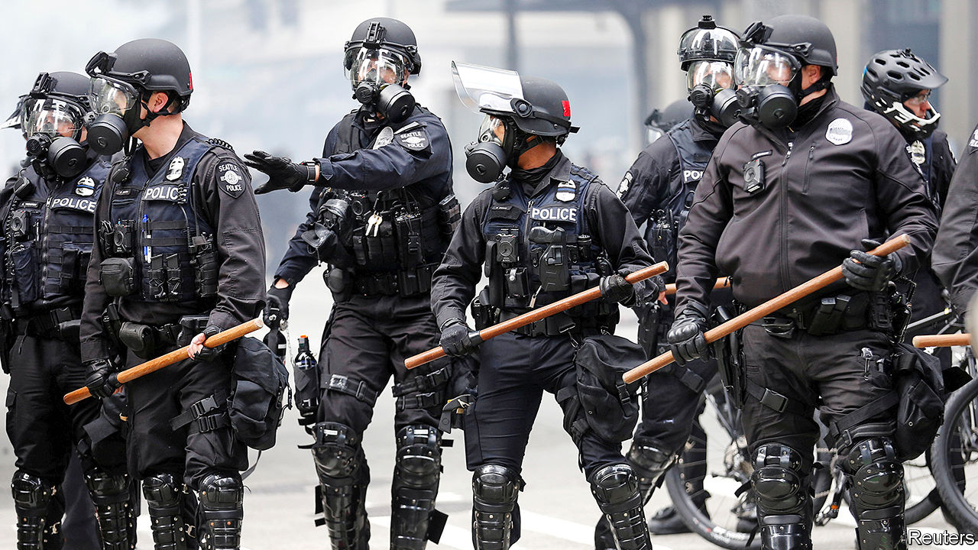

“THE UNION forever defending our rights,” rhapsodises Billy Bragg, a British singer and activist, in his song “There is Power in a Union”. And that, indeed, is what unions do: they advance the interests of their members. That means pushing for better pay, benefits and working conditions. Unions representing police officers are no different: their efforts keep police pensions and salaries generous, and provide their members with broad protections against disciplining and oversight, to keep them in work. That has long frustrated many criminal-justice reformers—but, buoyed by calls for change in the wake of George Floyd’s death, some governments have begun to rethink those protections.

Law enforcement is among the most heavily unionised sectors in America, and police unions occupy a unique position. They tend to be conservative, unlike much of the labour movement. The International Union of Police Associations, for instance, has endorsed Donald Trump, even though it is affiliated with the AFL-CIO, a staunchly Democratic union federation.

Politically, police unions are shielded on both sides. The right dislikes confronting the police—in Wisconsin Scott Walker, a former Republican governor, specifically exempted police unions from a measure passed in 2011 that limited public unions’ collective bargaining rights—whereas the left is loth to take on unions. Governments often find it easier to give in on disciplinary and oversight matters, which incur no direct or noticeable costs, than on pay and pensions, which might require tax rises or service cuts elsewhere.

Union contracts for police forces in most of America’s 100 largest cities have provisions reducing police accountability. In Chicago, for instance, officers have 24 hours after a shooting to make a statement, which they can amend after watching video footage of a disputed incident. Chicago also bans anonymous complaints of misconduct, which a Justice Department report argues “creates a tremendous disincentive” to report it, since complainants fear they may be targeted. Other states and cities indemnify police against misconduct by paying their legal fees and settlement costs, allow officers access to information that citizens do not get which they can review before being interrogated, and eventually erase disciplinary records from officers’ files.

A forthcoming paper from Rob Gillezeau, an economist at the University of Victoria, British Columbia, who studies police practices, found that the spread of police collective-bargaining in America between the 1950s and 1980s led to what he calls “a meaningful increase in civilians killed by law enforcement, mostly among the non-white population.” He argues that, “it looks like the collective-bargaining process is being used to protect the ability of officers to discriminate.”

Some states have begun taking measures to boost police accountability and rein in union power. In late June, Oregon’s legislature passed bills requiring officers to report or prevent misconduct by their colleagues and limiting the ability of arbitrators to overturn disciplinary actions. Connecticut’s legislature plans to pass police-accountability legislation in a special session later this month that may include measures limiting officer indemnification and unions’ ability to negotiate over some disciplinary and oversight measures. Some prominent Democrats in California have asked the party to stop accepting contributions from police unions—a move that would limit the unions’ influence in what is, in effect, a one-party state.

Some unions are dug in for a long fight. But others see that times are changing. Daryl Turner, who heads Oregon’s police-advocacy organisation, recognises that “It’s important to evolve in policing...with the needs of your community and the nation.” Three large police unions in California have called for reforms including a national use-of-force standard and database of officers fired for gross misconduct—though of course those reforms would not curb their collective-bargaining power. ■

This article was downloaded by calibre from <https://www.economist.com/united-states/2020/07/11/reining-in-police-unions-power-in-america>

|  |  |  |  |
| --- | --- | --- | --- |
| Previous | Articles | Sections | Next |

|  |  |  |  |
| --- | --- | --- | --- |
| Previous | Articles | Sections | Next |

#### Reform squared

# The challenges of reducing America’s jail population

Cash bail is unpopular. But the replacements are not necessarily better

Jul 9th 2020 |

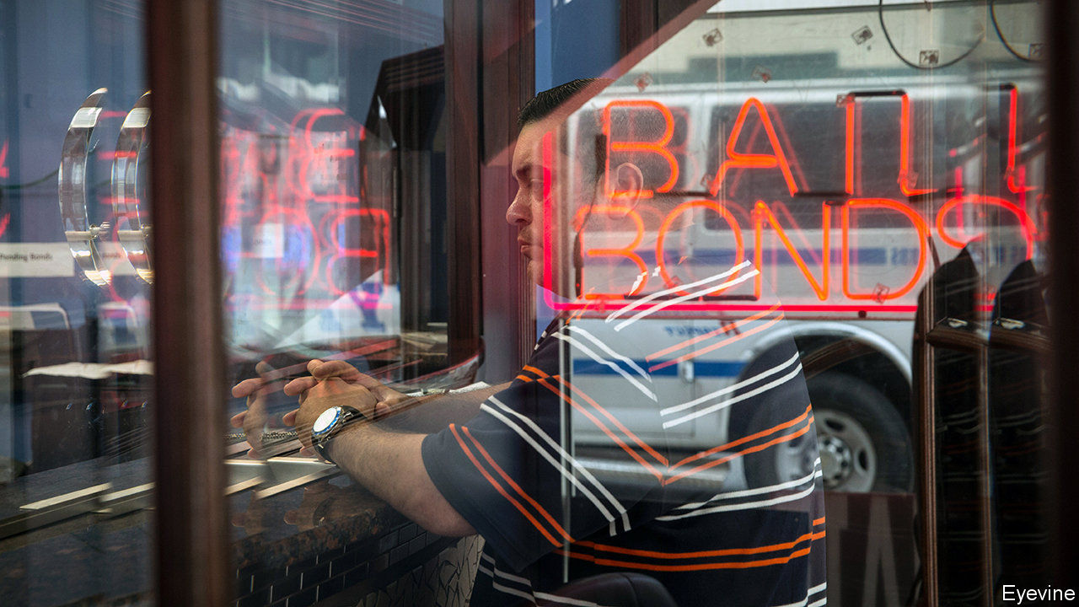

IT MIGHT have been the most polite bank robbery in New York’s history. At half past five in the afternoon on January 10th a man in a Chicago Bulls baseball cap walked into a Chase Bank branch in Brooklyn and handed a note to the teller. “This is a robbery,” the message said, in handwritten red ink. “Big bills only.” He walked out with $1,000. The man accused of the heist is Gerod Woodberry. Less than four hours before the Brooklyn incident, Mr Woodberry had been released from police custody after being charged with similar offences. “I can’t believe they let me out,” he told a detective.

His release was thanks to New York’s new bail-reform law, effective since January 1st, which eliminated pretrial detention for misdemeanours and non-violent offences. Critics of the reform jumped on Mr Woodberry’s case. In April the state legislature amended the new law to increase the number of situations in which judges can impose cash bail, effective from July 1st. The Centre for Court Innovation, a think-tank, estimates that this will increase New York’s pretrial jail population by 16%.

Before the reform was reformed, New York had been the first state in the country to end pretrial detention for such a swathe of charges, enough to account for 90% of arrests. Bail-reform advocates say that keeping unconvicted people detained before trial violates the presumption of innocence. The money-bail system, in which defendants pay cash as a guarantee that they will show up in court, means that only those with spare dollars can wait for their trial at home. The poor must either turn to the $2.3bn commercial-bondsmen industry—companies, found only in America or the Philippines, which bail out defendants for a fee—or wait in pretrial detention. In 2016 two-thirds of inmates in local jails were defendants awaiting trial.

But if money bail is reformed, what replaces it? California abolished it in 2018, replacing it with risk assessments. But the new law pleased few people. It replaces the former system with “an overly broad presumption of preventative detention”, says the American Civil Liberties Union. The American Bail Coalition has sponsored a $3.7m campaign to repeal it. Risk-assessment tools “penalise people based on what they might do in future,” says Jeff Clayton of the bail-industry group. The law will be put to a referendum in November.

Debates about bail reform have forced people to think about what bail is really for, says Taryn Merkl of the Brennan Centre, a think-tank. Posting bail is no more of a guarantee than other incentives that someone will show up in court. The Bronx Freedom Fund is one of several charities that bail out poor defendants. Between 2013 and 2014 98% of the organisation’s clients showed up for their court dates, despite the lack of a personal financial incentive. Such data have pushed the case for abolishing cash bail, says David Feige, the Fund’s chairman. So public safety is also invoked—though, among the people awaiting trial in local jails, 68% are accused of nonviolent offences.

This is where risk assessments come in. Many states look to New Jersey as the example of what abolishing cash bail would look like. Money bail was severely restricted there in 2017. Instead, judges use an algorithm to determine how dangerous or likely to flee a person is. It is far from perfect. Although New Jersey has reduced the overall jail population, the algorithms used to determine who gets bailed and who does not are said to entrench the kind of racial discrimination that getting rid of cash bail was supposed to solve.

In both 2012 and 2018, 54% of inmates were black. One of the risk factors used in the New Jersey algorithm is a person’s criminal record. But in 2013 a black person in New Jersey was three times more likely than a white person to be arrested for marijuana possession, despite a similar rate of use among the two groups. The algorithm also factors in pending charges that have yet to result in a conviction.

“There is no doubt that risk assessments are biased,” says Megan Stevenson of the University of Virginia. “Anything that has data from a biased world will have a biased output.” But this means that “there is no way to test a risk assessment tool for fairness”, because any measures, such as if a bailed person is rearrested, can also be affected by racial bias in the justice system.

The challenge of bail reform is that “we haven’t been able to establish a baseline of best practice”, says Rashawn Ray of the Brookings Institution. But many jurisdictions are moving away from a cash-for-freedom system. Washington, DC has gone furthest. The risk-assessment tool it uses is opaque, but it releases 94% of defendants before trial. “There is no perfect alternative” to cash bail, observes Marie Ndiaye of the Legal Aid Society, a law firm. Many would like to see pretrial detention eliminated for all but a tiny minority of dangerous defendants. Still, despite the rollback of the New York reforms, Mr Feige of the Bronx Freedom Fund thinks things are moving in the right direction. He is closing his organisation to focus on national bail-reform efforts. “We are realising”, he says, “the dream of our own irrelevance.”■

This article was downloaded by calibre from <https://www.economist.com/united-states/2020/07/09/the-challenges-of-reducing-americas-jail-population>

|  |  |  |  |
| --- | --- | --- | --- |
| Previous | Articles | Sections | Next |

|  |  |  |  |
| --- | --- | --- | --- |
| Previous | Articles | Sections | Next |

#### Civil rites

# As fewer Americans go to church, chaplains are finding work elsewhere

The hospital chaplain has become a key figure in the treatment of covid-19 patients

Jul 11th 2020 |

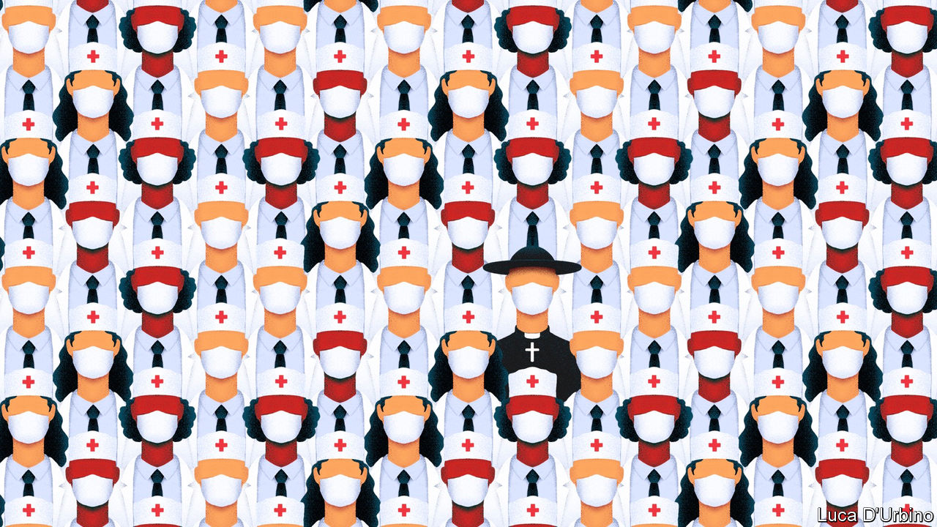

ONE OF THE toughest things about covid-19 for Pamela Lazor, as for workers in hospitals across the world, has been watching patients die without a loved one close by. As a chaplain at Cedars-Sinai Medical Centre in Los Angeles, part of her job is making sure dying patients have the company of a relative or a chaplain if they have signalled a wish for it. As the virus spreads, hospital chaplains are playing a crucial role in the care of patients, their families and the medical staff who treat them. This reflects the expansion of chaplaincy in America more broadly. As fewer people go to church, more of those who would once have become church ministers have become chaplains instead, says Wendy Cadge, a professor of sociology at Brandeis University and founder of the Chaplaincy Innovation Lab (chaplains are spiritual advisers attached to secular institutions such as hospitals or schools).

In the process, chaplaincy has become increasingly professionalised. In the past 20 years a quarter of theological colleges have started chaplaincy degree programmes. Though the only institutions legally required to have chaplains are federal prisons, the armed forces and the Veterans Administration, they are now found in veterinary clinics, fire stations, shopping malls and offices. A recent national survey found that 20% of Americans had engaged with a chaplain in the past two years.

Most hospitals now have chaplains on their payroll. Though many are ordained, they differ from other ministers in significant ways. No matter what their tradition, they are trained to tend to people of any faith or none, are familiar with hospital systems, and work closely with doctors and nurses. Arif Kamal, a palliative-care expert at Duke University and a hospital doctor, says hospitals have seen that having a chaplain can reduce staff turnover, especially at stressful times. Currently, he says, chaplains are operating as a “relief valve”, doing some of the jobs made necessary by a highly contagious virus that medical staff are too busy to attend to.

As PPE supplies have improved, some hospitals, like Cedars-Sinai, allow one visitor when a patient is close to death. But most patients are still largely isolated from their families. Chaplains help organise online meetings and serve as go-betweens, speaking to relatives who are unable to reach a doctor or nurse.

Their particular speciality is death. A majority of Americans die in hospital. Yet because few anticipate this, they and their families are often unprepared for what it can involve. Dr Kamal says that people, especially from conservative religious backgrounds, worry about the ethics surrounding end-of-life care; whether a ventilator should be switched off, for example. Intensive-care doctors may not have the time to discuss such issues; outside ministers are unlikely to understand the way such decisions are made in hospitals, and may even make them more difficult.

Covid-19 is also prompting chaplains and medical staff to work together more closely. Houston Methodist, a hospital in Texas’s biggest city, is one of many in which chaplains are still unable to visit covid-19 patients. Stacy Auld, the director of spiritual care, says the hospital tries to find ways round that. When it became obvious recently that a patient, who had expressed a desire to be baptised, would shortly die, a chaplain guided a nurse from behind a glass screen as he performed the rite.

A few have visited patients with covid-19 throughout the pandemic. At its peak in Massachusetts, Brian Conley, a Catholic priest, administered the last rites to between three and five Catholic patients a day at Brigham and Women’s Hospital in Boston, more than five times his usual rate. He recited verses of the Koran and Jewish prayers for the dying when an imam or rabbi was not available. Being at the bedside of a patient dying from covid-19 is different from attending other deaths, he says, because he has to keep a six-foot distance and wear a face shield. Patients often remain hooked up to ventilators even after they have been switched off to reduce the threat of infection. “It can feel strange and distant,” he says. “But the need is the same.”■

This article was downloaded by calibre from <https://www.economist.com/united-states/2020/07/11/as-fewer-americans-go-to-church-chaplains-are-finding-work-elsewhere>

|  |  |  |  |
| --- | --- | --- | --- |
| Previous | Articles | Sections | Next |

|  |  |  |  |
| --- | --- | --- | --- |
| Previous | Articles | Sections | Next |

#### Lexington

# The mark of Cain

A Christian pollster argues that a reckoning is due in America’s churches

Jul 11th 2020 |

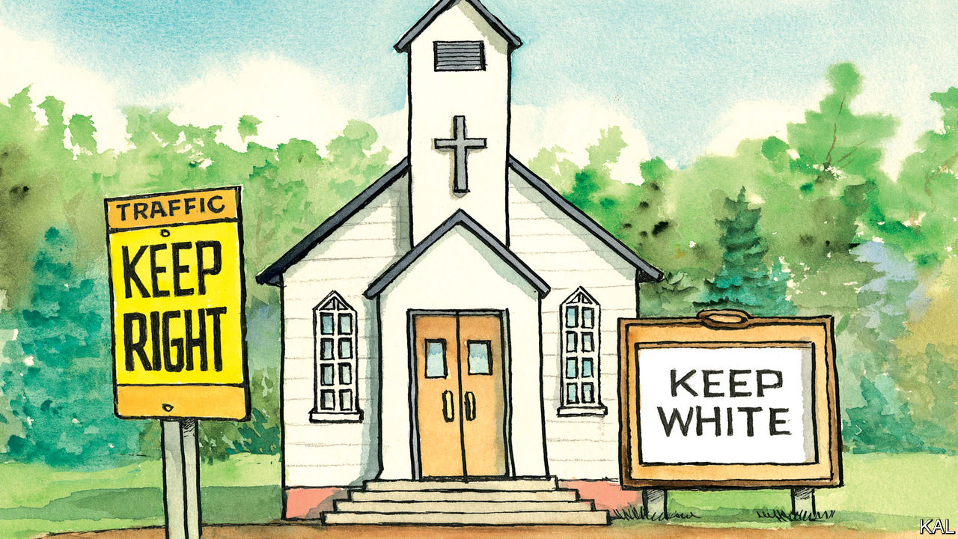

FEW THINGS about Donald Trump’s rise are harder to explain than the fact that some of the most religious Americans were behind it. In 2016, 81% of white evangelicals voted for him. It seems no one was more astonished by this than those who knew him best. “He has no principles. None!” marvelled his sister Maryanne Trump Barry, according to a forthcoming family exposé by Mary L. Trump, the president’s niece.

The popular explanation for this strange nexus is that white Christians overlooked the president’s failings because of his willingness to fight their corner, by nominating conservative judges and opposing abortion. This always seemed about as persuasive as the comparisons between Mr Trump and the flawed biblical heroes it gave rise to (…Cyrus, David, you name it). Mr Trump’s Republican opponents would have nominated similar judges; no president can do much about abortion. Another explanation, argues a new book by Robert P. Jones, an authority on American religion and politics, and head of the Public Religion Research Institute, is that white Christians were especially receptive to Mr Trump’s race-baiting. Mr Jones also offers a grim theory for why this was the case.

Melding history, theology, statistical modelling and his own experience, as a Southern Baptist seminarian, Mr Jones suggests in “White Too Long” that white Christian traditions are so steeped in historic racism that “the norms of white supremacy have become deeply and broadly integrated into white Christian identity.” This is not something most white Christians (a group that includes Lexington) are aware of. They probably condemn racism. Mr Jones finds white evangelicals especially likely to express goodwill to African-Americans. But dig into their unconscious biases, he claims, and you see a different picture emerge. “In survey after survey” white Christians are much likelier than non-religious whites to express negative attitudes towards minorities and complacency about the rough treatment of African-Americans, among other indicators of racism. Asked whether police killings of black men were isolated incidents, 71% of white evangelicals said they were, compared with 38% of non-religious whites.

This is a finding to which two qualifiers are often added. First, white evangelicals are likely to be old, conservative and live in the South—characteristics that point to unreconstructed views on race independently of religion. Second, while people who simply identify as white evangelicals might hold such views, the most pious do not. Mr Jones is unconvinced by either qualifier. He controls for age, partisanship and geography in his model—and finds the same pattern. And he finds that practising evangelicals score the highest on his index of racism. He concludes that white Christian identity is “independently predictive” of racist attitudes.

Such claims are shocking. But, Mr Jones argues, the history of American Christianity makes this likelier than it might sound. The dominant southern strains of white evangelicalism were formed amid and sometimes in response to slavery. The Southern Baptists, America’s biggest denomination, was launched to defend it biblically—which it did by representing black skin as the accursed “mark of Cain”. Many southern pastors were cheerleaders for the Confederacy, then shaped the culture of nostalgia and lament (the “religion of the lost cause”) that precluded a reckoning with Jim Crow’s legacy. The stained-glass windows of some southern churches still sparkle with Confederate flags. Almost 90% of white evangelicals consider the flag “more a symbol of southern pride than of racism”.

Post-war pessimism also led evangelicals to adopt a premillennialist theology, which viewed the world as irredeemable by man. Instead of wasting their time on social justice, it urged them to focus on their individual spirituality. The perverse effect, argues Mr Jones, was to imbue white evangelicals with “an unassailable sense of religious purity” that blinded them to their own behaviour. History records instances of white congregations pouring out of church to a lynching. And such scenes were not restricted to evangelicals or the South.

As African-Americans fled north, mainstream protestants and Catholics increasingly adopted the mores of southern evangelicals. The moral majority of the 1970s and 80s, fuelled by a Catholic aversion to abortion and common fears of the civil-rights movement, was the culmination of this fusion. Mr Jones’s model suggests the same racial attitudes are common to most white Christian traditions. Evangelicals are merely the most extreme case.

This is a bleak analysis. Perhaps the least that can be said for it is that Mr Trump, now tripling down on race-baiting, knows his base. So long as he can keep his white Christian voters happy, he has a chance, and harping on race looks like his likeliest means to do so.

## Mist on the water

If Mr Jones is right, a bigger question is whether churches can reckon with the bigotry the Trump era has brought to the fore. This will take more than a symbolic statement of guilt and desire for reconciliation. Most churches, to their credit, have been doing that sort of thing for decades. Mr Jones quotes a Baptist pastor in Georgia who is trying to go further as saying that the word “reconciliation” betrays a “desire to just kind of move through all the hard stuff.”

For him and his flock, the hard stuff involves trying to build a community with the black congregation next door, whose ancestors their ancestors owned. It might also mean revisiting the individualistic theology many traditions still adhere to. It could involve restitution—as slave-built Virginia Theological College demonstrated, by launching a $1.7m fund for black seminarians.

This troubling past was always the real mark of Cain, Mr Jones writes. And “today God’s anguished questions—‘Where is your brother?’ and ‘What have you done?’—still hang in the air like morning mist on the Mississippi River.”■

This article was downloaded by calibre from <https://www.economist.com/united-states/2020/07/11/the-mark-of-cain>

|  |  |  |  |
| --- | --- | --- | --- |
| Previous | Articles | Sections | Next |

|  |  |  |
| --- | --- | --- |
| United States | Sections | Asia |

The Americas

Brazil: Christianity, covid, contact

.

Dominican Republic: A rare power shift

.

Bello: Promise and disappointment

.

|  |  |  |
| --- | --- | --- |
| United States | Sections | Asia |

|  |  |  |  |
| --- | --- | --- | --- |
|  | Articles | Sections | Next |

#### Christianity, covid, contact

# A religious challenge to “no contact” with isolated indigenous groups

Missionaries want to win souls in the Amazon. Brazil’s president is on their side

Jul 11th 2020 | SÃO PAULO

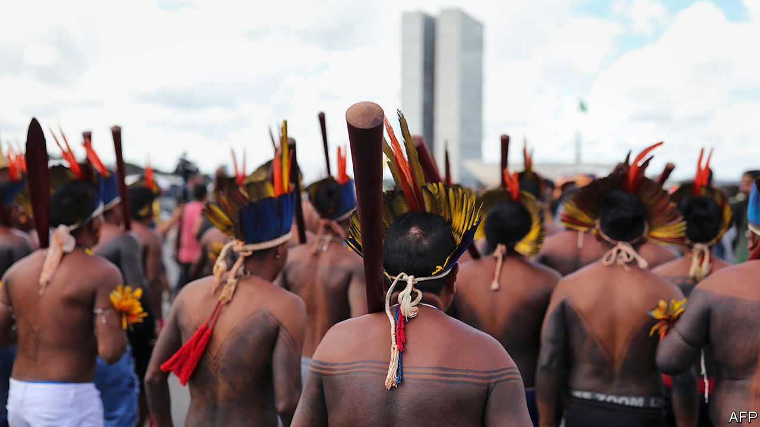

MARCOS MAYORUNA found Jesus 15 years ago. The son of a cacique (chief) from the Vale do Javari, an indigenous territory in the Brazilian Amazon larger than Austria, he was converted by a missionary from another ethnic group and became a pastor himself. After seminary in Rio de Janeiro he went home to spread the word of God to the Mayoruna and other tribes.

He sometimes worked with Brazilian and American missionaries, swapping his local knowledge for donations to his humble seminary in Atalaia do Norte, a dusty town in the northern part of the valley. But, he says, the missionaries seemed more interested in reaching isolated peoples, indigenous groups that, unlike the Mayoruna, have little or no contact with the societies that surround them. Worldwide, 100 probably exist today, says Survival International, an NGO. The largest concentration, of perhaps 16, is in the Javari valley.

They owe their survival to a decision by Brazil’s government in 1988. It discourages contact with isolated tribes, except to prevent medical emergencies, warfare between tribes or other catastrophes. The policy’s father is Sydney Possuelo, a revered sertanista, or Amazon explorer, who led contact missions for Brazil’s military government in the 1970s and 1980s. Development projects like the construction of the Trans-Amazonian highway cleaved through forest inhabited by scores of indigenous groups (see map). In some, 50-90% of their members died from diseases like measles and flu. Horrified, Mr Possuelo persuaded the government to adopt the no-contact policy. It has become a model for other countries in the region.

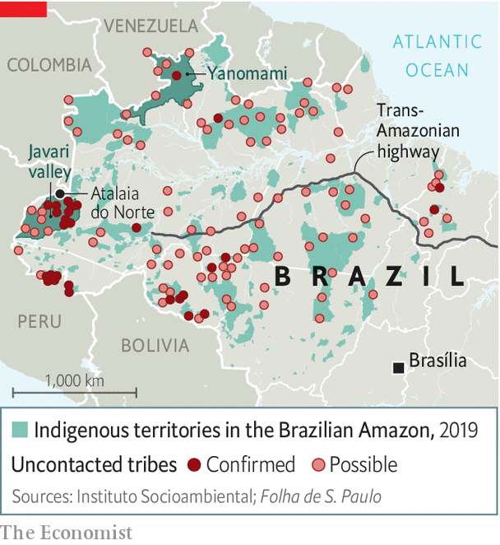

From the start, it encountered resistance, chiefly from people who want to farm and mine on indigenous land. Now, for the first time, Brazil has a president, Jair Bolsonaro, who is a critic of the policy. An evangelical Christian, he shares the proselytising zeal of the missionaries whom Mr Mayoruna has encountered. He is also sympathetic to businessmen who want to develop the Amazon. Though still on the books, in practice the no-contact policy is being dismantled.

One of Mr Bolsonaro’s first decrees transferred power to demarcate indigenous reserves from the indigenous agency (FUNAI) to the agriculture ministry, which is friendlier to farmers. The Supreme Court annulled it. This year he nominated Ricardo Lopes Dias, a former missionary, to oversee the part of FUNAI that deals with its policy on isolated tribes. Mr Possuelo says that Mr Bolsonaro poses the biggest threat to those groups since the no-contact policy began. “Contact is a road of no return,” he says. The alarm is heightened by covid-19, which could hurt indigenous people more than those with access to modern health care. Mr Bolsonaro, who revealed this week that he had tested positive for the coronavirus, has shown little interest in shielding Brazilians from it.

Even before his presidency, the no-contact policy was under threat. Between 1987 and 2013, FUNAI contacted only five isolated groups. But illegal logging, mining and drug smuggling have pushed non-isolated groups towards isolated ones. Tensions between them have drawn in the state. FUNAI has led as many contact missions since 2014 as it did in those previous 26 years. In 2015 it drew criticism for initially ignoring pleas from the Matis in the Javari valley to make contact with the isolated Korubo, whose members had killed two Matis leaders. FUNAI contacted the Korubo only after the Matis killed eight Korubo in revenge.

With Mr Bolsonaro in charge, religious pressures reinforce commercial ones. “I haven’t met an Indian who wants to be naked, and it’s a crime to keep them that way,” says an American missionary who lives in Atalaia do Norte. Edward Luz, the president of the New Tribes Mission of Brazil (MNTB), whose 480 missionaries evangelise “unreached ethnic groups”, wrote in an email to The Economist that contact will improve their health. Fear and worry “will be replaced by confidence and they will smile, procreate, have their cultural practices and grow in numbers again,” he prophesied.

Mr Lopes was once an MNTB missionary. His appointment to FUNAI is like “putting a fox in charge of the hen house”, says Beto Marubo, an indigenous activist. He fears that Mr Lopes will share secret information about tribes’ locations with proselytising friends. If contact is needed, it should be done by the government, not missionaries, said Mr Lopes in an email.

Missionaries deny that they are trying to contact isolated tribes. Their actions suggest otherwise. Ethnos360, the American partner of MNTB, raised more than $2m to buy a helicopter to “open the door to reach ten additional people groups living in extreme isolation” in the Javari valley. Mr Luz says the helicopter, which arrived in January, will help MNTB in areas where it already works, like Vida Nova, a Marubo village where it built a church in the 1950s. FUNAI has reported Andrew Tonkin, an American, to the police for flying a seaplane into the Javari valley. Indigenous leaders say he was searching for isolated groups. He denies this and denounces what he sees as FUNAI’s paternalism. “What about [indigenous peoples’] right to invite who they want to their community?” he emailed. “To worship God freely?”

It is not just missionaries and miners who challenge the no-contact policy. In an editorial in Science in 2015, two anthropologists, Kim Hill and Robert Walker, suggested that, given governments’ inability to protect indigenous lands, isolated groups are “not viable in the long term”. “Controlled contact” would be a better policy, they wrote. “If we can guarantee them protection from exploitation they would all choose contact tomorrow,” says Mr Hill. His research shows that by at least one measure they would be better off: among the Ache of Paraguay, half of children living isolated in the forest died before reaching adulthood. After contact in the 1970s, child mortality rates spiked for a few years, but are now 2-3%.

The Science article caused a furore. The idea of controlled contact ignores native peoples’ right to self-determination, say defenders of no contact. Many groups returned to isolation after traumatic encounters, such as enslavement by rubber tappers in the early 1900s. Uncontacted groups “know there’s a world out there,” says Mr Marubo. “They are making a choice by isolating themselves.” Many people doubt that any contact could be controlled, and that it would be accompanied by medical follow-up. “Can you trust that a government won’t think about what gold is there, what oil is there, what trees are there?” asks Glenn Shepard, an ethnobotanist.

Even if controlled contact were possible, now seems a bad time to initiate it. The prevalence of covid-19 among indigenous people in cities is five times that among white Brazilians. Mr Hill agrees contact should not happen until there is a vaccine and Mr Bolsonaro is no longer president.

Yet evangelists see the disease as a reason to initiate it. Congress’s evangelical lobby tacked on to a law that allocates money to protect indigenous people from covid-19 an amendment that allows missionaries to remain on indigenous lands. After a court ordered the government to evict 20,000 gold miners from the remote Yanomami territory, the army dropped off face masks and hydroxychloroquine, an antimalarial drug that Mr Bolsonaro thinks is effective against covid-19.

Mr Mayoruna, who left the forest because “I wanted to know who God was”, recently broke ties with the missionaries. He thinks it is a matter of time before the remaining isolated groups are confronted with modern Brazil, but says it is wrong for pastors to push the pace. “You can’t force anyone to convert,” he says.■

This article was downloaded by calibre from <https://www.economist.com/the-americas/2020/07/11/a-religious-challenge-to-no-contact-with-isolated-indigenous-groups>

|  |  |  |  |
| --- | --- | --- | --- |
|  | Articles | Sections | Next |

|  |  |  |  |
| --- | --- | --- | --- |
| Previous | Articles | Sections | Next |

#### A rare power shift

# The Dominican Republic changes its ruling party

The new president has a solid mandate, but the pandemic and a severe recession will hobble him

Jul 8th 2020 |

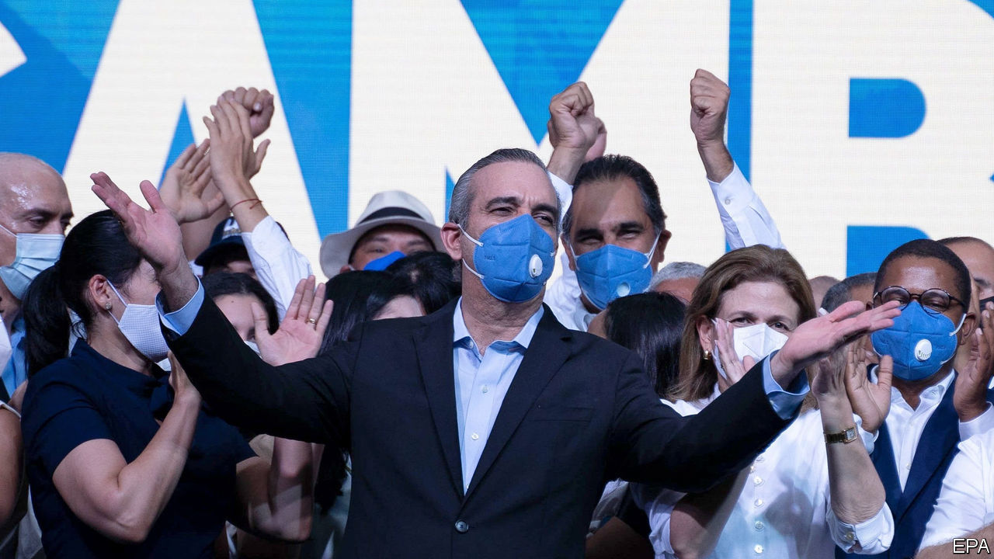

FOR A WHILE the Dominican Republic seemed doomed to a year of electoral chaos. Local elections in February were cancelled halfway through polling day because new voting machines malfunctioned. (A manual re-run in March succeeded.) A general election was due in May but covid-19 forced a two-month delay. To postpone it further would have required a constitutional change. When it went ahead on July 5th, chaos gave way to clarity. More than half of voters picked Luis Abinader, a businessman, to be president. That avoided a run-off. Early results suggest his Modern Revolutionary Party (PRM) will have majorities in both houses of Congress.

Mr Abinader’s victory unseats the Dominican Liberation Party (PLD), which has ruled for 20 of the past 24 years. Although power transfers in the country are rare, they do not necessarily bring change. Dominican politics is characterised by consensus on business-friendly centrism, and a propensity for corruption, clientelism and infighting that weakens, but does not prevent, its implementation. Mr Abinader must fight those old plagues while tackling the new one, which threatens to do lasting damage to the economy.

The outgoing president, Danilo Medina, is unpopular but accomplished a lot. The murder rate fell from 22 per 100,000 people in 2012, when he took office, to below ten in 2019. Mr Medina doubled education spending to 4% of GDP, complying with a law passed in 1997. He made school days longer and offered free school lunches. Over the past decade the economy of the Dominican Republic, which has 11m people, was the fastest-growing in Latin America. At his first inauguration Mr Medina promised to cut the official poverty rate in half to below 20%. He succeeded.

He stumbled in his second term. Odebrecht, a Brazilian construction firm that bribed officials across Latin America, found eager takers in the Dominican Republic. The $92m it paid there between 2001 and 2014 was exceeded only in Brazil and Venezuela. Mr Medina’s government investigated predecessors’ misdeeds but not its own. The two most recent attorneys-general sat on the PLD’s governing body.

Mr Medina tried and failed to change the constitution so he could run for a third term. That worsened a decade-long spat with Leonel Fernández, a former president who belonged to the PLD and hoped to be its candidate again. Mr Fernández ran this month for a rival party, helping to doom the candidacy of Gonzalo Castillo, a businessman who is Mr Medina’s political heir.

Mr Abinader, who studied management in the United States, is “slightly boring”, says Leiv Marsteintredet, a professor at the University of Bergen in Norway. His campaign was low-profile, partly because he contracted covid-19 and self-isolated.

The pandemic will do more damage to the new president’s programme of government. “Our first priority is formal employment,” says his manifesto. It pledges that his government will create 150,000 formal jobs a year. About that many jobs are created now, but just 30% are relatively high-paying formal ones, says Roberto Álvarez, an adviser to Mr Abinader. Some of the new jobs are to come from 15,000 hotel rooms that Mr Abinader hopes will appear along the beaches. He has also promised to balance the budget, which had a deficit last year of 2.2% of GDP. With the economy expected to contract by 6.5% this year, he will meet none of those goals soon.

Mr Abinader will be in a stronger position to fight the twin plagues of corruption and covid-19. A majority in Congress, if the PRM wins one, might reduce the need for grubby dealmaking with other parties. Mr Abinader has promised to pick an independent-minded attorney-general and provide more money to the office. New covid-19 cases are rising rapidly, in part because the country loosened its lockdown in the approach to the election. The current government may tighten it again, even before Mr Abinader takes office on August 16th. The Dominican Republic overcame electoral chaos. Vanquishing the virus and the recession will be harder.■

This article was downloaded by calibre from <https://www.economist.com/the-americas/2020/07/08/the-dominican-republic-changes-its-ruling-party>

|  |  |  |  |
| --- | --- | --- | --- |
| Previous | Articles | Sections | Next |

|  |  |  |  |
| --- | --- | --- | --- |
| Previous | Articles | Sections | Next |

#### Bello

# Spain’s complicated relationship with Latin America

The former colonial power wants to play a useful role, but undermines its own influence

Jul 11th 2020 |

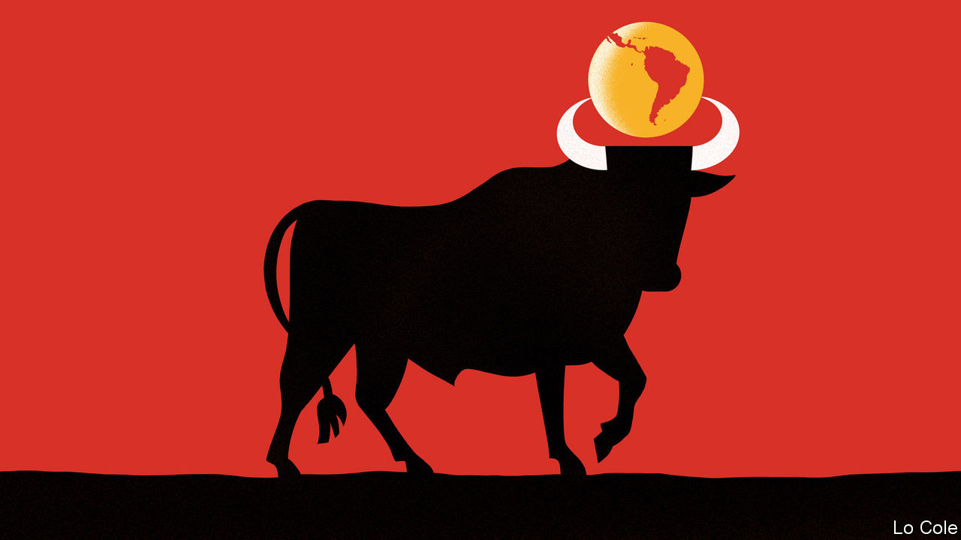

THEY HAVE gained few headlines and have barely been noticed even in Spain. But over recent weeks the Spanish government has organised six virtual ministerial meetings with its counterparts in Latin America to share experiences of dealing with the pandemic that has hit their countries so hard. These gatherings culminated in a video get-together on June 24th in which Pedro Sánchez, Spain’s prime minister, was joined by nine presidents. They agreed to work together to try to ensure that international financial institutions have more money to lend to Latin America as it struggles to support its economies.

This is a new and useful chapter in a relationship that has often promised more than it has delivered. In many ways, Spain and Latin America are close. They share ties of language, culture and history (though this does not apply to the same extent to Portuguese-speaking Brazil). But the political dialogue between them has had ups and downs over the past 40 years. Spain’s transition to democracy in the late 1970s influenced Latin America as it, too, shook off dictatorship. Felipe González, Spain’s Socialist prime minister from 1982 to 1996, forged close ties with the region’s leaders. Together with Mexico, in 1991 Spain launched the first of what would become regular “Iberoamerican” summits, which include Portugal, too. Spanish companies piled into Latin America, often by buying privatised firms. In 2005 Spain set up an Iberoamerican secretariat (known as SEGIB) to implement initiatives agreed upon at the summits.

It is a low-key outfit that does useful things, like arranging the portability of professional titles and social security, and acts as a vehicle for small-scale aid projects worth some €23m ($26m) a year, to which countries contribute as they wish. In a modest way, it works.

For Latin America, where the United States and China loom large, ties with Spain are a way of diversifying friendships. The heart of Spain’s political offer to Latin America is to portray itself as the region’s advocate in Brussels, which increases its own weight there. In fact, big countries like Brazil and Argentina often have no need of an intermediary. But Spain was important in easing visa requirements for the Schengen area for Latin Americans and in clinching a trade agreement between the European Union and Mercosur, the bloc based on Brazil and Argentina. In May Spain’s foreign minister, Arancha González Laya, organised with Josep Borrell, her predecessor who is now the EU’s foreign-policy chief, a successful conference of donors to support the needs of Venezuelan migrants.

But the past casts a shadow. When last year Mexico’s populist president, Andrés Manuel López Obrador, demanded that Spain apologise for its invasion of 1519, Spaniards were angered while many Latin Americans privately cheered. Latin American diplomats say that Spain tends to take the region for granted. SEGIB has sometimes seemed a vehicle through which to outsource policy towards the region, or not to have one. Once a big donor to Latin America, Spain slashed development aid after its economic slump of 2009-12. Some of its companies are now retreating from Latin America.

Spain’s biggest diplomatic failure has been over Venezuela’s slide into dictatorship under Nicolás Maduro. It was left to Norway to try to broker an agreement last year between the government and the opposition. Spain is hobbled by the antics of José Luis Rodríguez Zapatero, a Socialist former prime minister, who claims to be a mediator in Venezuela. The country’s opposition considers him a stooge for Mr Maduro. Because of Mr Zapatero, Spain “has lost a lot of prestige”, says a Latin American former foreign minister. Podemos, the far-left member of Mr Sánchez’s coalition, is also friendly towards Mr Maduro’s regime. So domestic politics undermines Spanish diplomacy on one of the most important issues in a region it claims is a priority.

Rebeca Grynspan, SEGIB’s boss, points out that the Iberoamerican summits are the only place where all the governments of Latin America sit down together. That reflects a region that is more divided than for decades, in which the presidents of Argentina and Brazil do not speak to each other and about which Mr López Obrador doesn’t care. It is a dereliction of duty that Latin America’s leaders have failed to come up with a joint position on many of the region’s pressing issues, starting with how to get international support to rebuild their economies. To Spain’s credit, on that at least, it has stepped into the breach.

This article was downloaded by calibre from <https://www.economist.com/the-americas/2020/07/11/spains-complicated-relationship-with-latin-america>

|  |  |  |  |
| --- | --- | --- | --- |
| Previous | Articles | Sections | Next |

|  |  |  |
| --- | --- | --- |
| The Americas | Sections | China |

Asia

Covid-19 in India: Flattening the wrong curve

.

Regional development in South Korea: Seoul v the rest

.

Asylum in Taiwan: A whispered welcome

.

Australia and covid-19: Lock, unlock, repeat

.

Lockdown in the Philippines: Four months and counting

.

Banyan: Wai-five

.

|  |  |  |
| --- | --- | --- |
| The Americas | Sections | China |

|  |  |  |  |
| --- | --- | --- | --- |
|  | Articles | Sections | Next |

#### Testing times

# Infections in India are soaring, but increased testing will help

Covid-19 has spread from big cities to country towns with alarming speed

Jul 11th 2020 | DELHI

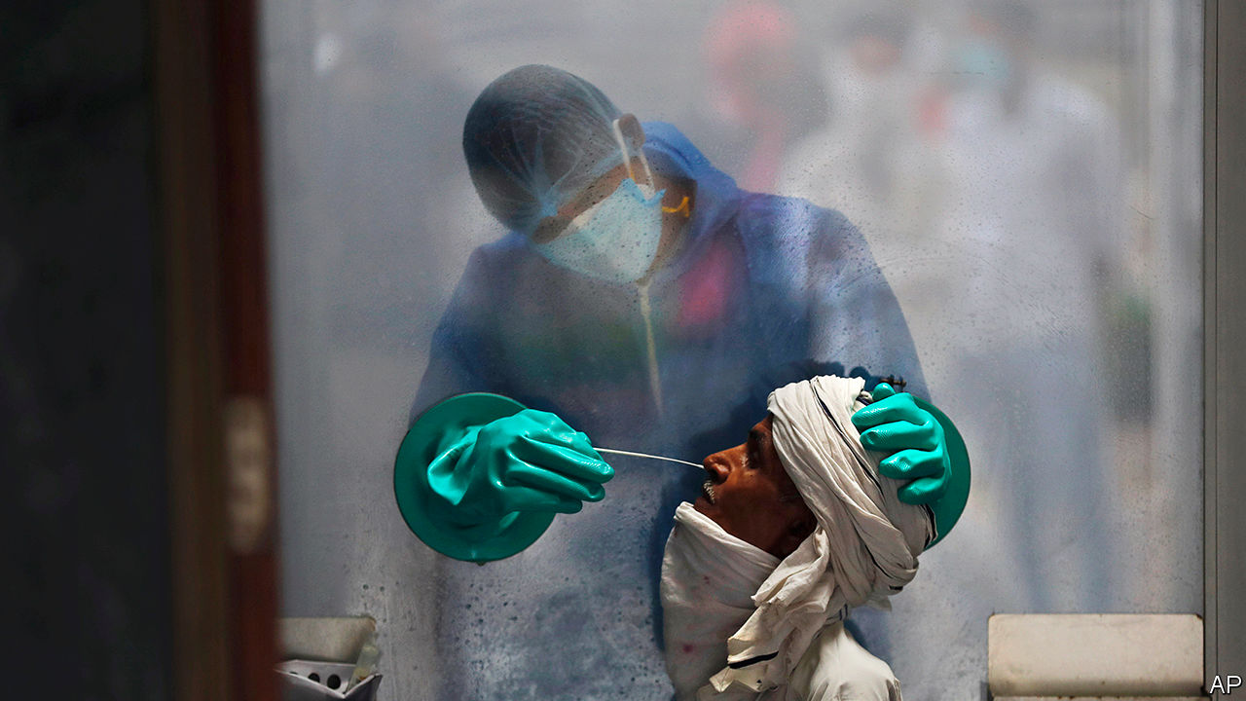

Editor’s note: Some of our covid-19 coverage is free for readers of The Economist Today, our daily [newsletter](https://my.economist.com/user#newsletter). For more stories and our pandemic tracker, see our [hub](https://www.economist.com/news/2020/03/11/the-economists-coverage-of-the-coronavirus)

SANDEEP IS ANXIOUS. A few days ago the owner of the clinic where his wife works as a receptionist came down with covid-19. Authorities sealed the building and whisked her off to quarantine, then sent him to a different isolation centre. Stuck now in a hostel, he worries that even if he tests negative, the families whose clothes he irons for a living will be afraid to let him back. They won’t appreciate that he covered for them, lying when asked if he had been visiting houses lately. “I didn’t want to inconvenience customers who might get forced to be tested,” he explains. With the clinic also holding up his wife’s salary, the couple will have to borrow to stay afloat.

Sangli, the big country town where Sandeep (not his real name) lives, is 300km (190 miles) south-east of Mumbai. Until recently the pandemic had spared such places. Now, even as the curve has flattened or fallen in Delhi and Mumbai, it is arching sharply upwards in satellite towns, and penetrating ever further into the interior. It is this surge that is pushing India inexorably upwards in the league of covid cases and which, given its population of 1.3bn, will probably see it rise to the top. The wave is moving beyond those parts of the country that are best equipped to manage it, to places that may prove far more vulnerable.

With nearly 800,000 confirmed cases so far, India ranks third after America and Brazil in infections. The tally of covid deaths, over 21,000, is relatively modest. It works out at fewer than 15 per million, a quarter of the world average and a fraction of the 651 per million in Britain. But, for reasons ranging from the relatively low level of testing to spotty medical record-keeping to political interference, many experts believe India is undercounting deaths by a third or more. With cases rising by some 25,000 a day (see chart), fatalities are anyway bound to soar.

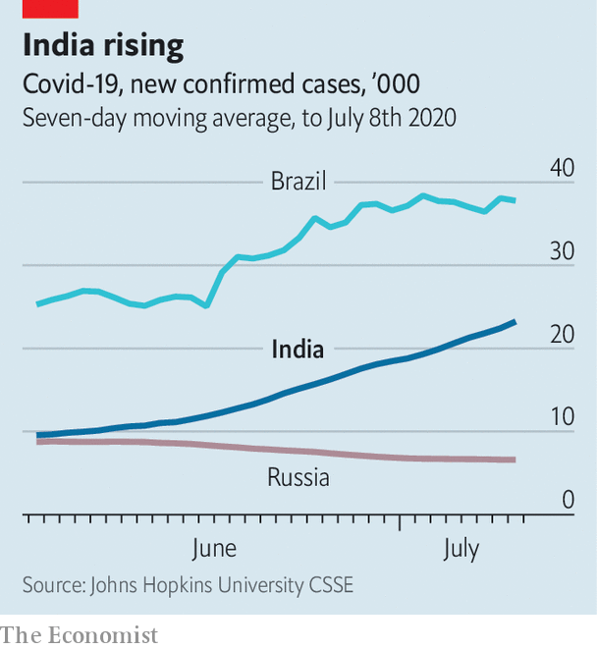

Unlike Brazil and America, India responded quickly and forcefully to the pandemic. Perhaps too quickly: two months of nationwide lockdown shattered the economy, but only slowed the disease. “You flattened the wrong curve,” is how Rajiv Bajaj, a prominent businessman, puts it. One deadly error was to freeze all travel with no warning, trapping millions of migrant workers where they were no longer wanted, in big cities with the highest rates of infection, and then later to let them go, carrying the infection with them. Local edicts have caused similar spikes: the state government in Tamil Nadu has declared several sudden lockdowns, prompting crowding in markets that have proved dangerous vectors for covid.

At Sulerikadu, south of the state capital Chennai, fishermen complain that when lockdown was lifted after eight weeks, a seasonal ban on fishing kept the fleet grounded. This was followed by a closure of the market, so that when they could at last catch fish they had no place to sell it. Nearby farmers voice similar despair. A transport ban at harvest time kept many from selling their crops. Individuals are not the only ones hurt. In the last two weeks of June, with shops everywhere mostly open for the first time since March, nationwide sales remained a dismal 67% lower than in the same period last year, says the Retail Association of India.

Yet even as tales of economic woe multiply, and are compounded by the spreading tragedy of covid itself, lessons are being learned. Some Indian states, such as Kerala in the far south and Punjab in the north, have ably contained the disease. Dharavi, a sprawling slum in Mumbai whose density and poor sanitation seemed likely to create conditions for covid to spin out of control, has instead proved a model of how thoughtful, local interventions in co-operation with residents can stem its spread. From hundreds a day in May, new daily infections among the slum’s 850,000 people are down to a handful.

In India’s big cities, fears that hospitals would be overwhelmed have for the most part failed to materialise, largely because medical protocols have been revised to keep all but those who are very ill from occupying beds. Hospitals, for example, can now send covid patients home as soon as they feel better, rather than having to wait for test results to prove they are free of the virus. One district of Delhi requisitioned more than 900 hotel rooms for use as isolation wards. In the end it has used just 25. The change in rules has also meant a welcome drop in what had become a nationwide rash of stories about patients being turned away from one hospital after another, for want of beds.

Another fear, that India would run out of ventilators, turned out to be still more misplaced. Even as doctors were finding that few patients benefited from forced ventilation, Indian manufacturers boosted production from 300 a month to some 30,000. Indian industry has proved so responsive to the crisis that it is now lobbying the government to drop restrictions on exports of medical equipment and protective gear. Makers of covid tests complain that their production was far outstripping the number of tests conducted, owing to cautious government guidance. At the centre’s behest, local authorities in Mumbai changed the rules no fewer than nine times. Often, even medical staff could not get tested—one reason why India has lost more than 100 doctors to the disease.

With the price of tests dropping and restrictions on their use lifted, the country should soon be conducting more than the current 200,000 a day. Mylab, a company based in the city of Pune, says it alone has the capacity to process 2m samples a week. This could be a big help, since testing allows a better understanding of the disease’s trajectory. Researchers at MIT recently suggested that India could have as many as 287,000 new infections a day by January, based on the old level of testing. That picture should now improve. Yet Sandeep, for one, is not reassured. Even in a relative backwater like Sangli, 28 neighbourhoods have been quarantined. “The number of cases is increasing a lot,” he says. “People should take it seriously. Only when it hits you do you know how bad it is.” ■

This article was downloaded by calibre from <https://www.economist.com/asia/2020/07/11/infections-in-india-are-soaring-but-increased-testing-will-help>

|  |  |  |  |
| --- | --- | --- | --- |
|  | Articles | Sections | Next |

|  |  |  |  |
| --- | --- | --- | --- |
| Previous | Articles | Sections | Next |

#### Seoul v everywhere else

# South Korea is rethinking its efforts to spread the wealth

Instead of trying to build spiffy new cities, it is buffing up old ones

Jul 11th 2020 | JINJU

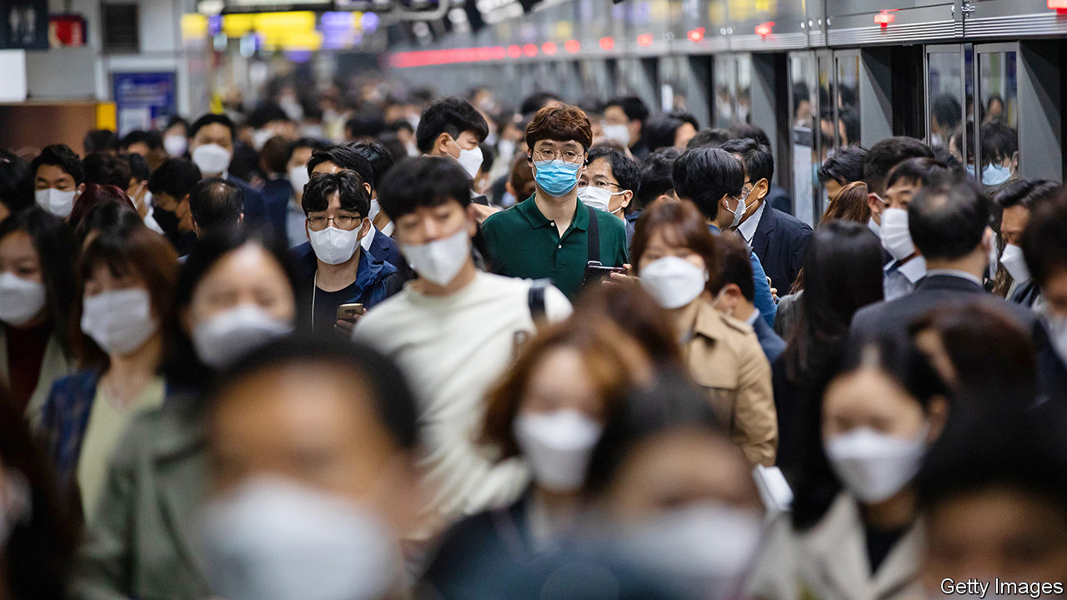

THE ROAD from Jinju’s high-speed train station towards the outskirts of town winds past row after row of brand-new high-rise apartment blocks decorated in dark grey and ochre. The buildings are surrounded by half-finished strip malls with mock-European brick facades. Construction is frantic, though large posters advertise steep discounts on flats in the finished complexes.

The buildings are the beginnings of Jinju’s “innovation city”, one of 12 such projects dotted around South Korea that are meant to reduce the concentration of politics, wealth and culture in the capital, Seoul. Jinju is supposed to become a hub for biotech and aerospace, creating tens of thousands of jobs in a region with comparatively little industrial heritage and thus encouraging internal migration.

Seoul, the neighbouring city of Incheon and the surrounding province of Gyeonggi are home to half of South Korea’s 52m people and produce half of its wealth. Vibrant and full of opportunity, the capital region is also congested, expensive and stressful to live in. The innovation cities, conceived in the mid-2000s and modelled on earlier plans for “balanced development”, are one of a long series of policies aiming to help less buoyant places advance.

The same impulse led to the creation of Sejong, the new administrative capital, 100km (60 miles) south of Seoul. A decade ago it was little more than a handful of building sites amid peach farms. Now wide streets and leafy paths surround ranks of apartment buildings, through which snakes an enormous glass-panelled government complex. More than half of South Korea’s ministries and dozens of government agencies have been relocated there since 2012. Around 300,000 people live in the area. Some are civil servants who have moved from Seoul, but most are locals whose former communities have been absorbed into the new city.

But for all the rapidity of its development, Sejong is a far cry from Seoul. Yoo Kyung-weon, a young official from the capital, moved to Sejong for her job but says a lot of her colleagues did not. “It’s cheaper than Seoul and I can cycle to work in a few minutes, which is nice,” she says. “But there’s nothing to do here, and every time I go out I worry about bumping into someone I work with.” She frequently spends her weekends back in Seoul.

Urban planners doubt that new cities will dent the capital’s supremacy. “Over the past 20 years, the economic disparity between Seoul and elsewhere has actually increased, despite all of these policies,” says Kang Myoung-gu of Seoul University. “People used to move to Seoul because they had to if they wanted to find work,” he says. “Now they come or stay because they want to. They like urban amenities, restaurants, green spaces, texture. You’re not going to convince anyone to move across the country if you can’t provide that.” He thinks the solution to Seoul’s problems is local. “We need to expand infrastructure and make public space better for everyone.”

Back in Jinju, a young mother who used to live in the older part of town says she enjoys life closer to schools and green spaces. Rather then enticing Seoulites, innovation cities seem to attract people from the surrounding areas. Villages and towns in poorer regions around innovation cities have higher-than-usual vacancy rates, which suggests the cities may simply be sapping economic vitality in their hinterland. As South Korea’s population declines, such trends will accelerate.

As a result, the government has begun to emphasise urban regeneration over building towns from scratch. Residents have a say in what they feel needs doing to improve their environment. In Jochiwon, a town half an hour from the government complex in Sejong, locals have planted a public garden around the old train station, installed a co-working space and convinced the city to pedestrianise some nearby streets.

Planners such as Mr Kang dismiss this approach as “planting flowers and painting walls”, but residents consider the place much improved from a few years ago. “The idea is to improve quality of life while preserving the fabric of a place,” says Lee Ji-hye of the Ministry of Land, which is now located in Sejong. ■

This article was downloaded by calibre from <https://www.economist.com/asia/2020/07/11/south-korea-is-rethinking-its-efforts-to-spread-the-wealth>

|  |  |  |  |
| --- | --- | --- | --- |
| Previous | Articles | Sections | Next |

|  |  |  |  |
| --- | --- | --- | --- |
| Previous | Articles | Sections | Next |

#### A whispered welcome

# Democracy activists fleeing Hong Kong present a dilemma for Taiwan

The government sympathises with their cause, but is wary of taking too many in

Jul 11th 2020 | TAIPEI

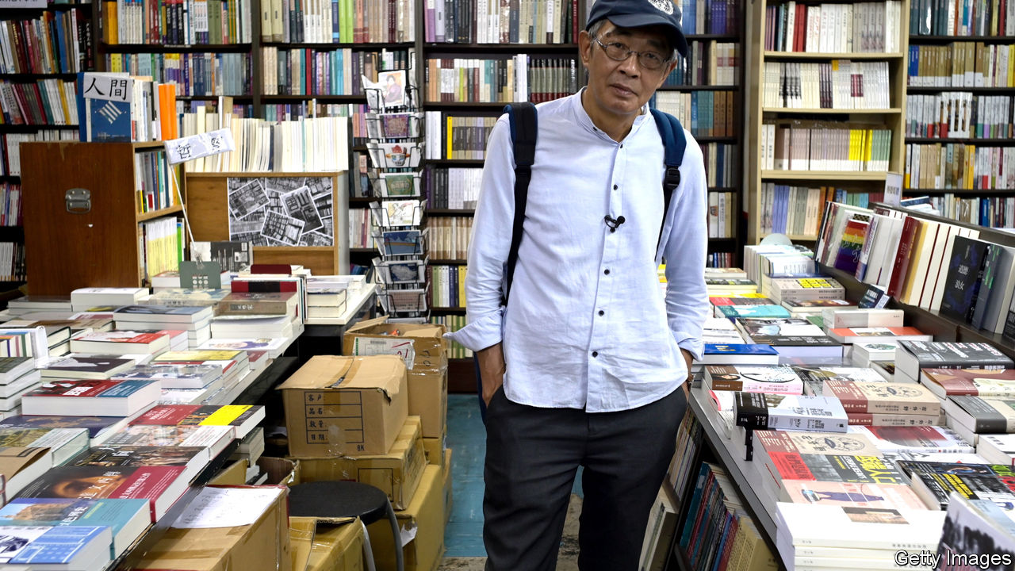

LAM WING-KEE runs a tiny bookshop on the tenth floor of an unremarkable building in Taiwan’s capital, Taipei. He is also the country’s most famous exile from Hong Kong. His shop is a replica of his former business in Hong Kong, Causeway Bay Books, which until 2015 sold material the Chinese government considered subversive. That year Mr Lam was kidnapped by Chinese agents and held without charge for eight months. He fled to Taiwan early last year, fearing that an extradition bill under consideration by Hong Kong’s legislature might see him sent back to the mainland—legally this time.

Now Mr Lam sleeps in a bed in the shop. Above a pile of books criticising the Chinese Communist Party hangs a banner calling for Hong Kong’s liberation from China. But when asked if Taiwan will be a haven for democracy activists from Hong Kong, he hums and haws. He himself wants to stay in a Chinese-speaking country, since he sells Chinese books. Others, he says, may prefer to flee to Western countries, farther from the long arm of the Chinese authorities. The Taiwanese government has treated him well, he adds. “They want to help Hong Kong but it is natural for them to be cautious,” he says.

Like most of her compatriots, Taiwan’s president, Tsai Ing-wen, is proud of her country’s democracy and sympathetic to Hong Kong’s activists. The day before China imposed a ferocious security law on Hong Kong last month, her government amended its covid-related border closure to make it easier for people from Hong Kong to enter. The day after the law took effect, it opened an office in the city to help locals visit or emigrate to Taiwan.

But Ms Tsai is indeed cautious: her government has not issued any sweeping offer of asylum. Instead, requests to resettle are considered case by case, and residency is often granted for mundane reasons, at least on paper. Mr Lam, for instance, is classified as an investor, since he set up a business in Taiwan.

Even this muted assistance has provoked outrage from the Chinese Communist Party. It considers Taiwan to be part of its territory and has threatened to take control by force, if necessary. Chinese officials rail about a “conspiracy between Hong Kong independence activists and Taiwan independence activists”.

Many Taiwanese, meanwhile, complain that the government’s help for activists from Hong Kong is half-hearted. Chen Yu-jie of Academia Sinica, a research institution, says the vague wording of immigration rules means asylum-seekers know neither whether they meet the criteria nor how long they will have to wait to find out. They also cannot appeal against a rejection. Should a government that is friendlier to China come to power, it could interpret the law much less generously. Yet the ruling Democratic People’s Party (DPP) has sidelined a proposal from a small opposition party to clarify and enhance the rights of asylum-seekers from Hong Kong.

Ms Tsai’s hesitation probably stems in part from a reluctance to provoke an already aggressive China. Taiwanese officials are also always worried about Chinese attempts at infiltration. Wang Ting-yu, a DPP MP, argues that it is helpful for the government to have some discretion to park asylum cases at moments of high tension with China. Were applications to be subject to appeal, moreover, the government might have to reveal details about the informal intelligence networks in Hong Kong and elsewhere that it uses to help determine applicants’ bona fides.

Huang Chun-sheng, pastor of a church that has orchestrated shipments of gas-masks and helmets to protesters in Hong Kong and has been helping those who wish to emigrate, approves of Ms Tsai’s discreet approach. “The government really has goodwill,” he insists. Instituting a formal system of asylum would draw unhelpful scrutiny, he says: better for an activist to come into Taiwan quietly, enroll in a university and switch to a student visa.

Whatever the rules, a growing number of people are moving from Hong Kong to Taiwan. Residency permits were handed to 2,383 of them in the first four months of the year—up by 150% compared with the same period last year. ■

This article was downloaded by calibre from <https://www.economist.com/asia/2020/07/11/democracy-activists-fleeing-hong-kong-present-a-dilemma-for-taiwan>

|  |  |  |  |
| --- | --- | --- | --- |
| Previous | Articles | Sections | Next |

|  |  |  |  |
| --- | --- | --- | --- |
| Previous | Articles | Sections | Next |

#### Lock, unlock, repeat

# Australia’s second city faces a new wave of contagion

This time, a targeted lockdown will be even tighter than before

Jul 11th 2020 | SYDNEY

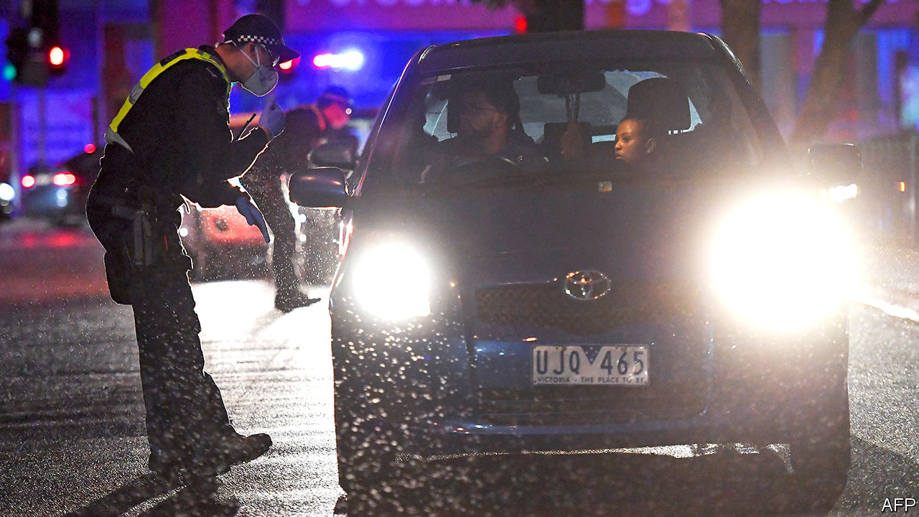

IT WOULD BE “the very worst thing” to have to impose a second lockdown, warned Daniel Andrews, the premier of Victoria, when he started easing the state’s restrictions in May. On July 8th he was forced to do just that to 5m residents of Melbourne, the state’s capital, plus a district to its north, where a second wave of covid-19 has been rolling in. Active cases almost tripled in the first nine days of the month, to more than 930. Contact-tracers are overwhelmed, Mr Andrews conceded, as he shut restaurants and bars for another six weeks. “To do anything else”, he sighed, “would have deadly consequences.”

The new wave threatens to undo Australia’s good work containing the virus. Locally acquired cases were virtually stamped out a month ago, largely because of stay-at-home rules and the quarantining in bleak hotels of the few people still allowed into the country. Victoria’s problems started with breaches of the mandatory two-week isolation for those arriving from abroad.

Blame has been levelled at poorly trained private security guards who were supposed to keep travellers in their rooms. They had not been using protective gear properly and have been accused of breaching social-distancing rules by sharing cigarettes and car-pooling to work. Local papers report that some had sex with the people they were supposed to be keeping in strict isolation. Several of the guards contracted the virus and passed it on to friends and family just as Victoria’s first lockdown, the toughest in Australia, was being lifted.

“This is what happens when you think you’ve got it under control,” says Peter Collignon, an expert on infectious diseases at the Australian National University: “apathy and complacency”. The seal would never have been broken if the army or police had overseen the private guards, as they do in New South Wales, argues Michael O’Brien, the leader of the opposition in the state. Businesses are dismayed. Victoria accounts for a quarter of Australia’s GDP. The new restrictions will do “untold damage to the economy and employment”, complains a business lobby group.

The state government has launched an investigation into what went wrong in its quarantine hotels. A testing blitz is now under way. Nationwide, infections are well below their peak in March, but in some ways this spike looks more threatening. Most of Australia’s early cases came from travellers who were intercepted on arrival from abroad. This time the virus has moved through the community, making carriers harder to identify. Whereas the first patients were mostly wealthy, returning from holidays in places such as Italy, poor multi-ethnic suburbs in Melbourne’s north and west are the worst-affected now.

Many of the residents of these areas suffer from the kind of ill health that makes them especially vulnerable to coronavirus. Nine public-housing towers in the suburb of Flemington were put on what authorities call a “hard lockdown” on July 4th, meaning that tenants were banned from so much as setting foot outside their flats until they had all been tested. With crowded lifts and airless lobbies, the government feared the buildings had become “vertical cruise ships” for contagion. On July 9th the government lifted the police cordon around eight of the buildings after detecting 158 cases—although residents are still subject to the city’s new lockdown.

Allowing life to return to normal in other parts of the country would be folly, warns the national medical association. The whole of Australia should “rethink the pace of easing”, it advises. Other jurisdictions seem to agree. The Australian Capital Territory paused plans to unwind its restrictions after it uncovered a handful of cases linked to the outbreak in Melbourne. Several more infections have trickled across the border from Victoria into New South Wales. It has now been shut for the first time since the flu pandemic of 1918-19. Soldiers and police have been called in to enforce the closure. They will use drones to hunt for scofflaws trying to sneak across via bush tracks or along rivers. All this is especially galling given Victoria’s long-standing rivalry with New South Wales. No need to patrol the border, sniffs an MP from Victoria, the coffee in Melbourne is far better than anything on the other side. ■

Editor’s note: Some of our covid-19 coverage is free for readers of The Economist Today, our daily [newsletter](https://my.economist.com/user#newsletter). For more stories and our pandemic tracker, see our [hub](https://www.economist.com/news/2020/03/11/the-economists-coverage-of-the-coronavirus)

This article was downloaded by calibre from <https://www.economist.com/asia/2020/07/11/australias-second-city-faces-a-new-wave-of-contagion>

|  |  |  |  |
| --- | --- | --- | --- |
| Previous | Articles | Sections | Next |

|  |  |  |  |
| --- | --- | --- | --- |
| Previous | Articles | Sections | Next |

#### Four months and counting

# The Philippines’ fierce lockdown drags on, despite uncertain benefits

Enforcement has been vigorous but patchy

Jul 11th 2020 |

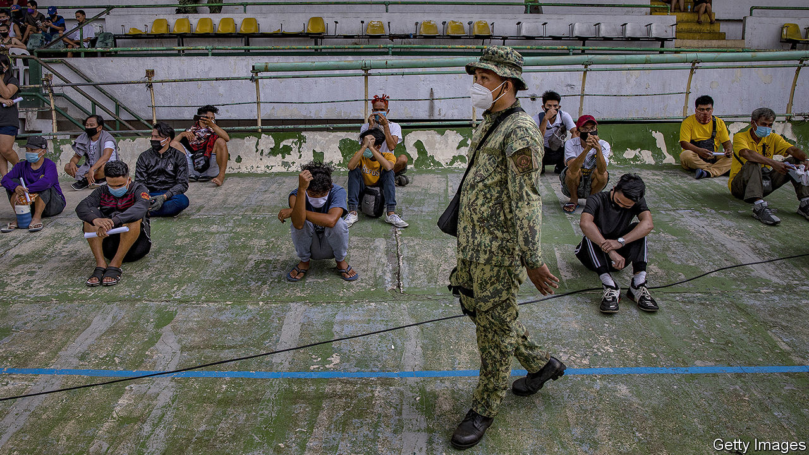

“I’M CONSTANTLY AFRAID that we will get infected,” frets Diverson Bloso, “We don’t have money to bring us to the hospital, in case that happened.” A messenger at a printing press in Quezon City, part of Manila’s sprawl, he prays he keeps his job. His boss told workers that the business might have to close because of quarantine measures to stop the spread of covid-19. But at least Mr Bloso still has regular income. A woman who lost her job at an online casino says the restrictions have prevented her from attending interviews for new jobs. With her husband in jail, she worries about how she will pay the bills for her and her child. “It’s been terrible for me and my family,” she says.

The Philippines’ lockdown, among the fiercest and longest-lasting in the world, has been terrible for millions of others too. On March 16th the government imposed “Enhanced Community Quarantine” (ECQ) across the island of Luzon, home to Manila and about half the country’s 107m people. Schools and offices closed and public transport shut down. People were only supposed to leave home to buy food and other essentials. In many areas, even then, they were required to obtain a special pass from a local official to be able to move around. Other parts of the country adopted similar rules. Some provinces sealed their borders. Manila’s residents were supposed to be free again by April 13th. Instead, the lockdown has been repeatedly extended. It was relaxed slightly on June 1st to make it easier to work, but will remain in place at least until July 15th.

Enforcement has been ferocious. Some 130,000 people, including those pictured, have been arrested or fined, often for small infractions such as failing to wear a mask. Were the army and police to encounter any violent lockdown violators, instructed Rodrigo Duterte, the president, with characteristic compassion, they should “shoot them dead”. But the rules have also been applied unevenly: Manila’s police chief hosted himself a boozy birthday party in May despite the ECQ’s stipulations and a ban on liquor sales.

In the meantime, more than 50,000 Filipinos have tested positive for covid-19. The University of the Philippines reckons there might have been 3.6m cases without the lockdown, a figure the government likes to trumpet. The number of deaths each day has dropped sharply since late March, and the ECQ bought the government time to ramp up laboratory capacity and to ready beds for patients. But the number of cases detected each day has been rising fast, despite a relative dearth of testing.

The Department of Health’s response to the virus has been plagued by “irregularities and anomalies” that have attracted the attention of the government ombudsman. An investigation is under way into confused reporting of infections and delays in purchasing protective equipment for health-care workers, among other matters.

This bureaucratic fiasco and the uncertainty over case numbers may help to explain why the lockdowns have lasted so long. They have been lifted in some cities outside Luzon, only to be reimposed when cases began rising wildly. Ronald Mendoza of Ateneo de Manila University argues for more targeted quarantines. Metaphorically speaking the government has been using an axe, he reckons, when it really needs only a scalpel.

Relaxing restrictions should soothe the country’s pummelled economy: the World Bank forecasts that it will shrink by almost 2% this year. The coronavirus has brought to an end 84 quarters of uninterrupted growth in the Philippines. The quarantine on Luzon alone may displace 11m workers from their jobs, reckons IBON, a research firm in Manila. And the lifelines that helped Filipinos stay afloat during the global financial crisis are fraying, too: remittances from Filipinos working abroad, as domestic helpers, nurses and the like, look set to fall by a fifth this year.

According to surveys carried out in May via mobile phone by Social Weather Stations (SWS), a pollster, 83% of working-age Filipinos say their quality of life has declined versus a year ago. That is the worst result in the 37 years that SWS has been conducting surveys. The government’s efforts to help have been as patchy as the lockdowns. It has distributed 200bn pesos ($4bn) to 18m poor families. But delays have beset other schemes, including one offering wage subsidies for employees at small and medium-sized businesses.

Mr Duterte’s priority appears to be boosting his own authority. A temporary law, approved by Congress in March but allowed to expire in June, gave him special powers to deal with the pandemic. On July 3rd he signed into law a sweeping anti-terrorism bill which, among other things, allows suspects to be detained without a judge’s approval for up to 14 days. How this will help the Philippines through its current trauma is anyone’s guess. ■

Editor’s note: Some of our covid-19 coverage is free for readers of The Economist Today, our daily [newsletter](https://my.economist.com/user#newsletter). For more stories and our pandemic tracker, see our [hub](https://www.economist.com/news/2020/03/11/the-economists-coverage-of-the-coronavirus)

This article was downloaded by calibre from <https://www.economist.com/asia/2020/07/11/the-philippines-fierce-lockdown-drags-on-despite-uncertain-benefits>

|  |  |  |  |
| --- | --- | --- | --- |
| Previous | Articles | Sections | Next |

|  |  |  |  |
| --- | --- | --- | --- |
| Previous | Articles | Sections | Next |

#### Banyan

# Why has the pandemic spared the Buddhist parts of South-East Asia?

Cambodia, Laos, Myanmar, Thailand and Vietnam have had only tiny outbreaks

Jul 11th 2020 |



Editor’s note: Some of our covid-19 coverage is free for readers of The Economist Today, our daily [newsletter](https://my.economist.com/user#newsletter). For more stories and our pandemic tracker, see our [hub](https://www.economist.com/news/2020/03/11/the-economists-coverage-of-the-coronavirus)

ONE OF THE bigger riddles of the global pandemic lies in South-East Asia. Despite being close to the source of covid-19, in China, and to one of the current hotspots of the outbreak, India, the partly or largely Buddhist countries of Cambodia, Laos, Myanmar, Thailand and Vietnam have scarcely sneezed.

Vietnam is the standout: with 97m people, it claims no deaths from covid-19. Thailand, with 70m, has seen just 58 fatalities and no local transmission in over 40 days. Impoverished Myanmar claims just six deaths from 317 cases, while Cambodia (141 confirmed cases) and tiny Laos (19 cases) also have no deaths apiece and no local transmission since April. Compare that with the nearby archipelagic nations of Indonesia (some 68,100 cases and 3,400 deaths) and the Philippines (50,400 cases and 1,300 deaths), where the pandemic still rages.

Set aside karmic grace as an explanation, especially given that Vietnam’s communist dictatorship is atheist. Vietnam’s success, indeed, is easiest to explain. The country has a suspicion of its big northern neighbour, China, rooted in millennia of historical interaction. At the start of the year it instinctively distrusted China’s reassurances about the disease and even launched cyber-attacks to get better information on the epidemic’s course. It closed its border and used authoritarian powers to lock down the population and trace and isolate cases. That, in essence, is what China’s communist authorities were also doing.

Few governments have both the overweening power and effective health systems needed to emulate China and Vietnam, but Thailand, a sham democracy overseen by generals, perhaps comes closest. The quality of its health care makes Thailand a popular destination for medical tourism. Moreover, the government was quick to set up a vigorous covid-fighting task-force.

Thailand’s success comes despite close ties with China. Plenty of people-to-people exchanges might have been expected to spread infection. But that has not happened in Laos, which is too small to resist China’s blandishments, Myanmar, which is awash with Chinese traders and smugglers, or Cambodia, whose strongman, Hun Sen, is the region’s biggest cheerleader for China. Chinese construction is reshaping these countries, which all came under pressure not to close borders with China even as the pandemic spread. Mr Hun Sen pointedly travelled to Beijing in February, at the height of the Chinese epidemic. Thailand was welcoming Chinese visitors well into March. Myanmar’s border with China is extremely porous. Why did visitors from China not seed more South-East Asian outbreaks?

One widespread suspicion is that they did, but these were not reported. Testing is severely limited in Cambodia, Laos and Myanmar. Yet, says Frank Smithuis of Medical Action Myanmar, a charity with several clinics around the country, if there had been large-scale transmission, his organisation would have noticed. It is not possible, he says, to hide a covid-19 outbreak—especially in Myanmar, the world’s “gossip country number one”. Experts in Cambodia, Thailand and Vietnam see no evidence of widespread transmission, such as people showing up at hospitals.

Even the poorest countries adopted measures that must have helped check the spread of the coronavirus. Thitinan Pongsudhirak of Chulalongkorn University in Bangkok reports that migrant workers returning from Thailand to their villages in Myanmar often had to quarantine for 14 days in a shack outside their village. Other factors that may have helped, say health experts, include high numbers of people living in the countryside rather than in crowded cities; people more likely to live with fans and open windows than air-conditioning; the relative youth of the region; and a pre-existing proclivity for masks. There may be a religious element, too. The wai, a Buddhist greeting of palms pressed together, helps with social distancing.

The question now is whether South-East Asia’s Buddhist successes can weather second or third waves. Perhaps, Mr Thitinan suggests, low transmission from China was not the miracle some divine—the giant neighbour, after all, quickly got on top of its epidemic. Now, transmission routes are changing. Across Asia, infections are being imported from all round the world, seeding local transmission, most recently in Hong Kong. The crowds this week in South-East Asian temples celebrating the start of Buddhist lent are a reminder of how easy it is to let covid guards fall.

This article was downloaded by calibre from <https://www.economist.com/asia/2020/07/11/why-has-the-pandemic-spared-the-buddhist-parts-of-south-east-asia>

|  |  |  |  |
| --- | --- | --- | --- |
| Previous | Articles | Sections | Next |

|  |  |  |
| --- | --- | --- |
| Asia | Sections | Middle East & Africa |

China

Civil society: Who you gonna call?

.

Human rights: The party’s grip

.

Chaguan: American soft power, trashed

.

|  |  |  |
| --- | --- | --- |
| Asia | Sections | Middle East & Africa |

|  |  |  |  |
| --- | --- | --- | --- |
|  | Articles | Sections | Next |

#### Directed by the party

# NGOs in China have helped the government provide covid-related relief

That will not earn them more freedom

Jul 11th 2020 |

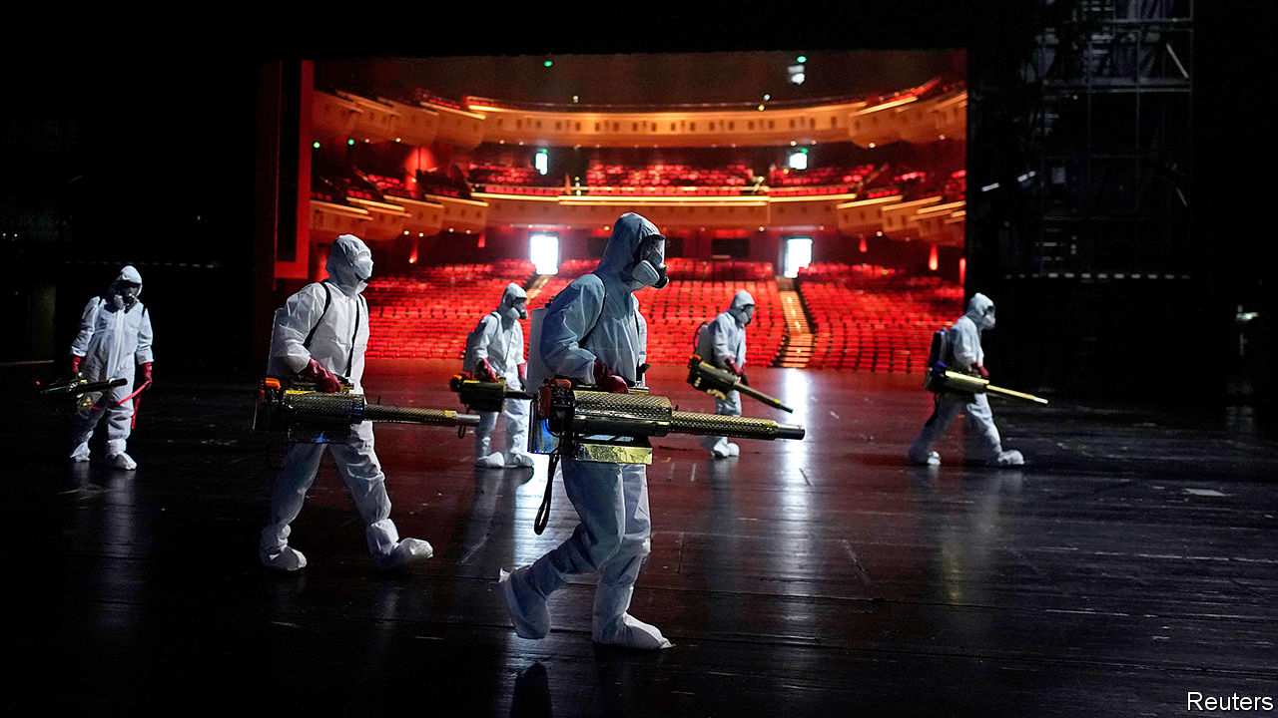

Editor’s note: Some of our covid-19 coverage is free for readers of The Economist Today, our daily [newsletter](https://my.economist.com/user#newsletter). For more stories and our pandemic tracker, see our [hub](https://www.economist.com/news/2020/03/11/the-economists-coverage-of-the-coronavirus)

THE CHINESE COMMUNIST PARTY winces at the term “non-governmental organisation”: to officials, it smacks of dissent. Search for news about NGOs and their response to covid-19 on Baidu, China’s equivalent of Google, and almost all results relate to other countries. But try the preferred term, “social organisations”, and the results may seem surprising, given the party’s relentless efforts to box in civil society. While endlessly extolling the party’s response to the pandemic, state media also give credit to groups that are not under the government’s direct control. This is not evidence of a softer approach towards NGOs. It is a sign that the party believes it has succeeded in keeping them tame.

Chinese NGOS were quick to respond after officials acknowledged the scale of the outbreak in late January. Some were newly formed groups of good Samaritans, who organised themselves through social media. Members drove their own cars day and night to bring relief supplies to residents of the central city of Wuhan, the first coronavirus hotspot. Others were well-established NGOs, like the Beijing-based Blue Sky Rescue Team. It sent hundreds of volunteers to Wuhan to help deliver emergency medical supplies and disinfect public places (see picture).

For a country that prefers to keep its NGOs small, Blue Sky’s size is remarkable. Founded in 2007, it is described by state media as the country’s biggest non-governmental humanitarian group, with some 30,000 registered volunteers reporting to 31 branches nationwide. Its leader, Zhang Yong, is a former member of China’s paramilitary police force. The government’s trust is evident in the publicity the group receives, including for its work abroad (Blue Sky helped with relief efforts after an earthquake in Nepal in 2015). The group can provide an “excellent supplement” to the government’s relief efforts, Mr Zhang told China Daily, a newspaper.

During the pandemic, other large NGOs have helped, too. One is the Han Hong Love Charity Foundation, named after a famous singer who founded it in 2012. It raised millions of dollars to buy masks, sanitising gear and other supplies, which it then distributed. The Ginkgo Fellows in Covid-19 Relief Action is another. Set up by an existing network of philanthropists, its volunteers have helped patients connect with medical services, provided transport and delivered medical kit to hospitals. They have also offered counselling.

Even the party’s main mouthpiece, the People’s Daily, has praised the “strong support” NGOs have provided. But the lines are clear: any activity, whether organised or not, that appears to challenge the party is off limits. On July 6th police reportedly seized Xu Zhangrun, a law professor in Beijing who has long been an outspoken critic of the government. In February he and several other academics signed an open letter calling for a “national freedom-of-speech day” to be declared in commemoration of a doctor who died of covid-19 after being reprimanded by police for drawing public attention to early cases.

Since Xi Jinping became China’s leader in 2012, the party has stepped up its scrutiny of NGOs, mindful of the role they have played this century in “colour revolutions” against authoritarian regimes. In 2013 the party issued a secret directive, known as “Document Number Nine”. It said civil-society activism was becoming “a serious form of political opposition” in China. In 2016 a new law was passed, barring Chinese NGOs from receiving funds from abroad and requiring foreign ones to find an official sponsor and register with the police.

The party accepts that it sometimes needs help from civic groups. China’s first charity law, also adopted in 2016, made it easier for domestic NGOs to register and to raise funds at home. Between 2013 and 2019, the number of registered social organisations rose from 385,000 to 844,000. But the party has been stepping up efforts to ensure their obedience. This has involved the same tactic that it has used among private firms: setting up party cells within them, or if NGOs do not have enough party members, making sure that any they do have report to an outside party branch.

Blue Sky Rescue has several party cells embedded within it. In February the People’s Daily website, in an article praising the NGO’s response to covid-19, described the organisation as “both blue and red”. Some of the groups that have sprung up during the pandemic are not so well-enmeshed with the party. Guobin Yang of the University of Pennsylvania says early blunders by Wuhan officials, including failings in the distribution of medical supplies, “forced citizens to self-organise and take things into their own hands”. But, desperate for help, officials welcomed them.

This marked a step forward from 2008, when the government was startled by the scale and rapidity of the non-party response to an earthquake in Sichuan province that killed about 70,000 people. “Their thinking then was, ‘Who are you and why are you doing this?’” says Zhang Xuemei of the Sichuan Academy of Social Sciences. “But now they understand what kind of role NGOs and volunteers can play.”

Even in need, officials are twitchy. After the outbreak in Wuhan, the authorities there issued orders—later ignored—that donations be disbursed only by a handful of official organisations. According to Holly Snape of the University of Glasgow, their edicts initially caused “critical bottlenecks”. The government may learn lessons, but it will keep NGOs on a tight rein. Officials nationwide are striving for “complete coverage” of local NGOs by the party, meaning all should have links with it. Hebei, the province surrounding Beijing, says it plans to achieve this by year-end. The pandemic is unlikely to get in the way. ■

This article was downloaded by calibre from <https://www.economist.com/china/2020/07/11/ngos-in-china-have-helped-the-government-provide-covid-related-relief>

|  |  |  |  |
| --- | --- | --- | --- |
|  | Articles | Sections | Next |

|  |  |  |  |
| --- | --- | --- | --- |
| Previous | Articles | Sections | Next |

#### The party’s grip

# Under a new national-security law, Hong Kong is already a changed city

Residents have long feared that it might turn into just another Chinese city. That is happening, fast

Jul 11th 2020 | HONG KONG

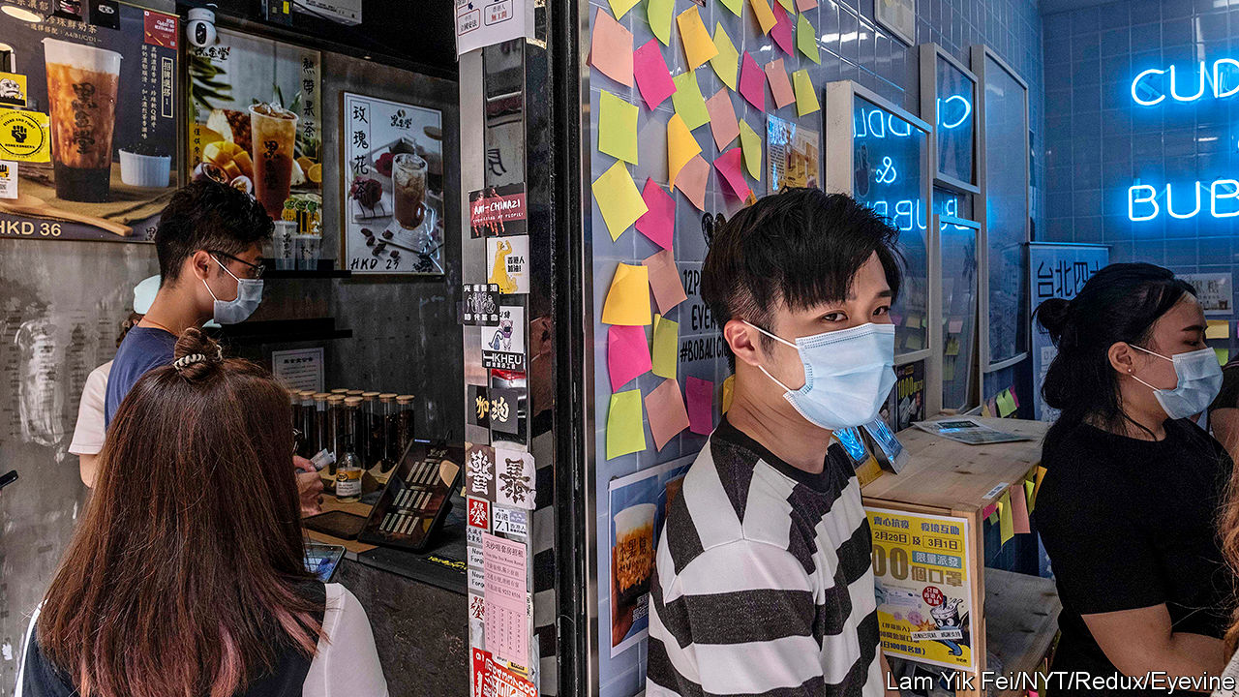

HONG KONGERS had long worried that the Communist Party would transform the territory by stealth into just another Chinese city. In the past few days, armed with a new national-security law which it imposed on Hong Kong on June 30th, it has been doing so brazenly. From the appointment of a party commissar to work with the chief executive, to the pulling of politically sensitive books from library shelves, Hong Kong is changing fast. The stockmarket has leapt, but many hearts have sunk.

On July 8th the central government opened a new outpost in Hong Kong called the Office for Safeguarding National Security. It occupies a luxury hotel, pending a move to permanent quarters. The director is Zheng Yanxiong, a hardline official from the neighbouring province of Guangdong (in 2011 he helped to suppress an outbreak of pro-democracy unrest in Wukan village that had grabbed global headlines). His two deputies are from the mainland’s Ministry of Public Security and secret police. In “complex” or “serious” cases, the office will enjoy sweeping powers to investigate and detain people for crimes covered by the new law: subversion, sedition, secession and collusion with foreign countries.

From his headquarters a few kilometres to the west, the mainland’s most senior official in Hong Kong, Luo Huining, has been wielding power more overtly than before. He is now an “adviser” on a newly established body chaired by the chief executive, Carrie Lam, known as the Committee for Safeguarding National Security. This brings Mr Luo—hitherto a shadowy figure—into the heart of local policymaking.

The committee has already granted extensive new powers to Hong Kong’s police, including the right in some situations to conduct searches without warrants and to freeze the assets of people suspected of national-security crimes. The police can now demand that any message posted on the internet that is deemed a threat to national security be removed and that its author be banned from the host platform. Tech firms such as Facebook, Google, Microsoft and Twitter have said that they will not co-operate (see [article](https://www.economist.com/node/21789109)). TikTok, a Chinese-owned video-sharing service, has announced that, “in light of recent events”, it will stop providing its app in Hong Kong.

Mrs Lam has begun picking judges to try national-security cases. The first one involving the new law relates to Tong Ying-kit, who is accused of separatism and terrorism for allegedly riding a motorcycle on July 1st towards a group of policemen while flying a flag reading “Liberate Hong Kong, revolution of our times”. This has been a popular slogan during recent anti-government unrest in the territory. The government now says it “connotes” secession.

Censorship is spreading. Public libraries have removed books by politicians who have called for greater autonomy for Hong Kong. Schools have been “recommended” to do the same. The education bureau has ordered pupils not to sing the protest anthem “Glory to Hong Kong” or otherwise “express their political stance”. Mrs Lam has told foreign journalists that their freedom to report is conditional on a “100% guarantee” that they abide by the new law. Among the hundreds of people who have taken to the streets to demonstrate against it, some have used the first line of the national anthem, “Arise ye who refuse to be slaves”, as a protest slogan. Cafés have been replacing pro-democracy Post-it notes with blank ones (see picture).

Mrs Lam insists that, as such laws go, Hong Kong’s is “relatively mild”. She says she has seen no sign of “widespread fears”. The stockmarket’s rally, she says, shows an “increasing appreciation of the positive effect” of the new law. If it means fewer people clogging streets and paralysing transport with protests, as often happened last year, then some companies may be happy. But many firms are deeply anxious. ■

This article was downloaded by calibre from <https://www.economist.com/china/2020/07/11/under-a-new-national-security-law-hong-kong-is-already-a-changed-city>

|  |  |  |  |
| --- | --- | --- | --- |
| Previous | Articles | Sections | Next |

|  |  |  |  |
| --- | --- | --- | --- |
| Previous | Articles | Sections | Next |

#### Chaguan

# A Sino-American bond, forged by Chinese students, is in peril

Plummeting Chinese demand for a US education will undermine American soft power

Jul 11th 2020 |

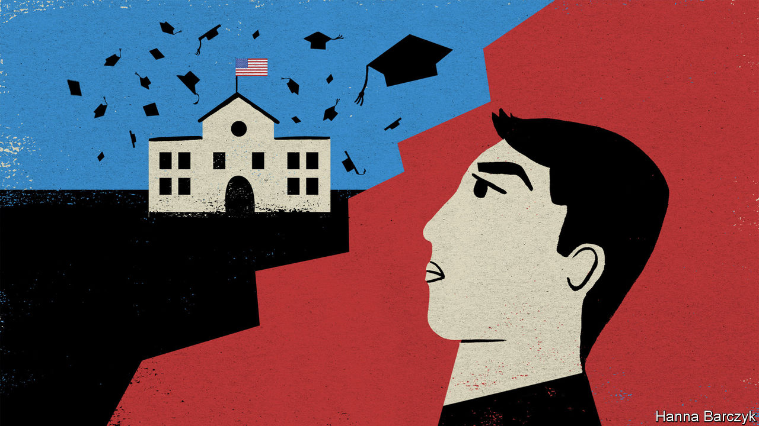

THE FIRST Chinese graduate from an American university, Yung Wing, deemed his college years the great adventure of his life. Alas, his graduation from Yale in 1854, sponsored by missionaries who spotted his talents as a boy in rural Guangdong, was a high point. Soon political mistrust and prejudice, both in America and China, filled his life with setbacks. These included the ending of his scheme that involved bringing 30 Chinese youths to America each year. Back in Beijing, imperial mandarins saw value in the science that the youngsters studied in New England. These officials were especially eager to take up a promise that the military academies of West Point and Annapolis would admit Chinese cadets. Then, in a mark of disdain for the ailing Qing empire, America broke that promise. Mandarins were further appalled by the irreverent, sports-loving, churchgoing Yankee ways picked up by Yung’s charges. In 1881 they summoned the boys home in disgrace. Yung lost his American citizenship to a xenophobic law passed a year later, the Chinese Exclusion Act.

Yung would recognise the pressures his Chinese heirs face today. In the coming weeks many will have to decide how and whether to pursue studies in America. They are living through a moment when campuses, borders and minds on both sides of the Pacific are being closed by mutual suspicion (including overly sweeping American fears about on-campus espionage) and a pandemic.

There are currently 370,000 Chinese students and fresh graduates in America without an easy route home, after China slashed international flights as a covid precaution. Many who plan to stay face months of online study while campuses remain shut. On July 6th American immigration officials caused panic (and a lawsuit from Harvard University, among others) by declaring that unless foreign students in America attend some in-person classes next term they risk deportation. Another 50,000 Chinese would normally take up new places at American universities this autumn, but visa offices at America’s missions in China are closed, with no word on when they will open. Parents will soon receive tuition bills for the next semester, often for tens of thousands of dollars, even if their child can only watch virtual lectures at home in China.

This is a crisis with large effects, unevenly distributed. Some American schools are offering classes on Chinese satellite campuses, such as New York University Shanghai. Cornell has announced a “Study Away” scheme, allowing students in China to take a mix of American and local classes at prestigious universities in Beijing and other cities. Many wealthy, well-connected Chinese with places at top colleges are not ready to give up their American dreams. Talk to such students and their families, and what they are really describing is a larger plan to become world citizens, of which a degree is one part. Elite Chinese call America a place to learn critical thinking, build social networks, and secure credentials that will help land them jobs and perhaps green cards.

Elle, 18, attends the international section of a top-ranked high school in Beijing, where fees run to 160,000 yuan ($22,800) a year. She has an offer from New York University and wants to accept it. Rival countries do not appeal. Australia is for “those with bad exam results,” she says over coffee in a smart Beijing suburb. In Canada, she adds: “There are so many Chinese students that you don’t even have a chance to speak English.” As for Britain, she attended summer school there, but sensed coldness towards foreigners. “I like America more than the UK, I think I am accepted there.”

Elle’s older brother is studying in New York and wanted to stay, even after rioters smashed windows in his building. “It’s one thing after the other,” sighs Elle’s mother. She remembers holidays in America when the country seemed great “in every way”. But officials there have “failed quite badly on fighting covid”, she laments. She is shocked by ordinary Americans refusing to wear masks. Still, she thinks America offers chances that a Chinese education cannot, starting with the different, thought-provoking ideas that her children may encounter. “It’s more of a globalised experience.”

Families are hedging bets. Half of this year’s 150 clients of Elite Scholars of China, an education counselling service focused on the Ivy League and its ilk, also applied to non-American universities. In the end, though, only four took up places outside America, says Tomer Rothschild, the firm’s co-founder.

Another perspective comes from a larger group: middle-class students from provincial cities, heading to mid-ranked American colleges. To generalise, this group is less likely to enthuse about Western freedoms, from raucous debates to an uncensored internet. Their focus is on which degree will boost their earning power when they return to China to compete with local graduates.

## Yes, Chinese teens know Donald Trump calls covid “kung flu”

Just now America is doing a remarkable job of making foreign students feel unwelcome. Chinese state media happily reinforce the message, with lavish reporting of American riots, anti-Chinese racism, gun violence and covid infections. Any decoupling may take time to be visible. Francis Miller, a college counsellor based in Xi’an, a western city, notes that the Chinese students he helps have to enroll in special international streams that prepare them for the SAT or other foreign exams from the age of 15 or so. That amounts to a commitment to study abroad, because they are abandoning the fearsome, three-year gaokao curriculum that governs entry to Chinese universities. Future trends are ominous. In the eastern city of Nanjing, a college-entry coach says her employer’s new-client numbers are down by two-thirds in a year.

Yung Wing wanted more Chinese to enjoy an American education to make his country “enlightened and powerful”. His dream involved risks for both sides. America was being asked to help China rise. Chinese rulers had to let youngsters taste new freedoms. Soon afterwards, leaders in both countries rejected that bargain. Over a century later, a folly repeated is still a mistake. ■

This article was downloaded by calibre from <https://www.economist.com/china/2020/07/11/a-sino-american-bond-forged-by-chinese-students-is-in-peril>

|  |  |  |  |
| --- | --- | --- | --- |
| Previous | Articles | Sections | Next |

|  |  |  |
| --- | --- | --- |
| China | Sections | Europe |

Middle East & Africa

Jihad in the Sahel: Fighting a spreading insurgency

.

Zimbabwe: For a few dollars more

.

Ethiopia: The fragile federation

.

Iran and the bomb: Booms in the night

.

|  |  |  |
| --- | --- | --- |
| China | Sections | Europe |

|  |  |  |  |
| --- | --- | --- | --- |
|  | Articles | Sections | Next |

#### War south of the Sahara

# Jihadists in the Sahel threaten west Africa’s coastal states

Thousands of soldiers are struggling to stem the violence

Jul 11th 2020 | OUAGADOUGOU AND PARIS

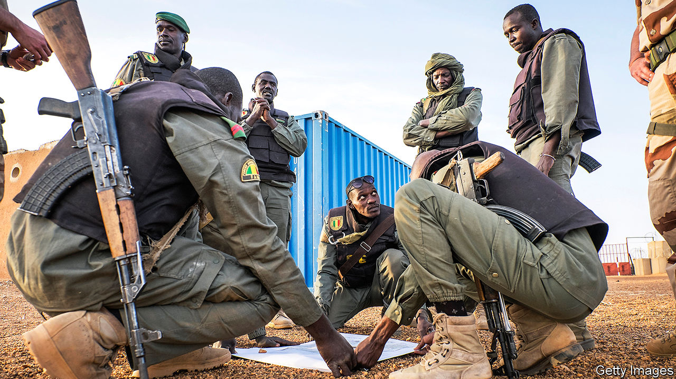

“YOU MAY think you’re safe,” says a 57-year-old resident of Doropo in northern Ivory Coast. “But jihadists are like ants, they can come in without being noticed.” On June 11th, just three weeks after Ivory Coast’s army reassuringly declared that its northern frontier with war-torn Burkina Faso was “under control”, a band of armed insurgents proved it wrong. Some 20 men on motorbikes descended on an army-and-police outpost near the border at Kafolo. The attackers killed 14 soldiers before roaring away into the bush.

The attack was the worst since 2016, when gunmen killed 19 people in a beach resort in Grand-Bassam, east of Abidjan, Ivory Coast’s commercial capital. It shows that even west Africa’s most populous countries, along the Atlantic coast, have become vulnerable to the predations of jihadists spilling out of failing states farther north in the Sahel, that vast swathe of land on the rim of the Sahara desert.

Jihadists seized control of chunks of Mali in 2012 and were stopped from overrunning Bamako, its capital, only after thousands of French troops were hurriedly flown in. The insurgents have since pushed across the border into Niger and Burkina Faso (see map). In those three countries alone, 4,800 people lost their lives in the conflict last year. Fully 1.7m people have been forced to flee their homes. Now the war is beginning to jump borders again, putting at risk some of Africa’s fastest-growing economies, including Benin, Ghana and Ivory Coast.

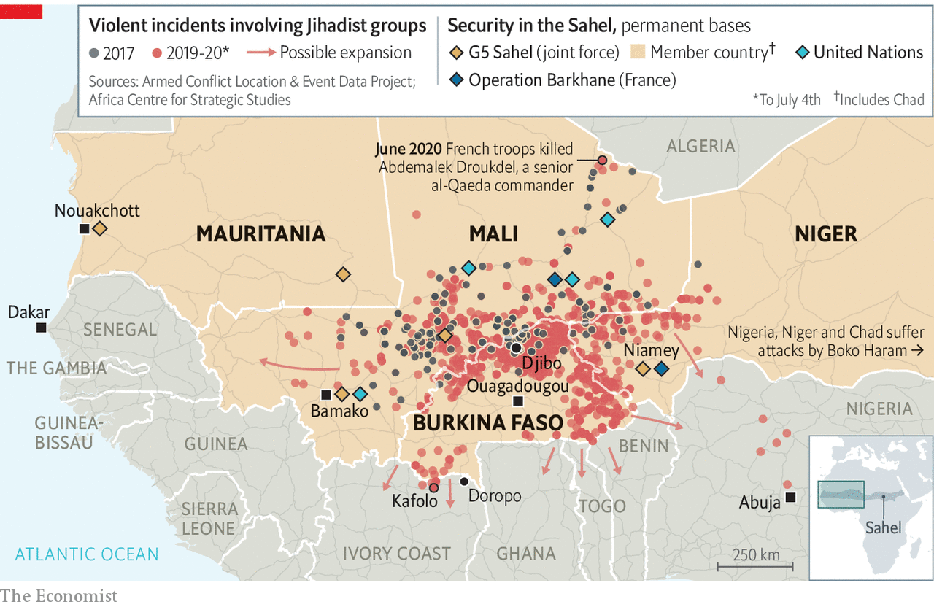

This war in the Sahel has been growing rapidly. Ten times more people were killed last year than in 2014 (excluding deaths in north-eastern Nigeria, which faces its own jihadist insurgents). Two main jihadist groups are behind most of the fighting: the Islamic State in the Greater Sahara (ISGS); and Jama’at Nasr al-Islam wal Muslimin (JNIM), which is linked to al-Qaeda. These groups have extended their reach, even though thousands of international peacekeepers and local and Western soldiers have been deployed to stop them. France has sent some 5,100 troops to the Sahel, while the United States has provided another 1,200. In addition, the UN has 15,000 blue helmets there, including about 350 Germans, plus 250 British soldiers who are soon to arrive. With American forces leaving Afghanistan, the Sahel will soon be the West’s biggest combat zone.

Progress is patchy. Emmanuel Macron, France’s president, claims that the coalition forces are achieving “spectacular results”. In June they killed Abdemalek Droukdel, a senior al-Qaeda commander. But such successes have not made civilians safer. In the first half of this year more than 4,200 people have been killed, two-thirds more than in the same period last year.

Worse, the jihadists are expanding in three directions at once. To the south they threaten Benin, Ghana, Ivory Coast and Togo. To the west there has been a spate of attacks in Mali close to its border with Senegal; and to the east with Nigeria’s insurgent groups. The jihadists already have a “de facto safe haven in northern Mali”, says General Dagvin Anderson, in charge of America’s commandos in Africa. He frets that as they expand they will have more scope to plan attacks on American soil.

The weakness of governments and the feebleness of their public services are helping the jihadists. In the neglected hinterlands of the Sahel the rebels offer themselves as an alternate state, serving up sharia and medical aid. Some 70% of people in the northern reaches of Ghana are classed as very poor, compared with a national rate of 25%. Ghana and Ivory Coast face divisive elections. So do Burkina Faso and Niger.

Moreover, the jihadists have been adept at exploiting ethnic faultlines, for instance between largely Muslim and seminomadic Fulani herders and more settled farming communities, which have their own armed groups of traditional hunters known as Dozos. Tit-for-tat attacks on civilians have led to young men joining jihadist groups or militias such as the Dozos. Similar tensions threaten Ghana and Ivory Coast, where farmers and herders have clashed in the past. Many Fulani in Ivory Coast are not even recognised as citizens.

Trade and commerce also provide an incentive for the jihadists to expand their reach. The migration corridor between Burkina Faso and Ivory Coast is the busiest in Africa. Jihadists cash in by taxing traders and smuggling stolen livestock, drugs and guns. The gold mines in Burkina Faso have become a target. Much of the gold is smuggled out through Togo, which officially exported seven tonnes of the metal to the United Arab Emirates in 2018, despite mining very little itself. Gold is also pulling jihadists towards Senegal.

Meanwhile ISGS is trying to create a corridor to link up with its allies in Nigeria. Islamic State’s propaganda now refers to the two Sahelian groups as one and the same.

As French forces have targeted ISGS, some of its fighters have sought sanctuary across other borders. The group already recruits from Benin, Ivory Coast and Togo, says Héni Nsaibia of Menastream, a research consultancy. Internecine fighting between ISGS and al-Qaeda may be scattering fighters over borders, too. The French army insists it is weakening the jihadists, not just pushing them south.

Though the jihadists stunned many by the speed of their advance through Mali and Burkina Faso, they face a tougher fight in the coastal states. The security forces of Ivory Coast, Ghana and Senegal are beefier than those of their neighbours in the Sahel. But Togo and Benin offer the jihadists softer targets. And Ivory Coast’s army, made up of fighters who were on different sides in a vicious civil war, may prove brittle. A recent raid was scuppered after an Ivorian officer leaked the plans.

## Lessons for the new fronts

The coastal states must avoid the mistakes of their Sahelian neighbours, whose security forces have often been brutal. This year, more civilians in the Sahel have been killed by government soldiers than by jihadists, says José Luengo-Cabrera of the International Crisis Group (ICG), a Brussels-based NGO. “When soldiers kill the head of the family, they almost throw his sons and nephews into the arms of bearded men in shorts hiding in the bush,” one villager told Human Rights Watch, a global monitor. It says in the town of Djibo alone, in Burkina Faso, evidence suggests government forces have murdered 180 men—many of them were blindfolded and had their hands bound before they were shot.

Governments in the Sahel recognise the problem but offer few solutions. According to cables seen by The Economist, a diplomat in Ouagadougou, Burkina Faso’s capital, reported that the president, Roch Marc Christian Kaboré, privately admitted that some of his citizens may feel safer living among terrorists than with their own country’s security forces. Mr Kaboré reportedly said that he could not ensure that his army’s abuses would stop altogether.

Governments in the region and some Western forces have made matters worse by supporting militias. In 2018 the French army allied itself with Tuareg militias from Mali to fight against ISGS. They clobbered the jihadists but also killed scores of civilians, aggravating ethnic tensions and fuelling recruitment by the insurgents. Coastal countries will face similar dilemmas. Security forces in Ivory Coast also have a history of working with local armed groups.

It is sometimes hard to avoid ruining livelihoods in the name of fighting terrorism. In northern Niger the authorities have banned motorbikes, which are the jihadists’ favourite mode of travel. But locals like to ride them to work. The authorities have annoyed people by closing markets and border crossings, raising youth unemployment. By contrast, the authorities in Niger’s south have subsidised the provision of motor tricycles, which get people to work but which the jihadists consider too slow to use in hit-and-run raids.

Above all, governments need to regain legitimacy by providing services and holding themselves to account. “It is not possible to win the war if there is not trust from the population,” says Niagale Bagayoko of the African Security Sector Network, an academic group founded in Ghana. Mass protests in Bamako have called for Mali’s president, Ibrahim Boubacar Keïta, to resign.

But good governance and decent services in the region are scarce. At a meeting of Sahelian leaders with Mr Macron in Mauritania on June 30th, there were congratulatory claims of military progress as well as talk of “a return of the state”. Yet the state must offer more than the jihadists are offering, including justice and development, says Rinaldo Depagne of the ICG. Foreign donors should abandon their dogmatic insistence on building infrastructure in densely populated areas to maximise returns. Even so, restoring the state in the face of an insurgency is hard. In Burkina Faso alone, the jihadists have forced about 2,500 schools to close.

As security worsens, calls are growing for negotiations with the jihadists. Mali has offered to talk to JNIM, which has agreed to do so once foreign troops have left. Yet the jihadists have little incentive to make concessions while they are winning on the battlefield. Their fighters are “cutting off Bamako to the north and slowly encircling Ouagadougou”, says General Anderson. The outlook is bleak. ■

This article was downloaded by calibre from <https://www.economist.com/middle-east-and-africa/2020/07/11/jihadists-in-the-sahel-threaten-west-africas-coastal-states>

|  |  |  |  |
| --- | --- | --- | --- |
|  | Articles | Sections | Next |

|  |  |  |  |
| --- | --- | --- | --- |
| Previous | Articles | Sections | Next |

#### For a few dollars more

# Zimbabwe’s worst economic crisis in more than a decade

Its rulers blame covid-19. But they are largely at fault

Jul 11th 2020 | HARARE AND JOHANNESBURG

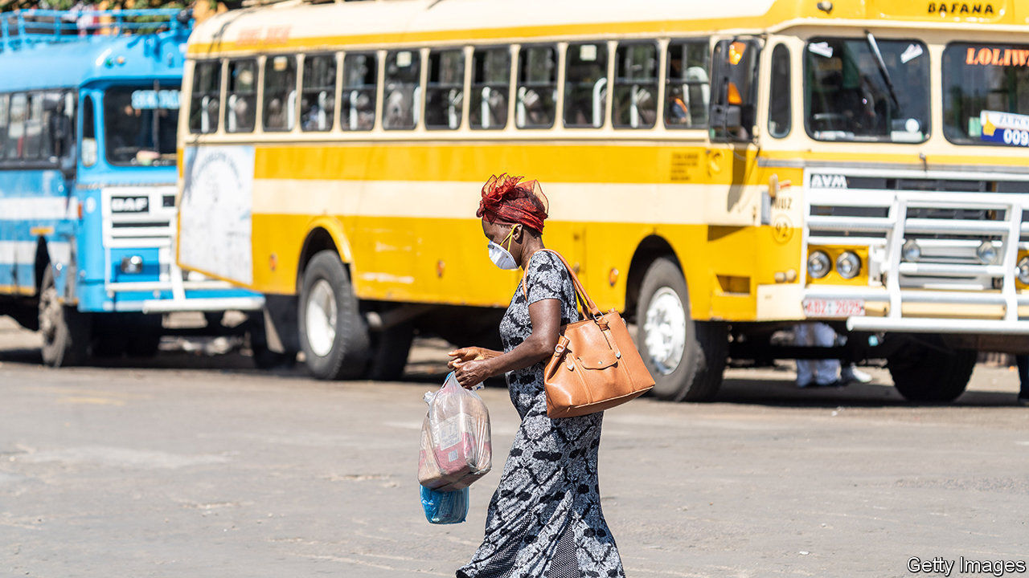

“TEACHERS ARE starving,” says Tsitsi, who works at a school in a township in Harare, Zimbabwe’s capital. Like nurses, soldiers and bureaucrats, teachers have seen their real incomes evaporate as annualised inflation approaches 1,000%. Their monthly pay, which they receive in Zimbabwe dollars, is worth about $30.

Covid-19 has hurt Zimbabwe. Trade is gummed up. Tourists are unable to go on safari or feel the spray of Victoria Falls. But contrary to the claims of those in charge, the pandemic is not why the economy is in its worst state since the hyperinflation of 2008-9. The reason is the regime itself.

This time there are no 100trn-dollar notes. But there is a familiar lack of faith in the currency, following years of printing money and fiddling with multiple exchange rates. Money is meant to be a store of value and a unit of account. Neither attribute applies to the Zimbabwe dollar. A few years ago the government was claiming that the value of its various forms of local currency was equivalent to an American greenback. Today it is worth about one cent. Businesses want to be paid in American dollars. Nurses and teachers are demanding likewise. Zimbabwe is, in effect, re-dollarising.

The authorities are trying to stop this. On June 26th, in an effort to reduce demand for real dollars, the government said it would ban some mobile-money transactions and shut down the stock exchange. The central bank has introduced a single weekly auction for banks and firms to bid for its scarce supply of foreign exchange.

How long that supply will last is unclear. Zimbabwe seizes a portion of the foreign earnings of exporters and in May it agreed to a $500m loan from Afreximbank, a pan-African lender, using platinum production as collateral. But the economy remains, in the words of one financier, “a giant Ponzi scheme”.

Under President Emmerson Mnangagwa, who took over from Robert Mugabe after a coup in 2017, there was supposed to be “a new dispensation”. He has even suggested that white farmers whose land was stolen by Mugabe would receive compensation. But his regime has, like Mugabe’s before it, killed, arrested and abused protesters. Largely as a result of this, Western governments have rejected its pleas for help from the IMF and World Bank.

As the economy shrinks, fighting over the spoils may become more vicious. Many in the army feel they have not received sufficient rewards for the risks they took in toppling Mugabe. Some resent the role of Kudakwashe Tagwirei, a businessman close to the president, whose firms have won many government contracts.

Mr Mnangagwa has stuffed ministries and his office with allies, many of whom hail from his home region. Some have been accused of graft, including, most recently, the health minister, Obediah Moyo, who allegedly agreed to a deal that included $28 face-masks. (Mr Mnangagwa’s son, Collins, whom local journalists have linked to the deal, has denied any involvement.)

In a sign of the heated atmosphere in Harare, on June 10th security officials held a press conference in which they assured reporters that there was no imminent effort to depose Mr Mnangagwa. “For the avoidance of doubt, there is no coup in the making,” said Kazembe Kazembe, the home-affairs minister. Since few people had sensed one in the first place, the event simply increased speculation.

Zimbabwe has long proved adept at finding new depths to plumb. But the difficulty for the regime is that, in the midst of a pandemic, ordinary Zimbabweans have fewer ways to survive. An indefinite lockdown makes it hard to “engage in any side hustles”, like raising chickens, says Tsitsi, the teacher. Then there is a bitter irony: though schools will reopen on July 28th, many teachers will not be able to afford the fees. “We will be teaching other people’s kids while ours stay home,” she says. ■

This article was downloaded by calibre from <https://www.economist.com/middle-east-and-africa/2020/07/11/zimbabwes-worst-economic-crisis-in-more-than-a-decade>

|  |  |  |  |
| --- | --- | --- | --- |
| Previous | Articles | Sections | Next |

|  |  |  |  |
| --- | --- | --- | --- |
| Previous | Articles | Sections | Next |

#### The fragile federation

# A musician’s murder sparks mayhem in Ethiopia

The country’s transition to democracy is at risk of being derailed

Jul 11th 2020 | ADDIS ABABA

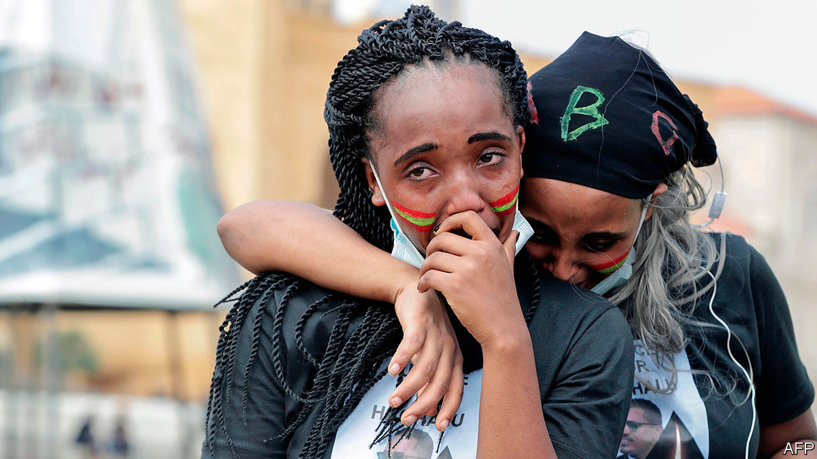

FOR TWO nights the sharp report of gunfire crackled through the pitter-patter of summer rain. Across the Ethiopian capital, Addis Ababa, cars and petrol stations were burnt, shops and businesses looted. At least ten people were killed in clashes between rioters and the police in the city. Similar confrontations took place in towns throughout Oromia, the largest of Ethiopia’s nine ethnically based regions and one that has been the site of repeated bouts of violence in recent years. In the country as a whole at least 166 people were killed, making this one of the deadliest episodes in Ethiopia’s already bloody transition from authoritarian rule.

The spark was the murder in Addis Ababa on June 29th of Hachalu Hundessa, a popular Oromo musician and activist. Oromos make up about a third of the country’s population of 115m. They are the largest and recently the most rebellious of Ethiopia’s many ethnic groups.

Violence escalated after a dispute with officials over where the singer’s body should be buried. “We are dead twice,” said Gelana Abeba, a protester. “First we lost our hero, then his funeral was disrespected.”

The unrest that raged over the next few days highlighted the three main faultlines in Ethiopian life. The first is distrust of the state by many young Oromos. They argue it has long been dominated by smaller groups such as Tigrayans and Amharas.

The second problem is a state that readily turns to violence and repression in response to protest. Although Abiy Ahmed, the prime minister, has promised to open up politics, old habits die hard. When violence started, the security forces cut off the internet and arrested some 1,200 people, including journalists accused of inciting violence as well as leading opposition figures. Among them was Jawar Mohammed, the most prominent Oromo leader.

The third fissure is along ethnic lines. Groups of young Oromo men attacked members of other ethnicities, notably Amharas, the second-largest group. “We all came out with sticks to protect ourselves,” says a resident whose housing estate was surrounded by a mob. The tensions also reflect a simmering dispute over the status of Addis Ababa, which is surrounded by Oromia. Oromo nationalists claim it forms part of their “homeland” and demand a greater say in its governance.

Many Ethiopians started this year optimistic that, with elections scheduled for August, the country would take a big step from authoritarianism towards democracy. But with voting postponed indefinitely because of covid-19, many now worry that the transition is at risk of being derailed altogether. It will take an almighty heave to put it back on track. ■

This article was downloaded by calibre from <https://www.economist.com/middle-east-and-africa/2020/07/11/a-musicians-murder-sparks-mayhem-in-ethiopia>

|  |  |  |  |
| --- | --- | --- | --- |
| Previous | Articles | Sections | Next |

|  |  |  |  |
| --- | --- | --- | --- |
| Previous | Articles | Sections | Next |

#### Booms in the night

# What to make of a series of odd explosions in Iran

Do they augur a return to the shadow war over its nuclear programme?

Jul 11th 2020 | BEIRUT AND JERUSALEM



IN THE EARLY hours of July 2nd a building caught fire in the grounds of the nuclear plant at Natanz in central Iran. Officials downplayed it as an accident in an unfinished shed. But photos showed a building with machinery on the roof. Satellite images added more doubt: scattered debris looked consistent with an explosion, not a fire. The cover story was short-lived. A spokesman for Iran’s nuclear agency soon admitted it was a factory for centrifuges used to enrich uranium. The damage, he said, could slow work on advanced models.

The apparent blast was one in a string of unusual incidents around Iran this summer (see map). On June 26th there was an explosion near Parchin, a military base south-east of Tehran that produces ballistic missiles. It was big enough to light the night sky in the capital. There have also been fires or explosions at power plants, clinics and other facilities. Some have innocuous explanations, like gas leaks.

But others look intentional. The blasts at Parchin and Natanz raise suspicions of an Israeli hand. For months the conflict over Iran’s nuclear programme has been overshadowed by covid-19. Now the virus may have helped resurrect it. President Donald Trump’s botched handling of America’s outbreak has put his re-election in doubt, and Israel may feel the clock is ticking on an administration committed to “maximum pressure” on Iran.

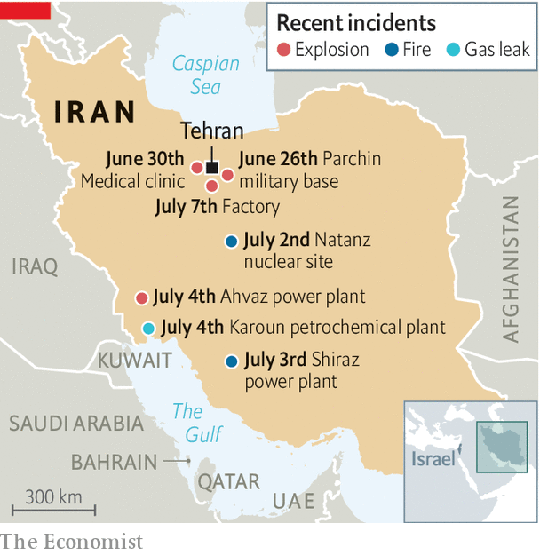

Not that anyone will confirm this. Save for rare exceptions, Israel does not take responsibility for covert operations in Iran. Officials settle for cryptic remarks like those made by Gabi Ashkenazi, the foreign minister, on July 5th: “We take actions that are better left unsaid.” That same day Binyamin Netanyahu, the prime minister, extended the tenure of Yossi Cohen, the Mossad chief. Ten days before, the army had awarded medals to Unit 8200, which oversees high-tech warfare, for “secret operational activity”; in May Iran’s main port was paralysed by a cyber-attack.

Even without these sly jabs, the explosions would have been ascribed to Israel, which has spent years fighting a low-intensity war against Iran. Stuxnet, a computer worm thought to be a joint effort by American and Israeli spies, sent Iran’s centrifuges spinning out of control. Israel has allegedly assassinated Iranian nuclear scientists with “sticky bombs” planted on their cars.

The deal that Iran signed with world powers in 2015, called the Joint Comprehensive Plan of Action (JCPOA), was meant to replace these tactical bites with a durable arms-control regime. Mr Trump withdrew from it two years ago and restored economic sanctions. After a year of restraint, Iran began to lash out last summer. It downed an American drone and attacked Saudi oil facilities. The new year brought the American assassination of Qassem Suleimani, Iran’s top commander, and a retaliatory missile strike by Iran on airbases in Iraq. Since then the conflict has gone quiet.

Mr Netanyahu is anxious to draw attention back to Iran, which has begun to shirk its own obligations under the JCPOA. It has exceeded both the deal’s limit on its heavy-water stockpiles and the cap on enriched uranium. It has also boosted enrichment to 4.5% purity, above the prescribed 3.67% threshold, though far below the 90% level at which it becomes weapons-grade.

The Israeli prime minister is mindful of the changing mood in America. “Netanyahu has finally realised that Trump won’t be around for much longer, and it’s more important for him to use this time to push Iran, rather than annex the West Bank,” says an Israeli intelligence official.

He may also wager that Iran will find it hard to retaliate, with its regional allies in a mess. Bashar al-Assad won the war in Syria but is losing the peace: his regime can barely feed its people. Lebanon defaulted in March and is struggling to keep the lights on. Iraq’s new prime minister, Mustafa al-Kadhimi, is taking on pro-Iranian militias.

Mr Trump’s opponent, Joe Biden, supports re-entering the JCPOA (if Iran starts complying again). Though even if America elects Mr Biden, Iran may be heading in the other direction. President Hassan Rouhani, a moderate by Iranian standards, will leave office next summer. Voters are frustrated with his camp, because of a miserable economy and a sense that “reformists” are not actually allowed to reform much.

That could augur well for Iran’s hardliners, who have already taken control of two branches of government. Parliament’s new speaker is a former Revolutionary Guard commander, and the chief justice was Mr Rouhani’s opponent in the past election. In a speech to Iran’s new parliament on July 5th, Muhammad Javad Zarif, the pragmatic foreign minister, was heckled. Several MPs chanted “death to a liar”.

When Mr Trump left the JCPOA, critics feared he would fail to replace it. If he leaves office in six months they will probably be proved right. He will have achieved little except raising tensions to their highest level since the 1980s. Mr Biden may find Iran in little mood for concessions. And he will have other problems to occupy his time. That leaves a return to covert war—and more booms in the night. ■

This article was downloaded by calibre from <https://www.economist.com/middle-east-and-africa/2020/07/11/what-to-make-of-a-series-of-odd-explosions-in-iran>

|  |  |  |  |
| --- | --- | --- | --- |
| Previous | Articles | Sections | Next |

|  |  |  |
| --- | --- | --- |
| Middle East & Africa | Sections | Britain |

Europe

Turkey: Converting Istanbul’s Hagia Sophia

.

France’s reshuffle: L’inconnu

.

Italy: The last bandit

.

Bosnia’s memory war: A genocide still denied

.

Spain’s economy: A lopsided recovery

.

Charlemagne: A Dutch dilemma

.

|  |  |  |
| --- | --- | --- |
| Middle East & Africa | Sections | Britain |

|  |  |  |  |
| --- | --- | --- | --- |
|  | Articles | Sections | Next |

#### Converting the Hagia Sophia

# Turkey’s president is playing religious politics

He wants to turn Justinian’s cathedral from museum back to mosque

Jul 11th 2020 | ISTANBUL

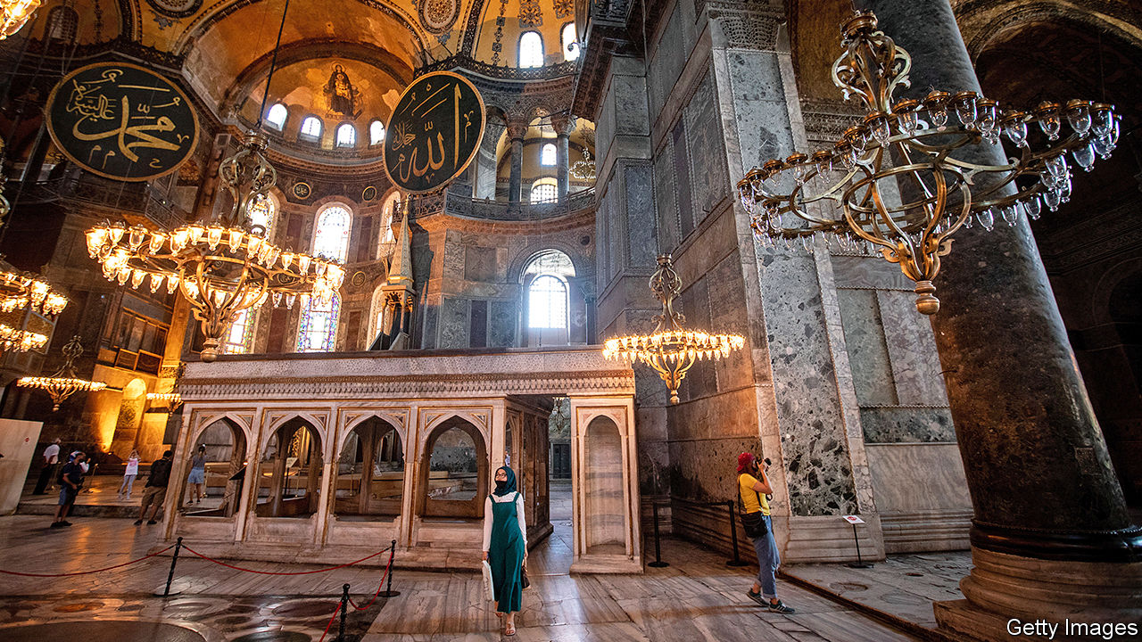

IT WAS BORN as a church, one of the icons of the Byzantine world, before being converted into a mosque by the Ottoman Turks and into a museum by their secular-minded successors. But now it would be transformed again. Workers squeezed a bland wooden minbar into a corner of the nave and a mihrab into a nearby portico, drew panels and screens to obscure the dazzling 13th-century Christian frescoes looking down from the vaults and the dome, and unfurled a red carpet over the marble floor. A muezzin summoned the faithful to prayers. The Hagia Sophia was now a mosque.

That was in 2013, and not in Istanbul, home of the Hagia Sophia known to millions of tourists worldwide, but in Trabzon, another Turkish city once populated by Greeks (and known in English as Trebizond), home to the ancient shrine’s much smaller and younger namesake. There are at least five former Byzantine churches dedicated to the Hagia Sophia (“Holy Wisdom” in Greek) across Turkey. Over the past decade, four, including the one in Trabzon, have reopened as mosques. The same fate now seems to await the most important of them, the sixth-century Hagia Sophia, the grand old lady of Eastern Christendom, and Istanbul’s domed crown.

Formally, the decision rests with Turkey’s top administrative court, which was expected to decide whether to convert the monument into a mosque as The Economist went to press. But as with most other things, the final word will belong to Turkey’s president, Recep Tayyip Erdogan. To the delight of his Islamist and nationalist base, Mr Erdogan seems determined to go ahead with the conversion. Last year, the Turkish leader said it was a “very big mistake” to use the building as a museum. Last month, he suggested Muslim prayers could be held inside the Hagia Sophia on July 15th, the fourth anniversary of a failed coup against him.

Built by the Byzantine Emperor Justinian I on the site of a church commissioned by Constantine, founder of Constantinople, the Hagia Sophia has hovered over the historical capital of the eastern Roman Empire since 537. Early visitors were awestruck, especially by the basilica’s central dome, covered with millions of shimmering gold tiles. “We did not know where we were, in heaven or on Earth,” envoys from Kievan Rus reported in the tenth century.

Crusaders plundered the cathedral in 1204, making off with its gold, silver and relics, many of which ended up in Venice. Similar scenes ensued in 1453, when the Ottoman army captured the city—the “red apple” at the end of the world, they called it. Mehmet, their 21-year-old sultan, marched into the cathedral, pouring dust over his head as a sign of respect, and immediately ordered its transformation into a mosque. Nearly five centuries later it was modern Turkey’s secular founder, Kemal Ataturk, who had the shrine converted into a museum. Christian mosaics covered up with plaster saw the light of day for the first time since the Ottoman conquest.

Mr Erdogan, who resides in a 1,100-room palace, surrounds himself with courtiers and appoints family members to senior positions, but resents being compared to a sultan, wants to conquer Istanbul and the Hagia Sophia all over again. He needs to deflect attention from the economy, now bracing for a second recession in as many years, and to reverse his Justice and Development (AK) party’s waning support in the polls. “We are living with a government that is running on empty,” says Soli Ozel of Kadir Has University. “The only thing in their inventory is to appeal to religion and nationalism.” Studies suggest that a large majority of Turks would support the Hagia Sophia’s conversion. But many also believe the government is using the issue to distract from more pressing problems. Some suspect Mr Erdogan may be preparing the ground for early elections, barely two years after the last ones.

That would also explain the rise in repression following a hiatus while Turkey has been dealing with covid-19. In the past month three opposition MPs and two journalists have been arrested on espionage and terrorism charges, and four human-rights activists, including two from Amnesty International, were sentenced to prison terms ranging from two to six years. The authorities also slapped a pair of opposition TV channels with a temporary broadcasting ban and closed a university linked to a former prime minister who is now one of Mr Erdogan’s political rivals. The lockdown is over. The crackdown is back.

Mr Erdogan also has a legacy to cement. The government and its religious backers see the era ushered in by Ataturk in the 1920s as a “parenthesis” in Turkish history, says Selim Koru of Tepav, a think-tank in Ankara. “Converting the Hagia Sophia would mark the closing of that parenthesis,” he says. “Ataturk unmosqued the Hagia Sophia to underline his commitment to secularism, taking religion out of public space,” says Soner Cagaptay of the Washington Institute, another think-tank. “Erdogan is doing nearly the opposite.”

All this comes at a high cost to Turkey’s reputation abroad as a relatively open Muslim society and to relations with its allies. Mike Pompeo, America’s secretary of state, had already urged Mr Erdogan to preserve the Hagia Sophia as a museum. Even the traditionally reserved Ecumenical Patriarch of Constantinople, Bartholomew I, warned that changing its status “will turn millions of Christians around the world against Islam”. A senior official of the Russian Orthodox Church said the move would signal “a return to the Middle Ages”. Russians have always felt a deep connection to Istanbul, the “second Rome”. Muscovites used to call their city the “third Rome”.

That may indeed be part of the plan. A good dust-up with foreign powers generally plays well in Turkey these days. But the damage Mr Erdogan will do to his country’s image by pushing ahead with his idea may well be irreparable. ■

This article was downloaded by calibre from <https://www.economist.com/europe/2020/07/11/turkeys-president-is-playing-religious-politics>

|  |  |  |  |
| --- | --- | --- | --- |
|  | Articles | Sections | Next |

|  |  |  |  |
| --- | --- | --- | --- |
| Previous | Articles | Sections | Next |

#### L’inconnu

# An unknown prime minister reinforces Macron’s centralised presidency

That may be half the point

Jul 11th 2020 | PARIS

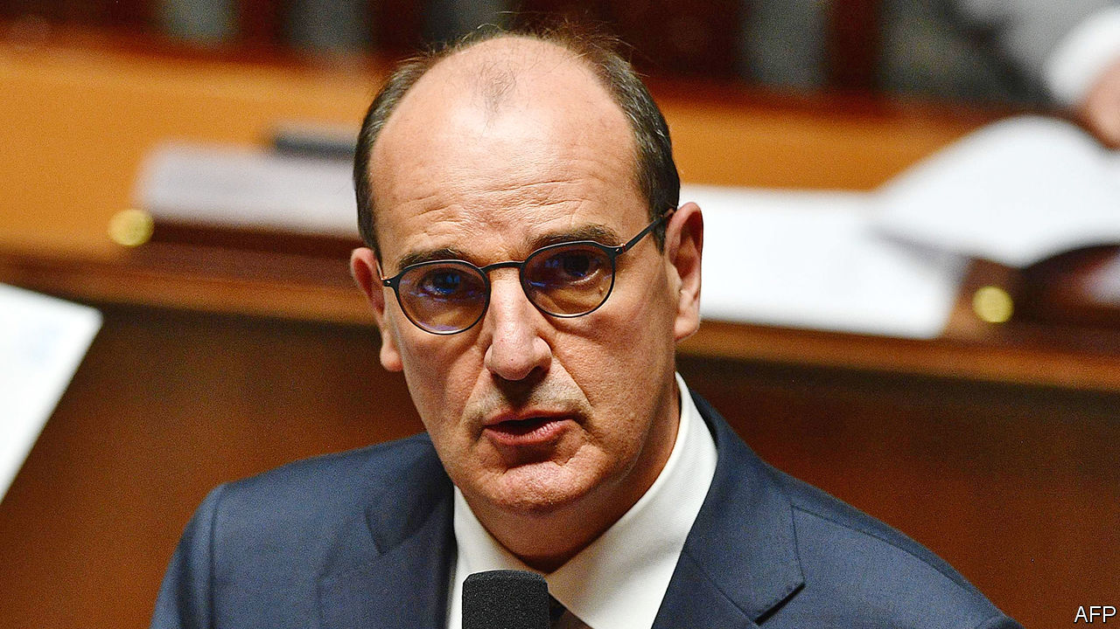

IT HAS LONG been a constitutional perk for a French president to treat the country’s prime minister as a shock-absorber: useful for cushioning damage, replaceable when worn out. Under the Fifth Republic, only one president, Nicolas Sarkozy, has governed with the same prime minister for his entire term. It is more unusual, however, to get rid of a prime minister who is popular—and swap him for another that nobody has heard of. Yet that is what Emmanuel Macron did on July 3rd, when he replaced Edouard Philippe with Jean Castex.

For weeks Mr Macron had let it be known that he was working on a “new course” for after lockdown. When his party failed to win a single big city at recent local elections, while the Greens scooped up town halls in places that once voted for him, many observers expected a left-leaning or greener government. So it was to general surprise that Mr Macron replaced one centre-right figure (and graduate of the elite Ecole Nationale d’Administration) with another. A career civil servant, and mayor of a village in the Pyrenees, Mr Castex was until recently the official in charge of France’s exit from lockdown.

Up to a point, it made sense for Mr Macron to seek a change. The next presidential election is in 2022. To wait another year would be to run into early campaigning. Mr Philippe was elected mayor of Le Havre at local elections on June 28th, offering him a dignified exit. The pair had differences, most recently over the pace of déconfinement. But Mr Philippe, say friends, remains loyal. “He will put all his energy into making sure the president is re-elected in 2022,” said Gilles Boyer, his close friend and a member of the European Parliament.

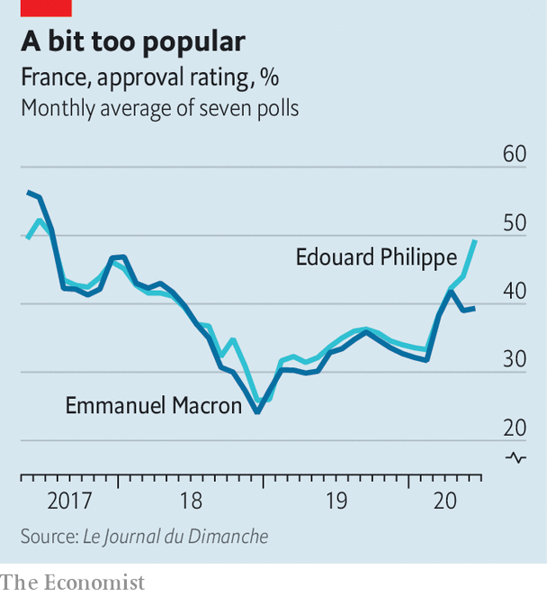

Yet the appointment of the 55-year-old Mr Castex, who worked at the Elysée under Mr Sarkozy, does not look much like the “reinvention” that Mr Macron promised. It is neither a shift to the left or the Greens, nor to a new generation. The new government, unveiled on July 6th, is broadly the same as the outgoing one. Occupants of the top posts—Bruno Le Maire at finance, Jean-Yves Le Drian at the foreign ministry, Florence Parly at defence—all kept their jobs.

Besides unexpected appointments to the justice ministry (Eric Dupond-Moretti, an outspoken criminal lawyer) and culture (Roselyne Bachelot, a minister under Mr Sarkozy), the main change is the arrival of Gérald Darmanin as interior minister. Yet another Sarkozy ally, he is Mr Macron’s outgoing budget minister, and—to the consternation of feminist campaigners—has a rape charge hanging over him, which he has denied. The chief nod to the Greens was the appointment of Barbara Pompili, an ex-Green converted to Mr Macron’s party, to the environment ministry.

Those around Mr Macron insist that the new team does represent renewal. Mr Castex, they say, blends knowledge of how to operate the Paris administrative machine with local links to la France profonde. He has a reputation for efficiency at a time when Mr Macron is frustrated with France’s bureaucracy. Mr Castex, with his south-west twang, was re-elected mayor of the village of Prades (population 6,000), and returns there often at the weekend. This might help to shift the perception that Mr Macron’s team is disconnected from the regions. It could also be a nod towards more decentralised decision-making, which the president says he wants in the wake of covid-19 and the gilets jaunes protests.

Yet it is hard to avoid the conclusion that, far from a change of direction, the reshuffle is an acknowledgment that Mr Macron runs everything himself. “The real prime minister”, says one Macronista, “is Macron.” Unlike Mr Philippe, Mr Castex has no national political base. He is said to be no pushover, but nobody doubts where decision-making will lie. “What emerges is a president who has taken stock of what the constitution offers him and is saying, ‘well in that case I might as well centre everything on myself’,” says Chloé Morin, of the Fondation Jean-Jaurès, a think-tank. “Macron locks down Matignon”, declared Libération, a left-leaning daily, referring to the prime minister’s office.

If Mr Macron is now more in charge than ever, this suggests broad policy continuity. That may not be bad news. Before covid-19, France was starting to see the benefits of early tax cuts and reforms to the labour market and training, with new businesses, jobs and apprenticeships. Despite his falling popularity, Mr Macron says he will not go back on these changes, and is expected to revive his contested pension reform, albeit reworked. Yet the economy could shrink by 11% this year, joblessness will rise, and covid-19 is still about. Getting the right balance between the desire for a more caring, greener and safer France, and the need for greater efficiency, will be perilous. The autumn, as Mr Macron himself put it, will be “very tough”. ■

This article was downloaded by calibre from <https://www.economist.com/europe/2020/07/11/an-unknown-prime-minister-reinforces-macrons-centralised-presidency>

|  |  |  |  |
| --- | --- | --- | --- |
| Previous | Articles | Sections | Next |

|  |  |  |  |
| --- | --- | --- | --- |
| Previous | Articles | Sections | Next |

#### The pensioner bandit

# At 78, a Sardinian ex-kidnapper is on the run

And his neighbours are no help to the police

Jul 11th 2020 | ROME

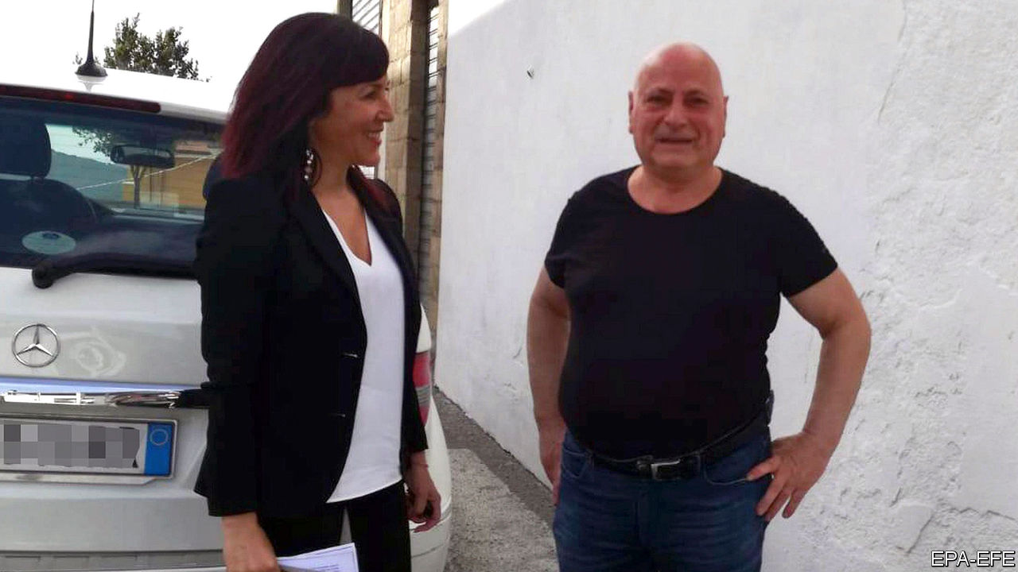

SOME SAID Graziano Mesina had absconded to the neighbouring French island of Corsica; others that he had fled to Tunisia. But what became increasingly clear on July 3rd was that the man known as the last balènte, or Sardinian bandit, was yet again on the run—at the age of 78. His younger sister, Antonia Mesina, said he had called by her house the previous day, just before the supreme court in Rome turned down her brother’s appeal against a 30-year sentence for a drug-trafficking offence. “I’ve not seen or heard from him since,” she said.

Police carried out house-to-house searches in his home town of Orgosolo, but soon learnt that no one else could—or, perhaps, would—help them. The town’s mayor said it was a coincidence that a surveillance camera near Mr Mesina’s house had twice been shot up before he vanished. But if there was complicity in the reaction to his disappearance, it may have had less to do with the code of silence that once shielded Sardinia’s brigands than resentment towards Italy’s sluggish judicial system. Meticulous in intent, the system is often cruelly slow in its application. Mr Mesina’s case had dragged on through the courts for seven years.

These days, Orgosolo is better known for its street art (it has some 150 murals) than for its kidnappers, among whom Mr Mesina was the uncontested master. Grazianeddu, as he is half-affectionately known, has been the subject of books, films and songs. He had, and evidently retains, an extraordinary talent for evading justice. Since his first arrest, aged 14, he has escaped or absconded on ten occasions, including from a top-security prison. Strikingly handsome when younger and widely acknowledged as intelligent and charming, Mr Mesina was reputed to have a string of lovers whom he visited in disguise while on the run. Police are said to have visited the homes of several elderly ladies in their search for the missing pensioner-bandit.■

This article was downloaded by calibre from <https://www.economist.com/europe/2020/07/11/at-78-a-sardinian-ex-kidnapper-is-on-the-run>

|  |  |  |  |
| --- | --- | --- | --- |
| Previous | Articles | Sections | Next |

|  |  |  |  |
| --- | --- | --- | --- |
| Previous | Articles | Sections | Next |

#### A genocide denied, 25 years on

# The massacre of Bosnian Muslims is still denied by Serbs

A Balkan battle of memory is still being fought

Jul 11th 2020 |

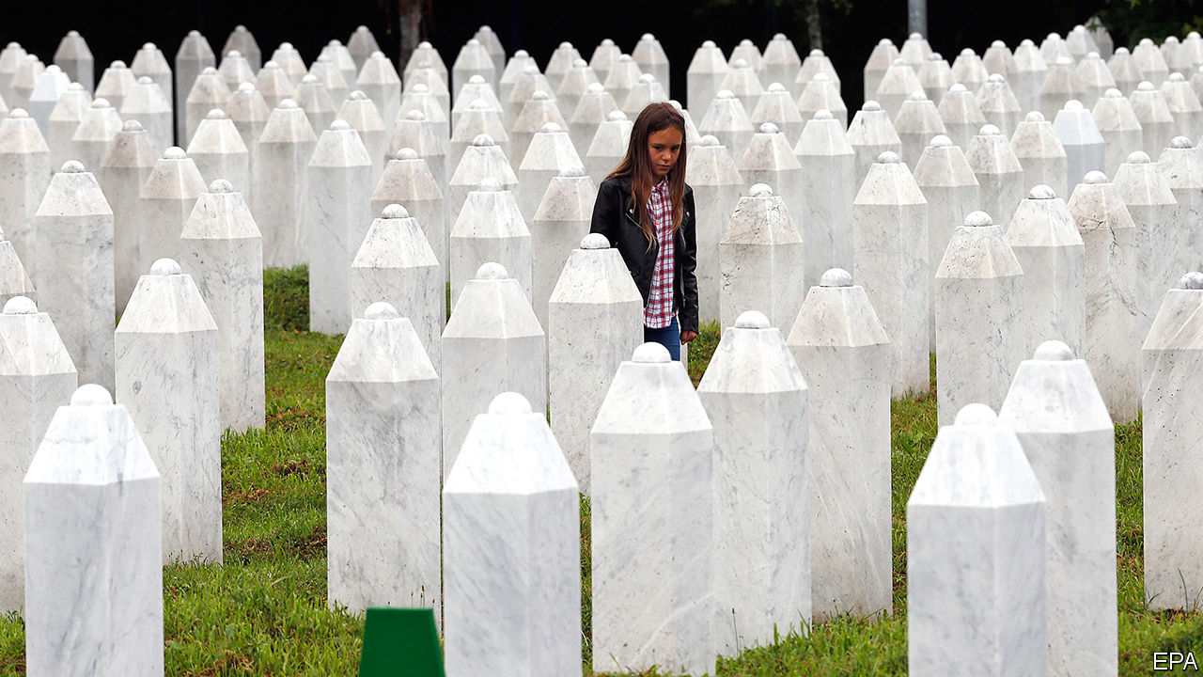

THEY WILL pour 8,372 commemorative cups of coffee in Srebrenica on July 11th. A quarter of a century after the fall of the Bosniak (Bosnian Muslim) enclave at the end of the Bosnian war, when that number of men and boys are reckoned to have been massacred by Bosnian Serb soldiers, this year’s ceremony will feature videos sent by princes, presidents and leaders from all over the world. But one prominent local figure will be conspicuously absent: Srebrenica’s own mayor.

Like most Bosnian Serbs, Mladen Grujicic will ignore the event. He denies that an act of genocide took place. Other theories widely believed by Serbs and promoted by their politicians and media are that the scale of the crime has been wildly exaggerated, or that the cemetery, where more than 6,600 of the victims are buried, contains the remains of those who had no connection to Srebrenica, which was besieged for three years before it fell to the Serbs in 1995.

Ever since the months after the massacre, when the Bosnian Serb leadership arranged the exhumation of the mass graves in an attempt to hide the corpses in dozens of smaller ones, “Srebrenica denial” has been one of the ugliest legacies of the war. Like Holocaust denial or Turkey’s denial that its troops committed a genocide of Armenians in 1915, it is damaging to the reputation of Serbs.

The UN’s Yugoslav war-crimes tribunal in The Hague convicted the leading perpetrators of the Srebrenica crime and concluded that it was the single act of genocide committed in the Balkan wars that followed the break-up of Yugoslavia. Chuck Sudetic, an American former war-crimes investigator, says it is incredible how much information has been collected, perhaps in greater detail than for any war crime ever committed. Every order has been recorded. We know what happened in virtually “every minute” of those days, he says.

In 2004 the Bosnian Serb president acknowledged what had happened—and apologised. But since then, Serb leaders in Serbia and Bosnia have back-pedalled. Milorad Dodik, the Bosnian Serbs’ representative in Bosnia’s current three-man presidency, says the genocide was “a fabricated myth”. In Serbia government officials admit that a crime took place, but fiercely deny it was an act of genocide.

Across the former Yugoslavia, says Marija Ristic of the Balkan Investigative Reporting Network, a regional group of NGOs that promotes freedom of speech and human rights, the bloody conflicts of the 1990s have given way to “memory wars”. Serbs reject the label of genocide for Srebrenica because “everyone in the Balkans wants to be seen as the ultimate victim”.

After the second world war Germans gradually faced up to the horror of the Holocaust, but a similar process is not yet happening in the Balkans. By the middle of the 1960s, says Eric Gordy, a sociologist, most of those Germans who would be most shamed by an open discussion of the past were dead or retired. Yet in the Balkans the same people are still in power or are competing for it.

A common argument is that almost everyone involved in the war committed crimes. In Bratunac, near Srebrenica, Bosnian Serbs commemorate their own dead. But most of those were soldiers who died in combat, not civilians. Attempts to deny or minimise the crime of Srebrenica fuels bitterness. Emir Suljagic, who runs Srebrenica’s memorial centre, says that “a culture of denial…lays the groundwork for future genocides.” He wants Bosniaks to remember “what our destiny is going to be if we are ever as weak as we were in July 1995”. ■

This article was downloaded by calibre from <https://www.economist.com/europe/2020/07/11/the-massacre-of-bosnian-muslims-is-still-denied-by-serbs>

|  |  |  |  |
| --- | --- | --- | --- |
| Previous | Articles | Sections | Next |

|  |  |  |  |
| --- | --- | --- | --- |
| Previous | Articles | Sections | Next |

#### A lopsided recovery

# Harsh economic realities push Spain’s government towards the centre

The left-wing government may not be able to afford its promises

Jul 11th 2020 | MADRID



LAST MONTH, as Spain loosened its tight lockdown, Carmen Olmos opened up her smart tapas bar in the Salamanca district of Madrid for the first time since early March. Little by little she brought all nine of her staff out of the government’s furlough scheme. She is allowed to use only 60% of her tables, the office workers who used to drop by for breakfast or lunch are still teleworking and trade is a third below its pre-pandemic level. She had to close two other bars in the previous slump, in 2009-12. This time she is optimistic. “I own the property, it’s an area with a lot of purchasing power so it’s viable even in these conditions,” she says. She is less sanguine about the Spanish economy as a whole. Many other bars are opening with fewer workers and for shorter hours, she adds. Many small shops in her neighbourhood are yet to come back at all.

Spain is suffering small but potentially worrying new coronavirus outbreaks that have seen the reimposition this month of some restrictions on movement in two rural areas with a total population of 270,000. Nevertheless, the main concern of the left-wing coalition government of Pedro Sánchez, the Socialist prime minister, is now to revive the economy. It has been the hardest hit in Europe (along with Italy’s), because of the preponderance of tourism and small, vulnerable businesses, plus the stringency of its lockdown. The government reckons GDP will shrink by 9.2% this year (the IMF says 12.8%), provided second waves of the virus can be contained locally, without a second general lockdown. Unemployment could hit 21% by December, wiping out years of strong job-creation.

The good news is that a recovery has started. But it is lopsided. Of the 3.8m workers furloughed in April, 1.5m are now back at work. Credit- and debit-card spending by Spaniards fell by 60% in the tightest phase of the lockdown, in April, but was only 4% below normal by last month, according to Rafael Doménech of BBVA, a bank (some of the rebound may be thanks to purchases postponed earlier). With borders closed until June 21st, spending by non-residents fell by 85% between March and mid-June. Much of the tourist industry’s 12.3% contribution to GDP will be lost this year. Other sectors have suffered, too. Nissan is to close its car factory in Barcelona, with the loss of 3,000 jobs, and Airbus is laying off hundreds from its Spanish plants.

The government has tried to cushion these blows. It has spent more than 3% of GDP on furloughing workers, waiving social-security payments and helping the self-employed, schemes which are likely to be extended to the end of the year. It has offered €100bn (8% of GDP) in credit guarantees for businesses. On July 3rd Mr Sánchez announced an additional €40bn plus a €10bn fund for equity stakes to support “strategic” companies.

Although the headline amount of aid is less than in some other European economies, officials insist that it has been effective, with quick disbursement. The government was constrained by Spain’s prior fiscal weakness, with the deficit rising last year to 2.8% of GDP. It has high hopes of the proposed European reconstruction fund, which it helped to inspire. Spain could get up to $140bn over several years. This won’t directly plug the deficit hole. But it could help to raise productivity in the medium term, through investments in IT, green technology and worker training.

The virus struck when the ruling coalition between the Socialists and the far-left Podemos was just two months old. Despite some mistakes in the handling of the epidemic, the prime minister’s position is stronger now than it was then. In a politically fragmented country, his approval rating is back to 50%, according to Metroscopia, a pollster, up from 37% in early April.

His next test is to get parliament to approve a budget, something he has been unable to do since he first came to power through a censure motion in 2018. The coalition’s programme included a pledge to raise corporate and income taxes to finance additional social provision, and a promise to repeal a labour reform of 2012, which powered the recovery in jobs. Hated by the unions, the reform cut severance pay (still high) and decentralised bargaining.

Mr Sánchez faces heavy pressure to drop these pledges. Antonio Garamendi, the head of the bosses’ association, points out that there is no mention of repealing the labour reform in the latest agreement that he and union leaders signed with the government. The coalition has said it will “modulate” its programme because of the harsh new circumstances. The budget will reveal whether modulation is a fancy word for backtracking. ■

Editor’s note: Some of our covid-19 coverage is free for readers of The Economist Today, our daily [newsletter](https://my.economist.com/user#newsletter). For more stories and our pandemic tracker, see our [hub](https://www.economist.com/news/2020/03/11/the-economists-coverage-of-the-coronavirus)

This article was downloaded by calibre from <https://www.economist.com/europe/2020/07/11/harsh-economic-realities-push-spains-government-towards-the-centre>

|  |  |  |  |
| --- | --- | --- | --- |
| Previous | Articles | Sections | Next |

|  |  |  |  |
| --- | --- | --- | --- |
| Previous | Articles | Sections | Next |

#### Charlemagne

# A Dutch dilemma

The art of compromise without capitulation

Jul 11th 2020 |

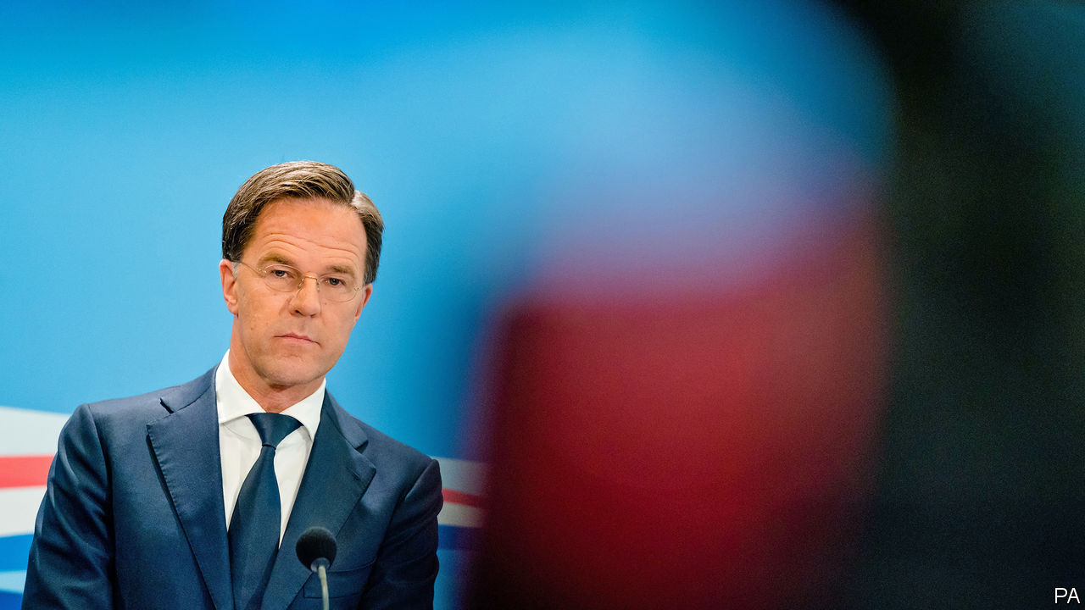

MARK RUTTE makes an unconvincing villain. In person, the Dutch prime minister resembles an over-caffeinated vicar, mixing manic good-cheer with sermons on the importance of living within one’s means. The 53-year-old lives alone in a modest apartment, cycles to his poky office in The Hague and takes time off from running the country to teach social studies at a local school. Such do-goodery has not stopped Mr Rutte being cast as the bad guy in Brussels as the EU argues over a €750bn ($845bn) fund aimed at pepping up the bloc’s lockdown-hit economies.

The Dutch government is leading opposition to the plan, which involves a mix of grants worth €500bn and loans of €250bn handed to individual countries and paid for by the EU issuing debt collectively at scale for the first time. The scheme, or at least the outline of it, is supported by France, Germany and every other big country. Mr Rutte is the unofficial head of a band of sceptics and refuseniks, consisting of Sweden, Denmark and Austria as well as the Netherlands, known as the “frugal four”. At a summit next week—the first in person since the start of the covid-19 crisis—these two sides will square off. Unanimity is required for the plan to go ahead.

A view exists among Dutch voters and politicians that countries in southern Europe are in trouble because they spent too much or failed to reform their economies. (That Italy has run a primary budget surplus—spending less than it earns through taxes, before interest—since the 1990s receives much less attention.) The Netherlands (and its allies) are happy for the EU to give money to countries in need, but only if such money is paid back. It is a popular position. Dutch voters oppose the EU’s proposal by a margin of two to one. Objections abound. Although designed for countries struggling with the pandemic, one of the biggest beneficiaries of the fund would be Poland, which has been least affected economically. Arguments that the fund is needed to stop the single market falling apart are dismissed as scaremongering. “And China will invade,” adds one Dutch MP, sarcastically.

Opposition is philosophical as well as fiscal. Across southern Europe, collective debt is seen as a path to freedom. Among lawmakers in The Hague, it means tighter control: if Dutch taxpayers must pay then they should have a say, the logic runs. Trust in the European Commission to do the job is low. In a fit of honesty, Jean-Claude Juncker, the previous president of the commission, once declared that France would not be punished for breaking EU rules on deficits “because it is France”. Politicians in Italy and Spain may not like the idea of lawmakers in the Netherlands and other hawkish governments examining their spending, warn Dutch MPs.

These arguments were once common in Berlin. But this was before Angela Merkel underwent a conversion to the merits of debt issued jointly by the EU. In some respects, Mr Rutte is in a similar position to his German counterpart. The duo are the two longest-serving euro-zone leaders. Both have seen their polling soar in recent months. Both lead countries that are historically wary of using common debt to bail southern countries out. But they have responded to the crisis in very different ways. Safe in the knowledge that she will not fight another election, Mrs Merkel spent political capital cajoling a reluctant German establishment into support for the radical step of joint debt. With a Dutch election due in March, Mr Rutte may feel there are better ways to use his popularity.

A soft, flexible Euroscepticism has been one of Mr Rutte’s characteristics since coming to power in 2010. His People’s Party for Freedom and Democracy (VVD) has thrived by stemming the flow of voters to more right-wing rivals. It has done so with tough talk on things such as asylum policy and the EU, while taking care not to scare off more moderate voters. It is a crowded part of the spectrum. Christian Democratic Appeal, the centre-right coalition partners of Mr Rutte, have taken an even firmer line during talks over EU spending. Polls give the parties of Geert Wilders, a perennial populist, and Thierry Baudet, a new challenger, just under a fifth of seats combined. Both offer full-throated condemnation of the EU. Capitulation in Brussels would be leapt on by opponents.

## Look before judging

Dutch Euroscepticism is more subtle than the breathless coverage of its populists allows. About 70% of Dutch people would vote to remain in the bloc if offered the choice, in line with the average figure across the EU. In comparison, only 53% of Italians would. This does not mean that Dutch voters want more of Brussels in their life—barely a third do. Euroscepticism, however, rears its head when money is involved. In such circumstances, the EU may require some defending, points out Rob Jetten, the parliamentary leader of D66, Mr Rutte’s Europhile liberal coalition partners. Britain provides a cautionary tale of what can otherwise happen.

In public the Dutch line is firm. The Netherlands will agree only to loans, Mr Rutte told an Italian newspaper. When speaking in the Netherlands, Mr Rutte has tended to focus on other matters, such as whether the money should have strings attached and ensuring the Dutch keep their rebate—a kickback on the EU’s €1.1trn budget, which will be negotiated at the same time as the recovery fund. These demands are more achievable than calling for the €500bn of grants to change to loans. Talks will be messy. But a good scrap in Brussels works wonders with domestic voters.

Flexibility has always been one of Mr Rutte’s skills. If the prime minister does sometimes resemble a man of the cloth, it may be because he has a touch of the famously adaptable Vicar of Bray. Under his leadership, the VVD has been more than happy to drift around the political spectrum. He likes to keep his options open. During one lecture on faith, he hedged his belief in God: 51% of him did, 49% did not. It is a tactic that has served him well for a decade. Compromise on the recovery fund is inevitable. When it arrives, Mr Rutte’s depiction as the villain will be revoked in the EU at large. The trick will be to make sure it is not introduced at home. ■

This article was downloaded by calibre from <https://www.economist.com/europe/2020/07/11/a-dutch-dilemma>

|  |  |  |  |
| --- | --- | --- | --- |
| Previous | Articles | Sections | Next |

|  |  |  |
| --- | --- | --- |
| Europe | Sections | International |

Britain

Relations with China: About turn

.

Human rights: From red carpet to blacklist

.

Fiscal policy: Sunak’s summer splurge

.

Economic data: Wrong numbers

.

Theatres: Cast adrift

.

Crime in lockdown: Catching up on their to-do lists

.

Food: Retro diners

.

Bagehot: Fading Anglophilia

.

|  |  |  |
| --- | --- | --- |
| Europe | Sections | International |

|  |  |  |  |
| --- | --- | --- | --- |
|  | Articles | Sections | Next |

#### Global Britain

# Britain’s worsening relations with China

Could China make Britain squirm?

Jul 11th 2020 |

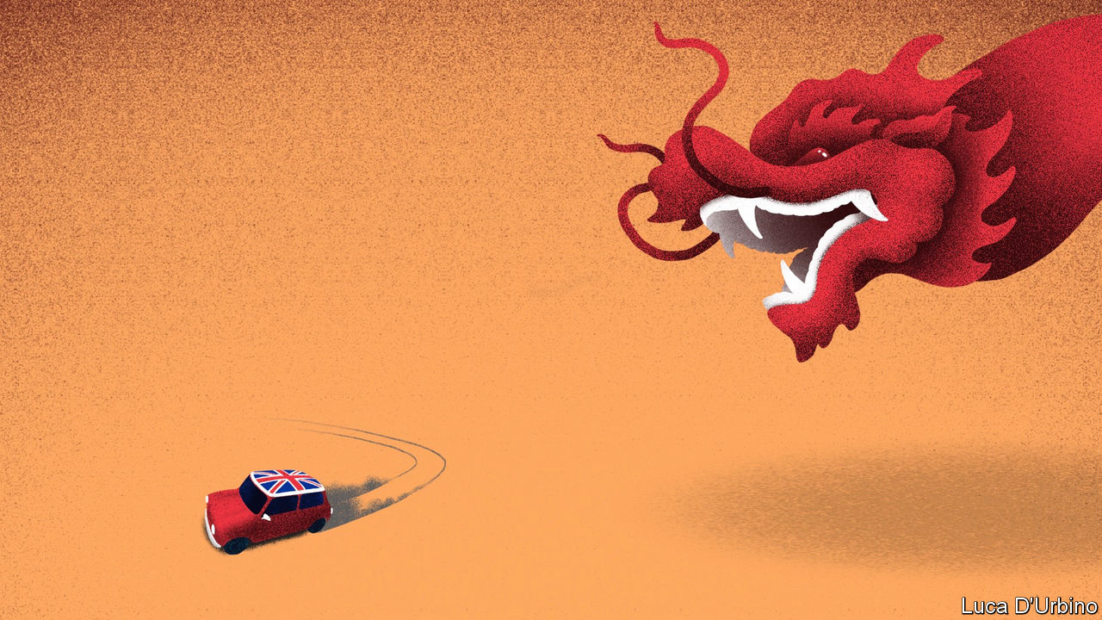

IN NOVEMBER 2010, addressing students at Peking University, David Cameron was asked what advice he would give the Communist Party in an age of growing pluralism. “An amazing noise went around the room, half admiration and half shock,” he later recalled. “As I looked around the sea of faces I thought: is this system really going to last? My conclusion was that, in its current form, it couldn’t.”

Mr Cameron hoped his premiership would be the dawn of a “golden era” of Anglo-Chinese relations. Behind this notion lay the belief that Britain could shape China’s approach to trade and human rights by doing business with it. That hope has not survived the decade. Trade and investment have increased, but China has become more repressive at home and more assertive abroad.

British politicians have found that tension increasingly hard to live with. Boris Johnson’s government is weighing a U-turn on the decision it made in January to let Huawei, a Chinese telecoms company, help build Britain’s fifth-generation (5G) mobile networks. That follows new advice from GCHQ, Britain’s signals-intelligence agency, on the impact that American sanctions will have on the supply of reliable components to the company. Britain will change its immigration rules to allow up to 2.9m Hong Kongers to gain citizenship in Britain, following the Chinese authorities’ decision to impose a draconian national-security law on the former British colony. Two MPs have called for Dominic Raab, the foreign secretary, to put Carrie Lam, Hong Kong’s chief executive, on the new sanctions list that Britain has published (see article). Mr Johnson intends to push on with long-delayed plans for a tougher investment-screening regime, which would allow a broader range of foreign takeovers of British companies to be blocked on national-security grounds.

Mr Johnson declares himself to be a “sinophile”, and as Mayor of London was even more enthusiastic than Mr Cameron in chasing trade and tourism. His office says that it wants China as a partner on climate change and global health, but “this relationship does not come at any price.” British business leaders are wearied by the hot-cold relationship, and wish the government would take a more consistent line.

Several factors are behind the hardened stance. One is China’s own policy. Britain says that China is in breach of the Hong Kong handover treaty that guaranteed the territory’s rights and freedoms, and the repression of Muslims in Xinjiang has appalled many MPs. Another is pressure to ditch Huawei from America and Australia, who are Britain’s allies in the Five Eyes intelligence pact and with whom Britain hopes to seal speedy trade agreements.

In Parliament, a new caucus of Conservative lawmakers who think China poses a threat to global norms and free societies has formed. The China Research Group’s appeal is broader than that of the European Research Group of Brexit hardliners. Tom Tugendhat, its leader, is a former army officer from the party’s liberal wing. “The UK has been hopeful and ambitious, and sadly that hope and expectation has met the cold reality of an authoritarian state,” he says. The Labour Party under Sir Keir Starmer has also become more hawkish. Lisa Nandy, the shadow foreign secretary, says Britain must find “homegrown alternatives” to Chinese telecoms and nuclear power.

Chinese officials have been telling foreign visitors that they expected post-Brexit Britain to be a biddable place because it needed to increase non-EU trade and preserve the City as a financial centre. This rapid change of course may therefore be an unpleasant surprise. The Chinese made their displeasure known at a press conference on July 6th at which Liu Xiaoming, the ambassador to London, accused British politicians of having a “colonial mindset”, and said that ditching Huawei would send a “very bad message” to Chinese investors about Britain’s economy. “We want to be your friend, we want to be your partner, but if you want to make China a hostile country, you have to bear the consequences.”

China routinely chastises states that say or do things that upset it. The first step is to cancel meetings between politicians, as happened when Mr Cameron’s government was put in the freezer for a year after he met the Dalai Lama, Tibet’s spiritual leader. Economic threats come next. China is Britain’s third-largest trading partner after America and the European Union, with 5% of total trade, and its government is skilled at targeting symbolic and politically sensitive exporters. Norwegian salmon exports were hit after the Nobel peace prize was awarded to a Chinese dissident. Australia’s beef and barley exports were choked after it called for an international probe into the coronavirus outbreak.

If China has an appetite to hurt Britain then it has a range of brands and sectors to choose from. A list of likely targets might include Scotch whisky or Jaguar Land Rover, the carmaker which makes about a fifth of its sales in China. In general, the City of London is not badly exposed, but two banks with roots in Britain’s colonial past, HSBC and Standard Chartered, make two thirds and a half of their profits, respectively, in China and Hong Kong. An insurer, Prudential, is also heavily involved there. “If China really wanted to pinch us...by sanctioning British companies there is form there,” says George Magnus of Oxford University’s China Centre. HSBC and Standard Chartered have announced their support for the new Hong Kong security law, but Mr Magnus doubts that will insulate them.

Charles Parton, a veteran British diplomat and senior associate fellow at the Royal United Services Institute, a think-tank, argues that such measures may spook leaders but are usually short-lived, do not prevent overall exports from rising, and should not deter politicians from challenging Chinese policy when Britain’s interests are threatened. Chinese investment in Britain is linked to profit-seeking, not politics or charity. “The pain gets put on the politicians,” says Mr Parton. “The real world goes on. Students study. Tourists tour. Business does its business.”

Yet the main cost may not be in present pain but in future benefits forgone. A falling-out with China would scotch new initiatives designed to give Britain a competitive advantage over its European peers. The spat may kill the tie-up between the London and Shanghai stock exchanges and hinder emerging fields, such as the issuing of green bonds in London by Chinese firms. Few MPs would notice that. But many fret that the lost advantages are stacking up. “We’ve had covid, we’re doing Brexit—do we need to pick a fight with China?” asks a former cabinet minister of the “golden era”. That will soon become clear.■

This article was downloaded by calibre from <https://www.economist.com/britain/2020/07/11/britains-worsening-relations-with-china>

|  |  |  |  |
| --- | --- | --- | --- |
|  | Articles | Sections | Next |

|  |  |  |  |
| --- | --- | --- | --- |
| Previous | Articles | Sections | Next |

#### From red carpet to blacklist

# Brexit Britain gets its own Magnitsky sanctions

New measures allow the precise targeting of human-rights violators

Jul 11th 2020 |

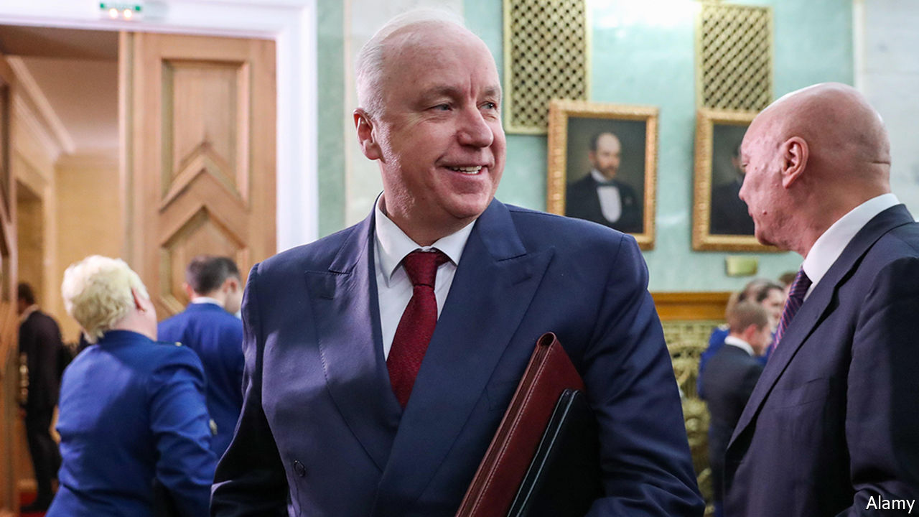

IN LIFE, SERGEI MAGNITSKY was a thorn in the side of Russia’s kleptocrats. The Russian lawyer paid the heaviest price for uncovering institutionalised tax fraud: he was tortured and died in prison. In death, he haunts them still. America already has a “Magnitsky Act”, aimed at people responsible for gross human-rights violations. On July 6th, the Foreign Office announced its own “Magnitsky” sanctions against 47 individuals and two entities. They went into effect on the same day.

Among those named are 25 Russians whom the government identifies as having contributed to Magnitsky’s mistreatment, including Alexander Bastrykin, head of Russia’s domestic investigative agency and an ally of Vladimir Putin. Another 20 are Saudi Arabian officials involved in the killing of Jamal Khashoggi, a journalist, in Istanbul in 2018. Two Burmese generals and two North Korean government departments round off the list. The government has the right to freeze the assets of those on the list and ban them from entering the country. Those named will no longer, as Mr Raab put it in Parliament, “be free to waltz into this country to buy up property on the King’s Road, or do their Christmas shopping in Knightsbridge, or frankly to siphon dirty money through British banks or financial institutions”.

Britain’s sanctions regime has until now worked through the UN or EU. Brexit allows the country to fashion its own rules. Indeed, the first piece of Brexit-related legislation passed by Parliament was the Sanctions and Anti-Money Laundering Act, says Maya Lester, a sanctions lawyer at Brick Court Chambers. It gives Britain the power to impose, change or lift sanctions independently. A Magnitsky clause was added after Russian agents poisoned five people in Salisbury in 2018.

There is some debate about whether Britain could have set up Magnitsky sanctions while in the EU. That the Baltic countries have done so suggests it could. But similar efforts at the European level, which would require unanimous support, have foundered. It “demonstrates [Britain’s] desire to go out on their own”, says Adam M. Smith, a lawyer and former sanctions official in the Obama administration. He characterises the move as “unilateral in style and multilateral in approach and impact”. Magnitsky legislation is a fulfilment of a manifesto pledge and Mr Raab, who has been calling for such an act since 2012, has achieved a rare political feat: delivering something he genuinely believes in.

What impact the sanctions will have is debatable. According to Andrew Wood, a former British ambassador to Russia, the measure does at least have an “emotive effect”, in the sense that people who would like to do business in Britain or have their children live there might feel more vulnerable. But there is “astonishingly little evidence” that their countries “will realise the errors of their ways and somehow change their own policies”, says Mark Galeotti, a Russia expert at the Royal United Services Institute, a security think-tank.

A likelier effect is a further chilling of relations between Britain and Russia, which finds Magnitsky sanctions particularly irksome. (Lifting the American ones was the focus of a pre-election meeting between Russian lobbyists and Donald Trump’s campaign team.) Russia has promised to retaliate. But, as Jamison Firestone, a London-based lawyer who was Magnitsky’s boss in Russia, puts it, “at some point you have to stop worrying about how things go down in Moscow.”■

This article was downloaded by calibre from <https://www.economist.com/britain/2020/07/11/brexit-britain-gets-its-own-magnitsky-sanctions>

|  |  |  |  |
| --- | --- | --- | --- |
| Previous | Articles | Sections | Next |

|  |  |  |  |
| --- | --- | --- | --- |
| Previous | Articles | Sections | Next |

#### Fiscal policy

# Sunak’s summer statement

A giveaway budget, vast in normal times, fails to impress

Jul 8th 2020 |

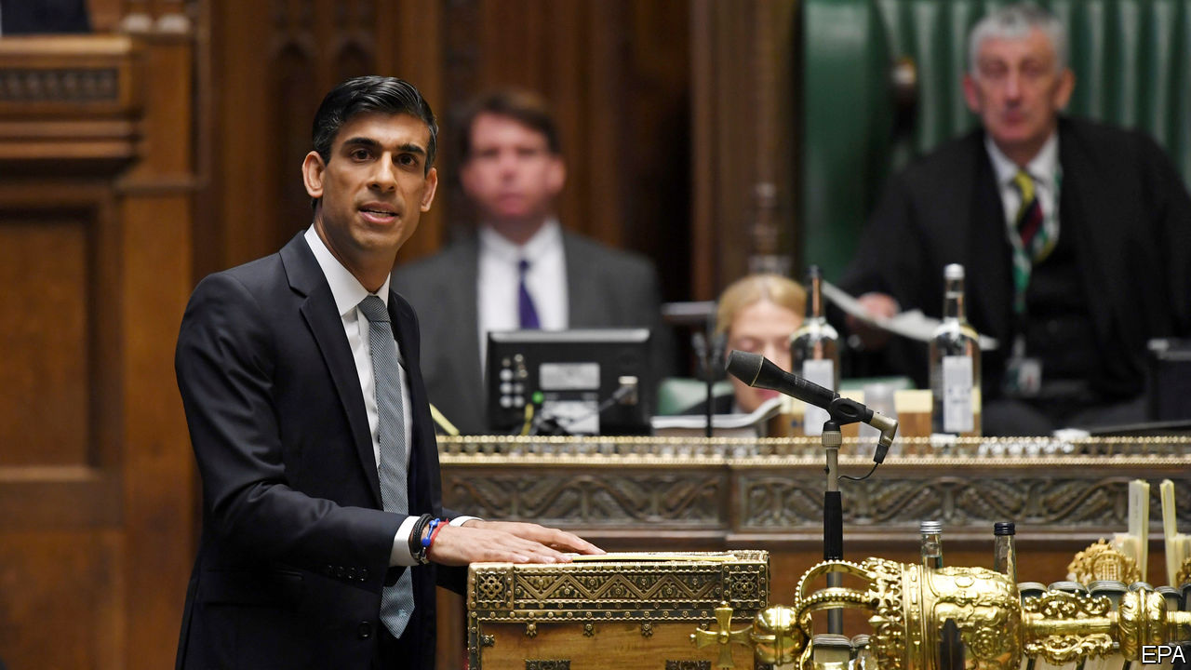

ON JULY 8TH Rishi Sunak, the chancellor, delivered what the Treasury called a “summer economic update”. Although it was not officially a budget, which would have required new forecasts and policy costings by the Office for Budget Responsibility (OBR), a fiscal watchdog, it felt like one. The chancellor spoke for only half an hour and yet still managed to announce around £30bn ($38bn) in new measures, some 1.4% of pre-crisis GDP, for the current fiscal year—a huge deal, in normal times.

Output, which shrank by around a quarter over the course of March and April, almost certainly began to expand again in May, but the pace and the shape of the recovery remain contentious (see article). Real-time data, which show consumer spending now down by a mere 10% year on year, point to a fairly rapid bounce, but other measures suggest a less rosy outcome. Capital Economics, a consultancy, reckons that the initial bounce-back in activity, as measured by visits to workplaces and shops, has been slower in Britain than in other rich economies. Both the OBR and the Bank of England appear to have been too pessimistic in their respective April and May forecasts on the scale of the plunge but independent forecasters reckon that both were too optimistic about the strength of the recovery. The hole is not as deep as the official forecasters feared but climbing out of it may take longer than they hoped.

In his statement, Mr Sunak outlined a three-phase plan to do that. The first phase was about limiting the fallout of lockdown. The second, current, one is reopening. The third will be rebuilding. The retention scheme, under which the government paid 80% of the wages of over 9m workers, was the centrepiece of the first phase. It worked. Unemployment was still below 4% at the end of May despite a record contraction in the economy.

With the furlough scheme now being tapered down before ending in October, redundancies look set to rise. The Centre for Retail Research, a consultancy, estimates that almost 50,000 jobs have already been lost in the sector this year. The chancellor has responded with a £2bn KickStart Scheme which will provide six-month work placements for 16- to-24-year-olds. The new Job Retention Bonus will pay any firm a bounty of £1,000 for each furloughed employee that they return to work and continuously employ until January 2021.

More conventional stimulus measures were targeted on especially hard-hit sectors. VAT on leisure and hospitality spending will be cut from 20% to 5% until January 2021. A gimmicky, cringeworthily entitled “Eat Out to Help Out” scheme will give a 50% discount of up to £10 a head on restaurant spending between Mondays and Wednesdays during August. With fear of infection being the main thing keeping people away from restaurants and pubs, tax cuts and discounts are unlikely to draw them back.

Commentators were underwhelmed. Samuel Tombs of Pantheon Macroeconomics argues that £30bn will not “fill the void” when the retention scheme ends in October. He still forecasts that GDP will be about 5% below its pre-covid-19 level at the end of the year. With the chancellor keen to emphasise that the policies in the summer statement were merely the next rather than the final step in his plans, more expansionary policies seem likely in the autumn fiscal statement. Adam Marshall, head of the British Chambers of Commerce, thinks that “the scale of the stimulus needed to help the UK economy restart, rebuild and renew will need to be greater still over the coming months.”

There was little mention in the speech or the accompanying documents of the overall health of the public finances. The Resolution Foundation, a think-tank, calculates that the deficit could hit £350bn, about 16% of pre-covid-19 GDP, this year. Phase four of the chancellor’s plan, the necessary tax rises and spending cuts to bring the deficit back to more normal levels, is not something on which the Treasury is keen to dwell.■

This article was downloaded by calibre from <https://www.economist.com/britain/2020/07/08/sunaks-summer-statement>

|  |  |  |  |
| --- | --- | --- | --- |
| Previous | Articles | Sections | Next |

|  |  |  |  |
| --- | --- | --- | --- |
| Previous | Articles | Sections | Next |

#### Economic data

# Has the ONS solved the “productivity problem”?

Dodgy data may explain a troubling mystery

Jul 11th 2020 |



FOR MORE than a decade, Britain’s productivity growth has lagged behind the rest of the world’s. This “productivity problem” has baffled economists and troubled politicians. Now the Office for National Statistics (ONS) has offered at least a partial solution. On July 6th, it published an update on the measurement of prices in the telecommunications industry, which suggests an underestimate of sectoral output so large that it had a sizeable impact on its sums for the economy as a whole.

The review focused on changes between 1997 and 2016, a period in which dial-up 56k modems and bricklike supposedly “mobile” phones gave way to fibre-optic broadband and 5G-enabled smartphones. Measuring output in a time of huge technological change is difficult. Three years of work with industry insiders and academics have led statisticians to better incorporate widening network coverage and faster download speeds. The biggest changes are in how the ONS proposes to weight data usage against older services such as voice calls and texts and in how the underlying index is constructed. The current price index is based on the revenues rather than the volume of usage.

The results are dramatic (see chart). Whereas the ONS previously believed prices for telecoms services fell by around half over the period it now reckons they collapsed by 95%. That means that output in the sector, when deflated by the new measure, grew nearly eight times faster than previously thought.

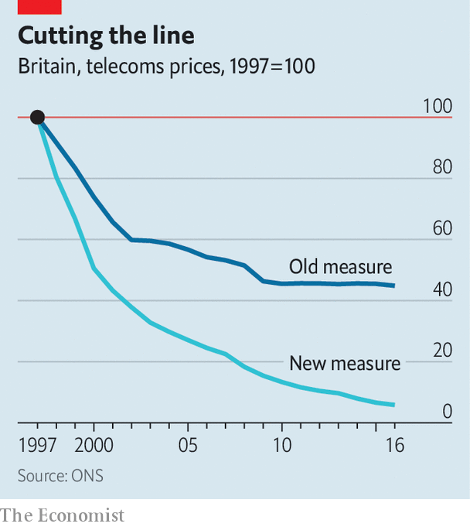

Just how much that change will boost the headline growth number will not be clear until October, when the ONS will detail the changes’ impact on the wider economy. Some of the newly discovered growth in telecoms output will come at the expense of other sectors, but higher overall growth will translate to a stronger productivity performance.■

This article was downloaded by calibre from <https://www.economist.com/britain/2020/07/11/has-the-ons-solved-the-productivity-problem>

|  |  |  |  |
| --- | --- | --- | --- |
| Previous | Articles | Sections | Next |

|  |  |  |  |
| --- | --- | --- | --- |
| Previous | Articles | Sections | Next |

#### Paying for the arts

# A bailout for Britain’s theatres

It won’t mean that the show goes on

Jul 11th 2020 | NEWCASTLE



THE STAGE is still set. The most recent production at Northern Stage, a theatre on Newcastle University’s campus, was in technical rehearsals when Britain went into lockdown. Props from the show are strewn across the stage. At the back of the auditorium, a bag of popcorn and a bottle of Lucozade lie on a table, as if the crew expected to return at any moment. “This show is ‘Arriving’,” explains Kate Denby, the venue’s executive director. Indeed.

Britain’s performers are in a pause that even Samuel Beckett might think a tad lengthy. Spotlights went off on March 16th and few believe they will be on again soon. The country’s theatres are the liveliest in the world, with more than 5,000 productions a year that generate £1.3bn ($1.64bn) or so in box-office revenue alone. But, as ticket sales dried up, about two-thirds of theatres risked going bust by Christmas. Newcastle’s neoclassical Theatre Royal is making half of its 100 permanent staff redundant; most of the rest will be put on retainers. Only a dozen are at work, says Philip Bernays, its chief executive. “The box office staff are refunding, refunding and refunding. That’s all we do now.”

Ironically, the most commercially successful places are hardest hit, because they rely wholly on box-office revenue. Northern Stage, for instance, has continued to receive its regular grant from Arts Council England (ACE), which makes up two-fifths of its income. The Theatre Royal, a charity that stages crowd-pleasing musicals and blockbuster plays, has lost everything.

So the government’s rescue package for the arts, announced on July 5th, drew much applause. Details remain sketchy, but its support for English venues will total £1.15bn. Left-leaning luvvies are adjusting to a world in which their principal benefactor is a Tory government. Theatres went ahead with a plan to light up their facades in red to highlight their plight on July 6th, despite the unexpected windfall. Mr Bernays chuckles that Tory blue would not be “a good idea in Newcastle”.

Even so, it may not be enough to keep the lights on. As Annabel Turpin of ARC, a venue in Stockton-on-Tees, puts it, much depends on whether the money is treated as “a bail-out or a stimulus”. Organisations like hers, which are small and relatively nimble, can stage productions at short notice to respond to the changing risk posed by covid-19. In the meantime, she will pay performers to work with children in care, the elderly and asylum-seekers.

But many of the most renowned venues, including theatres in London’s West End, are likely to use the money for mothballing, not productions. They need to sell tickets for about four in five seats for every performance just to break even. That is incompatible with social-distancing rules, even if the government lifts its ban on live performances. The Theatre Royal worked out it could seat only 221 people two metres apart from each other or 370 with a one-metre gap; it needs an audience of 1,000 a night to break even. Charities like the National Theatre would be keen to go ahead with some productions anyway, using their grant in effect to subsidise loss-making performances. Commercial producers are unlikely to take the risk. Cameron Mackintosh, an impresario, has cancelled his shows until next year.

The Royal Albert Hall is a venue for hire, so if loss-making concerts were staged there now some of the taxpayers’ money would go into promoters’ pockets. Craig Hassall, the chief executive, says he would find that hard to stomach. “With social distancing, irrespective of the support package, we can’t open our venues. That’s the West End, regional theatres, concert halls.”

Britain’s theatre world looks enviously to South Korea, where “The Phantom of the Opera” is still playing with measures to mitigate infection risks but without social distancing. Andrew Lloyd Webber, who owns seven London theatres, wants the British government to allow something similar. Unless it does, the bail-out is good news for theatres, less so for theatre. ■

Editor’s note: Some of our covid-19 coverage is free for readers of The Economist Today, our daily [newsletter](https://my.economist.com/user#newsletter). For more stories and our pandemic tracker, see our [hub](https://www.economist.com/news/2020/03/11/the-economists-coverage-of-the-coronavirus)

This article was downloaded by calibre from <https://www.economist.com/britain/2020/07/11/a-bailout-for-britains-theatres>

|  |  |  |  |
| --- | --- | --- | --- |
| Previous | Articles | Sections | Next |

|  |  |  |  |
| --- | --- | --- | --- |
| Previous | Articles | Sections | Next |

#### Policing and the pandemic

# How Britain’s cops spent lockdown

A decline in crime gives police forces the chance to catch up on their to-do lists

Jul 11th 2020 |

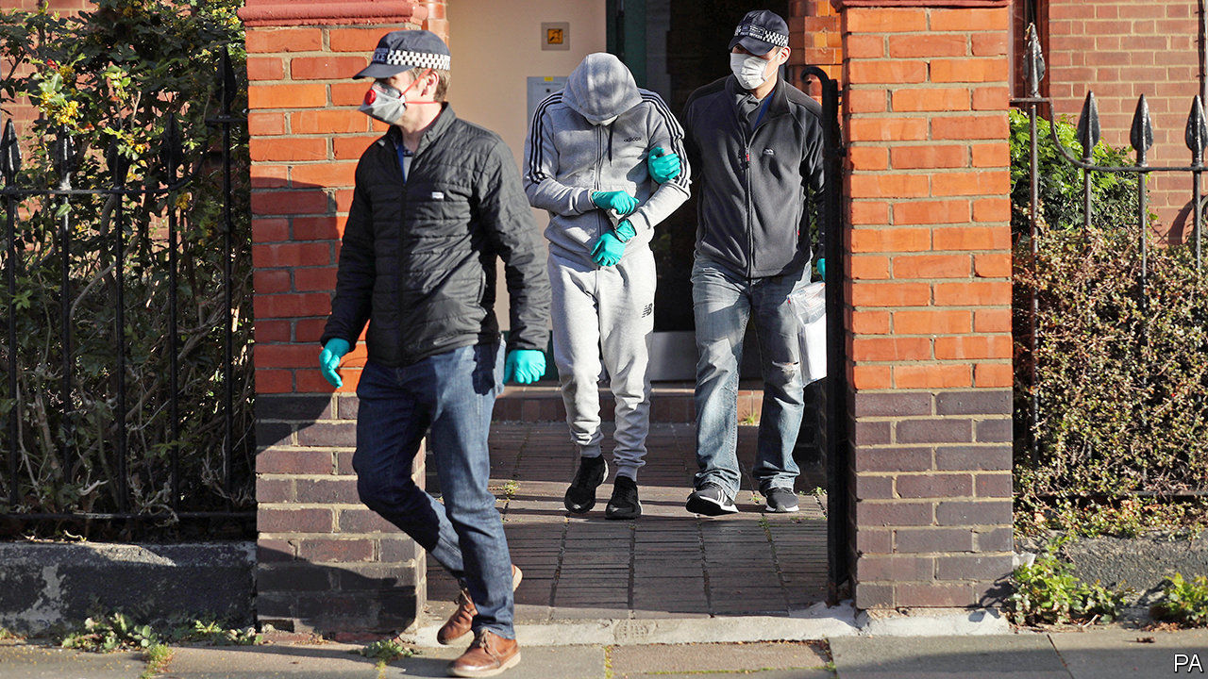

WHEN THE nation shut down in March, something both remarkable and utterly obvious happened to everyday crime: it plummeted. Graham Farrell, a criminologist at the University of Leeds who looked at data from the Lancashire Constabulary, found that within a week of lockdown recorded crime in Lancashire declined by 41%. Shoplifting was especially hard hit, falling by 62%. It is a difficult crime to commit when most shops are closed.

But not all crime fell. After lockdown started, even as overall crime declined in London just as it did elsewhere, drug offences recorded by the Metropolitan Police shot up (see chart). Drug offences data are a good indicator of disruption in organised crime since that is the mainstay of such groups, says Rick Muir of the Police Foundation, a think tank.

One reason for the rise is that the drugs trade became easier to disrupt. While other businesses shut down, it kept going. “Organised criminals are innovative people. They responded well, from their perspective, so actually there weren’t long term shortages or price rises within the UK,” says Steve Rodhouse, a director general at the National Crime Agency (NCA). But the business demands face-to-face contact, and drug dealers who were out on the streets when everybody else was inside were abnormally conspicuous.

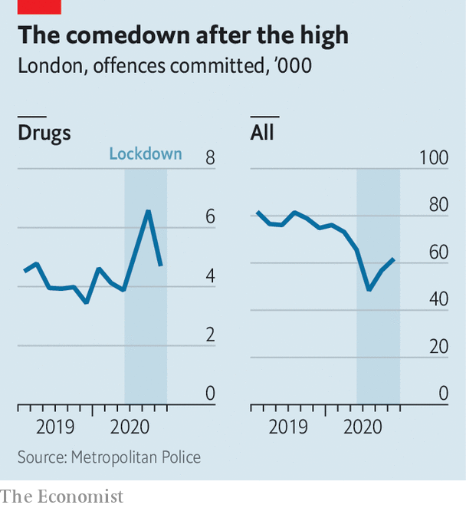

At the same time, while demands on the police declined, the supply of officers rose as leave was cancelled and new recruits promised by Boris Johnson last year arrived. Police forces used the time to tackle their to-do lists. Among the things they did was “progressing complex investigations, for example county lines”, a national network of drug-runners, says Julia Mulligan, North Yorkshire’s police and crime commissioner. North Yorkshire police worked with their counterparts in areas that supply drugs, including Merseyside, West Yorkshire and Greater Manchester. And as Peter Neyroud, a criminologist at Cambridge University and a former chief constable puts it, “It’s a great time to serve warrants, because everyone has to be at home.”

In London, the Metropolitan Police drew up a list of roughly 1,000 “prolific” offenders engaged in drug-related and violent crimes. Officers visited 733 to encourage them to “diversify away from crime”, says Commander Bas Javid of the Met. In the event, they spoke to 304, of whom 43 have expressed an interest in taking part in the scheme.

Another tactic used by the Met was to identify what it calls “micro beats” of 250 locations in London with high levels of violent crime and drug activity. In one special operation in a week in May the Met arrested 222 people. Long-running investigations also came to a head. On July 2nd the NCA announced that it had arrested 746 people and seized £54m in cash, two tonnes of drugs and 77 firearms as the result of investigations done over four years with various forces and other agencies.

As restrictions are loosened, the trends are reversing. Recorded offences rose in the past few weeks and drugs offences have fallen. That suggests that police once again have their hands full with everyday crime. But it may also mean that their efforts at disrupting the networks responsible for these crimes have had an effect. ■

Editor’s note: Some of our covid-19 coverage is free for readers of The Economist Today, our daily [newsletter](https://my.economist.com/user#newsletter). For more stories and our pandemic tracker, see our [hub](https://www.economist.com/news/2020/03/11/the-economists-coverage-of-the-coronavirus)

This article was downloaded by calibre from <https://www.economist.com/britain/2020/07/11/how-britains-cops-spent-lockdown>

|  |  |  |  |
| --- | --- | --- | --- |
| Previous | Articles | Sections | Next |

|  |  |  |  |
| --- | --- | --- | --- |
| Previous | Articles | Sections | Next |

#### Food

# Britons are defrosting decades-old diets

Fruit is out; fry-ups are in

Jul 11th 2020 | WELWYN GARDEN CITY

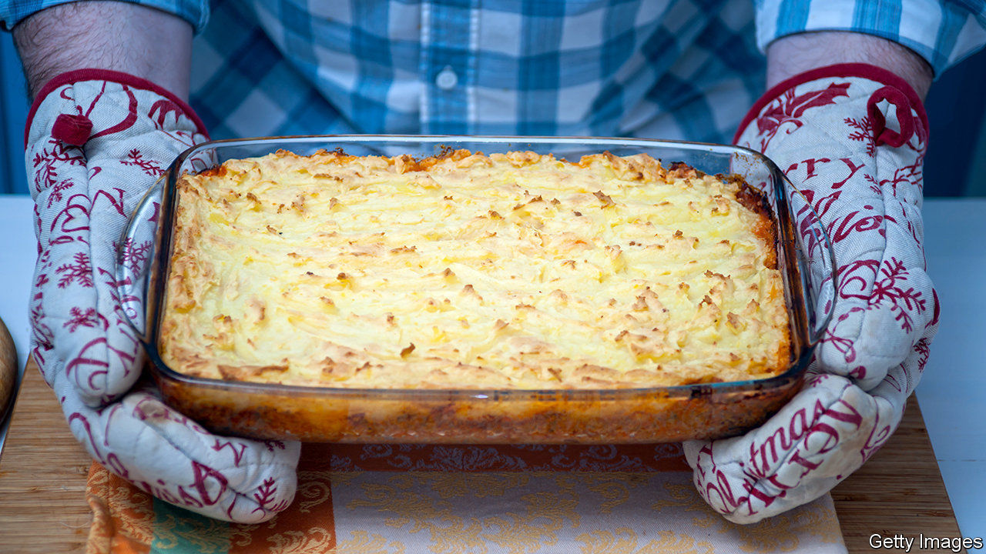

FIRST CAME the panic-buying and the stockpiling. As soon as it became clear that covid-19 was spreading through Britain, shoppers hit the grocery stores. Everything with a long shelf life was swept into trolleys—pasta, tinned beans, bottled water. People even cleared the shelves of pickled onions, recalls Peter Batt, who oversees the Co-Op’s convenience stores in southern England. “They were thinking a wartime sort of scenario,” he says.

In the end people had plenty to eat: in late May 48% told Ipsos MORI, a pollster, that they had gained weight. Sixteen weeks after the lockdown began, though, diets remain disrupted. If British eating patterns have not returned to those of the second world war, nor are they much like those of 2019. Instead, they have regressed roughly to a mid-point between those times.

With many offices only half-open and most children off school, more meals are being eaten at home. Spending on groceries in the week to June 27th was 13% higher than a year ago, according to IRI, a research firm. Because fewer people are commuting, mealtimes have changed. “Evening meals will be earlier, breakfast will be later,” says Giles Quick of Kantar, another research outfit. Family meals are more frequent and more orderly—a main course followed by a dessert. Mr Quick, who is 61, says it reminds him of his childhood.

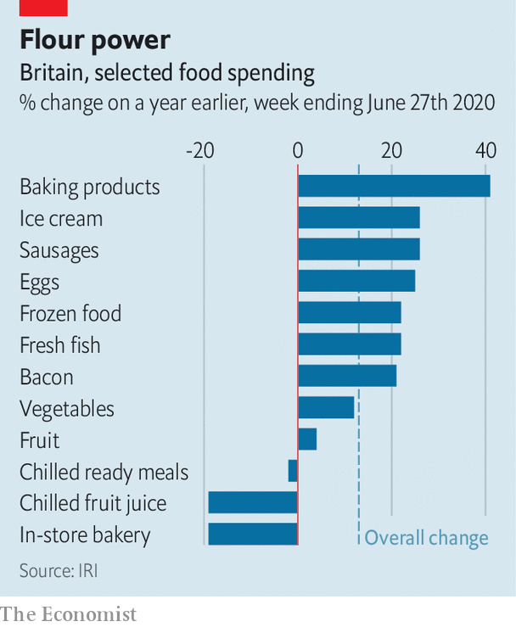

Old-fashioned foods are back. Over the past few decades the Family Food Survey has tracked a gradual decline in the eating of eggs and bacon. Britons are now consuming more of both, presumably in leisurely breakfast fry-ups. Sausages are selling well, too (see chart). Ready meals, the rise of which had come to seem inexorable, have not kept up with the general rise in grocery sales. They were often bought on the way home from the office.

As sharp-elbowed supermarket shoppers can attest, nothing has been so in demand as flour. In both April and May, all top ten most-viewed recipes on the BBC Good Food website were for bread or baking. The new army of amateur bakers may tell themselves that home-cooked bread tastes better. But a more likely explanation is that people have time on their hands, and that worries about food hygiene have sharpened, says Krishnakumar Davey of IRI.

Nick Robinson, the chief executive of Kerry Foods, an Irish firm that makes spreads, flour and sausages, thinks that the same concern for safety helps to explain the popularity of frozen food. Unlike tinned food, which flew off shelves in the panic-buying days before returning to more normal levels, frozen food has continued to sell well. Iceland, a supermarket that specialises in it, is exceptionally busy. Its sales rose by 31% in the 12 weeks to mid-June, according to Kantar.

There seems to be a limit to how much time Britons will spend cooking, though. Although sales of mince and burgers have shot up, joints of beef and lamb are less popular than a year ago. It may be that Britons associate joints with large, slow meals with their extended families. Those have not been happening.

“I’ve had a joint sitting in the freezer for months,” says Mandy Walker, who is shopping with her family at the Sainsbury’s supermarket in Welwyn Garden City, a commuter town north of London. She is buying more mince and chicken than before lockdown. That is because she has to prepare many more meals than usual for children, who do not object too violently to those foods. “And less fruit and veg,” she adds. “That’s the terrible thing”.

As pubs, restaurants and offices reopen, some of these trends will reverse. But probably not all of them. Even in New Zealand, which eradicated covid-19 a month ago, sales of flour and baking mixes are a tenth higher than a year ago, according to IRI, and the restaurant trade is not back to normal. The changes in Britain are caused not just by new living patterns, but also by recession. Andre Burger, who oversees Unilever’s food brands in the country, says that a shrinking economy affects people’s eating habits in odd ways. They try to economise by cooking from scratch and in bulk. They also indulge in more sweet treats. To the many signs that consumer confidence is slumping, add this: for each of the past ten weeks, sales of ice-cream and frozen desserts have been at least 16% above last year’s levels.■

This article was downloaded by calibre from <https://www.economist.com/britain/2020/07/11/britons-are-defrosting-decades-old-diets>

|  |  |  |  |
| --- | --- | --- | --- |
| Previous | Articles | Sections | Next |

|  |  |  |  |
| --- | --- | --- | --- |
| Previous | Articles | Sections | Next |

#### Bagehot

# Anglophilia is fading in America

But the British still have something to teach the Americans

Jul 11th 2020 |

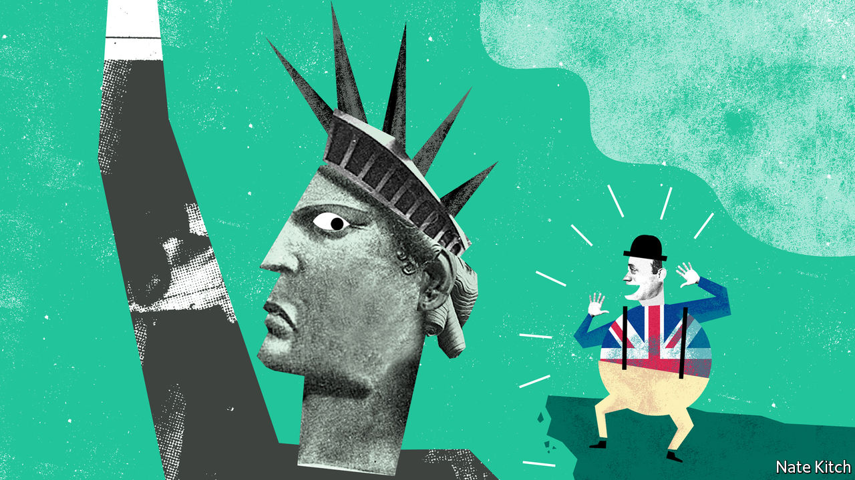

WHEN GHISLAINE MAXWELL arrived in New York in 1991 her life was in pieces. Her father’s corpse was found floating near a yacht that bore her name; her family business had imploded; the Maxwell name was mud. Yet within a few years she was back on top: living in style on the Upper East Side and sitting at the very heart of New York society.

Why was the newcomer such a hit? The dark pact that she formed with Jeffrey Epstein, a paedophile for whom she is accused of procuring minors, provided her with access to lots of money. Her wit and charm made her stand out. But being British also helped. Ms Maxwell was invariably described as an “Oxford-educated British socialite”. She dropped dinky British phrases into her conversation and traded on the smart British names in her address book, the most valuable of which was Prince Andrew’s.

Ms Maxwell was part of a generation of Britons who went to America in the 1990s and 2000s in search of fame and fortune. The invasion was driven by talent and ambition: with the advent of globalisation many Britons decided that if they wanted to play in the premier league, they needed to move to the United States. Britons rose to the top of a striking number of journalistic and cultural institutions from the New Yorker through Vogue to the Metropolitan Museum. Christopher Hitchens and Andrew Sullivan became America’s leading contrarians. Simon Schama and Niall Ferguson were among the academics who fled the low pay and heavy teaching loads at British universities and won profitable stardom at Ivy League institutions.

Anglophilia greased the entry of the British into the American establishment. Institutions such as the Council for Foreign Relations fostered it. A British accent was regarded as proof of intelligence and wit. Some of the immigrants were genuinely talented, but Anglophilia lifted plenty of flotsam and jetsam too, and allowed clever Brits to get away with things that Americans never could. Hitchens even lit a cigarette on television, leaving his interviewer speechless.

The British invasion was further eased by the Atlantic alliance, which was revived by Ronald Reagan and Margaret Thatcher, and flourished through Tony Blair’s relationships with Bill Clinton and George Bush. It was, in part, a convenient fiction for both sides, allowing America to claim that it was acting in something bigger than its own interests and Britain to believe that it still had a seat at the top table. But it also had some substance to it, particularly as globalisation gathered pace. Both countries embraced a distinctive model of finance-driven capitalism; indeed, London was arguably a bigger financial centre than New York.

In recent years, Britain has lost some of its cachet in America. The press regularly—and the president occasionally—portrays the country as a poverty-stricken, crime-ridden dystopia. America’s population is becoming less Anglo-Saxon and more Hispanic and Asian. Students across the country are demanding the “decolonisation of the curriculum”, which means, among other things, less British history and English literature. Walter Lippmann, one of America’s greatest columnists, once described America’s relationship with Britain as one of “discordant intimacy”. Today the discord sometimes drowns out the intimacy.

The combination of Donald Trump’s election and Britain’s decision to leave the European Union has also destroyed two of Britain’s most important assets. Mr Trump used the Atlantic alliance as a way of beating up the EU rather than building an alliance of democracies. Brexit simultaneously deprived Britain of its position as a bridge between America and the EU and destroyed its reputation as a well-run country capable of calming America’s frequent temper tantrums. A New Yorker cover shortly after the Brexit vote displayed a group of bowler-hatted lemmings racing over a cliff. And over the past four years the British have done their best to prove the magazine right, discarding two prime ministers, dismissing their Parliament briefly and—measured by deaths per head of the population—managing the covid-19 crisis even worse than America has.

Britain clearly still needs America, especially now that Brexit has divided Britain from Europe, and China’s clampdown in Hong Kong limits Asian options. Aspiring Britons will still go there to try to make their names. For all its recent travails America still offers fabulous rewards and continent-sized opportunities.

The more intriguing question is whether America needs Britain any longer. It still has an appetite for British talent, and not just of the floppy-haired ersatz-upper-class Hugh Grant-style variety: it has taken to comedians with non-U accents such as James Corden and John Oliver, as well as writers who chronicle the experience of minorities such as Zadie Smith. It will also have much more use for the old Atlantic alliance if Mr Trump loses the election, as looks increasingly likely. Joe Biden’s America will be in the business of rebuilding relationships across the board; and despite leaving the EU, Britain, with its deep military, diplomatic and security relations with the United States, will be an important part of that process.

Americans may also discover that they can profit from advice in an area the British know all too well—decline and stagnation. America bears more than a passing resemblance to early-20th-century Britain, which saw itself overtaken in one area after another by a rising and much more disciplined Germany. “The Coming Neo-Feudalism”, a new book by Joel Kotkin of Chapman University, describes a world quite familiar to the British, in which a hereditary ruling elite lords it over a compliant intelligentsia and an impoverished middle class. Britons may not have solved the problems of economic decline and neo-feudalism in their own country. But they have had plenty of time to reflect on them—and at the very least they can warn Americans what will happen if they don’t change course. ■

This article was downloaded by calibre from <https://www.economist.com/britain/2020/07/11/anglophilia-is-fading-in-america>

|  |  |  |  |
| --- | --- | --- | --- |
| Previous | Articles | Sections | Next |

|  |  |  |
| --- | --- | --- |
| Britain | Sections | Business |

International

Race and liberal philosophy: In the balance

.

|  |  |  |
| --- | --- | --- |
| Britain | Sections | Business |

|  |  |  |  |
| --- | --- | --- | --- |
|  | Articles | Sections | Next |

#### In the balance

# Enlightenment liberalism is losing ground in the debate about how to deal with racism

A new ideology is emerging

Jul 9th 2020 |

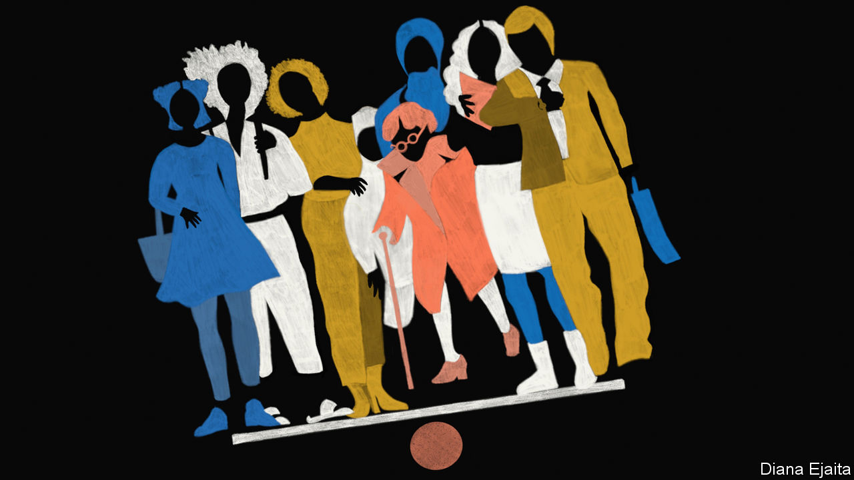

LIBERALISM—the Enlightenment philosophy, not the American left—starts with the assertion that all human beings have equal moral worth. From that stem equal rights for all. Libertarians see those principles as paramount. For left-leaning liberals, equal moral worth also brings an entitlement to the resources necessary for an individual to flourish.

Yet when it comes to race many liberals have failed to live up to their own values. “We hold these truths to be self-evident,” wrote Thomas Jefferson in America’s Declaration of Independence in 1776, “that all men are created equal.” More than a decade later the Founding Fathers would write into the country’s constitution that a slave was in fact to be considered three-fifths of a person. In Europe many liberals opposed slavery but supported despotic imperial rule overseas. “Perhaps liberal theory and liberal history are ships passing in the night,” speculated Uday Singh Mehta of the City University of New York in 1999.

What lies behind this failure? That question is especially important today. Norms are shifting fast. The global protests that sprang up after the killing of George Floyd denounced racism throughout society. Companies, often pressed by their own employees, are in a panic about their lack of diversity, particularly at the top. Television stations and the press are rewriting the rules about how news should be covered and by whom. There is a fight over statuary and heritage, just as there is over people forced out of their jobs or publicly shamed for words or deeds deemed racist.

It is a defining moment. At Mr Floyd’s funeral, the Rev Al Sharpton declared: “It’s time to stand up in George’s name and say, ‘Get your knee off our necks.’” At Mount Rushmore on July 3rd, President Donald Trump condemned “a new far-left fascism”. To understand all this, it is worth going back to the battle of ideas. In one corner is liberalism, with its tarnished record, and in the other the anti-liberal theories emerging from the campus to challenge it.

During the past two centuries life in the broadest terms has been transformed. Life expectancy, material wealth, poverty, literacy, civil rights and the rule of law have changed beyond recognition. Though that is not all thanks to Enlightenment liberals, obviously, liberalism has prospered as Marxism and fascism have failed.

But its poor record on race, especially with regard to African-Americans, stands out. Income, wealth, education and incarceration remain correlated with ethnicity to a staggering degree. True, great steps have been taken against overt racial animus. But the lack of progress means liberals must have either tried and failed to create a society in which people of all races can flourish, or failed to try at all.

America’s founding depended on two racist endeavours. One was slavery, which lasted for almost 250 years and was followed by nearly a century of institutionalised white supremacy. Of the seven most important Founding Fathers, only John Adams and Alexander Hamilton did not at some point own slaves. Nine early American presidents were slaveholders. And although slavery is a near-universal feature of pre-Enlightenment societies, the Atlantic slave trade is notable for having been tied to notions of racial superiority.

The other was imperialism, when British colonialists violently displaced existing people. Many 18th-century European liberals criticised the search for empire. Adam Smith viewed colonies as expensive failures of monopoly and mercantilism that benefited neither side, calling Britain’s East India Company “plunderers”. Edmund Burke (a liberal in the broadest sense) decried the “outrageous” injustices in British colonies, including “systematick iniquity and oppression” in India, which resulted from power that was unaccountable to those over whom it was exercised.

But, argues Jennifer Pitts of the University of Chicago in her book “A Turn to Empire”, in the 19th century the most famous European liberals gravitated towards “imperial liberalism”. The shift was grounded in the growing triumphalism of France and Britain, which saw themselves as qualified by virtue of their economic and technological success to disseminate universal moral and cultural values. John Stuart Mill abhorred slavery, writing during the American civil war in 1863 that “I cannot look forward with satisfaction to any settlement but complete emancipation.” But of empire he wrote that “Despotism is a legitimate mode of government in dealing with barbarians, provided the end be their improvement, and the means justified by actually effecting that end.” (Mill worked for the East India Company for 35 years.) Alexis de Tocqueville championed the French empire, in particular the violent conquest and settlement of Algeria.

A belief in the basic similarity of human beings, and of their march towards progress, led these thinkers to the belief that it was possible to accelerate development at the barrel of a gun. Even at the time, this paternalism should have been tempered by scepticism about whether it can be just for one people to impose government on another. Although Mill criticised the British empire’s atrocities, he did not see them, as Burke had, as the inevitable consequence of an unaccountable regime.

The turn in liberal thought was reflected in the pages of The Economist. From its founding in 1843 the newspaper opposed slavery, and early in its existence it criticised imperialism. But we later backed the Second Opium War against China, the brutal suppression of the 1857 Indian mutiny and even the invasion of Mexico by France in 1861. We wrote that Indians were “helpless...to restrain their own superstitions and their own passions”. Walter Bagehot, editor from 1861 to 1877, wrote that the British were “the most enterprising, the most successful, and in most respects the best, colonists on the face of the earth”. Although the newspaper never ceased to oppose slavery, it claimed, bizarrely, that abolition would be more likely were the Confederacy to win America’s civil war. It was not until the early 20th century that The Economist regained some of its scepticism regarding empire, as liberalism at home evolved into a force for social reform.

In America the big liberal shift took place in the mid-1960s. To deal with the legacy of slavery, liberals began to concede that you need to treat the descendants of slaves as members of a group, not only as individuals. Sandra Day O’Connor, the first woman to serve on the Supreme Court, argued that affirmative action, though a breach of liberal individualism that must eventually be dispensed with, had to stay until there was reasonable equality of opportunity between groups.

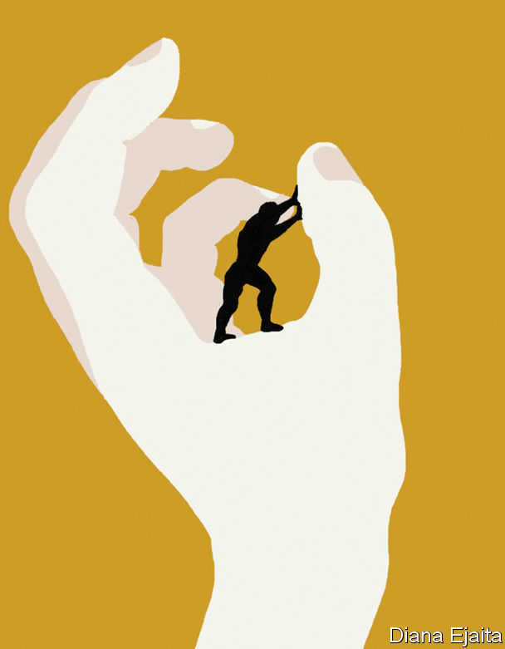

Plenty of thinkers grappled with affirmative action, including Daniel Patrick Moynihan, a politician, sociologist and diplomat, and Ronald Dworkin, a philosopher and jurist. However, the most famous left-liberal work of the 20th century, written in 1971, was notably silent on race. The key idea of John Rawls’s “A Theory of Justice” is the “veil of ignorance”, behind which people are supposed to think about the design of a fair society without knowing their own talents, class, sex or indeed race. Detached from such arbitrary factors people would discover principles of justice. But what is the point, modern critics ask, of working out what a perfectly just society looks like without considering how the actual world is ravaged by injustice?

Liberalism as it is theorised “abstracts away from social oppression”, writes Charles Mills, also of the City University of New York. The “Cambridge Companion to Rawls”, a roughly 600-page book published in 2002, has no chapter, section or subsection dealing with race. “The central debates in the field as presented”, writes Mr Mills, “exclude any reference to the modern global history of racism versus anti-racism.”

As the gains of the civil-rights era failed to translate into sustained progress for African-Americans, dissatisfaction with liberalism set in. One of the first to respond was Derrick Bell, a legal scholar working at Harvard in the 1970s. “Critical race theory”, which fused French post-modernism with the insights of African-Americans like Frederick Douglass, an abolitionist and former slave, and W.E.B. Du Bois, a sociologist, then emerged.

Critical race theory first focused on the material conditions of black Americans and on developing tools to help them win a fair hearing in the courtroom. One is “intersectionality”, set out in a defining paper in 1991 by Kimberlé Crenshaw, another legal scholar and civil-rights campaigner. A black woman could lose a case of discrimination against an employer who could show that he did not discriminate against black men or white women, she explains. The liberal, supposedly universalist, legal system failed to grasp the unique intersection of being both a woman and black.

In the three decades since that paper was written, critical race theory has flourished, spreading to education, political science, gender studies, history and beyond. HR departments use its terminology. Allusions to “white privilege” and “unconscious bias” are commonplace. Over 1,000 CEOs, including those of firms such as JPMorgan Chase, Pfizer and Walmart, have joined an anti-racism coalition and promised that their staff will undertake unconscious-bias training (the evidence on its efficacy is limited). Critical race theory informs the claim that the aim of journalism is not “objectivity” but “moral clarity”.

## More than words can ever say

Yet as critical race theory has grown, a focus on discourse and power has tended to supersede the practicalities. That has made it illiberal, even revolutionary.

The philosophical mechanics that bolt together critical race theory can be obscure. But the approach is elegantly engineered into bestselling books such as “How To Be An Antiracist” by Ibram X. Kendi and “White Fragility” by Robin DiAngelo.

One thing that the popular synthesis preserves is its contempt for the liberal view of how to bring about social and moral progress. To understand why, you need to start with how ordinary words take on extraordinary meanings. “Racism” is not bigotry based on the colour of your skin. Races, Mr Kendi writes, “are fundamentally power identities” and racism is the social and institutional system that sustains whites as the most powerful group. That is why “white supremacy” alludes not to skinheads and the Ku Klux Klan, but, as Ms DiAngelo explains, the centrality and superiority of whites in society.

Some acts also have an unfamiliar significance. Talking to someone becomes a question of power. The identity of the speaker matters because speech is not neutral. It is either bad (ie, asserting white supremacy, and thus shoring up today’s racist institutions), or it is good (ie, offering solidarity to victims of oppression or subverting white power). The techniques of subversion, called criticism, unpack speech to reveal how it is “problematic”—that is, the ways in which it is racist.

Speech is unfamiliar in another way, too. When you say something, what counts is not what you mean but how you are heard. A privileged person sees the world from their own viewpoint alone. Whites cannot fully understand the harm they cause. By contrast, the standpoint of someone who is oppressed gives them insight into both their own plight and the oppressor’s world-view, too. “To say that whiteness is a standpoint”, Ms DiAngelo writes, “is to say that a significant aspect of white identity is to see oneself as an individual, outside or innocent of race—‘just human’.”

Black people can also find themselves in the wrong. What if two black people hear a white person differently and disagree over whether he was racist? Critical race theorists might point out that there are many sorts of oppression. In 1990 Angela Harris, a legal scholar, complained that feminism treated black and white women as if their experience were the same. By being straight and male, say, the listener belongs to groups that are dominant along some axis other than race. The way out of oppression is through the recognition and empowerment of these group identities, not their neglect. Or one of them may have failed to grasp the underlying truth of how racism is perpetuated by society. If so, that person needs to be educated out of their ignorance. “The heartbeat of racism is denial,” Mr Kendi writes, “the heartbeat of anti-racism is confession.”

These ideas have revolutionary implications. One result of seeing racism embedded all around you is a tendency towards a pessimistic attitude to progress. Bell concluded that reform happens only when it suits powerful white interests. In 1991 he wrote: “Even those Herculean efforts we hail as successful will produce no more than temporary ‘peaks of progress’, short-lived victories that slide into irrelevance as practical patterns adapt in ways that maintain white dominance.”

The second implication is that well-meaning white people are often enemies. Colour-blind whites deny society’s structural racism. Ms DiAngelo complains that “White people’s moral objection to racism increases their resistance to acknowledging their complicity in it.” Integrationists—Mr Kendi’s term for those who want black culture and society to integrate with white—rob black people of the identity they need to fight racism. He accuses them of “lynching black cultures”.

Where does this leave liberalism? “Cynical Theories”, a forthcoming book by Helen Pluckrose and James Lindsay, two writers, argues that the two systems of thought are incompatible. One reason is that the constellation of postmodern thinking dealing with race, gender, sexuality and disability, which they call “Theory”, disempowers the individual in favour of group identities, claiming that these alignments are necessary to end oppression. Another is Theorists’ belief that power is what forces out entrenched interests. But this carries the risk that the weak will not prevail, or that if they do, one dominant group will be replaced by another. By contrast, liberals rely on evidence, argument and the rule of law to arm the weak against the strong. A third reason is that Theory stalls liberal progress. Without the machinery of individual equality fired up by continual debate, the engine will not work.

## No easy answers

But what will? The appeal of critical race theory—or at least its manifestation in popular writing—is partly that it confidently prescribes what should be done to fight injustice. It provides a degree of absolution for those who want to help. White people may never be able to rid themselves of their racism, but they can dedicate themselves to the cause of anti-racism.

Liberals have no such simple prescription. They have always struggled with the idea of power as a lens through which to view the world, notes Michael Freeden of Oxford University. They often deny that groups (rather than individuals) can be legitimate political entities. And so liberal responses to critical race theory can seem like conservative apathy, or even denial.

Tommie Shelby of Harvard University, who sees himself as both a critical race theorist and a liberal, argues that scepticism regarding liberalism’s power to redress racial inequality is “rooted in the mistaken idea that liberalism isn’t compatible with an egalitarian commitment to economic justice.” Mr Shelby has argued that the Rawlsian principle of “fair equality of opportunity” can mean taking great strides towards a racially just society. That includes not just making sure that formal procedures, such as hiring practices, are non-discriminatory. It also includes ensuring that people of equal talent who make comparable efforts end up with similar life prospects, eventually eradicating the legacy of past racial injustices.

This would be a huge programme that might involve curbing housing segregation, making schooling more equal and giving tax credits (see Briefing). That is not enough for Mr Mills, another liberal and critical race theorist. He wants liberal thinkers to produce theories of “rectificatory justice”—say, a version of the veil of ignorance behind which people are aware of discrimination and the legacy of racial hierarchy. Liberals might then be more willing to tolerate compensation for past violations. They might also demand a reckoning with their past failures.

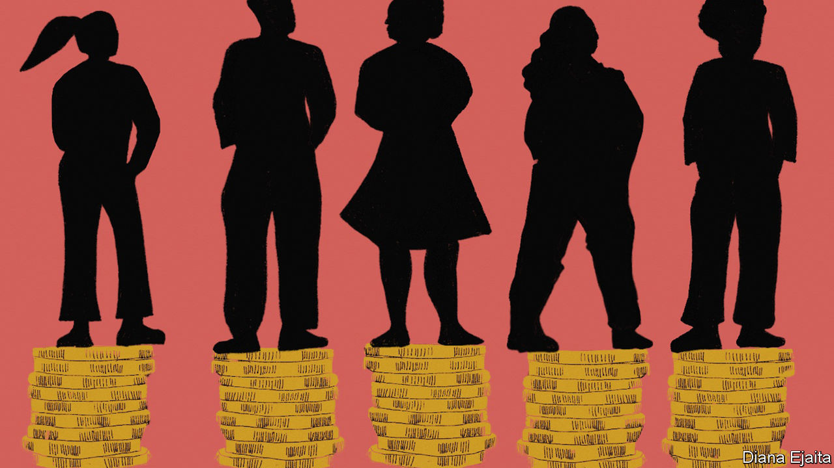

The problem is thorniest for libertarians who resist redistributive egalitarian schemes, regardless of the intention behind them. But even some of the most committed, such as Robert Nozick, concede that their elevation of property rights makes sense only if the initial conditions under which property was acquired were just. Countries in which the legacy of racial oppression lives on in the distribution of wealth patently fail to meet that test. Putting right that failure, Mr Mills says, “should be supported in principle by liberals across the spectrum”.

Plenty of people are trying to work out what that entails, but the practicalities are formidable. Having failed adequately to grapple with racial issues, liberals find themselves in a political moment that demands an agenda which is both practically and politically feasible. The risk is that they do not find one. ■

This article was downloaded by calibre from <https://www.economist.com/international/2020/07/09/enlightenment-liberalism-is-losing-ground-in-the-debate-about-how-to-deal-with-racism>

|  |  |  |  |
| --- | --- | --- | --- |
|  | Articles | Sections | Next |

|  |  |  |
| --- | --- | --- |
| International | Sections | Finance & economics |

Business

Executive compensation: Pay guaranteed, performance optional

.

Sino-American tech tussles: What goes up, and up and up

.

Online business: E-shopping frenzy

.

Bartleby: Parkinson’s law updated

.

Schumpeter: The battle for low-Earth orbit

.

|  |  |  |
| --- | --- | --- |
| International | Sections | Finance & economics |

|  |  |  |  |
| --- | --- | --- | --- |
|  | Articles | Sections | Next |

#### Pay guaranteed, performance optional

# How CEO pay in America got out whack

Bosses claim that their firms’ superior returns justify their own hefty pay cheques. Really?

Jul 11th 2020 | NEW YORK

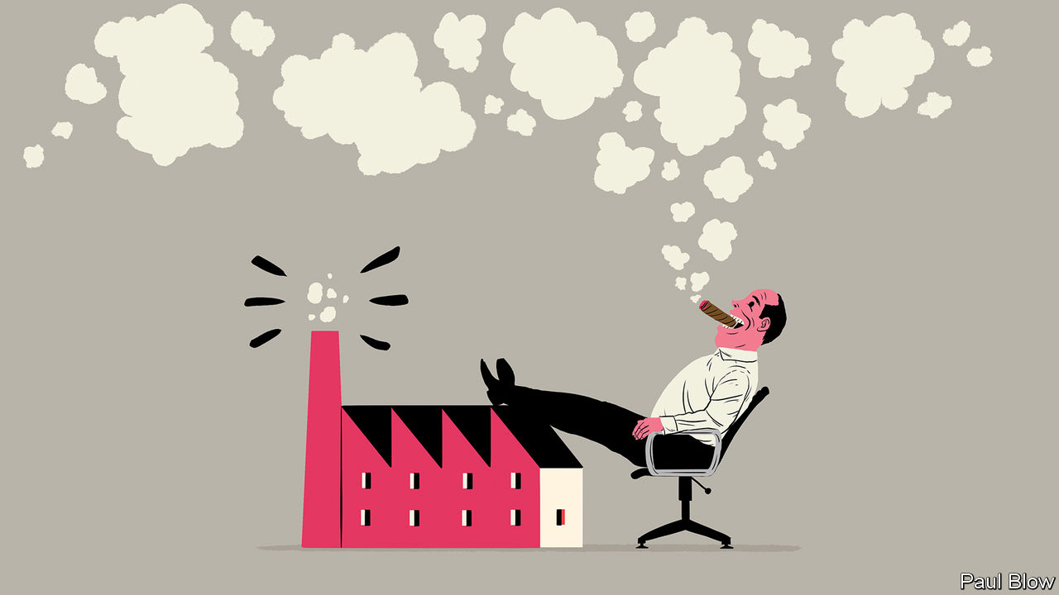

“TOO OFTEN, executive compensation in the US is ridiculously out of line with performance…The deck is stacked against investors.” It was with these words that in 2006 Warren Buffett, a legendary investor and red-blooded capitalist, challenged the received wisdom in corporate America about CEO pay. This maintains that bosses deserve generous rewards because these are tightly linked to their companies’ financial performance. Fourteen years’ worth of evidence later the received wisdom is still looking shaky.

“Pay for performance” has been the mantra of America Inc over the past few decades. A small circle of influential pay consultants, compensation analysts and academics has argued that American firms must pay top dollar for top candidates because they compete in a global market for talent. They argue that firms have grown more complex and bosses must know how to manage new technologies and the vagaries of globalisation. The controversial corollary is that pay should be allowed to rise ever higher because superior CEO performance is maximising shareholder returns.

Rise it has—and then some. According to Bloomberg, a research firm, the median CEO compensation at big American firms in the S&P 500 share index reached $14m last year. America’s top earners made far more. Alphabet’s Sundar Pichai received a cool $281m. The sums are considerably smaller across the Atlantic, where pay practices have historically been more restrained. The ten best-paid British bosses together did not make as much as Mr Pichai in 2019.

A forthcoming report by the Economic Policy Institute (EPI), a left-leaning think-tank, scrutinises how much bosses at the 350 biggest American firms by revenue actually made once stocks and options were vested and exercised (as opposed to their notional values at the time they were granted). Lawrence Mishel of EPI calculates that from 1978 to 2019 the average “realised” compensation swelled nearly thirteen-fold in inflation-adjusted terms, outpacing the stockmarket (see chart 1). It shot up by 14% in 2019 alone.

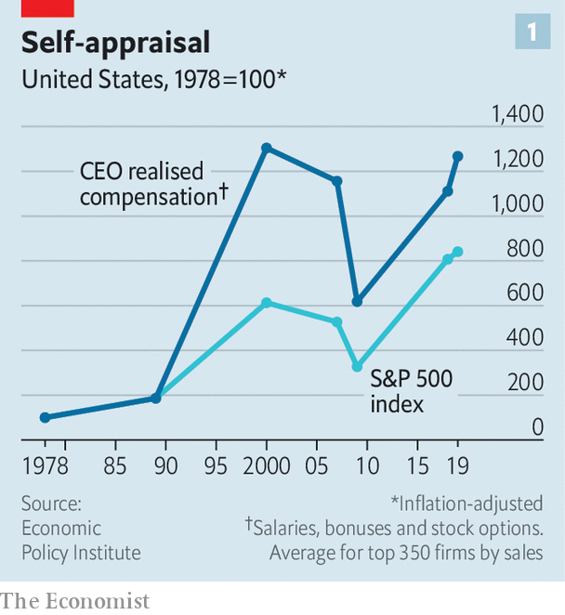

Such numbers were setting off alarm bells before the covid-19 crisis. Now the mass lay-offs and bleeding balance-sheets resulting from the recession have brought it into stark relief. According to official filings, one in ten members of the Russell 3000, a broad index of listed American companies, has slashed bosses’ salaries in response to covid-19. They include big airlines (like United and Delta), hotel chains (such as Marriott and Wyndham) and industrial conglomerates (for example, GE). Many others plan to review their compensation plans. Todd Sirras of Semler Brossy, a pay consultancy, predicts a busy autumn for his industry.

Though portraying this as a show of solidarity with workers, a few have quietly also handed bosses lucrative perquisites. A week after Hyatt Hotels cut its chief executive’s salary in March, it awarded him shares and options that could, if the company’s share price rebounds, be worth much more than the forgone pay. Courtney Yu of Equilar, a research firm, observes that bonuses, grants of stocks and options tied to performance at big American firms have risen from a small portion of executive compensation two decades ago to more than half today.

## Total recall

The favoured measure of performance is a company’s total returns, which combine share-price moves with any dividend payouts. As a consequence of a record bull market in equities after the global financial crisis of 2007-09, only brought to a halt by the covid-19 pandemic, executive pay in America shot up into the stratosphere. Today, after a rollercoaster ride this year, the S&P 500 is nearly back to where it was before the coronavirus struck; compensation may continue to rise.

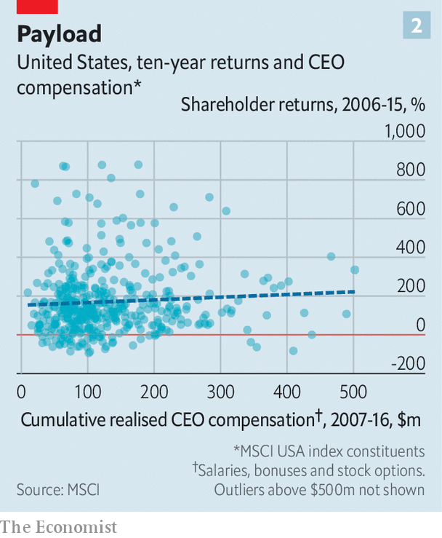

In 2017 MSCI, a research firm, published its analysis of realised chief-executive pay between 2007 and 2016 at more than 400 big public American firms. At more than three-fifths of the firms, it showed no correlation with ten-year total returns (see chart 2). Some firms overpaid lousy bosses; others underpaid successful ones. Pay-for-performance “may be broken”, MSCI concluded. A recent paper co-authored by Lucas Davis of the Haas School of Business finds “strong evidence” that bosses of energy firms see clear pay gains when stock valuations rise as a result of an oil-price spike which they have no way to influence.

A fresh analysis by Equilar, commissioned by CalPERS, a big Californian public pension fund, identifies similar trends. It looked at the past five years of realised CEO pay for most firms in the Russell 3000 and compared this with the companies’ total returns. The bosses in the top pay quartile made twelve times what those in the bottom quartile did, but produced financial returns only twice as good. The bosses in the second-lowest pay quartile made nearly three times as much as those in the bottom quartile, even though their firms’ total returns were actually worse. “There is no evidence that boards can tell in advance who is a talented CEO,” sums up Simiso Nzima of CalPERS.

Critics point to problems besides rewarding luck instead of skill. One is rent-seeking by bosses, who can take advantage of the opacity that tends to surround pay-setting. The process was long a dark art, explains David Larcker of Stanford University’s Graduate School of Business. Lucian Bebchuk of Harvard Law School, another expert in the field, has argued that American CEOs, who tend to tower over their boardrooms, have too much influence over this opaque process. Don Delves of Willis Towers Watson, a consultancy with a big pay-advisory arm, points to “lots of positive changes” in pay-setting over the last two decades, from greater independence for compensation committees to more sophisticated setting of performance targets. However, he concedes that bosses retain “more influence over their own pay than any other person”.

Compensation committees often rely on advice—and political cover—from pay consultants. A recent study of 2,347 firms, by Kevin Murphy of the Marshall School of Business and colleagues, finds that companies using consultants pay more. Independently, those with higher pay and more complex pay plans are also likelier to hire advisers. Most problematic is their use of pay benchmarking, which has led to the ratcheting-up of pay for all bosses. As Mr Nzima of CalPERS observes, “Everyone is targeting either median or above-median pay, so median is always going higher regardless of actual performance.” Gregg Passin of Mercer, another consultancy which advises clients on pay, accepts that the ratchet effect is real. “I can’t deny it,” he says. His firm recommends that some bosses, such as first-time CEOs, should be paid below the median.

The good news, says Pamela Marcogliese of Freshfields, a law firm, is that institutional investors are paying more attention to remuneration. She points to a surge in attention among big activist investment funds to “say on pay” proposals, which let investors express dissatisfaction with excessive pay.

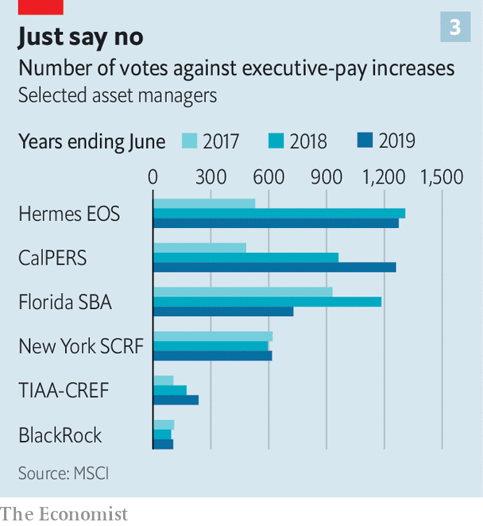

Though these votes are non-binding, managements typically respond to negative votes by paring back pay. Even mainstream investors like BlackRock, a giant fund that rarely gainsays the management on pay, are increasingly voting against compensation-committee members promoting egregious pay schemes.

America’s influential Council of Institutional Investors, which represents big asset managers, last year called for simplifying pay structures. CalPERS wants to replace common pay packages, such as those based on three-year performance, with plans reflecting rigorous five-year performance measures, or delay payouts from equity grants for at least five years. It is also rebelling against using median pay as the favoured benchmark.

In May Vanguard, a big American mutual fund, warned boards not to use the pandemics as an excuse to “create ‘easier’ performance targets”, adding that “at-risk pay should remain at-risk.”

Glass Lewis, a shareholder-advisory firm, has said that offsetting bosses’ pay cuts with options packages may lead to lawsuits. Institutional Shareholder Services, the other big proxy adviser, has discouraged sudden changes to long-term compensation, especially the repricing of options. Norges Bank Investment Management, which oversees $1trn in Norwegian pension assets, has criticised the short-termism of current compensation schemes, arguing that “a substantial proportion” of pay should instead be shares that are locked in for five or ten years.

Incentive packages that postpone payouts may, it is true, prompt bosses to demand higher pay to compensate them for the added wait. Martine Ferland, boss of Mercer, admits a tension exists between the short term and the long term. Even so, she is convinced change is afoot. Executives “cannot prosper at the expense” of everyone else. Mr Larcker of Stanford sees the pandemic as “a wake-up call for boards”. About time. ■

Correction (July 9th 2020): An earlier version of this article said that Bob Bakish, chief executive of ViacomCBS, last year received total compensation of $134m. That figure referred to the total compensation of Mr Bakish and Joseph Ianniello, CEO of CBS before its merger with Viacom in December 2019. Mr Bakish's total compensation in 2019 was $36.5m. Similar errors crept into a table of executive compensation, which has been removed. We also exaggerated the pay of Soren Skou, CEO of A.P. Moller-Maersk, as a result of an improper currency conversion. We apologise for the mistakes.

This article was downloaded by calibre from <https://www.economist.com/business/2020/07/11/how-ceo-pay-in-america-got-out-whack>

|  |  |  |  |
| --- | --- | --- | --- |
|  | Articles | Sections | Next |

|  |  |  |  |
| --- | --- | --- | --- |
| Previous | Articles | Sections | Next |

#### What goes up, and up and up

# Why SMIC is surging

China’s leading chipmaker looks unfazed by Uncle Sam’s semiconductor sabre-rattling

Jul 11th 2020 |

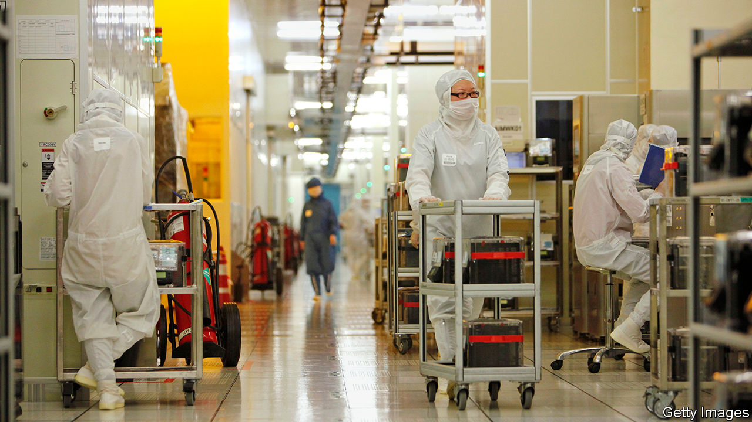

TIMES SEEM tough for China’s chipmaking champion, the Semiconductor Manufacturing International Corporation (SMIC). Over the past year America has attacked its supply chains, cutting it off from essential high-tech tools. It has slapped export controls on SMIC’s customers and enacted new rules which threaten to designate the firm as subservient to the People’s Liberation Army. The company’s sales slumped by 7% in 2019 to $3.1bn—not the kind of performance expected of a Chinese high-tech titan.

SMIC is one of many corporate casualties in the escalating conflict over access to advanced technology that is playing out between America and China. As the two geopolitical rivals try to decouple their economies, they and their allies have enacted tit-for-tat restrictions on each other’s software and hardware. On July 6th Mike Pompeo, America’s secretary of state, said America might ban TikTok, a Chinese-owned short-video app beloved of Western teenagers. Facebook, Google, Microsoft and Twitter have suspended habitual co-operation with Hong Kong police after the Chinese territory adopted a new security law giving Beijing greater control (of the quartet only Microsoft has significant business on the mainland that could be a target of Chinese retaliation).

You might reasonably conclude that limp revenues and American ire would be a drag on SMIC’s share price. Not a bit of it. The Hong Kong-listed company’s market capitalisation has quintupled in the past year, to $29bn. SMIC is teeing up a new listing of shares worth 46.3bn yuan ($6.6bn) on the Shanghai Science and Technology Innovation Board (better known as the STAR Market). It has set a price for those shares that values the company at 109 times its 2019 earnings, a ratio five times greater than that of more advanced competitors like the Taiwan Semiconductor Manufacturing Company. It could be one of the largest listings anywhere in 2020.

So what is going on? The answers lie in SMIC’s status as China’s best hope of building a domestic semiconductor industry. This is a long-standing strategic objective for the Chinese Communist Party, which is therefore happy to put the might of the Chinese state behind SMIC. Although the company lags behind global competitors at the moment, it is in a strong position to sell chips to the large and growing Chinese electronics market.

Investors who put assumptions about a company’s long-term success over its short-term performance may view the American government’s attention as a signal of SMIC’s potential. Many Chinese patriotic day-traders probably belong to that group. But the immediate risk to their investment from America’s actions is real.

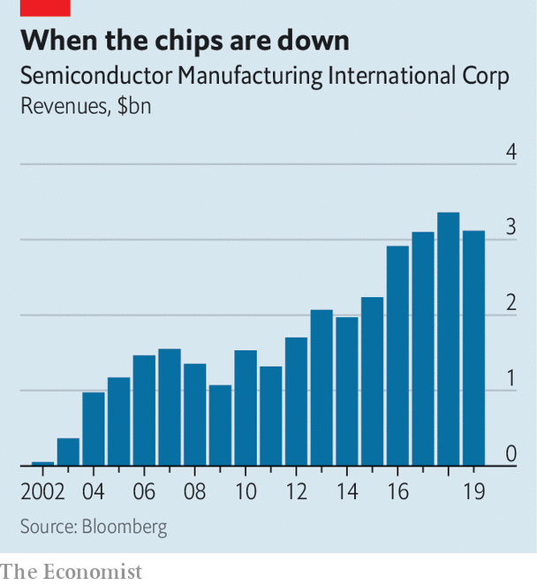

The latest assault came on May 15th, when the Department of Commerce introduced new export-control rules that prevent SMIC from using American chipmaking equipment to produce microprocessors for Huawei, the Chinese telecoms giant at centre-stage in the technological cold war. Bernstein, a research firm, says that if SMIC were to lose Huawei’s custom that would shave 20% from its existing revenue and, crucially, deprive it of “most” of its expected growth. SMIC’s already thin margins may turn negative when $1.7bn in capital spending since 2016 begins to incur depreciation costs, according to Bernstein, which recently said in a report that SMIC’s shares looked overvalued.

SMIC and its investors will hope that the firm can ride out these and future bumps to reach the lucrative position as chipmaker-in-chief to the Chinese market. Being backed to the hilt by China’s government will help. The question hanging over SMIC, and all of the country’s chip ambitions, is whether a combination of stockpiling kit and negotiating with partners can keep existing supply chains in place long enough, even in the face of American disruption, to allow for the development of domestic replacements. If it can, SMIC may flourish. If not, Beijing will miss its objective. ■

This article was downloaded by calibre from <https://www.economist.com/business/2020/07/11/why-smic-is-surging>

|  |  |  |  |
| --- | --- | --- | --- |
| Previous | Articles | Sections | Next |

|  |  |  |  |
| --- | --- | --- | --- |
| Previous | Articles | Sections | Next |

#### E-shopping frenzy

# Meituan-Dianping and Pinduoduo embody the excitement over digital China

Investors cannot get enough of two booming internet companies

Jul 11th 2020 |

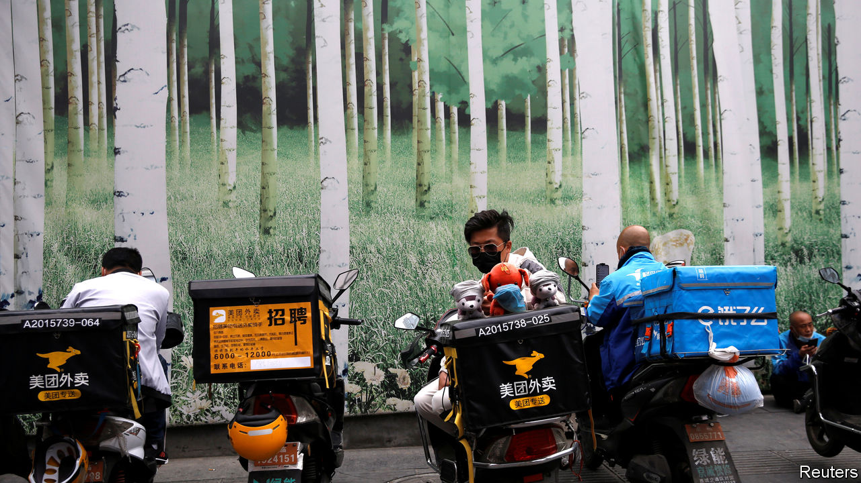

CHINA’S BUSTLING digital economy has spawned thousands of startups. Yet in the eyes of many it remains “BAT or bust”, to cite a saying among jobseekers from the country’s elite universities. The BAT in question refers to the original trio of Chinese internet stars: Baidu, a search engine; Alibaba, an online emporium; and Tencent, a mobile-payments and video-game titan. The acronym is overdue an update.

Alibaba and Tencent continue to lord it over digital China. With market capitalisations of nearly $700bn apiece, they are the world’s seventh- and eighth-biggest listed companies, respectively. Having struggled to adapt as consumers moved from desktops to smartphones, Baidu languishes in 319th place; its erstwhile equals can gain or lose the equivalent of its entire market value of $45bn in a day or two.

The BAT label also belies another development. Newer arrivals have been busily remodelling the upper reaches of China’s cyberscape. They include firms like JD.com, a $100bn e-merchant listed in New York, Didi Chuxing, a privately held ride-hailing giant valued at $60bn or so, and the $100bn-plus ByteDance, the world’s biggest unlisted startup (which owns, among other things, TikTok, a short-video app popular with Western teenagers).

None has set investors’ pulses racing of late more than Meituan Dianping and Pinduoduo. The duo have much in common. Both began by matching shoppers with discounts (on spa and cinema tickets in Meituan’s case and products from apples to Apple iPads in Pinduoduo’s). Both went public in 2018—Meituan in Hong Kong and Pinduoduo in New York. And both have seen their share prices soar since the start of the year (see chart). They are now worth more than $100bn each. But their routes to these highs look quite different.

Start with the bigger of the two, Meituan. It was founded in 2010 by Wang Xing, an engineering graduate from Beijing’s Tsinghua University, selling those discount vouchers. Like Tencent and Alibaba, it has expanded into other areas. In 2013 it launched a meal-delivery business and a travel arm that lets users book hotels and flights. Two years later it merged with Dianping, a restaurant-review and booking platform similar to Yelp. In 2018 it paid $2.7bn for Mobike, a bike-sharing service, and entered ride-hailing, which it expanded last year to dozens of Chinese cities. Today Meituan can be thought of as “a search engine for services”, says Elinor Leung of CLSA, a broker.

Some of these, like food delivery or bike-sharing, are low-margin, high-volume businesses. In 2019 the firm earned a profit of less than three cents per delivery (chiefly from commissions it charges restaurants). But it makes an awful lot of them. The platform has 700,000-800,000 drivers at its disposal. Two in every three yuan that the Chinese spend on having grub dropped off at their doorstep goes through Meituan.

Like Mobike (which is capital-intensive and still unprofitable), the food business lures users who can then be directed to more lucrative offerings such as travel. Meituan’s operating margins on hotel reservations hover between 20% and 35%. The pandemic briefly halted domestic bookings but by late May they had recovered to 70% of pre-coronavirus levels.

Pinduoduo has taken the opposite tack to Meituan. Rather than spread its bets, it has doubled down on e-commerce. Online retail is growing fast enough in China to justify not being “a jack of all trades”, says David Liu, in charge of strategy at the firm.

He has a point. Chinese e-commerce sales could expand by 16% this year, to 14.4trn yuan ($2trn), according to eMarketer, a research firm, even as total retail sales may dip by 4% to 35trn yuan as a consequence of lockdowns’ toll on bricks-and-mortar shops. Alibaba will capture perhaps half of this growth. Pinduoduo will slug it out with JD.com for the rest. Shoppers hit by the coronavirus slowdown may lean towards Pinduoduo’s bargains.

Central to the firm’s ascent is the concept of social shopping, which it describes as a fusion of Costco and Disneyland. Products are cheaper if you buy in bulk with fellow bargain-hunters. Users can join existing groups or invite pals using WeChat, a social-messaging app owned by Tencent (which holds a 16% stake in Pinduoduo). Merchants sacrifice margins in exchange for higher volumes.

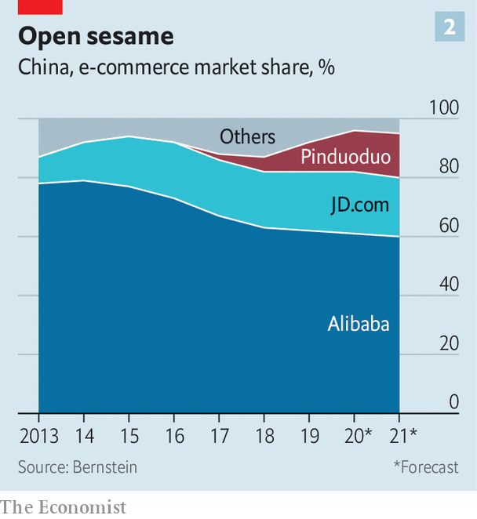

Colin Huang, Pinduoduo’s founder, who once worked as an engineer at Google in America, did not invent group shopping; Groupon has been doing a version of it since 2008. But he did develop the idea, for instance introducing games which reward players with credits on future purchases.

Chinese shoppers love it. At the end of March 628m of them had made at least one purchase on the app in the preceding 12 months, 42% more than the year before and 60% more than shopped on JD.com; only Alibaba has more active users (726m). Their average annual spending also rose, from 1,250 yuan to over 1,800 yuan. So has Pinduoduo’s share of Chinese e-commerce—from 2% in 2017 to 10% last year. Bernstein, a research firm, expects it to be 18% by 2024, in line with JD.com.

The shopping frenzy has boosted Pinduoduo’s revenues by 44% year on year in the first quarter, to 6.5bn yuan. The money comes from transaction fees and adverts bought by merchants to have their offers promoted in the app. Similarly to eBay but not many e-commerce giants, Pinduoduo does not hold inventory or operate its own logistics network, relying on merchants to ferry products to buyers. Instead, it burns a spectacular, and growing, amount of cash on sales and marketing: 112% of revenues in the first quarter.

Mr Liu insists these costs can easily be dialled back. Experience of other marketplaces suggests otherwise. Uber, which also matches sellers (drivers) with buyers (riders), has been perpetually loss-making. Like Uber, Pinduoduo enjoys some “network effects”—the more buyers use its app, the more sellers it draws, who in turn attract new buyers, and so on. But, again as in ride-hailing, buyers and sellers face few costs in switching to another app that offers a better deal. JD.com and Alibaba have already launched Pinduoduo clones to their vast user base.

The market is giving Pinduoduo the benefit of the doubt. The pandemic appears to have done it no harm; cooped-up Chinese consumers have turned to the firm for necessities and, sometimes, a dose of retail therapy. With negligible business outside China, it is, like Meituan, shielded from the Sino-American tech war making life difficult for TikTok, with its mostly non-Chinese users, or Huawei, China’s telecoms champion. White House threats to expel Chinese firms from American exchanges have not dampened investors’ enthusiasm. Nor has the sudden departure of Mr Huang, who stepped down as its chief executive on July 1st and cut his stake in the company from 43% to 29% (he remains chairman and holds 81% of voting rights).

Meituan’s path to riches is clearer. It ended last year in the black for the first time. Its profitable food and travel arms have been gaining market share from rivals (such as Ele.me, Alibaba’s food-delivery app, and Ctrip, China’s biggest travel agency). That gives its loss-making divisions financial breathing room.

Ultimately, both firms embody the excitement over digital China’s bright prospects. But TAMP will only become the new BAT if both firms can match Tencent’s and Alibaba’s consistently fat profits. ■

This article was downloaded by calibre from <https://www.economist.com/business/2020/07/11/meituan-dianping-and-pinduoduo-embody-the-excitement-over-digital-china>

|  |  |  |  |
| --- | --- | --- | --- |
| Previous | Articles | Sections | Next |

|  |  |  |  |
| --- | --- | --- | --- |
| Previous | Articles | Sections | Next |

#### Bartleby

# Slackers and Stakhanovites

How the lockdown has affected a classic dictum about work

Jul 11th 2020 |

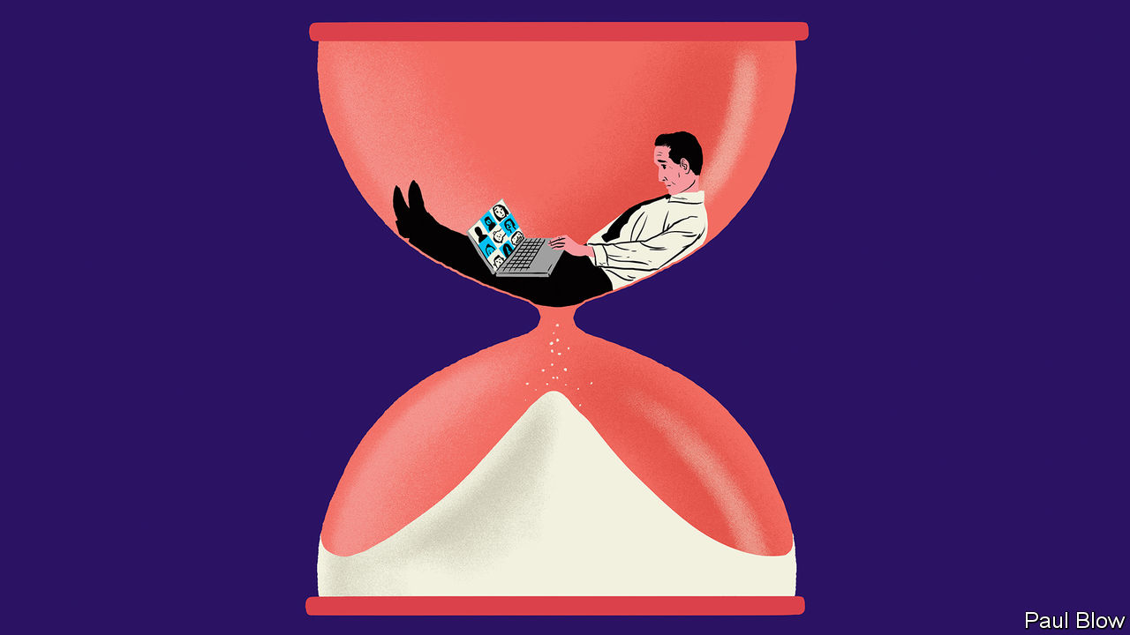

AS LAWS GO, the dictum devised by C. Northcote Parkinson, a naval historian, was admirably succinct: “Work expands so as to fill the time available for its completion.” His essay, first published in The Economist in 1955, has stood the test of time, in the sense that people still refer to “Parkinson’s law”. But the experience of working life during the pandemic means that Bartleby would now like to suggest three corollaries to the theorem.

At the start of his essay, Parkinson cited the case of an elderly lady requiring a day to send a postcard to her niece. The process involved time spent searching for spectacles, postcard and umbrella, as well as composing the message. The details may be dated but the idea is still resonant—faced with a task, people procrastinate.

When it comes to office work, the incentives to dawdle are pretty clear. Finish an assignment quickly, and the employee will just be given another. That second task may be even more unpleasant than the first. Workers may end up like a hamster on a treadmill, stuck in an endless cycle of needless effort.

Office workers know, however, that the mission itself is not the only thing. It is important to be seen to be working. This leads to “presenteeism”—being at your desk for long enough to impress the boss (and even turning up while sick). In the pre-internet era this would involve endless redrafting of memos, long phone calls, or staring meaningfully at documents. Thanks to the pioneering work of Tim Berners-Lee, presenteeism now requires less effort: many hours can be wasted on the world wide web.

When working at home, the boss is out of sight but not out of mind. Broadly speaking, the result is to divide workers into two factions. The first group, the slackers, has spent the lockdown working out the minimum level of effort they can get away with. They have no need to drag out each task; they do what is required and spend the rest of the day at leisure, submitting the work just before deadline. For this group, Parkinson’s law can be amended as follows: “For the unconcerned, when unobserved, work shrinks to fill the time required.”

The second group takes the opposite approach. Consumed by guilt, anxiety about their job security or ambition, they work even harder than before. Being at home, they find no clear demarcation between work time and leisure time. This group is the Stakhanovites (named after a heroically productive miner in the Soviet Union). They require their own amendment: “For anxious home workers, work expands to fill all their waking hours.”

But Parkinson was making a much broader point than people’s tendency to be dilatory. The bulk of his essay was concerned with the growth of bureaucracy in government. He warned that hiring more civil servants did not necessarily lead to more effective work.

This tendency resulted from two factors. First, officials want to multiply subordinates, not rivals. Second, officials tend to make work for each other. Any official who feels overworked will ask to be given two subordinates (asking for just one would create a rival). The senior official will then spend lots of time checking their subordinates’ work.

How does this process apply in the lockdown? Like their staff, managers also want to appear useful. In the office, they can seem busy by walking around and talking to their teams. At home, this is more difficult; a phone call is more intrusive than a casual chat. The answer is to organise more Zoom meetings.

Bartleby has heard from a number of contacts in recent weeks that they spend their day going from one Zoom meeting to another. Just as Parkinson suggested, managers are making more work for each other. Hence the third amendment to his law: “In lockdown, Zoom expands to fill all of the manager’s available time.”

To the extent that these meetings are voluntary, this creates another divide between slackers and Stakhanovites. The first group will avoid such meetings and the latter group will sign up for all of them. Furthermore, in the pre-lockdown days, staff could earn brownie points by turning up for such gatherings, provided they caught the boss’s eye. Mere attendance is insufficient for a Zoom meeting; one must be seen and heard. In turn, that makes Zoom meetings longer, further using up the time of managers and their Stakhanovite subordinates (many slackers have yet to learn how to use the “raise hand” button). It is a digital version of the paperwork shuffling described by Parkinson 65 years ago.

Editor’s note: Some of our covid-19 coverage is free for readers of The Economist Today, our daily [newsletter](https://my.economist.com/user#newsletter). For more stories and our pandemic tracker, see our [hub](https://www.economist.com/news/2020/03/11/the-economists-coverage-of-the-coronavirus)

This article was downloaded by calibre from <https://www.economist.com/business/2020/07/11/slackers-and-stakhanovites>

|  |  |  |  |
| --- | --- | --- | --- |
| Previous | Articles | Sections | Next |

|  |  |  |  |
| --- | --- | --- | --- |
| Previous | Articles | Sections | Next |

#### Schumpeter

# Elon, Masa and Boris in low-Earth orbit

What could possibly go wrong?

Jul 11th 2020 |

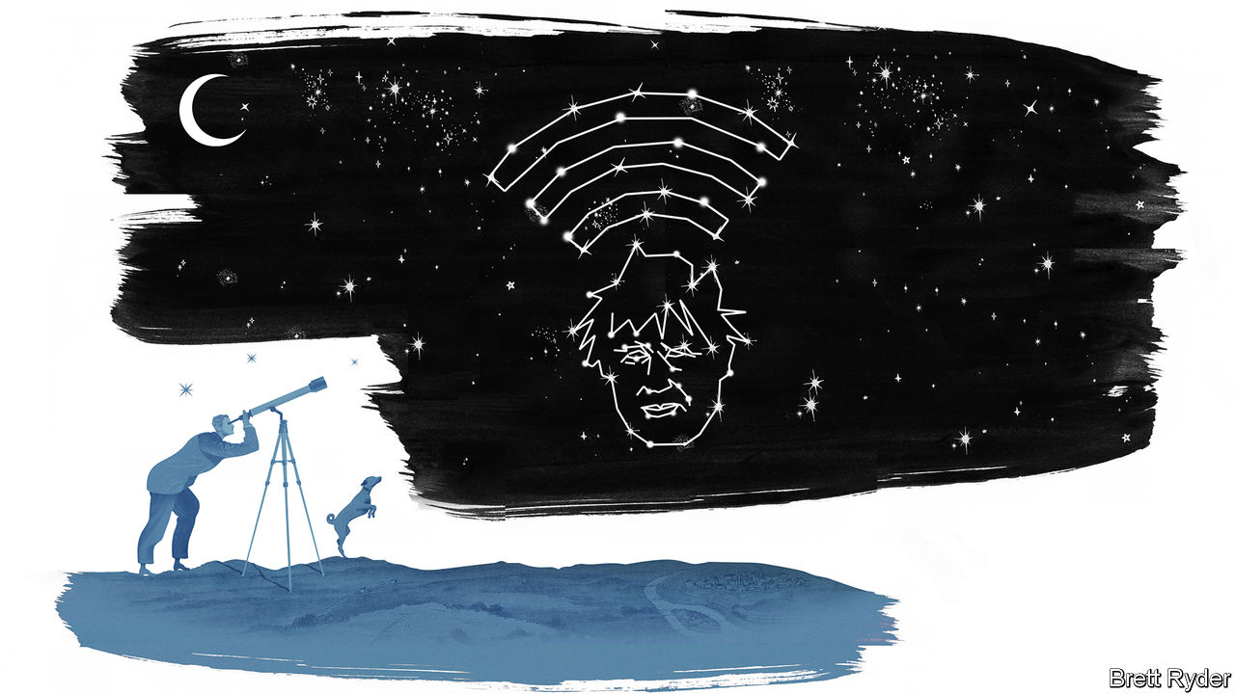

SCHUMPETER IS ONLY an amateur stargazer. His equipment is no fancier than a pair of eyes and a place in the countryside, away from London’s light pollution. That is enough to make out Venus, Mars, Jupiter and Saturn—and, occasionally, the International Space Station crossing the firmament. In the past few years a new spectacle has appeared, in the form of the Starlink satellites. Launched in batches by SpaceX, an American rocketry firm founded by Elon Musk, the tech billionaire behind Tesla’s electric cars, they resemble nothing else in the heavens, floating like a train of white dots in tight formation. Bad weather delayed the launch of the latest batch on July 8th. When they do go up, they will total nearly 600, making SpaceX the world’s biggest satellite operator.

SpaceX is a remarkable firm. It was founded in 2002, to further Mr Musk’s dream of colonising Mars. It is a case study in disruption—a startup with no track record has humbled incumbents like Boeing and Lockheed Martin. Its rockets cost half as much as its rivals’ do, thanks in part to their ability to land their first stages for reuse rather than dumping them in the sea in line with standard industry practice. The firm was last valued at $36bn, more than better-known tech darlings such as Airbnb, DoorDash or Palantir.

SpaceX’s rocket business alone does not justify this rich valuation. The market for launches is small and stagnant. Mr Musk himself has said that the most his firm could hope to earn from them is around $3bn in revenue a year. If he is to make it to Mars—and if his investors are to see big returns—he needs another plan. This is where Starlink comes in. Those satellites visible from Schumpeter’s garden are the vanguard of a planned constellation of over 1,000, designed to beam the internet to every corner of the globe.

Satellite broadband is not a new idea. But existing options are expensive and slow. Starlink’s cheap, mass-produced, low-flying satellites would, SpaceX claims, offer a service comparable to earthly broadband at competitive prices. It could serve poorly connected villages in rural Africa (or rural America for that matter), as well as oil rigs or cargo ships at sea. Mr Musk has noted that the global telecoms market is worth roughly $1trn. If SpaceX captured even a fraction of that, Morgan Stanley, a bank, recently opined, it could be worth anywhere from $50bn to $120bn or more, making its present valuation look like a bargain.

The world has been here before. Iridium announced similar plans in the late 1990s with gales of hype: the first call on its network was between Al Gore, then America’s vice-president, and a distant descendant of Alexander Graham Bell. Nine months later the firm went bust, swamped by the upfront capital costs of launching satellites. LeoSat, a firm based in Luxembourg, was founded in 2013. It shut down last year for lack of investor interest.

Starlink’s chief competitor is OneWeb, with 74 satellites in orbit and hundreds more planned. It, too, went bust in March, after failing to persuade even Son Masayoshi (also known as Masa), a Japanese tech billionaire with a stake and a well-documented affection for risky startups, to pony up more cash. But it has new backers. On July 3rd Boris Johnson, Britain’s shaggy-dog prime minister, announced that his government had stumped up $500m for a 45% stake in OneWeb, and a golden share giving it control over its future. Bharti Global, an Indian telecoms firm, also put in $500m.

Mr Johnson’s decision drew general bafflement—and an instant flurry of speculation about its rationale. Could he be trying to safeguard a domestic high-tech gem? Britain has long tried to nurture its small but sophisticated space sector and OneWeb is notionally a British firm; its parent company is based in Jersey, an island in the English Channel. But many of its operations, including satellite manufacturing, are in America. Perhaps the reasons were strategic? China was circling, claims one person close to the deal, and Britain pounced to frustrate its ambitions. Except that the American court administering the bankruptcy may be reluctant to hand OneWeb over to a Chinese firm. Politics almost certainly played a part. Britain’s exit from the European Union has limited its access to Galileo, the EU’s alternative to America’s GPS satellites. A bombastic promise to build an all-British replacement, at a cost of £5bn ($6.3bn) or more, looks dubious. Bolting a less capable navigation service onto OneWeb’s satellites may offer Mr Johnson a face-saving way to back down, while pushing back against the perception that Brexit has made the country parochial.

Yet there are also hopes, according to insiders, that the bizarre acquisition may work on purely commercial grounds. OneWeb has priority over SpaceX for the bits of the electromagnetic spectrum needed to beam the internet from the heavens. Those satellite companies that survived bankruptcy—such as Iridium—have come out on the other side as viable, if somewhat dull businesses. Like railways in the 19th century and subsequent infrastructure projects, globe-spanning satellite broadband may become a viable proposition once the initial investors, who often overpay exuberantly, have been wiped out.

And Mr Musk could use a rival in low-Earth orbit. Jeff Bezos, the biggest tech tycoon of all, is working on a similar project, but has yet to put any satellites into space. In the meantime, competition from OneWeb would spur innovation and prevent SpaceX from settling into a celestial monopoly.

## A giant leap of faith

Can the British government be a source of competitive pressure? The politest description of its entrepreneurial record is “spotty”—just ask owners of clunkers such as an Austin Allegro or Morris Marina, produced after the partial nationalisation in 1968 of British Leyland. OneWeb may need a further injection of cash if it is to complete its constellation. British taxpayers may never see a financial return on their investment. But if OneWeb keeps Mr Musk on his toes even for a little while, their loss may turn out to be global consumers’ gain. Stranger things have happened in space. ■

This article was downloaded by calibre from <https://www.economist.com/business/2020/07/11/elon-masa-and-boris-in-low-earth-orbit>

|  |  |  |  |
| --- | --- | --- | --- |
| Previous | Articles | Sections | Next |

|  |  |  |
| --- | --- | --- |
| Business | Sections | Science & ... |

Finance & economics

The global economy: How to feel better

.

China’s stockmarket: A bull market returns

.

Global trade: Leading question

.

The European Union: Seeking haven

.

Stock exchanges: Down time

.

Buttonwood: Default settings

.

Free exchange: Which way, Jay?

.

|  |  |  |
| --- | --- | --- |
| Business | Sections | Science & ... |

|  |  |  |  |
| --- | --- | --- | --- |
|  | Articles | Sections | Next |

#### How to feel better

# Some economies are bouncing back. But recoveries can easily go wrong

Our analysis shows just how fragile consumer confidence can be

Jul 11th 2020 | ORFORD

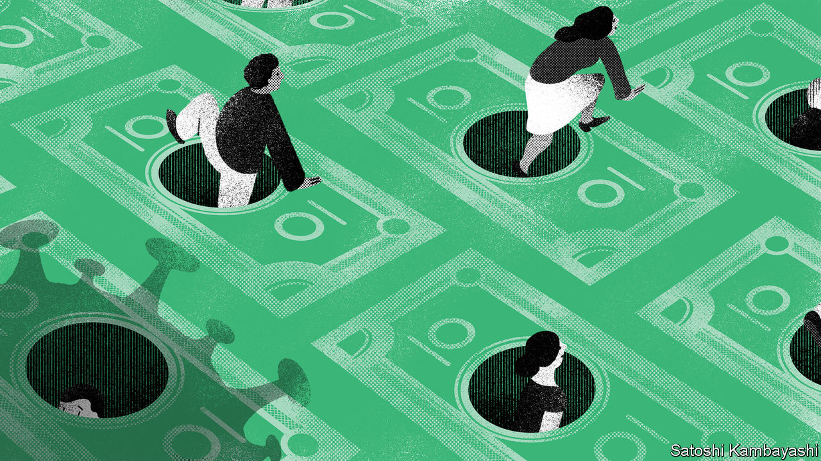

ORFORD NESS, on Britain’s east coast, was a site for military tests in the 20th century. Large pagodas on the shoreline, still standing today, were designed to prevent blasts from doing damage to the surrounding wetlands. On July 4th the area braced itself for another sort of explosion. “Super Saturday” marked the opening of pubs and restaurants for the first time since lockdown began. But in Orford the beery bomb never detonated. The Jolly Sailor, a pub near the quay, had only a handful of customers in the garden. Across Britain it was the same story. Restaurant reservations remained 90% lower than they were the year before.

The fate of the Jolly Sailor hints at the difficulties that rich countries face as they lift lockdowns. Most forecasters reckon that advanced-economy output, after plunging in the first half of 2020, is likely to regain its pre-crisis level some time after 2021. But not all recoveries will be equal. Some rich countries, such as Germany and South Korea, look best placed to bounce back—a “V-shaped recovery”, in the jargon. The path of GDP elsewhere may look more like an L or a W. The Economist’s analysis of real-time mobility data also shows how easily economic recoveries can go wrong, as consumers react to the possibility of fresh outbreaks.

Some countries have a tougher job on their hands because their output has fallen more since February, when lockdowns started to be imposed. No one knows for sure yet who has fared well or badly. GDP data for the second quarter are not yet available, and in any case will probably be subject to large revisions over time, as is often the case in downturns. But industrial structure is one indication. Surveys of economic activity in Germany suggest that it held up better between March and May than it did in France, Italy or Spain. That may be because of its heavy reliance on manufacturing, where maintaining both output and a social distance is easier than, say, in retail or hospitality services. Capital Economics, a consultancy, argues that Poland will experience Europe’s smallest contraction in GDP this year in part because it relies little on foreign tourists.

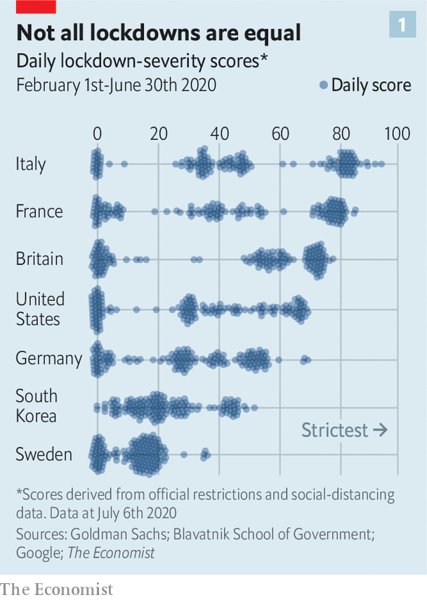

The stringency of official lockdowns, and changes to people’s behaviour, has clearly played a huge role. Research by Goldman Sachs, a bank, finds that lockdown stringency—in terms of both the strength of official rules and how enthusiastically people practised social distancing—is strongly correlated with the hit to economic activity, as measured by surveys. By this measure, Italy had the tightest lockdown for the most time (see chart 1). A back-of-the-envelope calculation suggests that its GDP for the first half of 2020 is likely to come in about 10% lower than it would have been otherwise—a lot of ground to make up for a country that struggled to grow even before the pandemic. By contrast, South Korea’s GDP looks likely to fall by 5%.

The lifting of lockdowns is now boosting economic activity. By how much, however, varies from country to country. Real-time activity data suggest that America and Spain are laggards, not only in terms of visits to restaurants but also to workplaces and public-transport stations. Others are powering ahead. By the end of June, economic life in Denmark and Norway had pretty much returned to normal. Danish retail sales actually rose by more than 6% year-on-year in May (compared with a double-digit decline in Britain). Germany’s restaurants were closed in May. But in recent days they have returned to full capacity (see left-hand panel of chart 2).

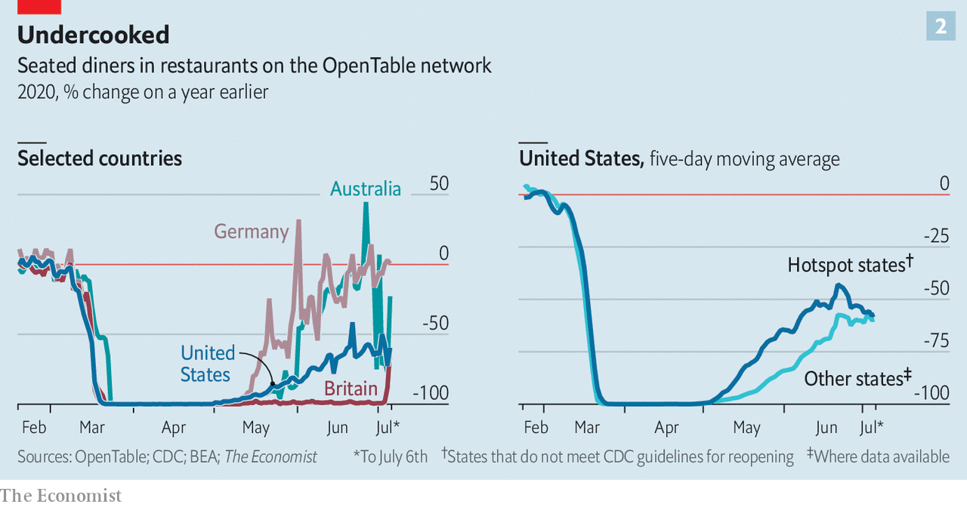

A number of factors influence how fast an economy can bounce back. The state of households’ finances is one. Government support has shored these up: in places where stimulus payments have been large and focused on families, people have built up large cash reserves, which they can now spend. Take the case of South Korea. Households quickly spent over 80% of a 10trn-won (0.5% of GDP, or $8.4bn) emergency handout. As a result, its economy might suffer less than other big advanced economies. Aggregate household income in Japan is forecast to rise this year, thanks in part to generous emergency payments from the state. By contrast, fiscal stimulus in Italy, which had staggeringly high government debt going into the crisis, has been less generous.

All this is nothing without consumer confidence. Americans have oodles of stimulus cash in their pockets (see article). Even so, they are cautious. A raft of evidence shows that if consumers are fearful, then lifting lockdowns makes little difference to economic outcomes. An analysis of American counties by Austan Goolsbee and Chad Syverson of the University of Chicago, for instance, finds that a higher number of deaths from covid-19 is associated with lower consumer activity.

That seems to be the case at the country level too. Those with a smaller number of deaths from covid-19 per million people have bounced back more decisively, according to an analysis by The Economist using data from Google on visits to retail outlets, workplaces and public-transport stations. Confidence today may also be shaped by the length of time spent under lockdown. Norway took just ten days to halve the intensity of its lockdown from its peak level. Many other European countries took ten weeks, however. That perhaps explains why Britons and Spaniards are still so cautious.

The latest mobility figures show precisely how fragile consumer confidence can be. People in American hotspot states, such as Arizona, Florida and Nevada, where the virus is surging, seem to have become more cautious (see right-hand panel of chart 2). A high-frequency measure of American credit-card spending maintained by JPMorgan Chase, a bank, stopped growing around June 21st—and a closely watched measure of weekly retail sales has barely increased since May. More ominously, high-frequency measures of the labour market suggest that employment in small businesses is once again declining. The risk of relapse is not confined to America. A huge drop in Australian restaurant diners in early July coincided with a large coronavirus outbreak in Victoria. Until the virus is stamped out, only one thing can be said about the recovery with certainty: it will be shape-shifting. ■

This article was downloaded by calibre from <https://www.economist.com/finance-and-economics/2020/07/11/some-economies-are-bouncing-back-but-recoveries-can-easily-go-wrong>

|  |  |  |  |
| --- | --- | --- | --- |
|  | Articles | Sections | Next |

|  |  |  |  |
| --- | --- | --- | --- |
| Previous | Articles | Sections | Next |

#### A bull market returns

# Stockmarket mania comes to China again. Can it last this time?

There are grounds for optimism but also signs of irrational exuberance

Jul 7th 2020 | SHANGHAI

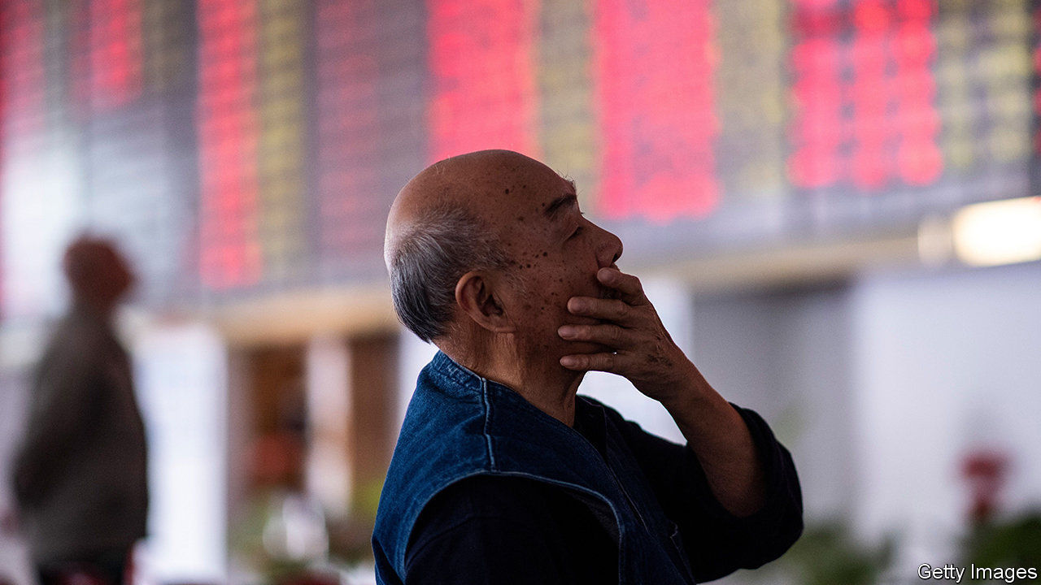

IN CHINESE STOCKMARKET mythology, the rarest of beasts is the slow bull. The past couple of decades have brought two fast bulls: vertiginous surges in share prices, neither lasting more than a year. Those soon led to fast bears when stocks crashed and, eventually, to slow bears as the descent became more gradual. Most of the time there have been what might be termed long worms as the market moved sideways, such that the CSI 300 index, a gauge of China’s biggest stocks, has averaged the same level over the past five years that it first reached back in 2007. The slow bull—a steady, almost dependable, rise year after year, well known to investors in America—has remained elusive.

China’s indomitable punters now hope that a trundling taurus has at last arrived. Stocks have jumped by 16% so far in July and they are up by nearly 40% from their low in March. That might sound like another fast, doomed bull run. But some believe this one will be more enduring than those of the past.

For starters, China appears to be in much better economic shape than other large economies. Because investors must allocate their funds somewhere, there is always a comparative element to stockmarket performance. China is the only big economy forecast to grow this year, and is also expected to record the strongest rebound next year, according to projections published by the IMF at the end of June. There are grave concerns about the toll that the coronavirus might take in America during the flu season in the autumn. By contrast, China has shown every intention of smothering renewed outbreaks. That has given people and businesses greater certainty about the path ahead.

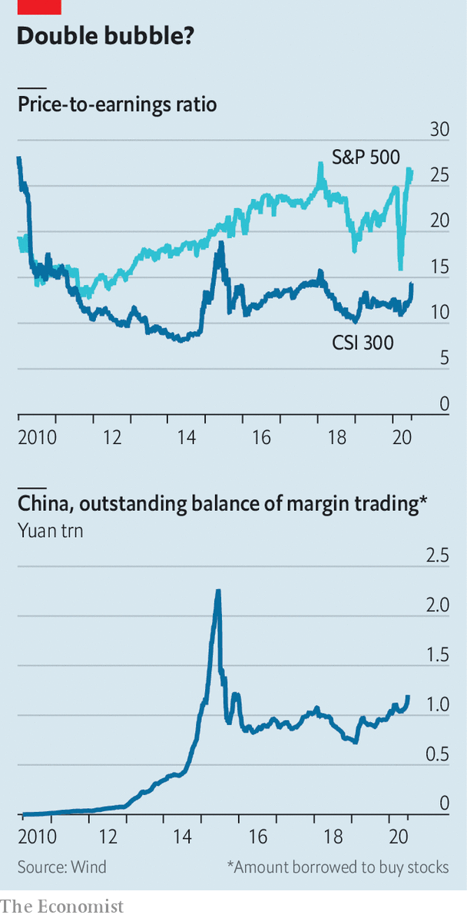

Market dynamics also seem to be helping. Even after the rally, valuations in China are reasonable. The CSI 300 trades at 14 times the value of company earnings, far below the 27-times multiple of the S&P 500, America’s most-watched share index (see chart). Foreign investors have more ways to enter China’s previously walled-off market; many are compelled to do so, because its shares are now included in key indices tracked by institutions. During the first three trading days of July, 44bn yuan ($6bn) flowed into Chinese equities via accounts in Hong Kong, a record high for any three-day period.

Although more investors have started buying shares with borrowed money, the outstanding balance of such margin trading is just over half the peak it reached five years ago, during China’s most recent manic run. It is now easier for companies to list shares on the mainland, so new offerings should help absorb some of the cash rushing into the stockmarket. “This lays the foundation for a slow-bull market that could last for ten or 20 years,” says Chang Shishan of Kangzhuang, an asset-management firm.

Nevertheless, it is hard to shake the feeling that the optimists might once again be getting ahead of themselves. The outlook for profitability, which ultimately should determine share prices, is still grim. Over the first five months of 2020, industrial profits were down by 19% compared with a year earlier.

Most worrying is the way that the Chinese media are swinging into cheerleading mode. If past episodes are anything to go by, this is one of the telltale signs of irrational exuberance. “The clicking of the bull’s hooves is a beautiful sound for our post-virus era,” declared a front-page editorial in the China Securities Journal, a state-run newspaper, on July 6th. The Shanghai Securities, its sister publication, was less poetic but more direct in an article that was posted online on July 3rd: “Hahahahaha! It looks more and more like a bull market!” Healthy bulls need only a diet of grass. Injecting them with steroids is an invitation to trouble. ■

This article was downloaded by calibre from <https://www.economist.com/finance-and-economics/2020/07/07/stockmarket-mania-comes-to-china-again-can-it-last-this-time>

|  |  |  |  |
| --- | --- | --- | --- |
| Previous | Articles | Sections | Next |

|  |  |  |  |
| --- | --- | --- | --- |
| Previous | Articles | Sections | Next |

#### Global trade

# The race to lead the WTO begins

Picking a winner could get messy

Jul 11th 2020 |

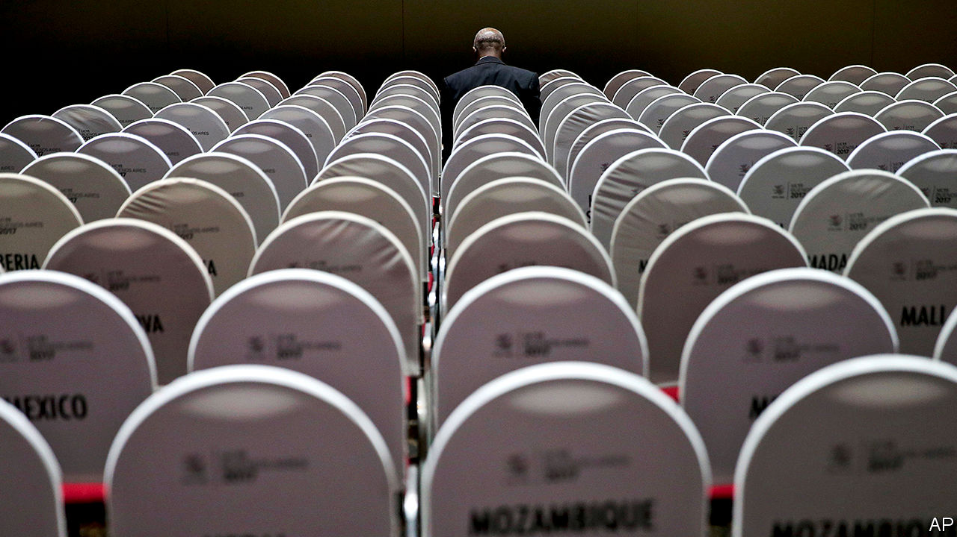

AND THEY’RE off! On July 8th the window for members to nominate the next director-general of the World Trade Organisation (WTO) closed. Over the next few months members will try to pick between eight candidates, each hoping to rescue the institution from its present sorry state. The process will highlight some of the WTO’s best features—but will also show why the organisation is in such a mess.

Fans of the multilateral trading system boast about its openness. In line with that principle, the top job at the WTO is not sewn up for a European or an American, unlike those at the IMF or the World Bank. In fact, there are no candidates from America, China, the European Union, India or Japan. Nominations range from Egypt and Moldova to Mexico and South Korea.

Members have several credible candidates to choose from. (Britain’s nominee, Liam Fox, is not one of them.) Nigeria’s candidate, Ngozi Okonjo-Iweala, is a political heavyweight: she is a former finance minister and has years of managing operations at the World Bank under her belt. Kenya’s pick, Amina Mohamed, is a trade heavyweight: she chaired the WTO’s ministerial conference in 2015.

From July 15th onwards, candidates will receive a grilling from members. Then the WTO’s consensus-building skills come into play: all 164 members will have to agree on the winner. The process will be a little like therapy, says Hosuk Lee-Makiyama of the European Centre for International Political Economy, a think-tank. “They don’t really understand what they want until they’ve sat and talked about it.”

At this point, the messy reality of trade negotiations will kick in. Just as the quest for consensus can sap ambition from trade talks, the search for a new director-general could end with members plumping for whoever gives the least offence. Robert Lighthizer, the United States Trade Representative, has already said that “any whiff” of anti-Americanism could lead him to use his veto.

The race will probably also highlight the tendency of the WTO’s constituents to talk past each other. A new survey of government officials, academics, NGOs and business groups published by the European University Institute (EUI) finds that many Geneva-based national representatives want a new chief to prioritise restoring the Appellate Body, a sort of supreme court for trade disputes, which the Americans nixed. But they are less interested in reforming the dispute-settlement system, without which the Americans will not get on board.

Expect the months ahead to reveal the disconnect between candidates’ ambitions and what the institution can achieve. Ms Okonjo-Iweala has pledged to mediate between America and China. Good luck with that. Egypt’s Abdel-Hamid Mamdouh has promised to “reboot” the WTO’s ability to negotiate new rules. But the director-general can only move as far as the members want—and members do not want to make the concessions needed.

The victor would therefore inherit a difficult job—if, that is, one is eventually chosen. In today’s fraught circumstances, consensus may not be reachable. The bar is low enough that the appointment of any director-general would count as a success. ■

This article was downloaded by calibre from <https://www.economist.com/finance-and-economics/2020/07/11/the-race-to-lead-the-wto-begins>

|  |  |  |  |
| --- | --- | --- | --- |
| Previous | Articles | Sections | Next |

|  |  |  |  |
| --- | --- | --- | --- |
| Previous | Articles | Sections | Next |

#### Seeking haven

# The pandemic revives ultra-safe European bonds

The European Commission could soon become a big player in capital markets

Jul 11th 2020 |

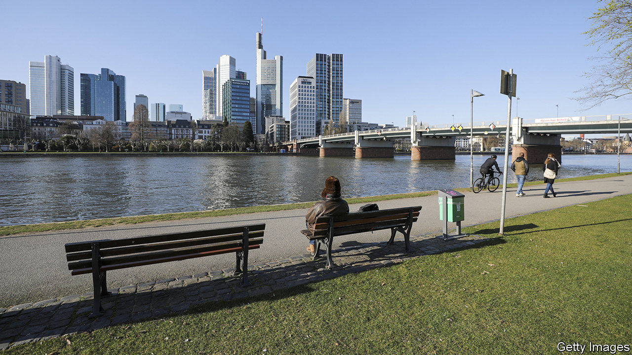

THE EURO ZONE has not been a hospitable place for investors seeking safety in recent years. The currency area’s pool of super-safe, AAA-rated sovereign securities shrank by 40% between 2007 and 2018. Rating agencies downgraded some of its members during the debt crisis of 2010-12. Two of its remaining top-rated issuers—Germany and the Netherlands—have energetically hacked away at their debt piles.

The pandemic might help alleviate the shortage. Germany, once fixated on its “black zero”, or balanced budget, will go deeply into the red. It may run a fiscal deficit of as much as 7.5% of GDP this year, reckons the Bundesbank. A raft of issuance may also come from an unusual source: the European Commission. If plans for it to finance the EU’s recovery spending go ahead, it could become a big influence in global capital markets.

The commission already issues a modest amount of bonds on behalf of the European Union, which it mostly lends on to member states. Its debt stock amounts to €52bn ($59bn, or 0.4% of EU GDP in 2019). Plans to fund the recovery from the pandemic will take this much higher. From September it will raise €100bn, which it will in turn lend to countries in order to finance temporary-employment schemes.

The bigger prize, though, would be the “recovery fund”, which is soon to be debated by national leaders. This would raise €750bn on the markets in order to fund grants and loans to member states. Though it has the support of most countries, including that of Germany, a few northerners are yet to sign up to the idea (see [Charlemagne](https://www.economist.com/node/21789065)). If it goes ahead, the commission’s stock of debt would be smaller only than those of the union’s four largest members, France, Germany, Italy and Spain.

Despite the uncertainty, the wave of issuance has piqued investors’ interest. Typical holders of the commission’s bonds are European institutional investors, but Asian ones looking to diversify their portfolios away from dollar exposures hold some too. (Precisely how safe the bonds are deemed to be by the rating agencies, though, will depend on the small print on members’ guarantees, which is yet to be finalised.) Another buyer of commission debt, albeit bought from other traders rather than directly, could be the European Central Bank. A tenth of its purchases made through its quantitative-easing scheme are of “supranational” debt issued by European institutions.

Safe assets will continue to be in high demand after the pandemic, as economic uncertainty and an ageing population push up the saving rate, says Agnès Belaisch of the Barings Investment Institute, the research arm of Barings, an investment firm. One sign of that, she points out, is investors’ keen interest in Austria’s 100-year bond issued in June. The sale was more than ten times oversubscribed, and the bond now trades at a yield of 0.7%.

Could the commission’s bonds one day act as a benchmark euro-denominated asset? The lack of one is often blamed for the single currency’s failure to make much of a dent in the dollar’s status as an international reserve currency. A benchmark might also help better integrate banking systems across the EU. For years members have been unable to agree on a common deposit-insurance scheme because lenders tend to hold vast amounts of home-country debt. That exposes them to trouble in government-bond markets, as the disastrous events of the sovereign-debt crisis showed all too clearly. A common safe asset would help to break the loop.

For the bonds to become a benchmark asset, investors would need to trade them, rather than hold them to maturity, as many do now, says Lorenzo Bini Smaghi, the chairman of Société Générale, a French bank, and a former member of the ECB’s executive board. Enthusiasts point out that the scale of the issuance might mean more secondary trading. The commission also plans to issue bonds across a range of maturities up to 30 years, helping build a yield curve. But for the moment, it all depends on the politics. ■

Editor’s note: Some of our covid-19 coverage is free for readers of The Economist Today, our daily [newsletter](https://my.economist.com/user#newsletter). For more stories and our pandemic tracker, see our [hub](https://www.economist.com/news/2020/03/11/the-economists-coverage-of-the-coronavirus)

This article was downloaded by calibre from <https://www.economist.com/finance-and-economics/2020/07/11/the-pandemic-revives-ultra-safe-european-bonds>

|  |  |  |  |
| --- | --- | --- | --- |
| Previous | Articles | Sections | Next |

|  |  |  |  |
| --- | --- | --- | --- |
| Previous | Articles | Sections | Next |

#### Down time

# Europeans quibble about long trading hours: the finance edition

Europe’s stockmarkets are open for longer than anywhere else

Jul 11th 2020 | PARIS

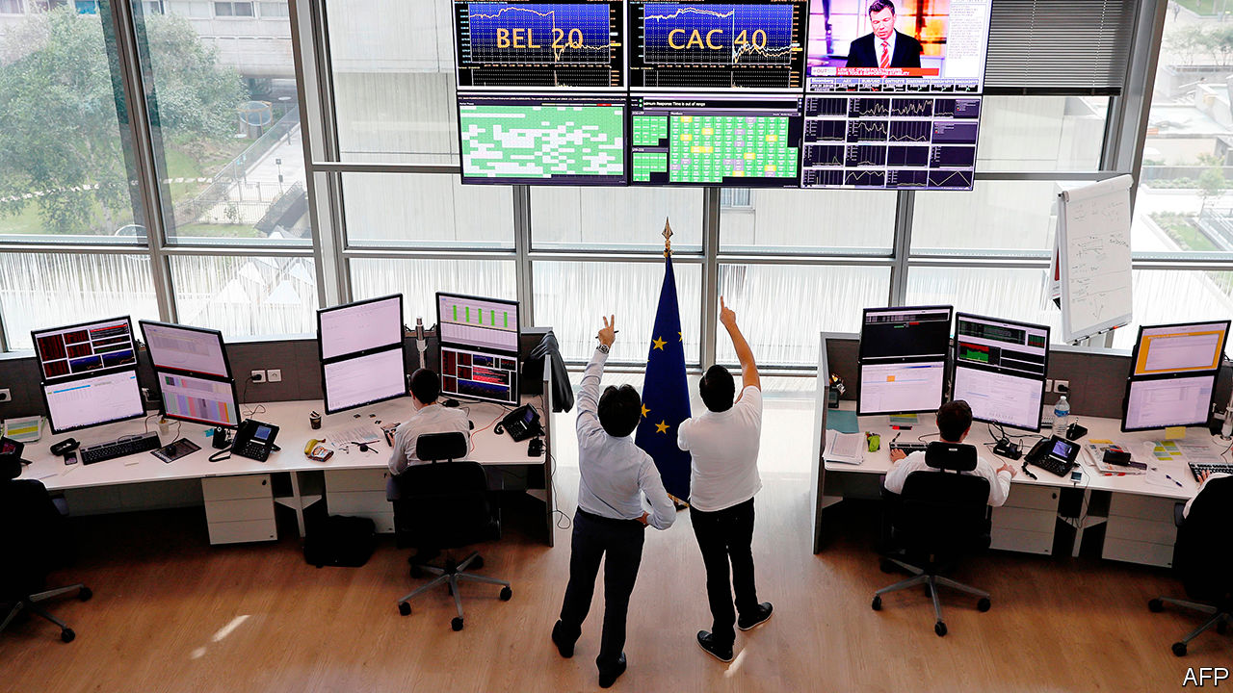

IN THE POPULAR imagination, Americans toil endlessly in the office while their European counterparts arrive late, lunch at leisure and depart punctually. If that were ever true equity traders were never let in on the scheme. Opening hours on stockmarkets in Europe are some of the longest in the world, keeping financiers at their Bloomberg terminals far longer than those following American or Asian bourses. Despite that, a proposal to cut back trading hours is making little headway.

That European markets open early and close late is partly a function of geography. Frankfurt, London and Paris (among others) aspire to be a kind of bridge between Asia, where stock exchanges close as Europe opens, and America, which gets going towards the end of its trading day. But that means eight-and-a-half hours of trading, from 9am to 5:30pm. That is two more than at the New York Stock Exchange, where vastly more shares switch hands. Tokyo’s market is open for just six hours, interrupted by lunch.

Late last year trade groups representing investors that buy shares and bankers that sell them had together suggested to operators of European stockmarkets that the working day be shortened. Opening an hour later and closing half an hour earlier, say, would concentrate buying and selling in a shorter window. Far from cutting traded volumes, they argued, the smaller and more liquid trading window might even entice more activity.

Starting an hour later and finishing a bit earlier would certainly mean less stress for traders, who have to be at their desk at least an hour before markets open. That might attract more diverse staff, notably women, not just in trading but in all the finance jobs that surround it. The pulse of the financial day—when companies release results, for example—is dictated in part by when markets open and close.

By and large, though, the stock exchanges are not keen. In recent weeks they have either rejected the idea outright or kicked it into the long grass. They argue that retail investors would find it harder to place their orders outside their own working hours. The overlap with Asia, though minimal, gives Europe special status in the financial world, even as the old continent’s markets are dwindling in relative importance. And if the days are too long for traders, perhaps they could simply work in shifts instead.

Surprisingly, the push for shorter hours is coming from the Anglo-Saxons of the City. The London Stock Exchange is the only bourse to have responded warmly to the pitch for shorter days. That could be because London opens an hour earlier, at 8am, in order to synchronise with continental exchanges. And hours will only be cut if everyone agrees to make the shift simultaneously.

Part of the reason for exchanges’ reluctance is that they worry that banks are angling to match buyers and sellers of shares themselves, as they do outside trading hours. Plenty of investors may even be wondering whether humans need to be involved, given that most financial transactions these days are conducted by machines. Flesh-and-blood traders angling for shorter hours may soon find they will be working none at all. ■

This article was downloaded by calibre from <https://www.economist.com/finance-and-economics/2020/07/11/europeans-quibble-about-long-trading-hours-the-finance-edition>

|  |  |  |  |
| --- | --- | --- | --- |
| Previous | Articles | Sections | Next |

|  |  |  |  |
| --- | --- | --- | --- |
| Previous | Articles | Sections | Next |

#### Buttonwood

# More corporate defaults seem to be on the way

Despite a mini-boom in the bond market, defaults are priced in

Jul 11th 2020 |

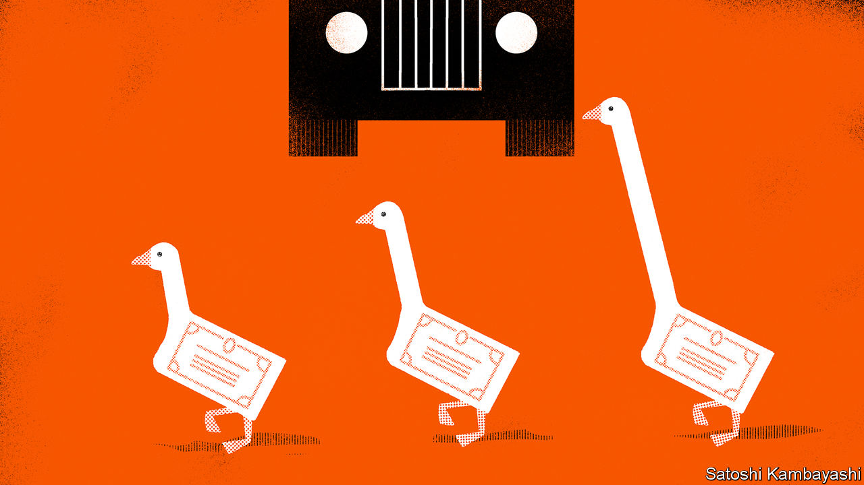

IT WAS A company revered by business-school gurus and investors alike. British consumers cherished it for its value-for-money clothing. Its own-brand biscuits were unrivalled. But the glory days of Marks & Spencer are long gone. As if to underscore this, it recently became a “fallen angel”: its bonds were demoted to speculative-grade (or “junk”) status by S&P, a rating agency. Many other once-admired companies have been similarly humbled. Ford, Renault and Kraft Heinz are among the bigger angels to have fallen in recent months.

Companies are mercilessly sorted by recessions. The strongest credits grow stronger. The weakest investment-grade firms descend into junk territory. And the most frail speculative-grade firms go into default. Just a few months ago there was a real concern that the sorting would be too brutal. Good companies might go under for a want of cash to see them through the covid-19 shutdown. But governments and central banks acted decisively to support the economy. Stockmarkets fell, and then rallied. Corporate-bond issuance surged.

Now you hear a different concern: not that some worthy firms might die, but that too many unworthy firms will live on in a zombie-like state. That is a testament to the dramatic change in market mood. This does not mean that the angelic and diabolical are treated exactly the same, though. This particular turning-point in the business cycle has its own peculiarities, but in some important respects it mirrors the past. And the general pattern after recessions is for corporate-bond markets to rally months before defaults reach a peak.

Begin, though, with the peculiarities. Even before the recession struck there was a widespread concern about an overhang of debt rated BBB, a notch above junk. The fear was that a deluge of falling angels would overwhelm the speculative-grade market. That this didn’t happen is in large part down to America’s Federal Reserve, which has backstopped the corporate-bond market. Since March 23rd, when the Fed first announced it stood ready to buy corporate bonds, companies have issued more than $1trn-worth.

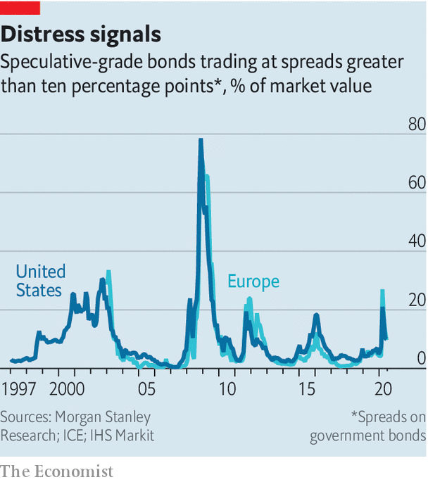

Yields on the best investment-grade credits—low-debt firms in defensive sectors like technology or health-care products—have fallen ever closer to those on government bonds. These are far from default. But not every issuer has been saved. Corporate defaults have already picked up. S&P expects the trailing 12-month default rate for junk bonds to rise to 12.5% in America and 8.5% in Europe by March. Many debt-laden firms in America opt for the protection of Chapter 11 bankruptcy, which allows them to keep operating as they settle their debts. In some cases, the trigger for default is a “distressed exchange”, where a company buys back its own bonds, or swaps them for new ones, when they are trading at a price much below their par value. And there is still a sizeable rump of bonds that trade at distressed prices—defined as yields that are ten percentage points above those of government bonds (see chart).

This default cycle will be more industry-specific than the one following the recession in 2008-09, says Mark Kiesel of PIMCO, a big bond house. One lot of vulnerable firms had cloudy long-term prospects even before the pandemic—think carmakers, oil firms and retailers. Another lot, including airlines and hotels, may be permanently scarred by changing consumer behaviour.

A bounce-back in economic activity seems assured. But there is still much uncertainty about what comes after that. Even a smooth recovery will leave some firms insolvent. And setbacks are likely. Investors seem willing to take a punt on risky credits all the same. In part this is a desperate search for yield when the safest bonds yield next to nothing. But there are other considerations. When the Fed buys corporate bonds, investors feel invited to follow its lead. And if a firm has access to cash, it has a chance to stay alive—and perhaps eventually to repay its debts. “Liquidity allows companies to extend their lives so you’ll have more survivors,” says Robert Tipp of PGIM, an asset manager.

History says you get the rally first, and then defaults peak: 2009 was a great year for corporate-bond returns even though plenty of firms stopped paying their creditors. Soon attention will move on. The next phase of the cycle is one of balance-sheet repair, says Max Blass of Morgan Stanley, a bank. Firms will pay down debt to lower their cost of credit—to avoid becoming a fallen angel, or perhaps even to become a rising star.

Editor’s note: Some of our covid-19 coverage is free for readers of The Economist Today, our daily [newsletter](https://my.economist.com/user#newsletter). For more stories and our pandemic tracker, see our [hub](https://www.economist.com/news/2020/03/11/the-economists-coverage-of-the-coronavirus)

This article was downloaded by calibre from <https://www.economist.com/finance-and-economics/2020/07/11/more-corporate-defaults-seem-to-be-on-the-way>

|  |  |  |  |
| --- | --- | --- | --- |
| Previous | Articles | Sections | Next |

|  |  |  |  |
| --- | --- | --- | --- |
| Previous | Articles | Sections | Next |

#### Free exchange

# Americans need more guidance from the Fed

Spelling out the future path of policy would help

Jul 11th 2020 |

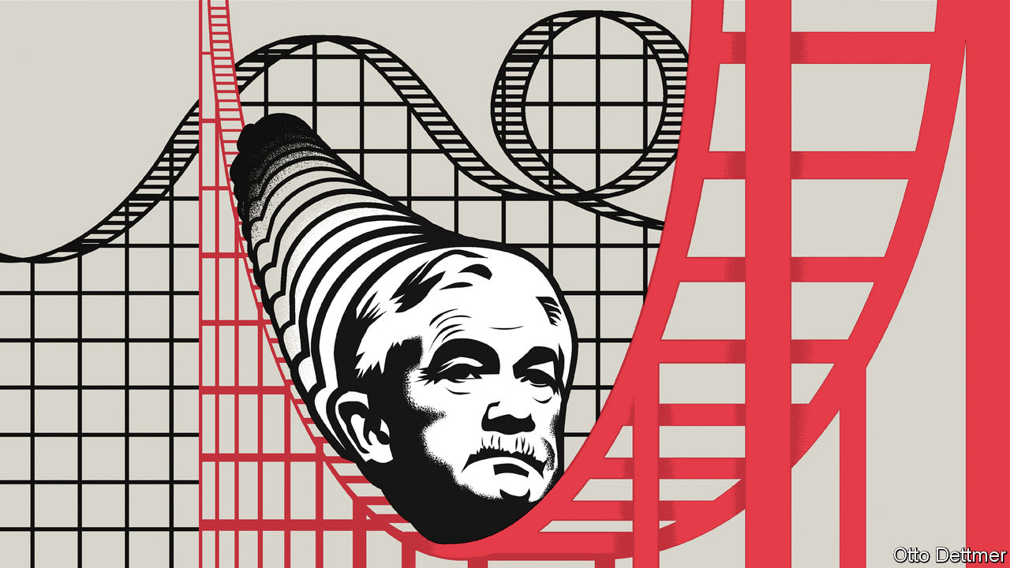

YOU MAY think that central banking is a sort of macroeconomic engineering—tweaking an interest rate here or a financial regulation there. But psychology enters into it, too. In order to achieve strong growth, people need to spend today as if the health of tomorrow’s economy were assured. That makes communication critical. Early on Jerome Powell, the chairman of America’s Federal Reserve, showed signs of an aptitude for managing collective confidence. He is plain-spoken, with a charm that often eludes economic policymakers. But now he faces a truly forbidding environment. Both his legacy and the trajectory of America’s recovery depend on how he wields the credibility he has earned.

When Mr Powell took over as chairman in 2018, expectations of him were modest. President Donald Trump chose him rather than offering Janet Yellen—a respected economist—a second term, even though she had done the job ably. Mr Powell had studied law not economics, and spent most of his career in finance. Though a Republican, he had been nominated to the Fed’s Board of Governors by Barack Obama, Mr Trump’s predecessor, as a concession to Congressional Republicans, who habitually stonewalled his Democratic nominees.

In fact the early Powell years proved surprisingly good. The economic expansion he had inherited stretched into the longest on record. By early 2020 America’s unemployment rate had sunk to 3.5%, the lowest level in half a century. In 2018 the central bank launched a review of its tools and communications, which included “Fed Listens”, a series of public events. These ran the risk of being little more than a public-relations exercise. Instead, they seem to have made a meaningful impression on Mr Powell. He credits them for the insight, frequently mentioned in his speeches, that low-income workers are often the last to benefit from economic expansions. A single-minded focus on low inflation can thus systematically impose hardships on working-class households.

It is difficult to be sure, but this lesson seems to have influenced policy. The Fed cut its benchmark interest rate by 0.75 percentage points in the second half of 2019 despite warnings—some from within—that doing so when unemployment was historically low and asset prices high could fuel inflation or provoke financial instability. Assessing America’s impressive employment figures in November, Mr Powell reckoned there was “still plenty of room for building on these gains”. When the pandemic struck, he moved quickly to limit its economic damage. The Fed launched an armada of lending programmes to keep financial markets functioning, swiftly slashed its main policy rate back to zero, and bought nearly $3trn in assets using newly created money. Congress acted too, passing legislation to help struggling firms and households. Amid America’s flailing institutions, however, Mr Powell’s Fed at times seemed uniquely competent.

The nature of the covid-19 downturn is now changing. The first steps towards reopening helped the economy claw back some of the enormous output losses sustained between February and May. But the early rebound masks a grim long-run outlook. Although employment jumped by nearly 5m in June, an astounding rise, the level is still nearly 15m below that in February. The number of permanent job losers rose by nearly 600,000. Forecasts have become gloomier. New projections by the Congressional Budget Office suggest that America’s economy will not return to operating at full capacity until 2028 at the earliest. Even by 2030, the unemployment rate may be no lower than when Mr Powell took over.

Mr Powell thus finds himself in a position uncomfortably similar to that of Ms Yellen and Ben Bernanke, who served as chairman in 2006-14: of having exhausted conventional monetary tools just as a long period of economic weakness looms. Like them, Mr Powell has emphasised that more fiscal stimulus is needed. But he seems in no rush to try unconventional policy tools, such as setting caps on long-term interest rates, cutting short-term rates below zero or talking more explicitly about the path of future policy (known as forward guidance). Mr Powell seems to be reticent not because he thinks the costs of such tools outweigh the benefits, but because he believes he has done enough. “I would say that we think that monetary policy today is currently well positioned,” he noted in June. The reluctance may seem sensible. Further reductions to already-low interest rates would provide a modest boost to demand at best. The logic of forward guidance is that the promise to tolerate above-target inflation tomorrow encourages spending today. But in the short run, the danger posed by covid-19 is quite clearly the greatest impediment to rapid recovery. The Fed can do nothing about that.

## Talkin’ bout my expectations

Inaction is riskier than it seems, however. The Fed cannot easily make things better for as long as the pandemic rages, but it can make things worse. Without clear guidance from the central bank on the sorts of conditions that would justify a rise in interest rates, expectations of rate rises and a slow recovery—like the last one—could become entrenched. Mr Powell has cultivated a reputation as a champion of full employment; this could allow him to make a credible commitment to keeping policy accommodative even as a rapid rebound unfolds. He could even borrow a trick from Mr Bernanke, for instance, who in retirement has argued that when interest rates fall to zero, central bankers should consider adopting a temporary price-level target, promising to make up for any shortfalls in inflation that occur during a recession, and tolerating temporary periods of above-target inflation.

Too little communication on policy could mean more permanent job losses, entrenched pessimism and the erosion of Mr Powell’s credibility. Few would blame him if another devastating downturn is followed by another anaemic recovery. But he may just be able to persuade Americans to expect something better. ■

Editor’s note: Some of our covid-19 coverage is free for readers of The Economist Today, our daily [newsletter](https://my.economist.com/user#newsletter). For more stories and our pandemic tracker, see our [hub](https://www.economist.com/news/2020/03/11/the-economists-coverage-of-the-coronavirus)

This article was downloaded by calibre from <https://www.economist.com/finance-and-economics/2020/07/11/americans-need-more-guidance-from-the-fed>

|  |  |  |  |
| --- | --- | --- | --- |
| Previous | Articles | Sections | Next |

|  |  |  |
| --- | --- | --- |
| Finance & economics | Sections | Books & arts |

Science & technology

The 23rd International AIDS Conference: Social distancing

.

Archaeology: How illuminating

.

Climate change: Delayed cool

.

|  |  |  |
| --- | --- | --- |
| Finance & economics | Sections | Books & arts |

|  |  |  |  |
| --- | --- | --- | --- |
|  | Articles | Sections | Next |

#### The 23rd International AIDS Conference

# This year’s AIDS conference has brought snippets of good news

But the HIV pandemic is nowhere near over yet

Jul 8th 2020 | NOT SAN FRANCISCO AFTER ALL

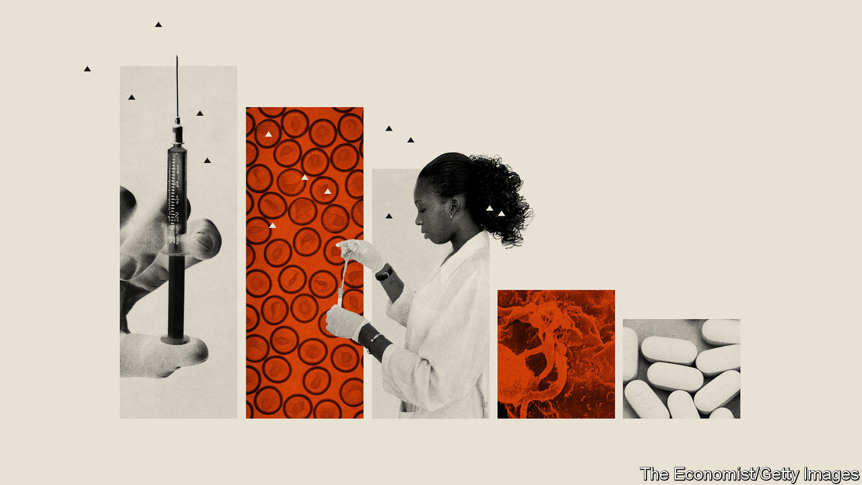

EVEN IN THE days of the internet, conferences remain the lifeblood of science. Young thrusters can meet old fogeys and lobby them for jobs. Ideas can be swapped in the knowledge that no electronic trail will come back to haunt you. And journalists can swoop, scoop up a bundle of interesting stories and, with luck, provide an update to their readers and viewers of developments in whatever field the conference was about.

The International AIDS Conferences, the first of which was held 35 years ago, in Atlanta, Georgia, have done all these jobs well. But they have also had two others. One is to bang a drum which reminds the world that AIDS is still a curse on humanity—hence the particular welcome offered to journalists. The second is to mix experts and activists from rich countries and poor for the better exchange of problems and solutions. Much of this mixing is serendipitous face-to-face contact. It is therefore poignant that one consequence of a different viral pandemic, covid-19, is that the organisers of this year’s AIDS conference decided not to hold it in San Francisco after all. Instead, they transferred everything to cyberspace.

## Drumming home the facts

A paradox of AIDS is that it has dropped off many people’s radar screens precisely because the response to it has been so successful. That risks neglect of the problem, which in turn risks a rebound of the disease. UNAIDS, the United Nations’ agency charged with combating the HIV pandemic, released its latest report on July 6th, the day the conference began. On the face of things, it makes grim reading. Though the error bars are wide, some 1.7m people were newly infected in 2019 and 690,000 of those already infected died. At the end of the year that left 38m people living with the virus, of whom 25.4m were taking antiretroviral (ARV) drugs of one sort or another to keep their viraemia under control. But, though these numbers are huge, they are all heading in the right direction (see chart 1).

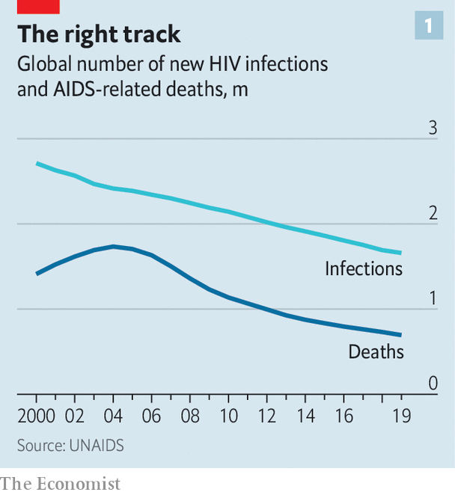

The world’s AIDS establishment is also coming closer to achieving its next self-imposed target, known as 90:90:90. This is to identify 90% of those infected, treat 90% of those so identified, and suppress to undetectability the viral load of 90% of those so treated. The aim, set by the UN in 2014, was to do all that by the end of this year. It always seemed ambitious, and is most unlikely to happen. At the end of 2019 the central estimates of the numbers in question were 81%, 82% and 88% respectively.

But again, things are moving in the right direction. Fourteen countries, including Botswana, Cambodia, Rwanda, Zambia and Zimbabwe, report that they have reached the 90:90:90 goal. Two of them, Switzerland and Eswatini (formerly Swaziland) report 95:95:95—which is actually the target for 2030. Though Eswatini is a small country, it has the highest prevalence of infection on the planet (27% among 15- to 49-year-olds), so that is a welcome success.

There are still worries. As chart 2 shows, the cash available to deal with HIV in poor and middle-income countries—the places where it is most prevalent—has been falling for the past couple of years. That is an especial problem in the case of this virus, for one of the costs involved, the supply of ARVs to those living with it, inevitably increases with success, since each life saved must be sustained by drugs indefinitely.

Another concern is the effect of covid-19. The economic downturn caused by the new coronavirus means HIV may not keep its priority status among finance ministers. And, more immediately, covid-19 poses a threat to the continued flow of ARVs. By July 1st 36 countries had made reports to the World Health Organisation of disruptions to services which provide these drugs. Together, these places are home to 11.5m recipients of ARVs—about 45% of the world’s total. In 24 of them, home to 8.3m users, stocks were reported as “critically low”. UNAIDS suggested in May that a six-month-long disruption to ARV treatments in sub-Saharan Africa might cause around 500,000 deaths.

## Injections of hope

With luck, covid-19 will be a blip. In the longer term, though, the search continues for better ways both to treat those currently infected with HIV and to stop others joining their numbers.

A vaccine seems as far away as ever, and little news emerged at the conference to change that assessment. Another means of prevention has, however, been advancing with impressive speed. This is a technique called pre-exposure prophylaxis (PrEP). It works by offering specially tailored formulations of ARVs to people at high risk of contracting HIV.

The established version of PrEP uses a combination of two drugs, emtricitabine and tenofovir, known collectively as Truvada. According to UNAIDS almost 600,000 people (mostly gay men) took Truvada at least once in 2019. As is often the case with new medicines, cost has dictated that a lot of these people live in rich countries.

Truvada is now, however, being deployed in poor countries, too. According to PrEPWatch, a not-for-profit clearing house for PrEP-related information, as of April this year about 56,000 people in Kenya were taking the drug combination—just under half the target set for that country by PEPFAR, the body that disburses much of America’s AIDS-related foreign aid.

And PrEP is getting better. A drug called cabotegravir is being tested for the purpose. Cabotegravir is an integrase inhibitor—meaning that it works by stopping HIV copying its genome into the chromosomes of its host cells, an important stage in its life cycle. Unlike Truvada, which must be taken daily, by mouth, prophylactic cabotegravir is delivered as an injection once every two months.

Cabotegravir also seems to be more effective than Truvada. A trial of 4,600 volunteers (gay men and transgender women) spread across Africa, Asia and North and South America was so successful that it was stopped in May, 22 months before its scheduled end. A parallel trial on women volunteers, which began more recently, is now being watched closely to work out if it is having a similarly positive outcome.

Periodic injections rather than daily pills may also be on the cards for the treatment of those already infected. Once again, cabotegravir is involved. Two trials which reported last year, of a combination of it and another antiretroviral, rilpivirine, suggest that this formula is just as effective, when injected once a month, as are standard oral drugs taken daily.

Advances in prevention and treatment, then, are clearly on the cards. One of the conference’s most intriguing announcements, though, concerned the tantalising possibility of a cure.

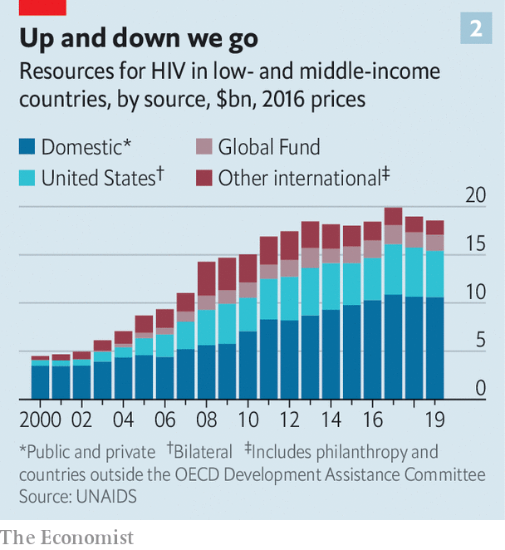

Until now, only two people were thought to have been cured of AIDS. In this case the term “cure” means a patient can stop taking ARVs without the virus emerging from the chromosomes in which it has been hiding. Ricardo Diaz of the Federal University of São Paulo, in Brazil, thinks that there may now be a third example.

The two established patients, who, though no longer anonymous, are still widely known as the Berlin and London patients, were recipients of carefully chosen bone-marrow transplants intended to treat blood cancers that they were suffering from. With the recipients’ consent these were made from donors who had a rare genetic mutation which confers immunity to HIV infection. This is not a realistic route to a routine treatment, though, because it is far too dangerous and expensive. What happened to the São Paulo patient, as he will no doubt come to be known, may be. Dr Diaz’s hope is that this man has been cured using workaday drugs.

The method Dr Diaz employed is called “kick and kill”. The “kick” part involves activating all cells with HIV genes integrated into their chromosomes, in order to switch those genes on and thus turn the cells into virus factories. Cells with integrated HIV genes are invisible to the immune system. Those where HIV is active are not. They will be sought out and destroyed—the “kill” part of the treatment.

## Kick, kill and cure

The trick is to find a suitable combination of molecules to do the kicking without the now-activated virus getting out of control. Dr Diaz’s mixture is a pair of potent ARVs called dolutegravir and maraviroc, and a derivative of vitamin B3 called nicotinamide. He administered dolutegravir, maraviroc and nicotinamide to a group of five volunteers, for 48 weeks, as part of a wider investigation into possible treatments for HIV. Results from one of these volunteers suggested that the treatment might have worked and this patient stopped taking HIV medicine altogether in March 2019. His blood is still virus-free.

Caution is needed here. Dr Diaz has not sampled solid tissue such as lymph nodes where HIV tends to hide, nor has his claim that his patient’s blood is virus-free been independently verified. But if confirmation comes, and the patient continues to do well, then this would be an important result. A safe, permanent alternative to a lifetime on ARVs would be a wonderful thing.

So, did the enforced transfer to cyberspace work? As a one-off, certainly. More than 20,000 people registered, a number similar to previous meetings, and the lectures themselves were well attended. As to those who came, Gopal Shrestha, a Nepalese who was the first HIV-positive person to climb Mount Everest, said he found the meeting fruitful. And Mark Dybul, the founding head of PEPFAR, while regretting the difficulty of remote networking, observed that future conferences could have the best of all worlds by permitting both physical and virtual attendance. If that happens, then some virtue may have come out of what was a necessary decision. ■

This article was downloaded by calibre from <https://www.economist.com/science-and-technology/2020/07/08/this-years-aids-conference-has-brought-snippets-of-good-news>

|  |  |  |  |
| --- | --- | --- | --- |
|  | Articles | Sections | Next |

|  |  |  |  |
| --- | --- | --- | --- |
| Previous | Articles | Sections | Next |

#### How illuminating

# Measuring luminescence helps to date a remarkable new discovery at Stonehenge

High-tech archaeology

Jul 11th 2020 |

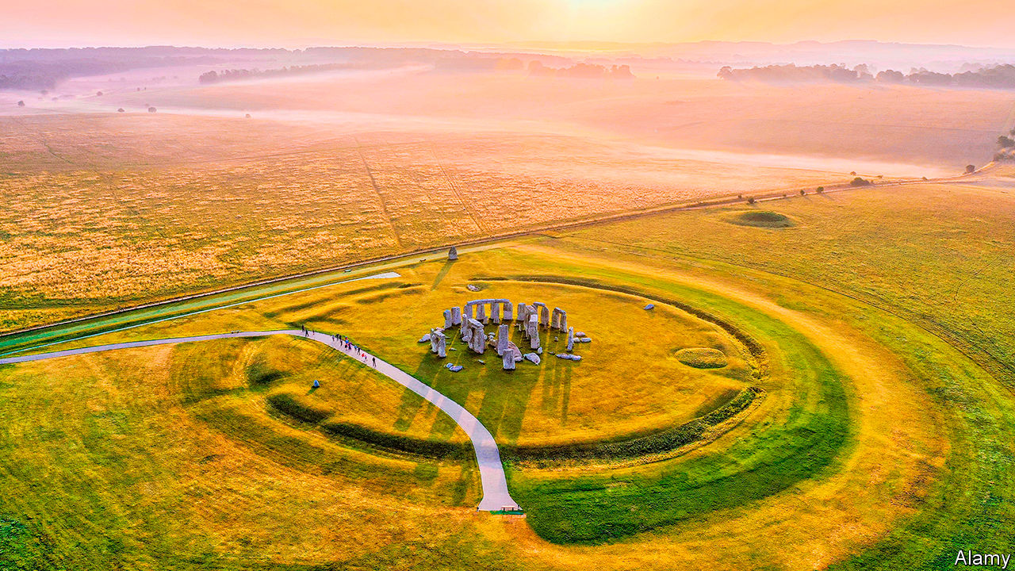

FOR MORE than 4,000 years Stonehenge has stood on Salisbury Plain in southern Britain. The landscape surrounding the Neolithic monument contains many secrets, with features dating back to much earlier times. Having surveyed more than 18 square kilometres in the vicinity, archaeologists continue to make surprising discoveries. The latest, a series of deep pits forming a vast circle more than two kilometres in diameter, shows how technology makes it possible to peer even further back into time.

Along with their shovels, trowels and brushes, archaeologists have put together a toolbox of new technologies. Using magnetometers, which can detect how different materials in the ground cause slight changes in Earth’s magnetic field, they found a series of anomalies forming circular disturbances in the ground on a broad arch around Durrington Walls, the remains of another large henge three kilometres north-east of Stonehenge. These were thought to be old filled-in ponds.

But ground-penetrating radar, another archaeological tool, raised questions about that notion. This technique, which reflects radio waves off underground structures, showed that far from being shallow, as ponds would have been, the anomalous features had deep vertical sides. They were some ten metres across and five metres or more deep. Up to 20 shafts were identified, but there may have been 30 or more as some of the land is now covered by buildings and roads. The archaeologists thought it was time to take a closer look with more high-tech tools.

Vince Gaffney of the University of Bradford and a team of researchers from Britain, Austria, Sweden and Norway, drilled into three of the sites to extract core samples. Fragments of shell and bone were found. As these fragments are organic materials containing carbon, they could be subjected to radiocarbon dating. This measures the presence of carbon-14, a mildly radioactive isotope created naturally in the atmosphere by cosmic rays. As this element decays, older samples have less carbon-14 in them than modern ones, and because the rate of radioactive decay is predictable, a date for the sample can be calculated.

The dates, though, varied widely; up to 6000BC for some of the shells and around 1300BC for some bones. Moreover, if a pit had been gradually filled in over the years, older material would have appeared at the bottom and younger material near the top. But some of the dates were inverted, showing older material near the top.

To work out what might have gone on, the archaeologists reached for one of their newest tools: optically stimulated luminescence (OSL). This measures when fragments of rocks made of quartz or feldspar, two of the world’s most common groups of minerals, were last exposed to sunlight.

The OSL process can be likened to measuring the power in a rechargeable battery, explains Tim Kinnaird, who tested the samples from the shafts at his lab at the University of St Andrews. When quartz and feldspar are removed from sunlight and buried, electrons start to accumulate in defects in their crystal structures from exposure, in the ground, to low levels of environmental radiation. When the minerals are re-exposed to the outside world, the electrons are stimulated with enough energy to escape their traps and they go on to release photons of light. As the intensity of this luminescence is directly proportional to the amount of environmental radiation absorbed by the minerals, this can be used to work out when they were last exposed to sunlight.

As they report in Internet Archaeology, the OSL analysis allowed the researchers to put the various radiocarbon dates and the different layers in their core samples into some context. The shells were considered outliers, as they probably contained material from earlier times. The inverted dates seemed to be caused by later earthworks, which might have exposed minerals to light and reset their timeclocks. One pit appears to have been recut in the Bronze Age. But there was enough of a reliable sample to date the pits to around 2500BC, which means they would have been dug by the same people who built Stonehenge.

What purpose the pits served remains speculation. They would have required a massive effort to build, with tools made from stone, wood and bone. They may have been boundary markers, possibly containing large totem-like poles. Henges have cosmological significance and some think Stonehenge was a site for the dead while Durrington Walls, which had wooden structures, was a site for the living. The archaeologists hope to open up trenches throughout the pits to discover more.

## The ancient olive

Elsewhere, OSL is proving successful in some surprising areas. Eren Sahiner of Ankara University in Turkey used the technique to date Ata Agac (Grand Tree), an ancient olive tree in western Turkey. The age of a tree can normally be determined by counting its growth rings, but the centres of ancient trees have often rotted away, making estimates difficult. Dr Sahiner carefully dug six holes to collect mineral samples from around the tree’s roots. His analysis, published in Journal of Quaternary Science, showed that quartz and feldspar in the soil were last exposed to sunlight up to around 3,000 years ago. That, reckons Dr Sahiner, means Ata Agac was probably planted during the Iron Age by early Greeks who valued olive oil imported from other regions and were keen to plant trees to produce their own. Which just goes to show how illuminating a photon can be.■

This article was downloaded by calibre from <https://www.economist.com/science-and-technology/2020/07/11/measuring-luminescence-helps-to-date-a-remarkable-new-discovery-at-stonehenge>

|  |  |  |  |
| --- | --- | --- | --- |
| Previous | Articles | Sections | Next |

|  |  |  |  |
| --- | --- | --- | --- |
| Previous | Articles | Sections | Next |

#### Climate action

# Emissions slashed today won’t slow warming until mid-century

Mitigation policies remain essential, but governments need to be wary of public perceptions

Jul 11th 2020 |

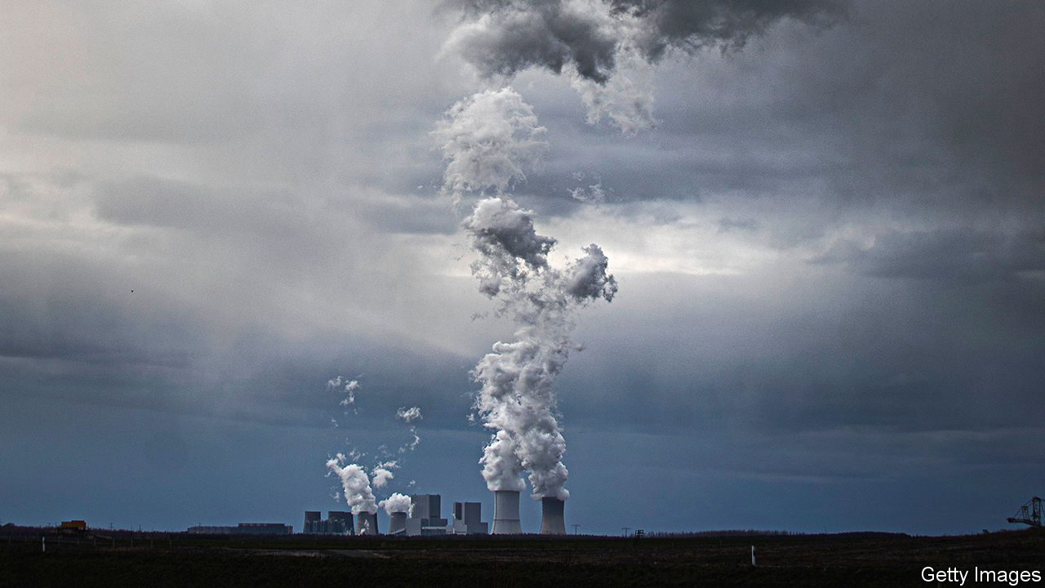

MUCH OF the international effort thus far to combat climate change has focused on cutting emissions of greenhouse gases, chief among them carbon dioxide. That is, of course, a rational approach. Global average temperatures are roughly 1.1°C warmer today than in pre-industrial times and CO2 is the main culprit. It and other greenhouse gases are produced when fossil fuels are burned to generate energy or power engines, in steel and cement-making, by farming and deforestation. In the long term, eliminating these emissions is the only sustainable solution for stopping the inexorable warming of the planet.

But greenhouse-gas emissions do not cause an instantaneous rise in global temperatures, and neither does cutting them result in instantaneous cooling. Instead, it will take decades for today’s policy efforts to result in measurable impacts on global temperature—as illustrated in a study published this week in Nature Communications.

Using climate models, Bjorn Samset and his colleagues at Norway’s Centre for International Climate Research probed hypothetical futures in which emissions of nine different industrial pollutants, including carbon dioxide and methane, were either eliminated instantly or phased out at a rate of 5% each year, starting in 2020. In order to isolate their respective effects, each chemical was knocked out individually while the rest were allowed to keep evolving as they would broadly if governments stuck to current climate pledges. Thus, the experiment tested how quickly additional efforts, as required by the Paris Agreement, would be seen in the rate of global warming.

Running these simulations over and over again in order to get statistically reliable results suggests that cutting CO2 emissions could slow the rate of warming as early as 2033, but only if they are ended worldwide in 2020. In effect, that would mean eliminating 80% of the world’s energy sources, including shutting down all fossil-fuel power stations, overnight—clearly not a realistic or desirable scenario.

Reducing CO₂ by 5% per year, starting this year, would produce a statistically significant deviation from what temperatures would have otherwise been only in 2044. And yet, even that rate of CO2 reduction is ambitious, on a par with the 4-7% drop estimated this year as a result of the covid-19 pandemic and widespread economic shutdowns. Before this, annual emissions were creeping up. Without concerted efforts from governments, they are likely to rise again as economies reopen.

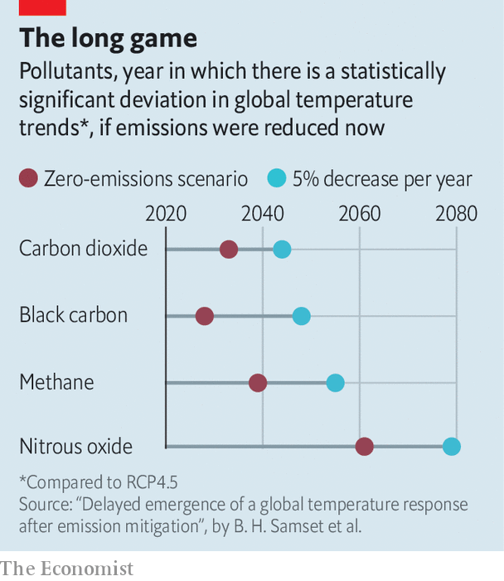

One reason for the delayed effect of slashing emissions is natural variability in the climate. Whether one year is warmer or cooler than the previous is not simply down to greenhouse gases. Large-scale natural climate effects also play a role (El Niño and La Niña are perhaps the best-known examples), warming and cooling the planet in a cyclical fashion by fractions of a degree. Depending on their phase, the warming of greenhouse gases is either masked or compounded by these kinds of natural effects. As emissions begin to drop, natural variability will also mask any slowdown of global warming that results. Dr Samset’s modelling took this into account.

In addition, more than 90% of the energy trapped by the greenhouse-gas emissions produced in the past half-century has been stored in the ocean and released to the atmosphere as heat only slowly. Even if all emissions were cut tomorrow, that process would continue to warm the air above for many years to come.

The main reason for the delay, however, is that carbon dioxide emitted today will remain in the atmosphere for decades to centuries before it is reabsorbed by vegetation and the oceans. That is not true of other industrial emissions. Each molecule of methane warms the planet 84-87 times more, averaged over 20 years, than carbon dioxide, but it stays aloft for merely years instead of decades or centuries. This has resulted in calls for immediate action to slash methane emissions, for instance by plugging leaks in natural-gas infrastructure, and reducing emissions from farming. But even then, Dr Samset’s work suggests that eliminating all sources of methane pollution in 2020 would not affect warming trends before 2039.

## Keep up the pressure

Tragically, the pollutant that could have the most immediate impact is one that currently keeps the world cooler. Sulphur oxides are a by-product of burning some fossil fuels, including coal and dirty bunker fuel, and are a target of policies to clean up maritime emissions and urban air pollution. In the atmosphere, they bounce a portion of solar radiation back out into space, producing a cooling effect. Because they are dragged back to Earth by rain within days of being emitted, cutting them out of industrial activities could boost warming by the end of the decade.

In spite of all this, mitigating emissions remains crucial to the stability of the global climate and the only way of meeting the Paris Agreement targets of limiting global warming to 1.5-2°C. But Dr Samset argues that temperature may not be the best yardstick to measure the effectiveness of climate mitigation, at least not until the 2040s. Instead, direct measurements of the concentrations of greenhouse gases in the atmosphere may be better, as they will remove the confounding effect of natural variability. And without clever messaging, there could be a public backlash against seemingly ineffectual policies.

More fundamental, however, results like these underline that even as economies begin to decarbonise, governments and societies need to drastically step up efforts to adapt to the inevitable warming that lies ahead.■

For more coverage of climate change, register for The Climate Issue, our fortnightly [newsletter](https://www.economist.com/theclimateissue/), or visit our [climate-change hub](https://www.economist.com/news/2020/04/24/the-economists-coverage-of-climate-change)

This article was downloaded by calibre from <https://www.economist.com/science-and-technology/2020/07/11/emissions-slashed-today-wont-slow-warming-until-mid-century>

|  |  |  |  |
| --- | --- | --- | --- |
| Previous | Articles | Sections | Next |

|  |  |  |
| --- | --- | --- |
| Science & ... | Sections | Economic & ... |

Books & arts

Populism and democracy: Party like it’s 1999

.

Japan under the shogunate: A handmaid’s tale

.

Johnson: Shock value

.

Choral singing: Voices off

.

Thought-provoking fiction: Not going gently

.

|  |  |  |
| --- | --- | --- |
| Science & ... | Sections | Economic & ... |

|  |  |  |  |
| --- | --- | --- | --- |
|  | Articles | Sections | Next |

#### Party like it’s 1999

# How the intellectual coalition forged by the cold war collapsed

It splintered amid the rise of populism, as Anne Applebaum recounts in “Twilight of Democracy”

Jul 11th 2020 |



Twilight of Democracy. By Anne Applebaum. Doubleday; 224 pages; $25. Penguin; £16.99.

FOR AT LEAST a decade after the end of the cold war, anti-communist intellectuals rode the crest of a wave. The Soviet system had imploded, miraculously, but there was work—important, exhilarating work—to be done in eliminating its vestiges and uncovering its misdeeds. As an American-born chronicler of communism, Anne Applebaum surfed that wave with aplomb. She wrote incisive books about the Soviet penal system and the Western fools who failed to see its horrors; about Stalin’s campaign, after 1945, to crush democracy in half of Europe; and about the appalling famine he inflicted on Ukraine in the 1930s.

In “Twilight of Democracy”, her tone is more personal and vulnerable. The informal transatlantic coalition of politicians, scholars and writers to which she belonged has broken up, and the worst parts have, for now, come out on top. From Brexit Britain and Donald Trump’s America to the cynical politics of Poland and Hungary, she feels beset by a new chauvinist right that has no regard for rules, truth or institutions.

Ms Applebaum evokes an acute sense of betrayal as people she trusted turn against her, quicker than she thought possible. Her personal story is a parable of what can happen to alliances in the absence of a common adversary, and when the hardships such enemies inflicted fade from memory. It has another implication, too. As she shifts between ruminations over political science and anecdotes meant to expose the nastiness of the new political right, she sometimes brings home the complacency of her own tribe of liberal internationalists who thought that history, if not quite over, was bound to evolve benignly.

## Friends like these

The author, who in the late 1980s and early 1990s wrote for The Economist, is frank about herself: an insider with stratospheric links to the American and above all British commentariat, married to Radek Sikorski, a Pole who studied in Britain and hobnobbed with its gilded Conservative youth, including Boris Johnson (now the prime minister). The book begins with an exuberant party which the couple threw at their manor house in Poland in 1999, gathering in foreign and Polish friends for stew, liquor and a few celebratory pistol-shots. Since then, both have flown high—she as a prizewinning writer, he as Poland’s defence and foreign minister.

But in other ways, life has delivered shocks. She no longer speaks to many of the guests, because they succumbed to the authoritarian temptations of the Law and Justice party that has dominated Polish politics since 2015. They have thus adopted an outlook that sees imaginary enemies everywhere, plays on anti-immigrant and anti-gay sentiment and has no respect for independent judges or media. Ms Applebaum, a product of secular Jewish America, has been singled out for opprobrium.

In various political case studies, she finds a style that assuages a yearning for simple answers. In Poland, a master-narrative was provided by conspiracy theories about the plane crash in Russia in 2010 that killed President Lech Kaczynski. (He recklessly insisted on landing in fog.) In Hungary, the Jewish philanthropist GeorgeSoros has become a bogeyman. Ms Applebaum’s erstwhile British friends see leaving the European Union as a panacea. Mr Trump excoriates the liberal elite and even the moderate Republicans who are Ms Applebaum’s natural allies.

What interests her most is the phenomenon described by a French writer in 1927 as the treason of the intellectuals: the way many academics, editors and leaders of civil society have been supine or collaborative in the face of populist authoritarianism. Her sharpest passages describe the milieu of British Tory journalism in which she once sat at the top table in every sense. Few gain entry into this charmed circle only to break out of it. As deputy editor of the Spectator, a right-of-centre weekly, and co-host of its networking lunches, the author joined a scene where every conversation was laced with multilayered irony—a baffling British subculture in which real feelings are carefully hidden.

She reveres Margaret Thatcher’s memory, but her account lays bare the inherent contradictions of Thatcherism—an appeal to preserve old mores and communities combined with economic change that wrecked them. Once the EU was identified as the enemy, she suggests, the mawkish nostalgia felt by her former friends could let rip. But newcomers like her had no place in that fiercely sentimental world.

In the United States and Hungary, her personal ties are weaker and her observations more abstract. But she mournfully anatomises the breakdown of America’s anti-communist coalition. She thought she was part of a moral crusade to spread constitutional principles and the rule of law. Now she realises that there were other agendas at work. Some American conservatives were most concerned with spreading Christianity; for them, Vladimir Putin’s Russia has (bizarrely) become an attractive alternative to the decadent West. Some saw the defence of America’s narrow national interests from all comers, including immigrants, as paramount. Many never had that much interest in advancing democracy.

## Ghosts at the feast

This is too short a book to probe deeply into the roots of the conservative camp’s embrace of coarse populism. In any case, though, Ms Applebaum evinces relatively little interest in why ordinary voters are tempted by that option. She notes that neither economic hardship nor migration flows are correlated in any linear way with rightward political lurches (Hungarians, for instance, are obsessed with migrants who do not actually exist). But those factors are surely not irrelevant either.

Elites and would-be elites concern Ms Applebaum far more—and these, she knows and describes well. Her approach is touchingly intimate; “Twilight of Democracy” ends with the onset of the pandemic, which forced her and one of her sons to race back to Poland before the borders closed. But her fine book would have been even better if there were clearer hints of self-awareness in her description of the liberal internationalist project. The effervescent mood of 1999 reflected not just a moral victory over Soviet darkness but the apparently unchallenged might of the United States. Ronald Reagan and Thatcher had helped bring down communism; Bill Clinton and Tony Blair felt they could export liberal democracy everywhere. But even then, plenty of conservatives had doubts, including some of Ms Applebaum’s Tory friends, brought up as they were on Rudyard Kipling’s imperial pessimism.

Given the finitude of all human endeavours, and of individual careers, that whole enterprise was always in danger of stalling as global power balances shifted. As a result, defending truth, law and liberty has again become a hard job for principled characters prepared to put friendships, livelihoods and even lives on the line. Such people continue to exist; Ms Applebaum herself is one of them, albeit among the less imperilled. Meanwhile, pandemics permitting, she and her husband will still throw parties—the book features another shindig, held 20 years after the first. But now the guest list is shorter. ■

This article was downloaded by calibre from <https://www.economist.com/books-and-arts/2020/07/11/how-the-intellectual-coalition-forged-by-the-cold-war-collapsed>

|  |  |  |  |
| --- | --- | --- | --- |
|  | Articles | Sections | Next |

|  |  |  |  |
| --- | --- | --- | --- |
| Previous | Articles | Sections | Next |

#### Japan under the shogunate

# The experiences of an obscure woman illuminate Japanese history

Tsuneno’s life was not heroic—but Amy Stanley’s patient reconstruction of it is

Jul 11th 2020 |

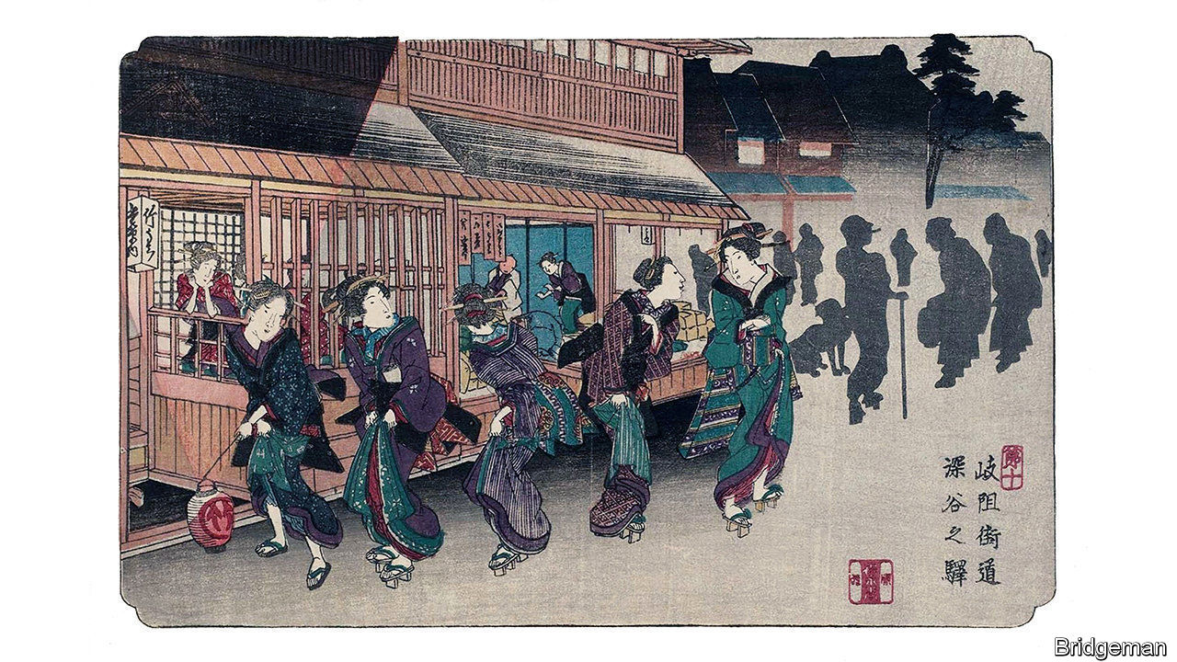

Stranger in the Shogun’s City. By Amy Stanley.Scribner; 352 pages; $28. Chatto & Windus; £16.99

IN THESE TIMES of self-isolation, it is worth remembering that for more than two and a half centuries, from 1603 to 1868, Japan cut itself off almost entirely from the outside world. The imperial line was cloistered in Kyoto, the capital. But real power was wielded by shoguns, or military chieftains, from the Tokugawa dynasty, whose seat was Edo (modern-day Tokyo).

Their fear of Christianity induced them to shut the country’s borders to most foreign traders. Their obsession with stability led to a strictly hierarchical class system. They suppressed internal dissent by demanding that every other year feudal lords leave their homelands and take up temporary residence near the shogun’s palace in Edo. It was an era of stifling political orthodoxy. Yet at the same time, self-reliance led to a flowering of art, theatre and craftsmanship. These traits still echo beneath the post-modern surface of Tokyo, in the form of kabuki, noodle and eel bars, dolled-up hostesses and manga comic books, which date back to the beautifully illustratedstorybooks of the Edo era.

Amy Stanley, an American historian, is enchanted by this faintly remembered world. And she has found a key to unlock some of its most hidden secrets. It comes, she writes, in the form of an extraordinarily extensive archive, comprising letters, diaries, ledgers, tax bills, receipts, petitions and other documents. These were compulsively filed away and preserved by a population in which both men and women were, for their time, relatively well-educated and literate; village priests and farmers kept meticulous records, as did the elite samurai. The result is a visit to the past that is a refreshing antidote to the histories of great men—and the occasional great woman—at times of flux.

It does not dwell on the feats of the shogunate; it barely mentions the shoguns’ women, drafting letters at their lacquered desks. Instead, the book follows the restless footsteps of a crotchety priest’s daughter, Tsuneno, born in 1804 in a snowy village far from Edo, through letters and other documents in the care of a brother (who would often tear out his hair at her behaviour). It tells the story of her hapless love life, her failed marriages, the numerous men who courted and abandoned her, her reckless decision to desert her birth family and travel to Edo, and the excruciating difficulties she encountered there as it slowly became her home.

Tsuneno’s life was not a heroic one. The heroism lies rather in Ms Stanley’s efforts to decipher her story from scraps of paper written in archaic Japanese up to 200 years ago. Yet the paper trail Tsuneno left behind is remarkable; it makes clear the obstacles a strong-willed woman faced in trying to make a living in a man’s world. Tsuneno was a defiant letter-writer, not a charming one. She tells of the hardship of maid’s work in a samurai household, her desperation to retrieve the clothes she has pawned to survive, her vexations with men. Yet there are flickers of rapture about Edo, a city she knew from its teeming streets to the chambers of its elite; enough to persuade her to defy the entreaties of her family to return home and get married (again).

What her letters lack in lyricism, Ms Stanley makes up for by painting a vivid portrait of village life and of the parts of Edo where Tsuneno lived. For women, life was often brutal. One of Tsuneno’s sisters was caged by her in-laws for her behaviour. A sister-in-law was sexually assaulted (as Tsuneno, too, probably was). Sometimes the author overdoes her attempts at reconstructing Tsuneno’s life from the fragmentary evidence that remains. Her task might also have been easier if her protagonist were more lovable.

To add to the poignancy of the tale, though, Tsuneno lived in the decades just before the arrival of Commodore Matthew Perry’s “black ships” from America in 1853, which led to the opening of Japan and the downfall of the shogunate. As Tsuneno struggles to make ends meet amid famine, rice riots, inflation and failed efforts to modernise the regime, her story becomes a portent of Edo’s doom. ■

This article was downloaded by calibre from <https://www.economist.com/books-and-arts/2020/07/11/the-experiences-of-an-obscure-woman-illuminate-japanese-history>

|  |  |  |  |
| --- | --- | --- | --- |
| Previous | Articles | Sections | Next |

|  |  |  |  |
| --- | --- | --- | --- |
| Previous | Articles | Sections | Next |

#### Johnson

# Papers should print offensive language if it is crucial to a story

The issue is part of a larger question: should they publish upsetting material?

Jul 11th 2020 |

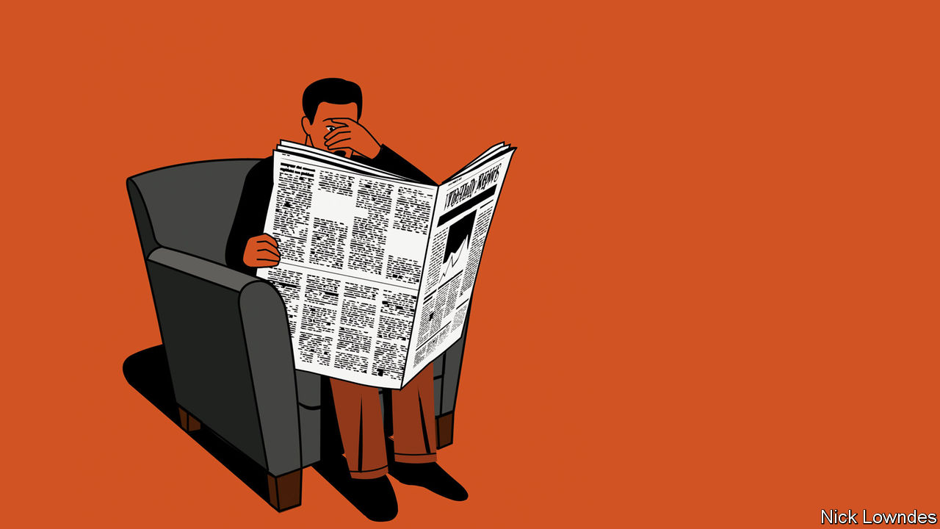

THIS COLUMN comes with an unusual warning—the type that is sometimes called a trigger warning. It will mention a word that was once in common usage in parts of the United States, but which many people have come to regard as the foulest in the English language.

On June 24th three policemen in Wilmington, North Carolina, were sacked because of conversations that had been accidentally recorded in a patrolman’s car. In the most egregious of the taped exchanges, one of the cops, boasting about plans to buy an assault rifle, said: “We are just gonna go out and start slaughtering them”—proceeding to refer to black people with an expletive and a racial slur.

That is how the New York Times reported the story, in any case. What the policeman actually said was: “We are just gonna go out and start slaughtering them fucking niggers.” Such vicious racism in police departments should cause shock (though perhaps not surprise: some activists argued that the incident proved a point they had been making for ages). Yet the redacted account of the episode given in the Times conveyed very little shock at all.

Other news outlets, including the Washington Post, replaced the slur with “f------ n------”. This might seem a best-of-both-worlds policy, in which the facts are clear, but the reader is spared the experience of the abhorrent terms in full. But as with all halfway solutions, it can also be seen as the worst of both. Readers have the vocabulary clearly in their minds, yet they have also been treated as too delicate to handle it.

Philosophers of language distinguish between “mention” and “use” of words. In this case, the cop used the word, but those discussing the story are mentioning it. Black public figures have disagreed on whether the “n-word” should even be mentioned in its uncensored form. At an academic discussion of racism your columnist once attended, a black speaker sought the audience’s permission to do so. One black attendee did object, but after a polite disagreement the speaker continued, and said the word. Barack Obama mentioned the term quite deliberately in a podcast during his presidency, in the course of arguing that the naked racism it represented was hardly the only kind left to fight against.

Hearing obscenities, including slurs, causes a physical stress response—increased blood pressure, skin conductance because of sweat, dilated pupils and the like. But the experience of racist attitudes (even without slurs) causes the body to react similarly. Given that overlap in responses, the issue of whether to print insulting terms may be considered part of a larger question: should newspapers include shocking material? They routinely report on violent events, but such coverage might itself trigger a post-traumatic stress response in people who have experienced violence of the same kind.

Consider, as an emblematic case study, the appearance of gruesome photographs in print. A picture has more direct power to arouse emotion than any reporter’s description. Newspapers do, and should, use caution when deciding, for example, whether to run images of dead or injured bodies. But sometimes they do—and should.

In other words, the decision over whether to reproduce a vile slur is also a judgment about what role emotion should play in journalism. If humans were perfectly rational, f------ n------ might be enough. Readers get what they need to understand the story and will react accordingly.

But people are not entirely rational, as good editors, along with advertisers and politicians, know. The photograph of a single dead three-year-old washed up on a Turkish beach in 2015 is often credited with galvanising a response to the European refugee crisis in a way that accounts of thousands of faceless deaths had failed to do. Not without reason do journalists often begin stories with heart-rending vignettes before going into systemic injustices. One of the core tools of journalism is emotion, used judiciously to reach readers’ hearts as well as their minds.

No one thinks that papers should casually toss around hurtful words. (And, by the by, no one serious about the issue thinks that because some African-Americans have reclaimed the slur for themselves, outsiders are now free to use it, too.) But The Economist’s style book says of obscenities that “if you do use them, spell them out in full.” Let the shock, sadness and anger that readers feel upon hearing them turn into action.

This article was downloaded by calibre from <https://www.economist.com/books-and-arts/2020/07/11/papers-should-print-offensive-language-if-it-is-crucial-to-a-story>

|  |  |  |  |
| --- | --- | --- | --- |
| Previous | Articles | Sections | Next |

|  |  |  |  |
| --- | --- | --- | --- |
| Previous | Articles | Sections | Next |

#### Voices off

# Choral singing has been hit hard by the pandemic

Its social aspect—the main appeal for many singers—now makes it seem risky

Jul 8th 2020 |

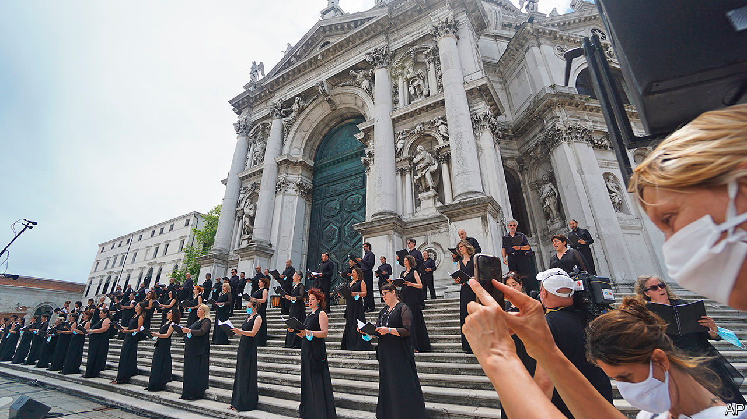

A FEW MONTHS ago Emilia Olsson, a social worker in Sweden, received an email from her amateur choir informing her that, because of covid-19, there would be no rehearsals for a couple of weeks. Then they were cancelled until the summer. She missed the music-making, Ms Olsson says, but especially the sense of community, which had prompted her to join the choir in the first place.

A quintessentially social art form, choral singing has been devastated by the pandemic. Suddenly, groups of people exhaling together in close proximity seem dangerous. According to Sonja Greiner of the European Choral Association-Europa Cantat (ECA-EC), an umbrella group for choirs, rumours of super-spreading at rehearsals were unfounded. In any event, they were suspended en masse, along with concerts and church services.

All this is causing financial hardship for professional singers and heartbreak for amateurs. According to Chorus America, a networking group, 42.6m Americans regularly sing in choirs; the country has almost 270,000 choruses, most of them religious. In Europe an estimated 37m people take part. In many places, choirs bring together individuals who have little in common besides a love of music. Researchers at Oxford University, and at the universities of Oldenburg and Vienna, have found that amateur choral singing helps establish bonds and boosts feelings of connectedness.

In a recent survey by the ECA-EC, virtually all respondents said their choirs had been affected by the virus. Some are able to rehearse online, but the social aspect—the main appeal for many singers, which now makes the activity seem risky—is harder to replicate. “The joy of making music with others,” says Annie Sedley, who sings with the Royal Free Music Society Choir in north London, “the excitement of the performance—all that has gone.” Her choir meets for Zoom sessions while its members “dream of getting together again”. “The choir plays an important role at our church,” says Charles Olson, who sings at North Park Covenant Church in Chicago, “so this situation is devastating.”

Like other artists, meanwhile, professional singers, most of whom are freelancers, are struggling financially. “There’s just no work,” laments Lawrence Wallington, a British bass who has sung with the choir of Westminster Abbey, among others. Mr Wallington doesn’t know when he will perform again; he is hoping that a concert scheduled for November will prove feasible. By then he will have gone more than half a year without choral singing—and without an income.

Westminster Abbey’s choir, which kept singing through the second world war, is bound to survive the pandemic. Others will adapt to a new, socially distanced reality. Justin Doyle, conductor of the RIAS Chamber Choir in Berlin, suggests the disruption could be a spur to new formats. After the hiatus, his group’s live performances may involve three teams of singers taking turns to deliver the same programme to small audiences. “We can innovate more than football can,” Mr Doyle reckons.

But without targeted financial support, many other ensembles may have to fold; the prospects of the highly regarded Vienna Boys’ Choir, among others, look bleak. For many enthusiasts, life after lockdown will be less melodious, and lonelier. ■

This article was downloaded by calibre from <https://www.economist.com/books-and-arts/2020/07/08/choral-singing-has-been-hit-hard-by-the-pandemic>

|  |  |  |  |
| --- | --- | --- | --- |
| Previous | Articles | Sections | Next |

|  |  |  |  |
| --- | --- | --- | --- |
| Previous | Articles | Sections | Next |

#### Not going gently

# When love means saying goodbye

The protagonist of Rick Gekoski’s novel faces a murder charge for helping his wife die

Jul 11th 2020 |

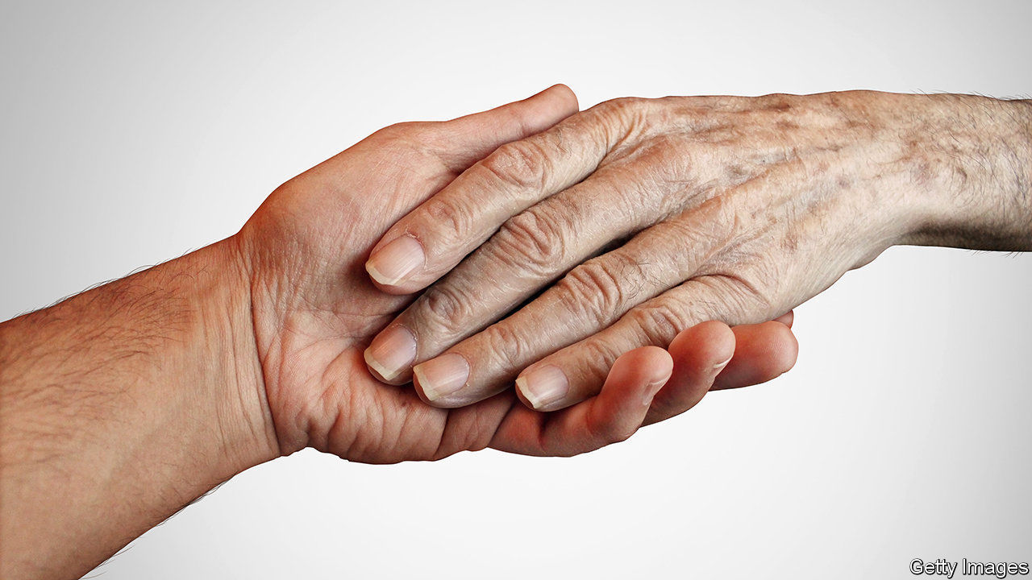

Darke Matter. By Rick Gekoski. Constable; 336 pages; £16.99

THE HERO of Rick Gekoski’s debut novel at first seemed to be a misanthropic crank. James Darke, a retired English teacher, spent months at home wallowing in gloomy thoughts, replaying wistful memories and berating the cruel and idiotic ways of the world and his fellow man. When it emerged that Darke was broken by the loss of his wife, the story and its protagonist acquired heft. A coming-of-old-age tale unfolded into a poignant yet hard-hitting meditation on grief, with a richly complex character at its centre.

Three years on and Mr Gekoski has written a supremely accomplished tragicomic sequel. If “Darke” depicted a painful journey into the light, “Darke Matter” charts forward steps and glances back at the abyss, while exploring a murky moral issue. It is more ambitious than its predecessor, and the author pulls it off in style.

When the novel opens Darke is bracing himself for the first family Christmas without his wife, Suzy. He is no longer an “urban hermit” and has reconnected with his daughter, Lucy. But he is still angry, jaded and bereft, and reluctant to open his door. One day he gives in to insistent knocking and finds two police officers outside. Soon he is taken in for questioning about the circumstances of Suzy’s death.

Darke, it transpires, relieved his beloved wife’s suffering by administering “a fatal draught”. He has no regrets. In his view the terminally ill should be allowed to die with dignity: to have, as he puts it (quoting John Keats), an “easeful death”. When he is charged with murder he is compelled to overcome his “people-phobic” instincts to rally support and argue his case. But does he have the stomach to fight for his beliefs?

Once again, Mr Gekoski’s flawed and vividly drawn hero is the book’s driving force. Darke’s bilious temperament and no-nonsense attitude are a regular source of humour. His acerbic commentaries target Christmas trees, potted plants, parks, politicians, trains, infants and “that flatulent haggis Walter Scott”. The bravura set pieces include a poetry evening with “a bunch of superannuated, sofa-bound littérateurs”.

The only wrong note in Darke’s otherwise commanding voice is an occasional wordiness (“her liquacious, loquacious spirit”). But his heart is laid bare in his contemplation of the woman who still haunts him. It is good to have him back. ■

This article was downloaded by calibre from <https://www.economist.com/books-and-arts/2020/07/11/when-love-means-saying-goodbye>

|  |  |  |  |
| --- | --- | --- | --- |
| Previous | Articles | Sections | Next |

|  |  |  |
| --- | --- | --- |
| Books & arts | Sections | Graphic detail |

Economic & financial indicators

Economic data, commodities and markets

.

|  |  |  |
| --- | --- | --- |
| Books & arts | Sections | Graphic detail |

|  |  |  |  |
| --- | --- | --- | --- |
|  | Articles | Sections | Next |

# Economic data, commodities and markets

Jul 11th 2020 |

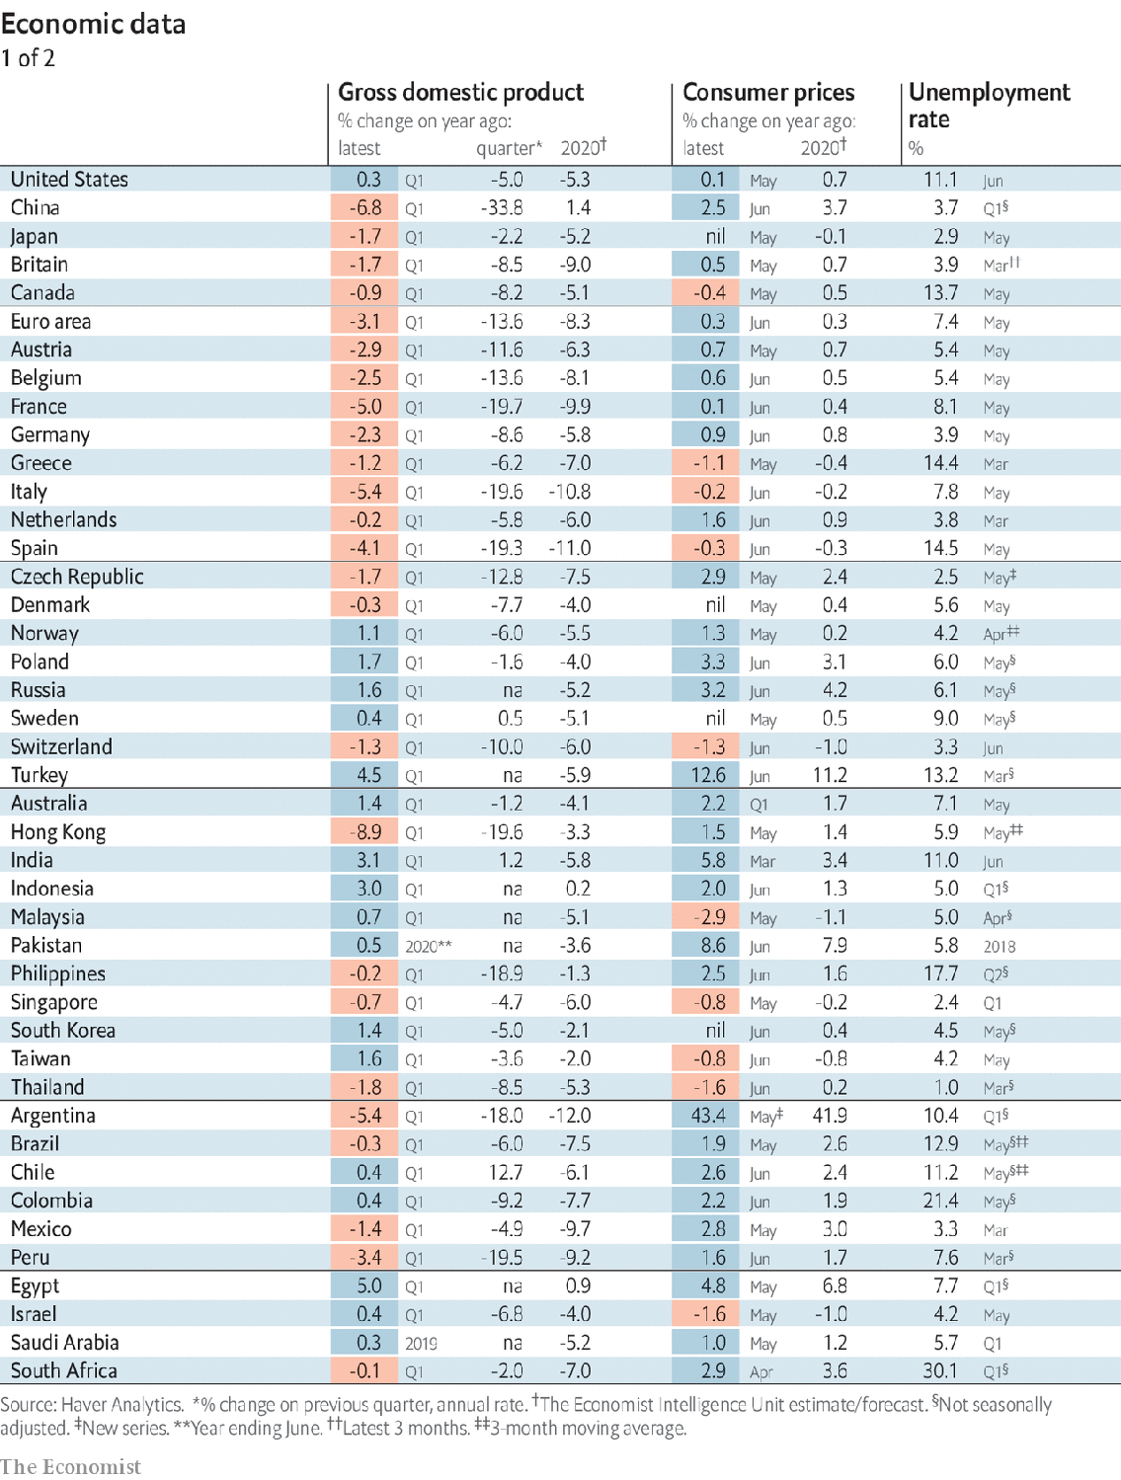

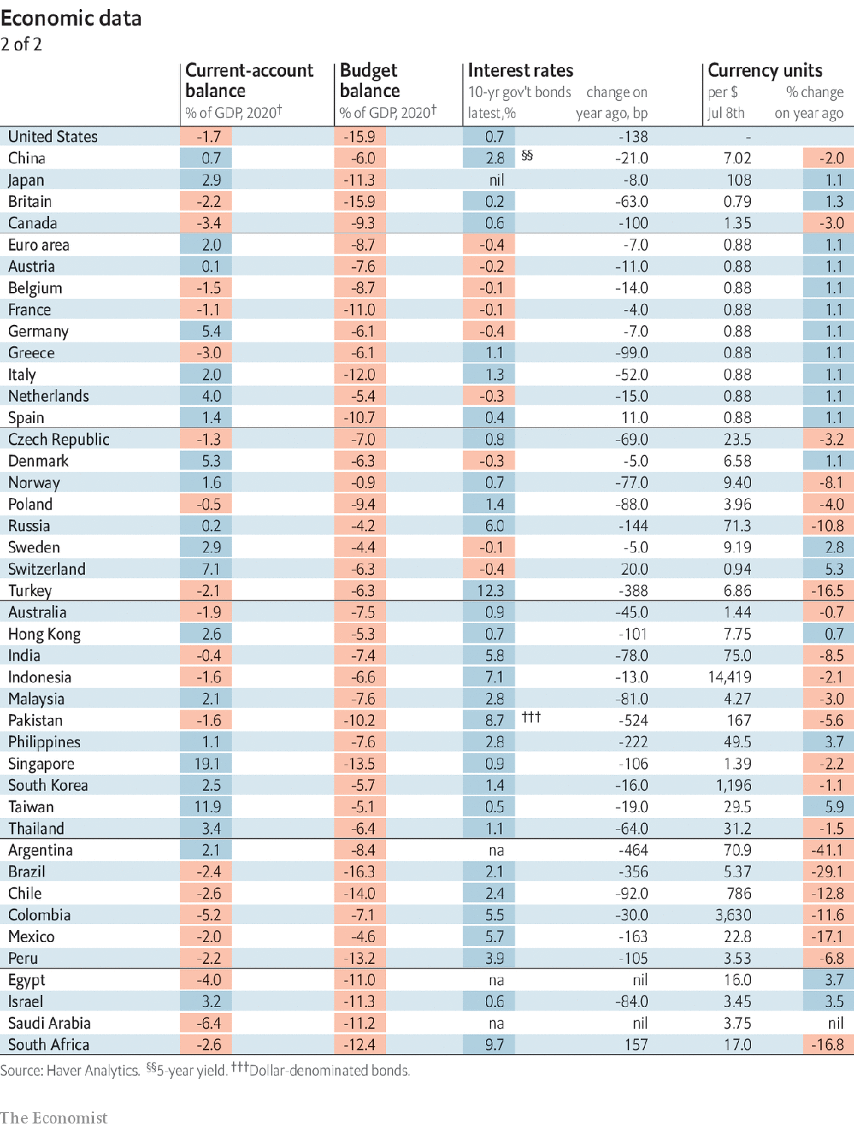

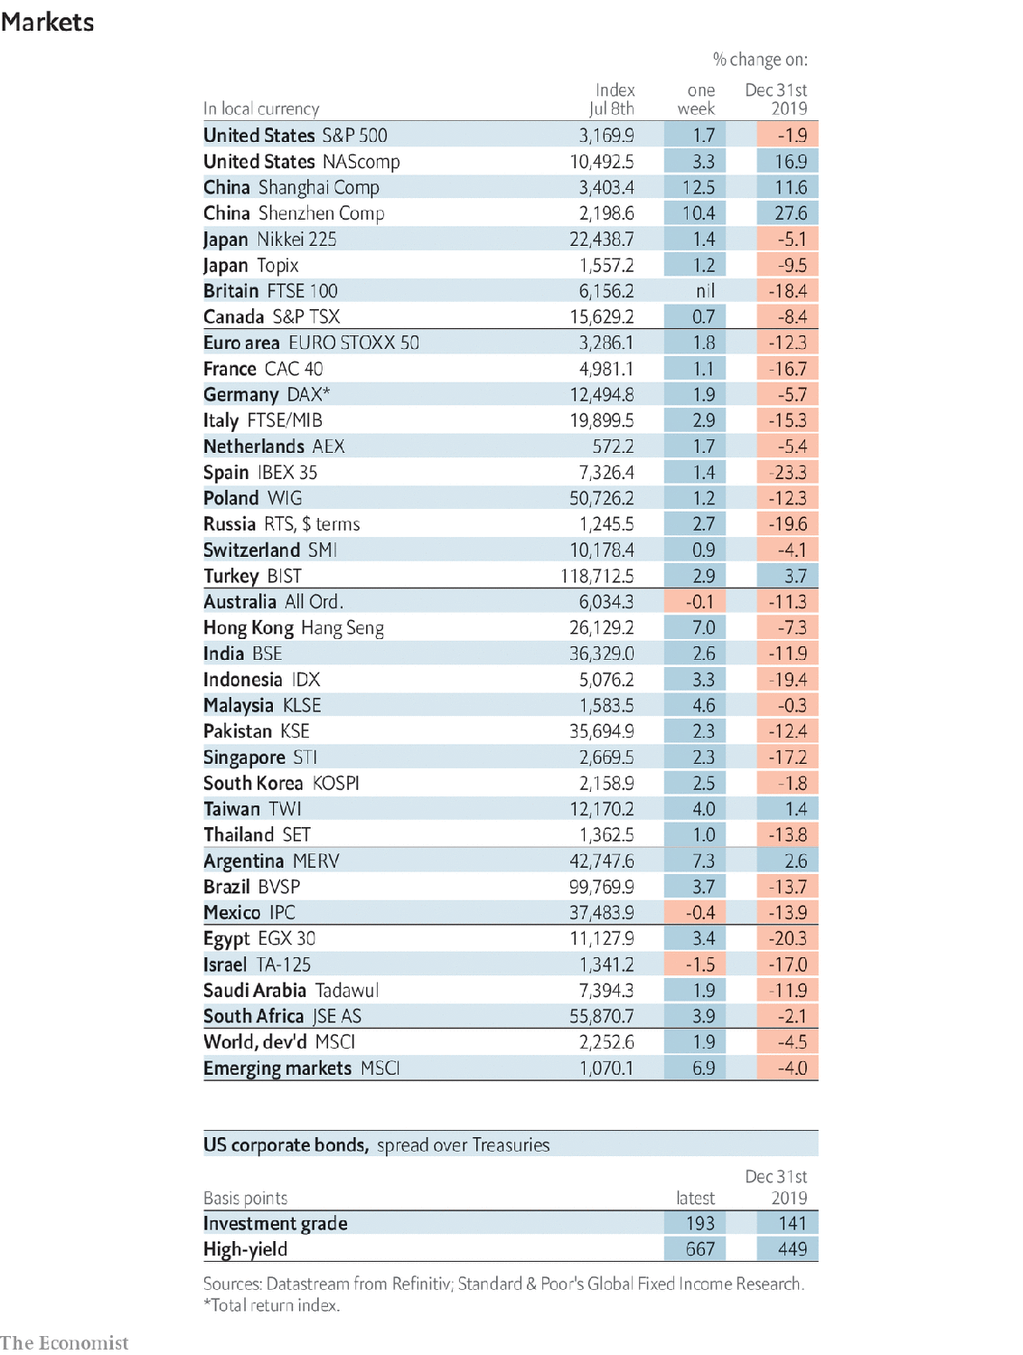

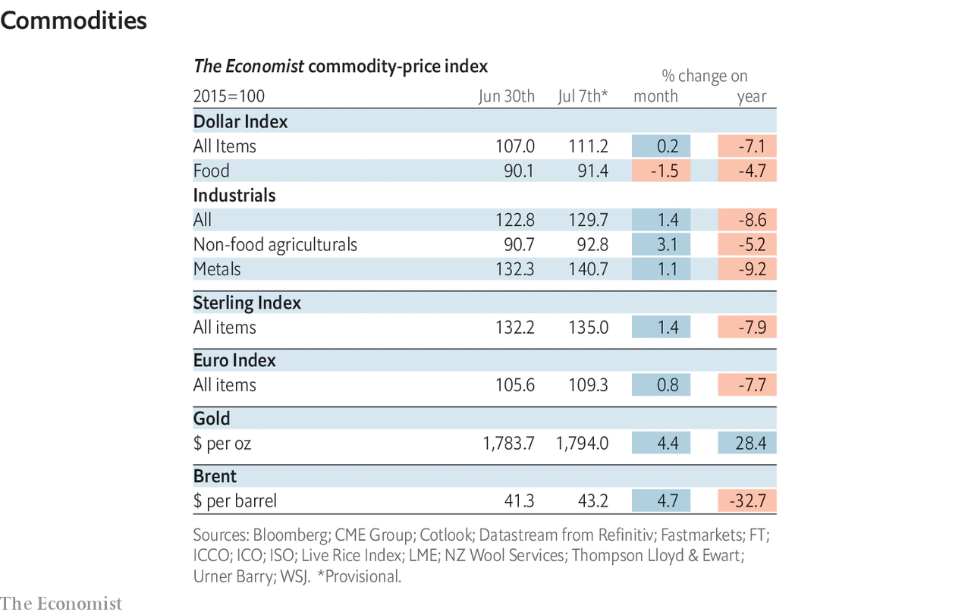

This article was downloaded by calibre from <https://www.economist.com/economic-and-financial-indicators/2020/07/11/economic-data-commodities-and-markets>

|  |  |  |  |
| --- | --- | --- | --- |
|  | Articles | Sections | Next |

|  |  |  |
| --- | --- | --- |
| Economic & ... | Sections | Obituary |

Graphic detail

GDP and life satisfaction: Blessed are the rich in spirit

.

|  |  |  |
| --- | --- | --- |
| Economic & ... | Sections | Obituary |

|  |  |  |  |
| --- | --- | --- | --- |
|  | Articles | Sections | Next |

#### Blessed are the rich in spirit

# Money really can buy happiness and recessions can take it away

Polls from 145 countries show that citizens of wealthier ones are more satisfied and secure

Jul 11th 2020 |

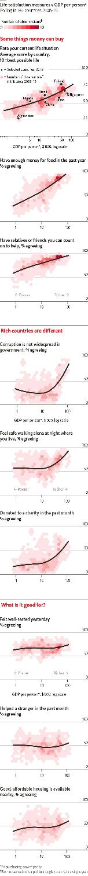

GROSS DOMESTIC PRODUCT (GDP), the most common gauge of national prosperity, has taken a lot of flak in recent years. Critics say that counting a country’s spending on goods, services and investment misses the full value that citizens get from products such as Google and Facebook. They also note that GDP ignores other aspects of development, including personal health, leisure time and happiness.

These criticisms probably exaggerate GDP’s failure to capture the wealth of nations. Gallup, a pollster, has asked people in 145 countries about various aspects of well-being. Many of these correlate strongly with GDP per person. To take an obvious example, nearly all residents in the top 10% of countries by spending say they have enough money for food, compared with just two-fifths of those in the bottom 10%.

Strikingly, many non-financial indicators also track GDP per person closely. Residents in the top 10% of countries score their life situation as seven out of ten, compared with just four for those in the bottom 10%. They are also more likely to feel supported by their families, safe in their neighbourhoods and be trusting of their politicians—though they complain nearly as much as people in poor countries do about a lack of rest and affordable housing.

Scholars disagree over the extent to which national wealth itself causes contentment. Some countries’ citizens have remained glum even as GDP per person has risen, a paradox noted by Richard Easterlin, an American economist. But one way of testing if money buys happiness is to analyse what happens when it goes away.

Studies of the previous global recession in 2009 suggest that economic hardship does indeed lead to emotional woe. Academics found dips in life satisfaction and other measures of well-being in the United States and several European countries, though the effects were mainly limited to people who lost their jobs. Adam Mayer of Colorado State University found that among Europeans of similar wealth and education, those who had recently become unemployed and struggled to buy staple foods had the worst outlook on life.

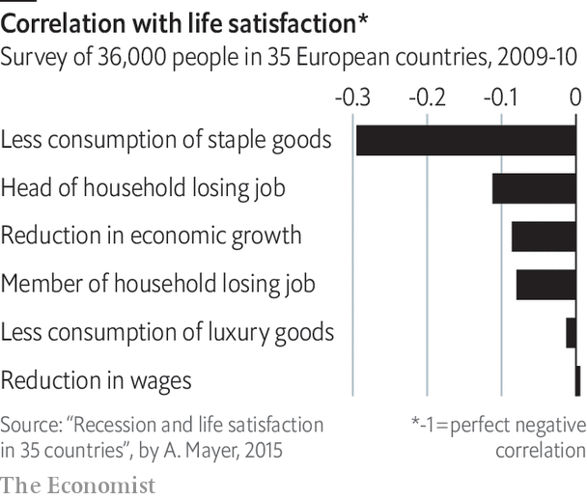

Covid-19 will allow economists to probe this pattern further. The IMF’s latest forecast points to a fall in global GDP, weighted by purchasing-power parity, of 4.9% this year. If past recessions are any guide, the severe shock will have long-lasting effects. Economies will eventually grow larger than they were before the pandemic, but will be less rich than they would have been otherwise. The virus’s human toll is therefore vast in terms of deaths and dollars. But given the correlation between GDP per person and Gallup’s measures of well-being, it may have an enduring impact on the world’s quality of life too. ■

Sources: Gallup; World Bank; World Happiness Report

This article was downloaded by calibre from <https://www.economist.com/graphic-detail/2020/07/11/money-really-can-buy-happiness-and-recessions-can-take-it-away>

|  |  |  |  |
| --- | --- | --- | --- |
|  | Articles | Sections | Next |

|  |  |  |
| --- | --- | --- |
| Graphic detail | Sections |  |

Obituary

William Dement: Perchance to dream

.

|  |  |  |
| --- | --- | --- |
| Graphic detail | Sections |  |

|  |  |  |  |
| --- | --- | --- | --- |
|  | Articles | Sections | Next |

#### Perchance to dream

# William Dement died on June 17th

The pioneer of sleep science and founder of the world’s first sleep clinic was 91

Jul 11th 2020 |

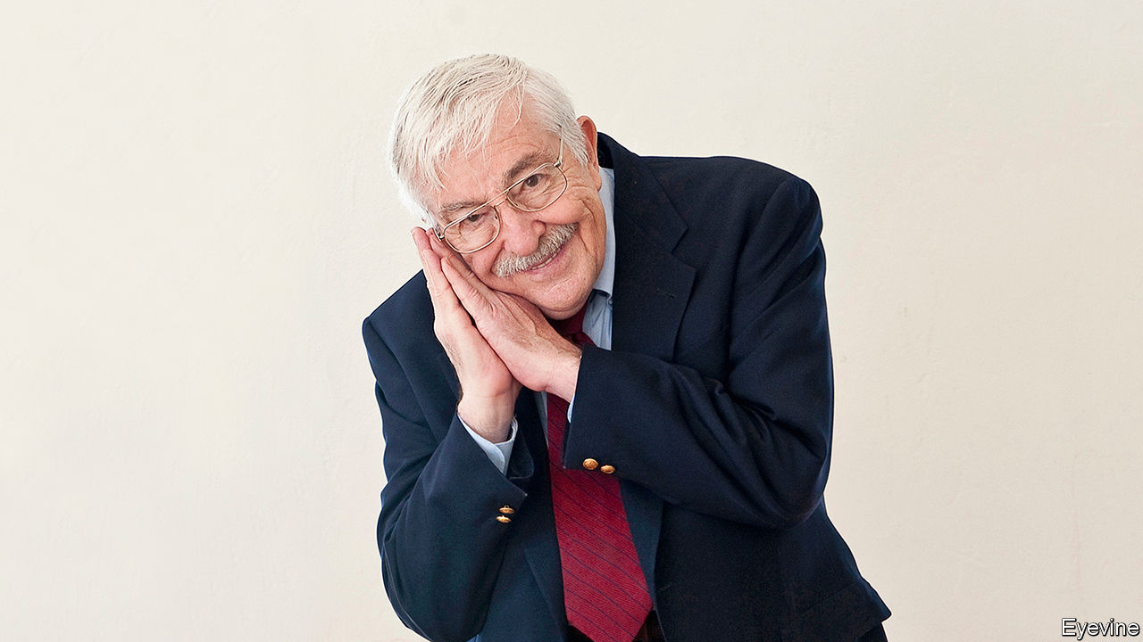

THERE SEEMED nothing much wrong with Stanford, as far as William Dement could see. To someone like him, who had left New York in January 1963 with his car buried in snow, this university—with its palms, its Spanish-colonial buildings and its skies of unbroken blue—looked like paradise. He and his wife strolled about and ate ice creams, in January, in a state of wonder.

Yet all was not quite perfect. When he made a scientific study of the students later, he found that 80% were dangerously sleep-deprived. That did not surprise him. In America, the problem was general. Adults longed for the sweet, peaceful slumber of children; but night after night they tossed and turned, lay awake for hours, contended with continually restless legs, and faced the new day feeling horrible. Worse, they woke up in debt: a debt of sleep, which like the financial kind was cumulative, making them more and more unhealthy until, at worst, they could barely function.

The result was a national plague of drowsiness. People blamed warm rooms or boring lectures for the fact that they kept nodding off in the daytime; but this was their sleep debt being called in. And the results, he warned them with increasing urgency, could be catastrophic. Someone who drowsed was mere seconds from sleep. The grounding of the Exxon Valdez, the near-meltdown at Three Mile Island, the loss of the space shuttle Challenger, had all been caused totally or in part by sleepy people. A horrendous number of the fatal accidents on America’s roads, especially among the young, were caused by drivers falling asleep at the wheel.

More shocking to him was the fact that, well into the 1990s, America’s medical establishment barely noticed. It did not matter that sleep made up a third of human life. It was such a profound state of disengagement from the sensory world that, once their patients were in it, doctors lost interest, too. At the start of the decade, when he was appointed chairman of a federal commission that went through thousands of medical records, he found an estimated 40m Americans suffering from sleep problems that were undiagnosed and thus untreated. In 1993 Congress set up a National Centre on Sleep Disorders Research, but progress was slow. Five years later, when he gave evidence to the health and environment subcommittee, he reckoned that almost half America’s adults had insomnia and as many as a quarter had obstructive sleep apnea, which stopped their breathing hundreds of times a night. That could prove fatal. Yet the lack of awareness in society, and the indifference of doctors, remained “pervasive and complete”, as if almost everyone apart from himself was still in Morpheus’s thrall.

His pursuit of the sleeping self had long been fairly solitary. In the 1950s he began to study dreaming—that strange activity which, every night, allowed him to be quietly and safely insane—at the University of Chicago and then at Mount Sinai in New York. There his apartment was his laboratory, where volunteers, including Rockettes from Radio City Music Hall and a girl he was especially sweet on, were fitted with electrodes and regularly roused to see if they recalled their dreams. He discovered that in REM sleep, where eye movements were rapid and sleep shallower, the eyes followed what people were observing in their dreams, though all their limbs stayed still. This was intriguing; but since he had come no closer to unveiling the purpose of dreams, and never did, he arrived in Stanford with his focus already turned to sleep.

It was a good moment. At a heady time of protest and upheaval he was nicely alternative, a shaggy-haired professional bass-player as well as a scientist, who had jammed with Quincy Jones and Stan Getz on his houseboat when he was at college in Seattle. In 1970 he set up a sleep clinic in Stanford, probably the world’s first and now one of its biggest, where he tested insomniac volunteers. In summer he ran sleep camps, deploying more electrodes. To study narcolepsy, the uncontrollable urge to sleep most of the time, he brought in a dozy French poodle called Monique and, in a while, established a much-loved sleepy-dog colony.

His Sleep and Dreams class was phenomenally popular right from the start, in 1971. So many signed up for the first lecture that no space was big enough except Memorial Church. And the class, which he went on teaching past 90, became famous, a sort of true-believers’ gathering, where heavy-eyed students would be sprayed awake with his trusty squirt gun and made to shout “Drowsiness is red alert!”, the motto of the cause. He looked on his students as an army of proselytisers, and in the end word spread: by this year there were more than 3,000 sleep clinics in America, and medical schools increasingly took the subject seriously. Not least, his small home town of Walla Walla, Washington, which he had used as a test case, had become the Healthy Sleep Capital of the world.

So what did he advise himself to ensure blissful slumber? His several books and his website, “The Sleep Well”, offered all kinds of tips. Most of them quickly became familiar: ergonomic pillows, a cool dark room, warm baths, no daytime naps, no alcohol or caffeine within four hours of bedtime. If sleep had not come in 20 minutes, it was best to sit quietly in the dark or read something dull, like the warranty on the refrigerator, until the eyelids closed. The best response when caught napping in the office was: “And I especially thank you for my excellent boss. Amen.”

He hoped, however, that people would determine their own sleep requirement and best practice. His was relaxed. He loved to watch favourite films again, especially “Lilies of the Field”, even if he already knew that the nuns would make Sidney Poitier build them that church; or read favourite books again, in his case the detective stories of Rex Stout, even if he already knew how every single one turned out. Re-runs of the sit-com “Everybody Loves Raymond” sent him off with wonderful ease. So much for no screens before bed. He drifted away by 10pm or so and was up by 5am, bright-eyed and bushy-tailed, with not a trace of sleep-debt.

Almost inevitably, he died in his sleep. What transformations he might have discovered then, after that first so-simple and daily one, it would have been nice to know. ■

This article was downloaded by calibre from <https://www.economist.com/obituary/2020/07/11/william-dement-died-on-june-17th>

|  |  |  |  |
| --- | --- | --- | --- |
|  | Articles | Sections | Next |